Managing OrCAD schematic parts at MBARI

P. McGill
14Feb12
J.Rosal
29March12

You’ll need at least three pages open to complete this process: the OrCAD schematic, a Web page showing the CIP-E database (//water2/cip-e), and the Web page of a vendor site such as Digikey.

- Create the schematic with generic parts using provided libraries.
  - A script written by Cathy Sewell will make a daily copy of the libraries used in the database into a folder in your local drive (C:\0_WORKSPACE\CIP-E_LIB_LOCAL-COPY). Supply Jose with your computer name in order to get these files.
  - Replace OrCAD supplied “Place Parts” libraries in OrCAD Capture with MBARI supplied libraries.
  - If a generic part doesn't exist, create a new part symbol in the schematic and then copy the part from the design cache into ProjectLibrary\TechServices\PCB_Layout\Layout_Libraries\Temp Parts\YOUR-LIBRARY.olb library and save. This is where Jose will look to copy your symbol to the CIP database later.
- Link all resistors, caps, LEDs, etc. that are likely to be in CIP database.
  - Right click on the schematic or DSN file in the OrCAD project and select Part Manager.
  - Sort by Value to group like components together.
  - Select the part(s) and right click to Link Database Part.
  - Select the part to link to from the database list by double clicking on the row (don't pick parts that start with EMA). The Part Status should change from red to green in the Part Manager.
  - Keep a list of parts that aren't in the CIP database so you can link them later.
- Add any new parts to the CIP database. If the part has a generic symbol (e.g. RESISTOR, CAP, etc.) you'll be able to link it to the part on the schematic. If you’ve just created a new symbol (e.g. a new IC), you'll have to wait for Jose to edit the database before you can link the part.
  - Find the exact part you want at Digikey or other vendor’s site. Copy the part number, and paste into Distributor Search tab of CIP Website. Make sure correct vendor is selected in Distributor field.
  - Select the desired part from the search results by clicking on the row. This will open the Part Detail tab.
  - Select the correct type of part in the Table drop down menu.
  - Select Create TMP Part in the Action drop down menu.
  - If the part is likely to have a schematic symbol already (e.g. resistors, caps, diodes, etc.), then select the correct symbol in the Map Schematic Part dropdown. Otherwise, leave it as UNASSIGNED.
  - Don't worry about the footprint - Jose will. DO NOT link the parts with unspecified symbols yet or it will change the part on the schematic into a generic box (not good).
  - Click Add. It will either say "Temporary part created successfully" or it will hang if the part is already in database.
  - Edit Common Part Info to include Depth_Tested, TMP Manufacturer, TMP Manufacturer PN, and Part Type (Example below), using Manufacturer Part Data at bottom of CIP-E page and Part Type categories on list from Jose. Do this by hitting the Edit button in the Common Part Info tab. Don’t forget to hit the Update button to save the changes.
  - For new parts that have symbols, right click the part in the Part Manager and Link Database Part. You may have to right click again to Update Selected Part Status. The Part Status should change from red to yellow because it's still temporary.
- Update the status for your linked temporary parts (the ones that had symbols) once Jose notifies you that they are complete (i.e. have footprints and final part numbers).
  - Right click the part in the Part Manager and select Update Selected Part Status.
  - A dialog will show you the differences between the current part and the database part. Accept the changes by clicking Yes. This will change the Part Status from yellow to green.
- Link your previously unlinked temporary parts to the schematic once Jose notifies you that they are correctly added to the database, including their symbols and footprints.
  - Right click the part in the Part Manager and select Link Database Part.
  - Select the part to link to from the database list by double clicking on the row. The Part Status should change from red to green in the Part Manager.

PART TYPE CATAGORIES
The following is a partial list of part types for the “Part Type” field within CIP-E. For a complete list, go to the “CIS Explorer – Place Database Part” window in Capture CIS and expand the “CIP-E_CIS-DB” network folder.

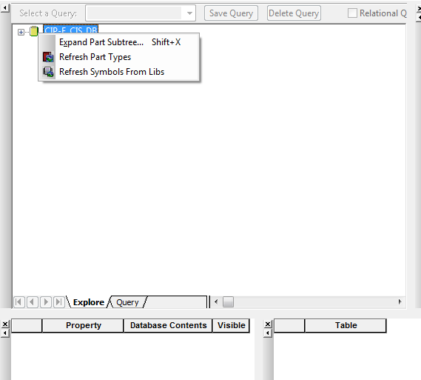

Example entry:
An OP-AMP in the IC table would need the following typed in the PART TYPE field:
AMPLIFIERS AND COMPARATORS\OP AMPS

- Capacitors
  - CERAMIC
  - ALUMINUM
  - FILM
  - TANTALUM
  - ARRAYS
  - MISC
- Connectors
  - CONNECTORS
    - Manufacturer’s Name
  - HEADERS
  - JUMPERS
  - QUICK-FITS
  - RING TERMINALS
  - TERMINAL BLOCKS
  - CRIMP PINS
    - Manufacturer’s Name
- Crystals and Oscillators
  - CRYSTALS
  - OSCILLATORS
- Diodes
  - LED
  - MISC
  - PROTECTION
  - SCHOTTKY
  - STANDARD
  - ZENER
- ICs
  - AMPLIFIERS AND COMPARATORS
    - OP AMPS
    - COMPARATORS
    - CURRENT SENSE AMPS
    - MISC
  - CLOCK AND TIMING
  - CONVERTERS
    - A/D
    - D/A
    - DIGITAL POTENTIOMETERS
  - INTERFACE
    - DIGITAL ISOLATORS
    - SERIAL
    - MISC
  - LOGIC
    - BUFFERS AND DRIVERS
    - COMPARATORS
    - COUNTERS
    - FLIP FLOPS
    - GATES AND INVERTERS
    - LATCHES
    - ETC…
  - MEMORY
  - MISC
  - POWER MANAGEMENT
    - LINEAR
    - SWITCHING
    - VOLTAGE REFERENCE
    - SUPERVISORS
  - PROCESSORS
  - SWITCHES
    - ANALOG
    - DIGITAL
    - MISC
  - OPTOCOUPLERS
  - TRANSDUCERS
    - HUMIDITY
    - TEMPERATURE
    - PRESSURE
    - OPTICAL
- INDUCTORS
  - CHOKES
  - FERRITE BEADS
  - FIXED
- MISC
  - FILTERS
  - FUSE AND FUSE HOLDERS
  - MODULES
    - COMMUNICATIONS
    - CONTROLLERS
    - DC-DC
    - MBARI
    - TRANSDUCERS
  - TEST POINTS
- RELAYS
  - ELECTRO-MECHANICAL
  - SOLID STATE
- RESISTORS
  - ARRAYS
  - FIXED
  - POTENTIOMETERS
- SWITCHES
- TRANSFORMERS
- TRANSISTORS
  - BJT
  - MOSFET
  - MOSFET DRIVERS
  - MISC

* You may enter a new part type if you find that an existing part type is not available for your part.
**Make sure your PART TYPE entry is capitalized as shown in the example.

