Exploring the promise of broadband fisheries echosounders for species discrimination with quantitative assessment of data processing effects

Running head: Species discrimination using broadband backscatter

Keywords: broadband acoustic backscatter, fisheries acoustics, species discrimination, fish, zooplankton

Kelly J. Benoit-Bird¹
Chad M. Waluk

Monterey Bay Aquarium Research Institute
7700 Sandholdt Rd., Moss Landing, CA 95003

¹kbb@mbari.org

ABSTRACT
It remains an open question how well the increased bandwidth afforded by broadband echosounders can be leveraged to improve species discrimination in fisheries acoustics. Here, an objective statistical approach was used to determine if there is information available in dual channel broadband data (45-170 kHz) to allow discrimination between in situ echoes obtained from monospecific aggregations of three species (hake, Merluccius productus: anchovy, Engraulis mordax; and krill Euphausiia pacifica) using a remotely operated vehicle. These data were used to explore the effects of processing choices on the ability to statistically classify the broadband spectra to species. This ability was affected by processing choices including the Fourier transform analysis window size, available bandwidth, and the method and scale of data averaging. The approach to normalizing the spectra and the position of individual targets in the beam, however, had little effect. Broadband volume backscatter and single target spectra were both used to successfully classify acoustic data with modestly greater success using volume backscatter data. Broadband data were much more effectively classified to species than simulated multi-frequency narrowband data, supporting the presumption that greater bandwidth increases the information available for the characterization and classification of biological targets.

- INTRODUCTION
Remotely sensed data have played a significant role in revealing ecological processes at both large and small scales and have provided critical data for the management of natural resources. One of the grand challenges in the remote sensing of biological systems is understanding the relationship between the measurements made and the organisms under study (Turner et al., 2003; Pettorelli et al., 2014). In fisheries and ocean ecosystem acoustics, the challenge is in the identification of the taxa creating the measured echoes (MacLennan and Holliday, 1996). How efficient an individual animal scatters sound depends on its acoustic properties, for example whether it has a gas inclusion, such as a swimbladder, or hard parts, such as a shell or bony skeleton. Scattering from an individual also changes with its size, shape, and orientation relative to the acoustic source and receiver. Scattering efficiency further varies strongly with acoustic frequency – different types of animals exhibit characteristic frequency responses that have been modelled and measured (see a recent synopsis in Benoit-Bird and Lawson, 2016).

The dependence of backscatter from zooplankton and fish on acoustic frequency is a key feature used in the separation of animals into different groups by size and/or taxa (McNaught, 1968; Holliday, 1977; Korneliussen et al., 2016). Historically, this frequency dependence has been exploited by utilizing multiple, discrete frequencies strategically chosen to best discriminate major scattering groups (Greenlaw, 1979; Holliday and Pieper, 1995). Discrimination amongst acoustically similar species or age classes of a single species with these low-resolution spectra is difficult (Horne, 2000; De Robertis et al., 2010). That has led to the philosophy that the more frequencies are used, the better the classification capabilities (Horne, 2000; Stanton et al., 2010; Warren, 2012). Broadband systems that transmit and receive a frequency-modulated signal from a single transducer to allow acoustic backscattering to be measured continuously over a range of frequencies, typically spanning about an octave, increase the information for spectral characterization relative to narrowband techniques. Combining multiple broadband measures to develop wideband responses may further increase the information available for the characterization and classification of biological targets (Lavery et al., 2017).

The application of broadband sound to understand biological sources of scattering in the ocean goes back to the 1940s (Love, 1975). However, broadband echosounders for in situ biological studies are only recently becoming prevalent with the introduction of several custom systems (Lavery et al., 2007; Stanton et al., 2010) and the wide adoption of a commercially available echosounder capable of both narrowband and broadband application (Simrad EK80, Demer et al., 2017). Compared with narrowband echosounders, broadband echosounders collect considerably more data, necessitating more storage, computationally expensive processing, complex calibration, and complicated interpretation. It remains an open question to what extent the increased bandwidth and frequency resolution afforded by broadband systems can be exploited to improve target discrimination (Bassett et al., 2017) and few clear protocols exist to guide the user in making choices in processing these voluminous data (Lavery et al., 2017).

The objectives of this work were to 1) determine if information in broadband data is available to allow discrimination between in situ echoes obtained from known species and 2) explore the effects of data processing choices on the ability to statistically classify these broadband data. We used a dual-channel, broadband echosounder system extending from 45 kHz to 170 kHz to collect acoustic backscatter from aggregations of fish and invertebrates in situ using a remotely operated vehicle (ROV). Acoustic data were accompanied by video data to identify the targets at a comparable scale and resolution, confirming that acoustically measured aggregations were mono-specific. The data set contains a large number of echoes collected in a minimally manipulated context, avoiding any effects of compression/decompression of gas-containing targets. Data presented include only regions where video data were available, encompassing the narrowest part of the acoustic beam so many individual targets were fully resolved in addition to volume backscatter. These characteristics allowed us to quantitatively explore the effects of 1) data normalization choices, 2) the chosen frequency resolution, or the Fourier transform window length, 3) characterization of volume scattering vs. resolved single targets, 4) position in the beam, 5) available bandwidth on discrimination success, and 6) the method and scale of data averaging. The results identify sampling and data analysis choices that can play a role in the ability to realize the promise of broadband data for taxonomic discrimination of biological targets in situ.

- METHODS
Wideband acoustic data and high-definition video data were simultaneously collected from the remotely operated vehicle (ROV) Ventana (Fig. 1) at depths between 50 and 650 m in Monterey Bay between June of 2017 and July of 2018. ROV dives were targeted to locations and depths of interest by a multi-frequency echosounder system (70, 120, 200, 333 kHz) aboard the deployment vessel, R/V Rachel Carson. Once aggregations of target animals were located with the ROV, the ROV remained with the group for as long as possible, ranging from ~30 minutes to over 2 hours. This allowed the collection of a large number of echoes from biological aggregations while a parallel video camera monitored their behavior. Parallel lasers with 10 cm spacing were used to size individuals and direct samples were opportunistically obtained using the ROV to validate size estimates. Here, we present data from animal groups identified in concomitant video data to be monospecific groups of one of three abundant species in Monterey Bay, North Pacific krill (Euphausiia pacifica), Northern anchovy (Engraulis mordax), or juvenile (<30 cm long) North Pacific hake (Merluccius productus). Krill were too small to be measured with the lasers but visual comparisons to known length references provided total length estimates between 1.5 and 2.5 cm, in agreement with collocated samples. Anchovy ranged from 10 to 17 cm in total length and hake 11 to 19 cm, both in agreement with sampled individuals. The size distribution of each species did not vary appreciably across ROV dives.

A. Echosounder data collection and calibration
The subsea echosounder, a Kongsberg Simrad EK80-Tube, is a variant of the EK80-Mini broadband-capable transceiver (Benoit-Bird et al., 2018) contained inside an underwater pressure housing. The Tube contains two, 4-channel broadband transceivers (WBTs) and was designed to run off 20-50 V DC power. For data collection, the Tube was connected to a custom underwater pressure housing containing a linear AC-DC converter to convert the 120v AC power provided by the vehicle along with a power filter to reduce electrical noise transmitted to the echosounder (Benoit-Bird et al., 2018). In addition to power conditioning, the housing contained a network switch to provide connectivity between the two transceivers and the vehicle’s gigabit network which was connected via the vehicle’s tether to a control and data recording computer running Simrad’s EK80 software at the surface. The two synchronously-controlled transceivers were connected to 7 degree 3-dB beamwidth, pressure-rated transducers with nominal center frequencies at 70 and 120 kHz (Simrad ES70-7CD; Simrad ES120-7CD) and nominal Q values of ~2. The transducers were mounted forward-facing on either side of the ROV’s main science camera using a shock-isolating design to minimize the introduction of vibrational noise to the echosounder data (Fig. 1). Both the transducers and the camera were on a single pan and tilt to allow for fine-scale, coherent steering of their imaging volumes. The echosounders collected forward-looking data synchronously at a rate of ~2 Hz continuously throughout each ROV dive, covering a bandwidth of 45-170 kHz with a gap from 85-95 kHz to avoid overlap between the two systems. Each 1.024 ms long signal was transmitted as an upward, linear frequency sweep using a half-raised cosine taper at the beginning and end of the signal (Simrad’s ‘Fast’ taper).

Prior to the first deployment, the echosounder system was calibrated in the Monterey Bay Aquarium Research Institute’s 10 m x 13 m x 10 m deep seawater test tank in the same physical and electrical configuration as used on the ROV. We conducted two calibration measurements for each transducer using Simrad’s EK80 software routines. We employed both a 19.1 and 38.1 mm tungsten-carbide sphere with a 6% cobalt binder as reference targets (Foote and Maclennan, 1984), using the split-beam capabilities of each transducer to localize the target within their beams. A conductivity, temperature, depth profile through the test tank was used to calculate the speed of sound based on temperature and salinity. The calibration for both channels and both spheres agreed with the theoretical target strength curves for the spheres which confirmed the interpolations across nulls present in the target strength curve of each sphere were appropriate (Lavery et al., 2017). The data generated with the 38.1 mm sphere were reprocessed using window sizes ranging from 0.1 to 1.5 m in 0.1 m steps to generate calibration curves used in data analysis. All calibration curves were smooth and were consistent with those generated for the same model transducers in prior studies.

B. Acoustic data processing
Initial processing of acoustic data was conducted in Echoview version 9. For each target species, we isolated samples from four separate deployments that contained moderate to dense parts of monospecific aggregations that were approximately 10 m along the beam by 100 pings in time. These twelve regions were between 3 and 15 meters from the transducers, overlapping reasonably with the video data that typically allowed 5-10 m of visibility in front of the camera (Fig. 2) while remaining beyond the ringdown range of the transducer and the nearfield of each transducer (nearfield zone: 70 kHz ~2.9 m,120 kHz~1.7 m). Data from separate species were sometimes collected on the same ROV deployment but regions for each species were selected from separate ROV deployments. Each region covered a range of depth up to 75 m as aggregations were surveyed and tracked. The data selected were separated in depth as much as possible (krill: ~75, 175, 250, 350m; anchovy: ~50-, 250, 275, 450 m; hake: ~150, 325, 350, 600 m). Three regions for each species were used to develop and explore classifiers while a fourth, the second deepest for each species, was held back for later testing. Since calibration at ambient pressure was not feasible, sample data were matched across depth as much as possible to limit pressure as a species covariate.

In each of these twelve regions, single targets were isolated in the ~3 mm resolution pulse-compressed echograms. This resulted in between about 8,000 and 15,000 targets per species. For comparison with volume scattering data, 250 targets from each of three regions for each species for a total of 750 points per species were randomly selected for analysis, including comparison with volume scattering data. The remaining targets from these regions and all of the targets from the fourth region for each species were used to test the robustness of the classification statistics. In the same regions, the frequency response of volume scattering from 250 regions one ping wide by one Fourier transform window long were examined. To calculate frequency spectra, the echo strength data for each echo was Fourier transformed to get a frequency distribution. This distribution was then divided by the frequency distribution of a perfect autocorrelation of the transmitted pulse before the frequency calibration values, including beam compensation in the case of single targets, were applied to each value in the distribution.

C. Statistical examination
Two approaches were used to examine the frequency spectra of these three species. To determine if there were significant species-specific differences in individual frequency bands, analysis of variance (ANOVA) was used. To quantitatively examine the effects of various analysis choices on the ability to separate echoes by species, discriminant function analysis was used (DFA, SPSS Statistics 24). This approach builds a predictive model for group membership using discriminant functions based on linear combinations of predictor variables. The purpose of discriminant analysis is to maximally separate the groups, to determine the most parsimonious way to separate groups, and to discard variables which contribute little to group distinction. This approach allowed us to assess the relationship between a group of independent variables, in this case scattering strength at a given frequency for each echo, and a single categorical variable, species, similar to its application to narrowband data (McKelvey and Wilson, 2006) but with many more independent variables. Using this relationship, it is possible to predict a classification based on the independent variables. It is also possible to assess how well the independent variables separate the categories in the classification. This latter utility allows the effects of various analysis choices on the classification of echoes to be examined quantitatively by looking for differences in the overall correct classification of each species using the resulting discriminant functions. Tests, their connection to the objectives, and a summary of results is found in Table I.

1. Normalization
For classification of targets, the goal is to examine the frequency response of the echo, not its absolute amplitude or total backscattered energy. In narrowband data, scattering is typically referenced to a single frequency with all other frequencies represented as a difference in dB, equivalent to a ratio of echo intensity in the linear domain (frequency differencing: Korneliussen and Ona, 2002; Logerwell and Wilson, 2004). A parallel approach has been utilized in broadband data (Bassett et al., 2017). To determine the best approach for these data, DFA was used to test the effects of a variety of normalization options on classification success. Single target data and volume scattering data were analyzed using a 0.4 m Fourier transform window length and normalized using a variety of reference frequencies for each echo: 70 kHz (the nominal value of our lower frequency channel), the maximum of each individual echo, the 95th percentile of each echo, the 90th percentile of each echo, the maximum in the 5 kHz surrounding 70 kHz, and the median of each echo. To explore a normalization approach that does not require the identification a specific reference, the absolute amplitude was also removed bytaking the first derivative of the spectra. The result was that there was little effect of the choice of normalization procedure on the outcome. For all normalization procedures, the percent of echoes correctly classified by discriminant function analysis were within a ±1% range of each other. This was true for both the single target and volume scattering data. For simplicity, all data was normalized using the maximum value for each echo as the reference as this normalization approach is independent of the actual frequencies available and is easy to calculate.

2. Window length
Using Fourier transform to examine broadband echoes, it is possible to have high resolution in time, that for echosounder data is typically converted to range using the speed of sound in seawater, or high resolution in frequency but not both at the same time, a relationship referred to as the uncertainty principle. Changing the window length used in the calculation changes the trade-off between range resolution and frequency resolution.

As a result of tools built into Echoview that allowed for rapid extraction of the position-corrected spectra for individual targets, target strength spectra were derived at 0.1 m intervals of Fourier transform window size from 0.1 m to 1.5 m, approximating the proposed limit of two times the pulse length (Lavery et al., 2017). Unfortunately, current Echoview processing tools for extracting spectra from volume scattering data are limited so fewer data points and fewer window sizes could be obtained for comparison. For volume scattering data, Fourier transform analysis was conducted at window sizes of 0.2, 0.4, 0.6, 0.8, and 1.0 m. Each analysis was conducted on a sample that extended over the same range as the analysis window to avoid averaging or padding within each transform. Each of these windows was centered about the same range point to facilitate inter-comparison across window sizes. Bins were separated in range by 1 m so there was no overlap between adjacent bins, regardless of window length.

Discriminant function analysis was used to test the effects of the frequency resolution, or the Fourier transform window size. For normalized frequency spectra from both volume scattering and single target data, a separate DFA was conducted at each available window size. Note that while increasing the window length increases the number of frequency bins that can be calculated in the Fourier transform, Echoview exports data in 0.244 kHz bins regardless of the original bandwidth of the data or the size of the window. This keeps the number of frequency bins in each analyzed echo constant

3. Volume scattering vs. single target data
The classification success rates from the DFAs for volume scattering and single target data were compared to determine if one data type had an advantage in species discrimination. Data from the 4th region for each species was classified using the same discriminant functions to determine if the classifiers have the potential to be generalized to new data and how the rates of successful classification of novel data varied between data obtained near the data used to build the classifiers and independently collected data.

4. Position in the beam
In measuring single targets, their position in the beam is estimated using phase information and corrected for in the development of target strength spectra using a lobe model for each transducer supplied by the manufacturer. In order to understand if residual errors in this compensation affect the information content in the spectra, 750 single targets that were within one degree of the center of the beam in both directions were randomly selected for each species. Discriminant functions were then developed for these centered targets using the 0.5 m Fourier transform window size data. This window size was chosen because of the relatively high classification rate, allowing decrements to be easily detected. The correct classification rates for the centered data were compared to those of the targets selected from the full 0.5 m window size dataset with the hypothesis that centered targets would be easier to correctly classify than targets for which position in the beam was not considered as beam compensation potentially introduces error into the spectra.

As a second method of exploring the effects of beam angle compensation, 1,000 targets estimated to be between 3.5 to 7 degrees from the center of the beam in at least one direction were randomly selected for each species and classified using the discriminant functions developed for the centered targets. A reduction in classification rates is expected whenever novel data are classified using DFA. There were not enough centered targets to test the classification of new targets against the DFA developed with centered targets. In order to provide a scalar to interpret the magnitude of this reduction, the DFA developed on a random subset of data from all angles was tested against a 1,000 point per species random subset of novel data at all angles instead. If position in the beam was affecting the information in the spectra, a reduction in classification rates for edge relative to centered targets would be higher than the reduction due to the effects of novel targets without a change in beam position.

5. Bandwidth
To examine the effects of scattering spectra bandwith on classification, the volume scattering and single target spectra were trimmed in a variety of ways before conducting discriminant analysis. This analysis used the spectra developed using a 0.4 m window size to allow overlap between the two data sets. To approximate typical narrowband multi-frequency analysis, data from the nominal center frequencies, 70 and 120 kHz were selected from the spectra before conducting the DFA. In addition, data from five frequencies were selected in the spectra, 50, 70, 100, 120, 165 kHz before conducting DFA. This represents the broadest spread possible within these data while providing a similar number of datapoints to the available number of narrowband channels available in field studies. Recognizing that single-frequency echosounders typically have a wider bandwidth than a single value in the broadband spectra, these analysess were repeated with the data averaged in linear space for 2.5 kHz surrounding these five center frequencies, approximating the bandwidth of a 1024 μs long narrowband signal from a Simrad EK60. Data from the 4th regions for each species were then processed similarly and classified using the developed discriminant functions.

Broadband spectra are often trimmed relative to the band transmitted by removing extremes of each band for analysis to deal with edge effects introduced by Fourier analysis.This process was simulated by removing 1 kHz, 2.5 kHz, and 5 kHz of data at each of the backscatter spectra edges for a total of four edges, 2 edges per transducer for two transducers resulting in the removal of 4 kHz, 10 kHz, and 20 kHz, respectively. Discriminant functions for 0.4 m windowed volume scattering and single target data were then developed for each of the trimmed datasets. To explore whether this trimming has an effect equivalent to removal of other frequencies, 20 kHz of data, the greatest total amount trimmed from band edges but made up of 82 individual 0.244 kHz frequency bins, was removed randomly throughout the data. This random removal and generation of a new DFA was repeated five times. To determine if the contiguity of the removed data had an effect, 20 kHz of data was removed in 5-kHz bands from two randomly selected locations in each channel before the development of discriminant functions. This process was also replicated five times.

6. Averaging
The effects of averaging multiple echoes on species discrimination were explored in both volume scattering and single target data. Datasets used included those analyzed with Fourier window sizes of 0.2, 0.4, 0.6, 0.8 and 1.0 m. Echoes within each data set were randomly ordered and then a running average of the normalized scattering strength in each frequency bin was taken over 3, 5, 9, and 17 echoes. Using a running average maintained a nearly constant number of samples, removing sample size as a potential variable. Acoustic backscattered energy typically exhibits a highly skewed distribution, making description by simple metrics, including the arithmetic mean, challenging. Log transformation, as is done when backscatter is expressed in decibels, compresses the overall distribution and dramatically reduces its skew. The result is data that approximate a normal distribution that can be adequately described by simple metrics and analyzed with parametric statistics (Zar, 1999). While averaging log-transformed data does not maintain the relative energy relationships, the goal here was not to estimate biomass but instead to describe species-specific differences in the dataset. To test the effects of averaging on classification, averaging was conducted in two ways. First, by linearizing the normalized echo strength values, taking the average, and converting the spectra back to decibels. Second, the normalized spectra were simply averaged in decibel space, analogous to taking the geometric mean but without converting the final units. In order to test the ability of the discriminant functions of averaged data to effectively classify new data, two approaches were taken. First, randomly selected single targets, 5,000 of each species, not used in the development of the discriminant functions were classified using the discriminant functions developed for similarly processed targets from the same regions. The correct classification rates of these new targets were compared to the correct classification of the original 750 targets from each species. Second, data from the 4th regions of each species not used in the development of the discriminant functions were classified and the rates of success compared to the original data.

III. RESULTS AND DISCUSSION
A unique, in situ dataset combining forward-looking wideband acoustic backscatter measures with video observations was used to explore the information available for species classification in broadband data (Fig. 2). The three pelagic species targeted are abundant in the California current: Northern anchovy, Pacific hake, and North Pacific krill; a physostome that refills its swim bladder at the surface, a physoclist that metabolically regulates the volume of gas in its swim bladder, and a decapod crustacean, respectively. By examining changes in the ability to use statistical tools to correctly segregate these three echo data sets, this study described the effects of 1) data normalization choices, 2) the chosen frequency resolution, or the Fourier transform window size, 3) use of volume scattering vs. resolved single targets, 4) position in the beam, 5) available bandwidth on discrimination success and 6) the method and scale of data averaging

For both volume scattering and single target data, the relative scattering spectra from the three target classes were generally well-described by discriminant function analysis and were well segregated (Fig. 3). For example, in the 0.4 m window data, Echoview’s default Fourier transform window size, 74.3% of the volume scattering data and 71.5% of the single targets were correctly classified by the discriminant functions. Classification success rates for both single targets and volume scattering data were reduced an average of ~10% when independently collected data were classified. There was less of a decrement at larger transform window sizes than smaller ones. These results suggest that the statistical descriptions of backscatter spectra can be applied to new data collected similarly, at least at some window sizes. There is information available in broadband spectra to statistically separate these three distinct species using either volume scattering or individual targets. This separation was completed with no prior knowledge of the expected spectra and no supervision.

Differences in backscatter spectra between species are also visually apparent (Fig. 2). The overall volume scattering spectra for krill, best represented by a logarithmic curve, conforms to the general pattern expected for krill which increases monotonically until a rolloff at the transition between Rayleigh and geometric scattering as expected for weakly scattering, fluid-like zooplankton (Stanton et al., 1998a; Stanton et al., 1998b). Anchovies had a fairly flat frequency response, as expected for a swimbladder-bearing fish (Love, 1971) and observed in laboratory measurements over the same frequency band (Conti and Demer, 2003). Hake, which also has a swimbladder, showed a much different response. Over the lower frequency band, the data was best represented by a polynomial u-shaped curve, with weakest scattering near 70 kHz. Removing the edges of this lower frequency band, regions of the spectra known to be prone to unexpected variation, flattens the curve considerably, suggesting this shape should be interpreted with care. Scattering from hake in the upper frequency band decreased linearly with increasing frequency, approximately 0.2 decibels per kilohertz, much greater than the decrease of ~4 dB between 70 and 200 kHz observed with narrowband, shipboard echosounders by Sato et al. (2015). While few measurements of hake target strength at a range of frequencies have been made, this steep decline in scattering strength deviates from the expectations for swimbladder-bearing fish above resonance. However, a similar pattern of an above presumed swimbladder resonance frequency peak in scattering strength with a >10 dB decrease in scattering strength at higher frequencies has been observed in a wide range of swimbladder bearing species while other closely related fish show the more typical approximately flat frequency response in the same experiments (Au and Benoit-Bird, 2003; 2008). Other researchers have shown frequency responses for swimbladdered fish with similarities to the hake measurements shown here, but only at some orientations (Reeder et al., 2004; Imaizumi et al., 2008). Differences in the presentation of data across studies, particularly the frequency resolution used to generate the spectra and the approach to describing the central tendency should be considered, however, in comparing broadband spectra across studies as results are highly sensitive to these choices (Fig. 3).

Animal orientation strongly affects the strength of acoustic backscatter (Love, 1969; 1971). An increase in the scope of target orientations means greater variability in backscatter strength values and spectral responses with the most extreme differences typically observed between lateral and posterior aspects (Benoit-Bird et al., 2003). In situ acoustic backscatter data is usually collected from downward-looking, hull-mounted transducers, reducing the range of target orientation to ~15 degrees about the dorsal aspect for some species (McClatchie et al., 1996). Forward-looking transducers, including those utilized here, are more likely to collect data from multiple orientations since sound reflecting off the front, back, or side of a target are all possible, representing the widest range of potential backscatter values. The ROV video observations showed that all possible animal orientations, including lateral, dorsal, ventral, and end-on were recorded in the acoustic data though aspects near lateral were more frequently observed. The changes in orientation were frequent and rapid as animals interacted with the ROV, a large close-proximity sampling platform. Despite these forward-looking transducers on the ROV collecting perhaps the most variable acoustic data from these targets, both statistical results and visual examination of the spectra (Fig. 2) show species-specific backscatter patterns. The spectra and classification functions presented here are not directly applicable to the majority of field data collected from downward-looking configurations. However, the availability of information for species discrimination in these ‘worst-case scenario’ data holds promise for the effective use of broadband data for in situ classification and allows quantitative analysis of data processing effects with realistic variation.

The best-fit curves shown in Fig. 2 describe the general frequency response pattern from each species. However, they do not capture statistically significant differences in species-specific features like isolated peaks and nulls that are evident in the full distribution of volume scattering for each of the three species. Analysis of variance of normalized 0.4 m Fourier transform spectra reveal that 91% of frequency bands in volume scattering data and 87% of bands in target strength data varied significantly between species. Discriminant function analysis is not using the ordered, relative position of frequencies in discrimination as would be required to use the overall frequency response information that is evident in the data (the blue trend lines in Fig. 2) and typically emphasized in efforts to model scattering spectra. The repeatable peaks and nulls revealed by the ANOVA, however, are important for the development of discrimination functions. Statistical techniques that can examine both general trends and isolated features in spectra may prove effective for practical classification efforts.

A. Normalization
To examine the frequency spectra of acoustic backscatter, normalization removes the effects of the absolute amplitude on the scattering strength. Following the approach most commonly taken in narrowband data, frequency differencing using a number of different reference values for normalization were explored. Another approach that did not require identifying a reference frequency, using the first derivative of the spectra, was also examined. There were negligible differences in the classification success of discriminant functions developed using these various normalization approaches, ±1% difference in classification success across all normalization approaches. Here, a simple, flexible approach of using each echo’s maximum value as the reference was utilized for additional analyses.

B. Window size
Increasing the window size, and thus increasing the frequency resolution (Fig. 3), increased the ability for the target groups to be discriminated using DFA for both single target and volume scattering data (Fig. 4). This pattern was consistent for all three species when examined individually (Fig. 5). Because a fixed number of frequency bins was used regardless of the window size, this effect was not simply due to the number of additional independent variables in the statistic. For both volume scattering and target strength data, the effect of increasing the window size began to asymptote around 0.4-0.6 m. Gains in classification success after a window size of 0.5 m were modest. These results inform the choice of window size as window size is typically a tradeoff between the number of frequency bins and spatial resolution, important for reducing the risk of potentially including echoes from more than one target group (Bassett et al., 2017).

Increasing the window size does not increase the likelihood of correct classification consistently for the three species, however. In both volume scattering spectra and target spectra, across all window sizes, krill was most often correctly classified follow by anchovy, and lastly, hake. The rate of classification improvement with increases in window size varied by species (Fig. 5). As a result, the odds of mixing up a specific pair of species are also dependent on window size. Krill were misclassified as hake far more often than as anchovy at small window sizes. As window size increased, the misclassification rates as hake reduced while the anchovy misclassification rate remained similar. At the smallest window size, anchovy misclassifications were split evenly between krill and hake in both volume scattering and single target data. At larger window sizes, misclassification of anchovies as krill decreased but misclassification as hake remained fairly constant. Hake were misclassified as anchovies about 40% more than krill, with proportionate improvements seen in both comparisons as the window size increased. That fish were more often mislabeled as the other fish species than as krill is not surprising given their presumably more similar acoustic characteristics. It is interesting, however, that hake consistently sat between the two other species in classification when it is the most evolutionarily derived and physiologically distinctive as a fish with a metabolically-regulated swimbladder, in contrast with a fluid-filled scatterer (krill) and one with a swimbladder that must be filled with air at the surface (anchovy).

It should be noted that changing the window size also has other effects on the data processing. For single target data, the data outside the identified target was masked so that at large window sizes, the data is padded before Fourier transformation. For volume scattering data, the amount of data incorporated in the transform was increased as the window size increases. That both data sets show the same pattern of increasing classification success with increasing window size supports the interpretation that changing the frequency resolution is the principal factor driving the improvement in classification as Fourier analysis window size was increased.

C. Volume scattering vs. single target data
Across all window sizes, species were more accurately classified within volume scattering data than single target data, with an average improvement of about 6% across all window sizes examined. These differences were similar for all three species groups. The modest increase in classification suggests there is more consistent, species-specific information available in volume scattering data relative to single target data. These patterns were consistent when novel and independent data were classified despite decreases in overall classification success.

D. Beam position
One of the challenges of broadband data analysis is that most commercially available transducers do not have a constant beamwidth over their full frequency range. Instead, their beams become narrower with increasing frequency. Here, the 70 kHz transducer has a beamwidth ranging from 10.9 degrees at the lowest frequency in our band to 5.8 degrees at the highest while the 120 kHz transducer’s beam angle ranges from 8.8 to 4.9 degrees. To examine the effects of target position in the beam on the information available for classification in the position-corrected echoes, two approaches were employed. First, the success rates of a classifier developed from targets measured the center of the beam was compared to those made using the full 7 degree beam (e.g., the data shown in Figure 3). The classification success rate for centered targets was similar to that for samples taken from the full beam (71.7% classification success for targets from all angles vs. 71.5% classification success for center targets only). These results indicate there is little effect of the position in the beam on overall classification rates.

As an additional test, off-axis targets were classified using the discriminant functions developed using the centered targets. There was a modest decrease in classification success of these novel targets of ~11%. This was similar to the ~10% decrease in classification success for novel data over all angles categorized using discriminant functions developed from targets at all angles. These results indicate that while novel data are, not surprisingly, not as well classified as those used to build the classifier, the position of the target in the beam had little effect on classification success of these three species using discriminant function analysis. Together, these results refute the idea that variation introduced by beam correction reduces the information available for species classification in spectra changes with beam position.

E. Bandwidth
To examine the effects of reducing the width of scattering spectra, the volume scattering and single target spectra developed using a 0.4 m window size were trimmed in a variety of ways before conducting discriminant analysis. To approximate narrowband multi-frequency analysis, data from only the nominal frequencies of each of the two channels. This reduced the classification success to about 30-35% for volume backscatter and single target data, essentially chance for three classes. The number of narrowband channels often used in field sampling is higher so data from 5 frequencies were selected in the spectra, 50, 80, 100, 120, 165 kHz (Fig. 6), reducing the classification success by ~27% for volume scattering data and ~26% for single target data relative to the full spectra shown in Fig. 4. Recognizing that single-frequency echosounders typically have a wider bandwidth than a single value in the broadband spectra, this analysis was repeated by integrating the regions around these five center frequencies to approximate the bandwidth of a narrowband signal while maintaining the same number of data points. These data were also less successfully classified, still approximately chance for the two-frequency dataset and reduced by even more, 26-34% relative to the full spectrum of data, in the five-frequency data. Increasing the bandwidth incorporated in the simulated narrowband data did not improve the classification outcomes. More frequencies of narrowband data improved classification but broadband data were significantly more useful for classification than the simulated narrowband data.

Broadband data are often trimmed relative to the band transmitted by removing extremes of each band after generation of the spectra to remove visible edge effects of the Fourier transform. This process was replicated by removing 1 kHz (a total of 3.9% of the data), 2.5 kHz (a total of 8.5% of the data), and 5 kHz (a total 17% of the data) from each of the edges of the frequency bands before developing discriminant functions. The result was a reduction in classification success of 1.0%, ~2.2% and ~4.8%, respectively, for both volume scattering and single target data. To explore whether edge-band trimming has an effect equivalent to removal of other frequencies, a total of 20 kHz of data were removed randomly throughout the spectra. This 17% data reduction is the same amount removed by 5 kHz edge band trimming. The removal of 82 random frequency bins totaling 20 kHz resulted in an average loss of classification success of 11.2% (range: 8.7%-12.6%). To determine whether contiguity of the removed data had an effect, 20 kHz of data were removed in four, randomly-chosen 5 kHz bands, two from each channel. This reduced the classification success by somewhat less than the independently removed bins, an average of 5.7% (range: 4.1%-7.4%). Trimming the edges of the bands resulted in less loss of classification ability than expected based on the total percentage of data lost and relative to randomly distributed data loss of the same magnitude. However, the decrement in classification success was similar to that observed by removing similarly sized but randomly placed signal bands. These results indicate that removal of these data needs to be carefully considered, as species-specific information is found throughout the spectra. Even when it appears that edge effects of the Fourier transform and other sources of variance are introducing outliers into the spectra, these edges continue to contribute to the ability to discriminate amongst species.

F. Averaging
Volume scattering data are typically averaged over a number of data points in space and/or time to decrease the variance in the resulting amplitude and frequency response (Simmonds and MacLennan, 2006). Similarly, broadband spectra have been averaged for classification (Lavery et al., 2007; Bassett et al., 2017). Recently, Jech et al, (2018) argued for the calculation of the mean and variance estimates of dB difference values in the logarithmic domain but did not explicitly compare the results of this approach to linear averaging. In these data, two main methods of averaging were explored: the traditional, linearized approach to averaging (linearizing the backscatter strength values, averaging, and then returning to the log domain) and averaging the log transformed (dB) data (Examples shown in Fig. 3). As the number of data points averaged increases, the estimate of the sample mean is expected to more closely approach the population mean and the standard error to decrease (Zar, 1999). As a result, it is expected that the performance of the classifier will increase as well.

In data presented here, linear averaging did not result in predictable increases in statistical separation of the three classes of echoes (Fig. 7). While there was generally a modest improvement in classification success with the inclusion of an increasing number of points in the average, for some Fourier transform window sizes, the discriminant functions performed no better than those constructed with individual data points. In some cases, the classifier performance even decreased by as much as 10% as the scale of averaging increased. Examining the patterns of individual classes showed even more variability. For example, at a given Fourier transform window size, one species might show little to no improvement in classification accuracy while another exhibited as much as a 14% decrease in classification accuracy as more points were averaged. Which species exhibited improvements and which decrements in classification success with an increasing scale of linear averaging was inconsistent, changing with window size.

When performing the averaging on the log transformed normalized data, in contrast to linear averaging, we found that increasing the scale of averaging increased the performance of the DFA consistently for all window sizes and for each class (Fig. 7). Both individual species correct classification rates and the total accuracy rate for all window sizes followed the same asymptotic form shown in Fig. 7. This is the anticipated and hoped for effect of by averaging. Species were consistently more accurately separated in averages of the log-transformed data than either the normalized raw data or the data averaged in the linear domain at the same scale. Relative to linearly averaged data, averaging the log-transformed data, improved classification success by an average of 9.5% but up to a 23% improvement was observed. If average spectra were generated using Echoview, with its defaults of a 0.4 m Fourier window size and linear domain averaging, classification would be nearly 20% less successful than if the data were averaged after log transformation. While volume scattering data are shown in Fig. 6, single target data showed similar patterns.

Discriminant function analysis can be used in multiple ways. One way is to describe how well the variables separate known groups, as done above. Another way is to use the developed discriminant functions to classify new targets, the real goal of most classification endeavors. Using the classifiers built using linear-averaged single target data, classification success for novel targets, whether pulled from the same three regions used to develop the classifiers or from an independent deployment, was reduced by 16%-31% relative to the data used to create the discriminant functions. In many cases, the discriminant functions based on linear-averaged data performed no better than random chance (for three classes, chance=33% success) in assigning a target to a class though class-specific variation was observed. Classification of novel, log-averaged data using the classifiers built using log-averaged data was also reduced, but to a much lesser degree whether considering data from the original three regions or an independent deployment. The reduction was 2%-11%, with smaller effects at larger averaging scales and window sizes. For example, 5 point, log-averaged 0.4 m window data from the independent deployment was classified with 97% success. Classification results using log-averaged data were always substantially higher than chance. The classifiers built using the linear averaged data were not generalizable to new data, even data taken at the same time and under the same conditions. In contrast, the log-averaged data was quite effective at classifying new data, even that collected at a separate time, suggesting greater utility of this approach to averaging for the goal of target classification.

IV. CONCLUSIONS
The availability of broadband echosounders has been heralded as a new era in fisheries acoustics. It remains an open question, however, to what extent the increased bandwidth and frequency resolution afforded by broadband systems can be exploited in target discrimination (Bassett et al., 2017). Here, a relatively simple, robust, statistical approach was used to determine if information in broadband data is available to discriminate between in situ echoes obtained from known species and explore the effects of data processing choices on the ability to statistically classify these broadband data. Broadband volume backscatter and single target spectra were both used to successfully classify acoustic data with modestly greater success using volume backscatter data. Broadband data were much more effectively classified than simulated multi-frequency narrowband data using this statistical approach, supporting the presumption that greater bandwidth increases the information available for the characterization and classification of biological targets.

The statistical approach employed here allowed us to quantitatively and objectively examine the effects of data processing on the information present in spectra from three pelagic species. The position in the beam and the specific reference value used to normalize the data for spectral examination had little effect on ability to successfully discriminate between species. Volume scattering data, the most common measurements collected in situ, were somewhat easier to correctly classify than spectra from single targets. Increasing the frequency resolution of the Fourier transform by increasing the window size improved the ability to separate species, though this effect plateaued so that gains were minimal after a window size of ~0.5 m. The available bandwidth in the processed spectra had considerable effects on classification success. Care must be taken when trimming the signal to avoid loss of discrimination capability as there is information in the full spectra that can be leveraged for classification.

One of the largest analysis effects on discrimination capability was observed in the method and scale of data averaging. Averaging the linear form of the acoustic backscatter data retains information on the energy in the echo, important for the calculation of biomass. However, for most target classification approaches, the absolute energy level has already removed from the spectra by normalizing the data to a reference value. More importantly, the arithmetic mean of this highly skewed data (see example distributions in Bassett et al., 2017) does not robustly represent the central tendency of the observations. Using these linear averaged spectra proved ineffective for discrimination between species under many conditions, with unpredictable effects on classification success including reduced success relative to raw data for some data processing combinations. In contrast, averaging in the logarithmic domain consistently improved the ability to use discriminant functions to separate species, both relative to raw data and relative to linear averaged data. Even modest averaging scales of five data points improved the classification success to nearly 100% for most data processing combinations. This is much less than the 100 points shown necessary in other studies employing linear averaging techniques (De Robertis et al., 2010) and the number of points likely necessary to reach consistently high levels of classification success in linear averaged data here. Using log-averaged data allows the estimate of the central tendency to converge more quickly in highly variable data than the linear mean. Even more compellingly, the discriminant functions developed on the log-averaged data performed well with novel and independent data while those based on linear-averaged data performed close to chance when tested against new and independent data. The poor performance of the linear-averaged data is a result of the consistent positive-skew where most of the data falls to the right side of the mode of the distribution of acoustic data in linear units which includes both the raw scattering strength values and the frequency response data.

Logarithms are often used to transform skewed data to make it easier to describe with simple statistics and more amenable to parametric statistical tests (Zar, 1999). One common descriptor the log-normally distributed data typical of acoustic backscatter data is the geometric mean. The geometric mean can be computed as the average of log-transformed data, as conducted here, which is then typically converted back to linear units, a final step is not necessarily helpful for those used to working with backscatter in decibel units. There is much to learn here from the satellite oceanography community which has carefully considered the use of arithmetic versus geometric means in quantifying the distribution and variability of remote optically sensed algal biomass data (Campbell, 1995) and concluded that the best approach is dependent on the objective of the study (Morel and André, 1991; Bricaud et al., 2002). As demonstrated here, it can be appropriate and effective to work in decibel units when taking the mean and estimating dispersion of acoustic backscatter data for the purposes of comparison between spectra, and perhaps for other applications as well.

The results presented support the conclusion that broadband data contains information that can aid in the discrimination of species in situ. Here, volume scattering data had a modest advantage over single target data for species discrimination. Processing choices, including the Fourier transform window size, available bandwidth, and the method and scale of data averaging, had strong effects on how well broadband information can be leveraged. The gains in classification observed using broadband data may balance the costs of more extensive data storage, computationally expensive processing, complex calibration, and complicated interpretation necessitated by broadband sampling. Objective, quantitative approaches to assessing the effects of data processing on the resulting acoustic spectra are critical as the fisheries acoustics community develops protocols for the application of broadband techniques to biological questions in the ocean.

ACKOWLEDGEMENTS
The captain and crew of the R/V Rachel Carson expertly supported field efforts. ROV pilots DJ Osborne and Mike Burczynski guided the development and deployment of the ROV system and skillfully navigated the vehicle to targets of interest. Mike Conway fabricated hardware for the ROV system. Paul McGill and Craig Okuda designed and fabricated power systems for the ROV acoustic sensors. Bruce Robison, Kim Reisenbichler, and Rob Sherlock aided the development of the video-acoustic data collection and analysis protocols. The staff of MBARI’s video lab, particularly Susan von Thun and Lonny Lundsten aided in the analysis the video data. John Ryan engaged in timely discourse on statistics. This work was supported by the David and Lucile Packard Foundation through the Monterey Bay Aquarium Research Institute.

V. REFERENCES
Au, W. W. L., and Benoit-Bird, K. J. (2003). "Acoustic backscattering by Hawaiian lutjanid snappers II: Broadband temporal and spectral structure," J Acoust Soc Am 114, 2767-2774.
Au, W. W. L., and Benoit-Bird, K. J. (2008). "Broadband backscatter from individual Hawaiian mesopelagic boundary community animals with implications for spinner dolphin foraging," J Acoust Soc Am 123, 2884-2894.
Bassett, C., De Robertis, A., and Wilson, C. D. (2017). "Broadband echosounder measurements of the frequency response of fishes and euphausiids in the Gulf of Alaska," ICES J Mar Sci 75, 1131-1142.
Benoit-Bird, K. J., Au, W. W. L., and Kelley, C. D. (2003). "Acoustic backscattering by Hawaiian lutjanid snappers I: Target strength and swimbladder characteristics," J Acoust Soc Am 114, 2757-2766.
Benoit-Bird, K. J., and Lawson, G. L. (2016). "Ecological Insights from Pelagic Habitats Acquired Using Active Acoustic Techniques," Annual Reviews of Marine Science 2016.8, 463-490.
Benoit-Bird, K. J., Welch, P. T., Waluk, C. M., Barth, J. A., Wangen, I., McGill, P., Okuda, C., Hollinger, G. A., Sato, M., and McCammon, S. (2018). "Equipping an underwater glider with a new echosounder to explore ocean ecosystems," Limnology and Oceanography: Methods 10.1002/lom3.10278.
Bricaud, A., Bosc, E., and Antoine, D. (2002). "Algal biomass and sea surface temperature in the Mediterranean Basin: Intercomparison of data from various satellite sensors, and implications for primary production estimates," Remote Sensing of Environment 81, 163-178.
Campbell, J. W. (1995). "The lognormal distribution as a model for bio‐optical variability in the sea," Journal of Geophysical Research: Oceans 100, 13237-13254.
Conti, S. G., and Demer, D. A. (2003). "Wide-bandwidth acoustical characterization of anchovy and sardine from reverberation measurements in an echoic tank," ICES J Mar Sci 60, 617-624.
De Robertis, A., McKelvey, D. R., and Ressler, P. H. (2010). "Development and application of an empirical multifrequency method for backscatter classification," Can J Fish Aquatic Sci 67, 1459-1474.
Demer, D. A., Andersen, L. N., Bassett, C., Berger, L., Chu, D., Condiotty, J., Cutter, G. R., Hutton, B., Korneliussen, R. J., Bouffant, N. L. M., G, Michaels, W. L., Murfin, D., Pobitzer, A., Renfree, J. S., Sessions, T. S., and Stierhoff, K. L. T., C H (2017). "Evaluation of a wideband echosounder for fisheries and marine ecosystem science," ICES Cooperative Research Report 336, 70 pp.
Foote, K. G., and Maclennan, D. N. (1984). "Comparison of copper and tungsten carbide calibration spheres," J Acoust Soc Am 75, 612-616.
Greenlaw, C. F. (1979). "Acoustical estimation of zooplankton populations," Limnol Oceanogr 24, 226-242.
Holliday, D. V. (1977). "Extracting biophysical information from the acoustic signals of marine organisms," in Oceanic Sound Scattering Prediction, edited by N. R. Anderson, and B. J. Zahuranec (Plenum, New York), pp. 619-624.
Holliday, D. V., and Pieper, R. E. (1995). "Bioacoustical oceanography at high frequencies," ICES J Mar Sci 52, 279-296.
Horne, J. K. (2000). "Acoustic approaches to remote species identification," Fish Oceanogr 9, 356-371.
Imaizumi, T., Furusawa, M., Akamatsu, T., and Nishimori, Y. (2008). "Measuring the target strength spectra of fish using dolphin-like short broadband sonar signals," The Journal of the Acoustical Society of America 124, 3440-3449.
Jech, J. M., Lawson, G., and Lowe, M. (2018). "Comparing acoustic classification methods to estimate krill biomass in the Georges Bank region from 1999 to 2012," Limnology and Oceanography: Methods 16, 680-695.
Korneliussen, R. J., Heggelund, Y., Macaulay, G. J., Patel, D., Johnsen, E., and Eliassen, I. K. (2016). "Acoustic identification of marine species using a feature library," Methods in Oceanography 17, 187-205.
Korneliussen, R. J., and Ona, E. (2002). "An operational system for processing and visualizing multi-frequency acoustic data," ICES J Mar Sci 59, 293-313.
Lavery, A. C., Bassett, C., Lawson, G. L., Jech, J. M., and Demer, H. e. D. (2017). "Exploiting signal processing approaches for broadband echosounders," ICES J Mar Sci 74, 2262-2275.
Lavery, A. C., Wiebe, P. H., Stanton, T. K., Lawson, G. L., Benfield, M. C., and Copley, N. C. (2007). "Determining dominant scatterers of sound in mixed zooplankton populations," J Acoust Soc Am 122, 3304-3326.
Logerwell, E. A., and Wilson, C. D. (2004). "Species discrimination of fish using frequency-dependent acoustic backscatter," ICES J Mar Sci 61, 1004-1013.
Love, R. H. (1969). "Maximum side-aspect target strength of an individual fish," J Acoust Soc Am 46, 746-752.
Love, R. H. (1971). "Dorsal-aspect target strength of an individual fish," J Acoust Soc Am 49, 816-823.
Love, R. H. (1975). "Predictions of volume scattering strengths from biological trawl data," J Acoust Soc Am 57, 300-306.
MacLennan, D. N., and Holliday, D. V. (1996). "Fisheries and plankton acoustics: past, present, and future," ICES J Mar Sci 53, 513-516.
McClatchie, S., Alsop, J., and Coombs, R. F. (1996). "A re-evaluation of relationships between fish size, acoustic frequency, and target strength," ICES J Mar Sci 53, 780-791.
McKelvey, D. R., and Wilson, C. D. (2006). "Discriminant classification of fish and zooplankton backscattering at 38 and 120 kHz," Trans Am Fish Soc 135, 488-499.
McNaught, D. C. (1968). "Acoustical determination of zooplankton distribution," Proceedings of the 11th Conference on Great Lakes Research, 76-84.
Morel, A., and André, J. M. (1991). "Pigment distribution and primary production in the western Mediterranean as derived and modeled from coastal zone color scanner observations," Journal of Geophysical Research: Oceans 96, 12685-12698.
Pettorelli, N., Laurance, W. F., O'Brien, T. G., Wegmann, M., Nagendra, H., and Turner, W. (2014). "Satellite remote sensing for applied ecologists: opportunities and challenges," J Appl Ecol 51, 839-848.
Reeder, D. B., Jech, J. M., and Stanton, T. K. (2004). "Broadband acoustic backscatter and high-resolution morphology of fish: Measurement and modeling," The Journal of the Acoustical Society of America 116, 747-761.
Sato, M., Horne, J. K., Parker-Stetter, S. L., and Keister, J. E. (2015). "Acoustic classification of coexisting taxa in a coastal ecosystem," Fish Res 172, 130-136.
Simmonds, J., and MacLennan, D. N. (2006). Fisheries Acoustics: Theory and Practice, 2nd Edition (Wiley-Blackwell, Oxford, UK).
Stanton, T. K., Chu, D., Jech, J. M., and Irish, J. D. (2010). "New broadband methods for resonance classification and high-resolution imagery of fish with swimbladders using a modified commercial broadband echosounder," ICES J Mar Sci 67, 365-378.
Stanton, T. K., Chu, D., and Wiebe, P. H. (1998a). "Sound scattering by several zooplankton groups: II. Scattering models," J Acoust Soc Am 103, 236-253.
Stanton, T. K., Chu, D., Wiebe, P. H., Martin, L. V., and Eastwood, R. L. (1998b). "Sound scattering by several zooplankton groups: I Experimental determination of dominant scattering mechanisms," J Acoust Soc Am 103, 225-235.
Turner, W., Spector, S., Gardiner, N., Fladeland, M., Sterling, E., and Steininger, M. (2003). "Remote sensing for biodiversity science and conservation," Trends Ecol Evol 18, 306-314.
Warren, J. D. (2012). "Counting critters in the sea using active acoustics," Acoustics today 8, 25-34.
Zar, J. H. (1999). Biostatistical Analysis (Prentice Hall, Upper Saddle River, NJ).

Table I. An overview of the approaches used to test the effects of data processing choices along with a summary of their results.

FIGURE LEGENDS

Fig. 1. A photograph of the remotely operated vehicle Ventana configured for the collection of broadband acoustic backscatter measurements. The transducers were mounted forward-facing on either side of the ROV’s main science camera on a single pan and tilt allow for fine-scale, coherent steering of their imaging volumes.

Fig. 2. Observations of three species from the ROV Ventana. Top panels: still frames from video. Center panels: 70 kHz echograms including 10 minutes of backscatter data from each species with the seafloor highlighted in grey. Echoes were collected while the ROV was attempting to remain with the group. Vehicle motion is evident in the long, diagonal tracks of near-stationary targets. Dramatic depth changes are also apparent as the vehicle approaches the steep-sides of Monterey Canyon. Bottom panels: Volume scattering spectra computed using a 0.4 m Fourier transform window. Thick black lines represent the median volume scattering value of 750 data points for each species while light gray lines show the 2.5 and 97.5 percentiles for each species. Shown in blue are simple, best-fit curves representing the overall, smoothed frequency response for each species, a logarithmic curve for krill, a relatively flat, linear response for anchovy, and a polynomical for the lower frequency band with a decreasing linear response for the upper band for hake. Spectra at the edges of each band should be carefully interpreted as these regions tend to be affected by a number of sources of error and are frequently removed from presentation of spectra.

Fig. 3. Representative target strength spectra from anchovy highlight the effects of processing choices on the results. As window size increases, moving down the rows, the frequency resolution increases. Averaging the linearized spectral data over five echoes (middle column) smooths the spectra considerably while tending the shift the values towards outliers, higher target strength values in this case. Averaging the data in the log domain (right column) retains deeper nulls and more of the small-scale structure observed in the raw echoes (left column).

Fig. 4. Percent correct classification by discriminant function analysis as a function of Fourier transform window size for both volume backscatter (solid lines) and single target data (dashed lines) across the three species measured. The classification accuracy of independently collected data using these discriminant functions is shown in gray. Increasing the window size out to a value of two times the pulse length increased the success of classification though gains after a window size of 0.5 m were modest, informing the choice of window size as, unlike in this situation where monospecific groups were identifiable, window size is typically a trade off between potentially including echoes from more than one target group and the number of frequency bins. Novel, independent data were classified, on average, about 10% less successfully. The reduction in classification success decreased with increasing window size.

Fig. 5. Classification rates for discriminant function analyses as a function of Fourier transform window size for single target data for each species across the three species measured. The top panel shows correct classification rates by species. Each of the remaining panels shows the classification rates for each known species as both the correct class and the two alternate classes.

Fig. 6. Visual summaries of discriminant function analysis of 5-point log-averaged data using only 5 frequencies of 0.4 m windowed volume backscatter data (left) versus using the entire spectrum from the same echoes (right). Broadband data were correctly classified in nearly every case, as indicated by the minimal overlap of points in each group and the wide spacing of group centroids. In contrast, the reduced, 5-frequency data had a high error rate as indicated by the overlap of points and the close spacing of the group centroids (note the differences in scales between the two plots). Hake in the frequency-reduced data were classified correctly at about the rate of chance while krill and anchovy were correctly classified only 2/3 of the time.

Fig. 7. Percent correct classification of volume backscatter data by discriminant function analysis as a function of the number of the scale of averaging. Averaging in the linear domain is shown on the left while averaging on the log-transformed (dB) data is shown on the right for a range of Fourier transform window sizes. While linear averaging represents the relative energy of each echo, the data is strongly skewed and the effects of averaging are affected by outliers. As a result, averaging did not increase the classification success as might be expected; in some linear cases averaging decreased classification success. Averaging in the logarithmic domain increased the classification success predictably and more effectively than linear averaging. While volume backscatter data are shown, results from single targets showed the same patterns.

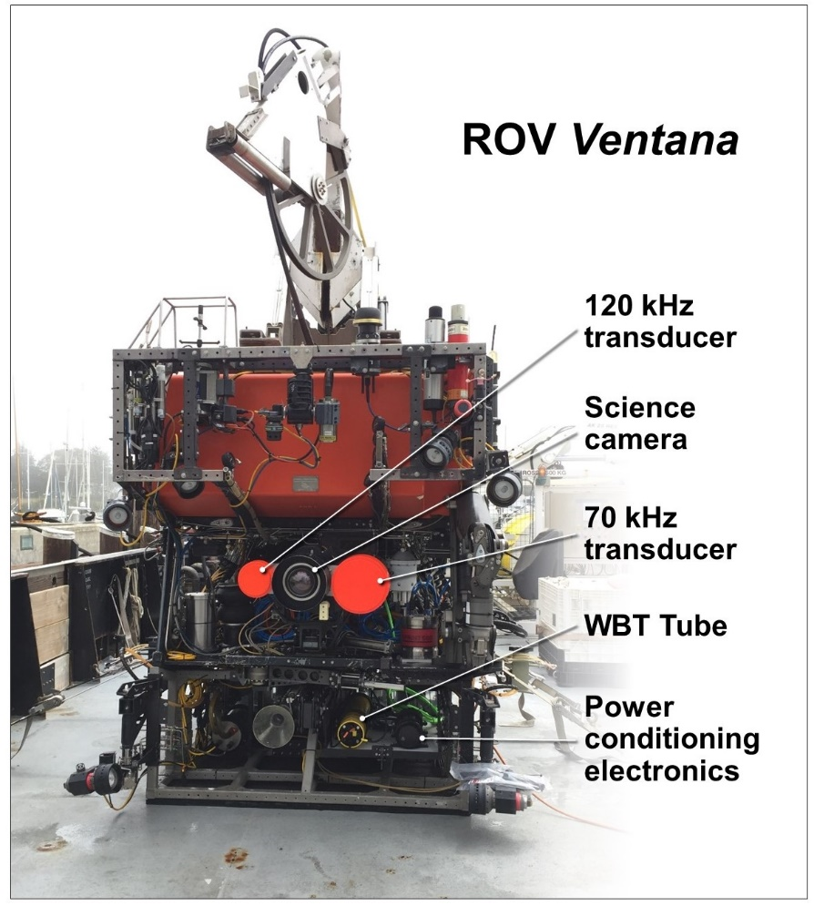
Fig. 1

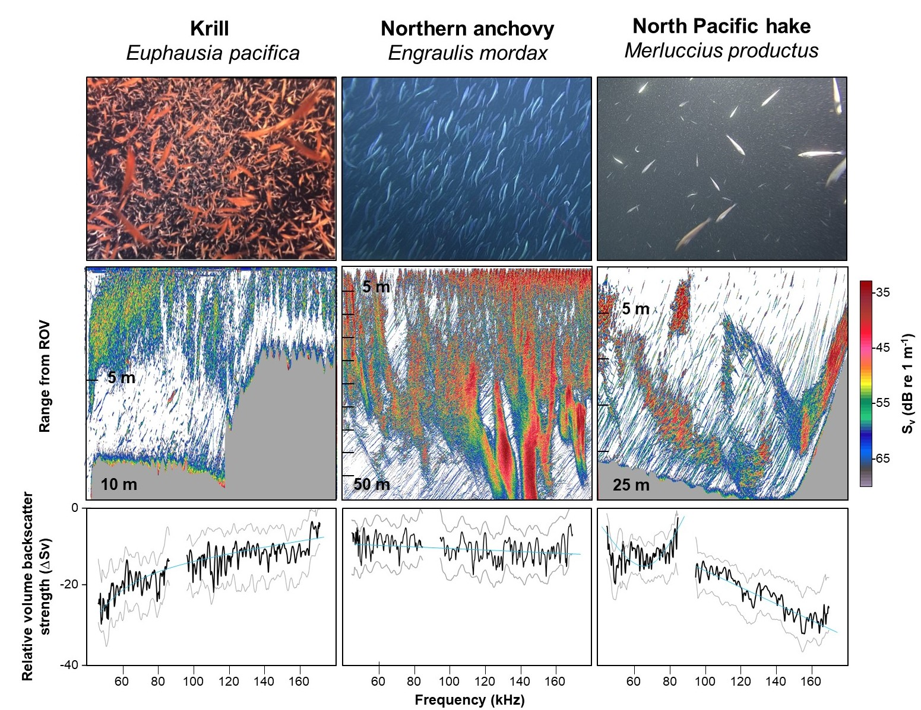
Fig. 2

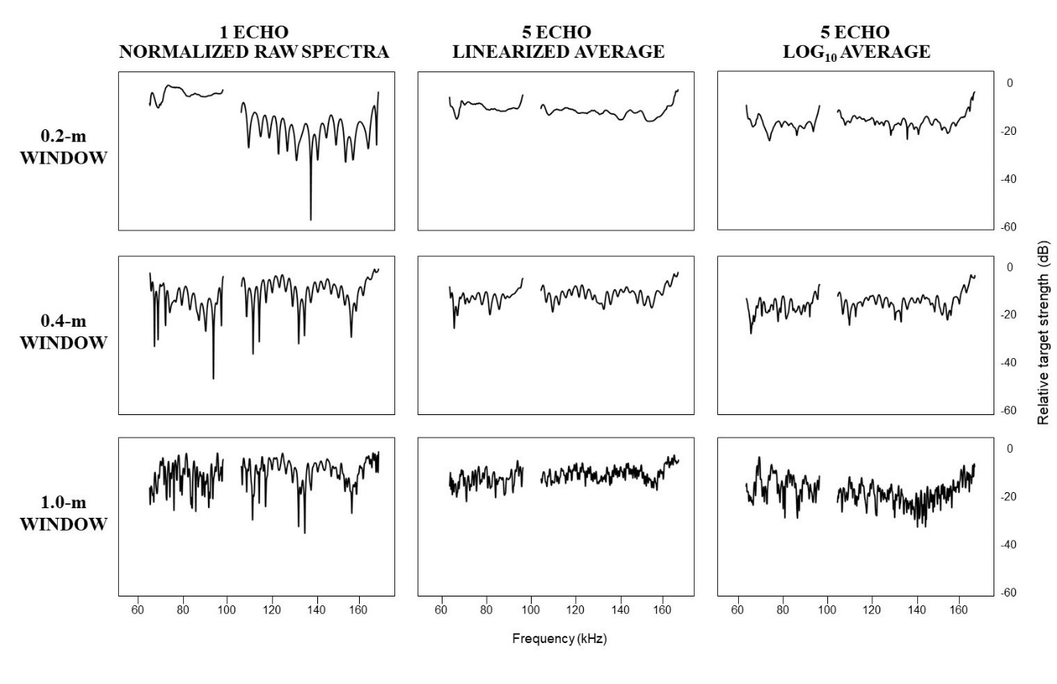
Fig. 3

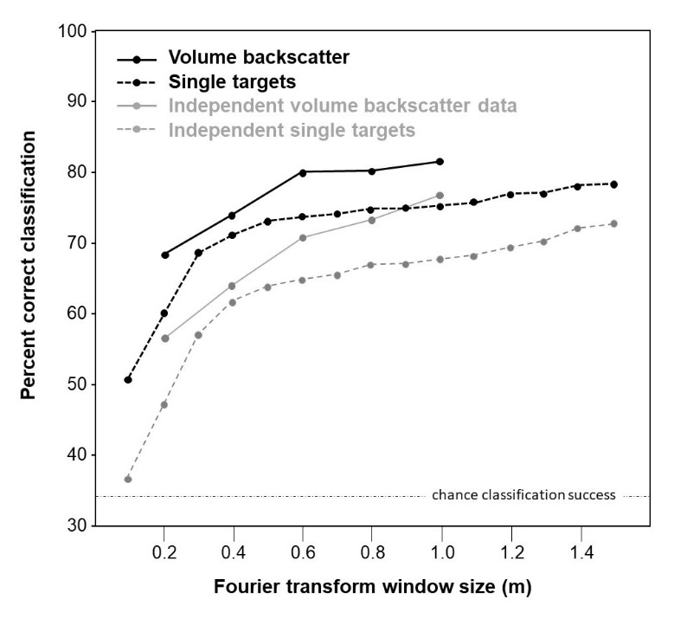
Fig. 4

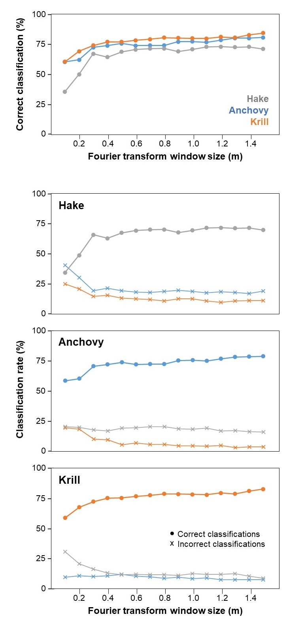
Fig. 5

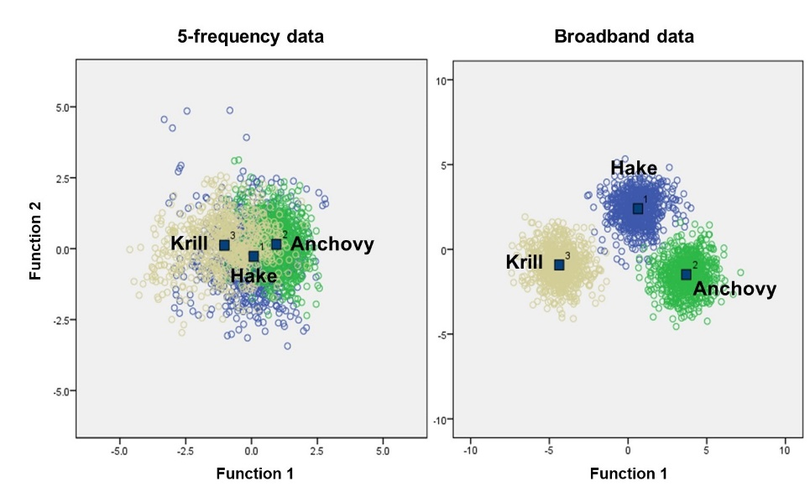
Fig. 6

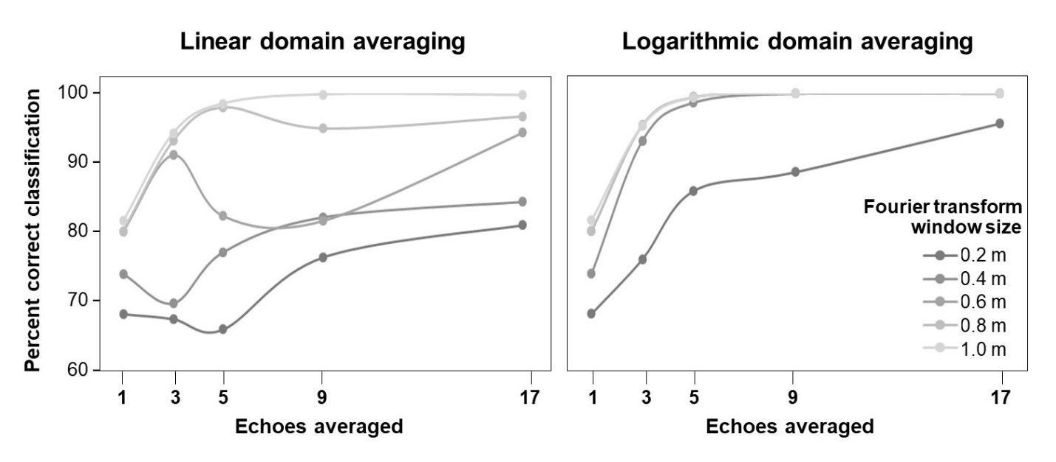
Fig. 7

