Project Number: | 901902

Project Start: Jan. 1, | 2019 | Project Duration (in years): | Year 1 of 3 ¹

Please indicate if proposal includes requests for any of the following (mark all that apply).

 | x
Ship Time |  |  | ROV |  |  | AUV |  |  | Wave Glider |  |  | Mini ROV

Please indicate what type of project is being proposed (mark only one).

 |  |  |  | x |  |  |  |  |  |  |  |  | x
Feasibility/Scoping  [Less than 100 days effort] |  |  | Development |  |  | Research |  |  | Infrastructure² |  |  | Education |  |  | Time Series |  |  | Institute Initiative

Project Manager: Ben Erwin
Principal Investigator: John Ryan
Lead Scientist: Steve Haddock
Lead Engineer: Tom O’Reilly

Project Title:
Unmanned Aerial Vehicles for science, operations, and outreach

Please indicate which category best describes the project theme (mark only one).

 |  |  |  | X
Ocean  biogeochemistry |  |  | Ecosystem dynamics |  |  | Ocean visualization |  |  | Exploration & discovery

Please indicate percentage of effort on this project anticipated for 2019 toward these three highest institutional goals (percentage total should equal 100%).

Goal | Developing/adapting innovative technologies | Utilizing developments to explore and understand ocean systems | Technology/knowledge transfer
Percentage | 50 | 50 | 0

- ABSTRACT (new projects only)

We propose to develop applications of uncrewed aerial vehicles (UAVs) for scientific research, marine operations and outreach during this three-year project. We’ve identified the following application areas as being particularly relevant to MBARI:

1. Aerial surveys over select regions of Monterey Bay, acquiring still images and/or video of marine mammals, birds, jellies, fish, turtles, kelp, algal blooms, ocean color, and oceanic fronts, using visible light, thermal IR and multispectral imagers. These survey images will enable studies of relationships between animals and ecosystem structure. Examples include (1) foraging hotspots where krill and fish aggregate and draw mammals and birds, (2) gelatinous animal population distributions, (3) predative / protective interactions between marine mammal species (among orca, gray, and humpback whales). These surveys can be acquired day and night (infrared) and underneath cloud cover. The surveys can be operated on a specific schedule (i.e. monthly) or triggered by the appearance of specific phenomena. The surveys might be flown across long transects, or targeted to a very specific region, depending on specific research goals. UAV-based imaging will be combined with other observing methods, including active and passive acoustic sensing from ships and autonomous platforms.

2. Locate RF-tagged animals or MBARI assets floating on the ocean surface, including AUVs, BEDs, profiling floats, etc. from one or more UAVs. Most MBARI assets have at least one locator beacon, but some of these have a kilometer-scale location accuracy. UAVs will provide a “last mile” asset locator capability, using a radio direction-finding payload (combined with appropriate beacons/transponders on the asset) and possibly use a camera to aid target location. The same strategy could be applied to tagged animals on or near the surface. Use of the UAV would avoid expensive aircraft rentals. We expect this capability to become even more important as MBARI expands its fleet of LRAUVs and other autonomous assets.

3. Acquire cinema-quality aerial video and still images of MBARI vehicles and operations as well as wildlife and other oceanographic phenomena in support of ITD Outreach.

We will refine application requirements and evaluate relevant techniques, sensors, and UAVs in the first year, and actually implement the applications in the second and third year. We propose to acquire two reasonably-priced UAVs in 2019. Sensors will be evaluated for cost, accuracy, and other specifications. UAVs will be evaluated by comparing their cost, flight duration, range, speed, payload mass and other relevant factors.We are coordinating with the ITD Outreach project, which proposes to procure a UAV for aerial photography.

- PROPOSAL

  - All Projects
Statement of the challenge, why it is important
MBARI helped to revolutionize oceanography by its development of ROVs and AUVs, and as a world class ocean research institute, we can continue to lead the way in exploring the physical, chemical and biological processes at the air-sea interface utilizing the rapidly developing technology of unmanned aerial vehicles (UAVs). Many critical processes occur or are exposed at this interface, and these aerial sensing platforms can provide safe methods to observe them in great detail, with regularity, and on short notice. UAVs will enable a wide variety of repeatable and low-cost science applications including animal counts and locations, front tracking, harmful algal bloom detection and monitoring, kelp forest health, and predation behavior.
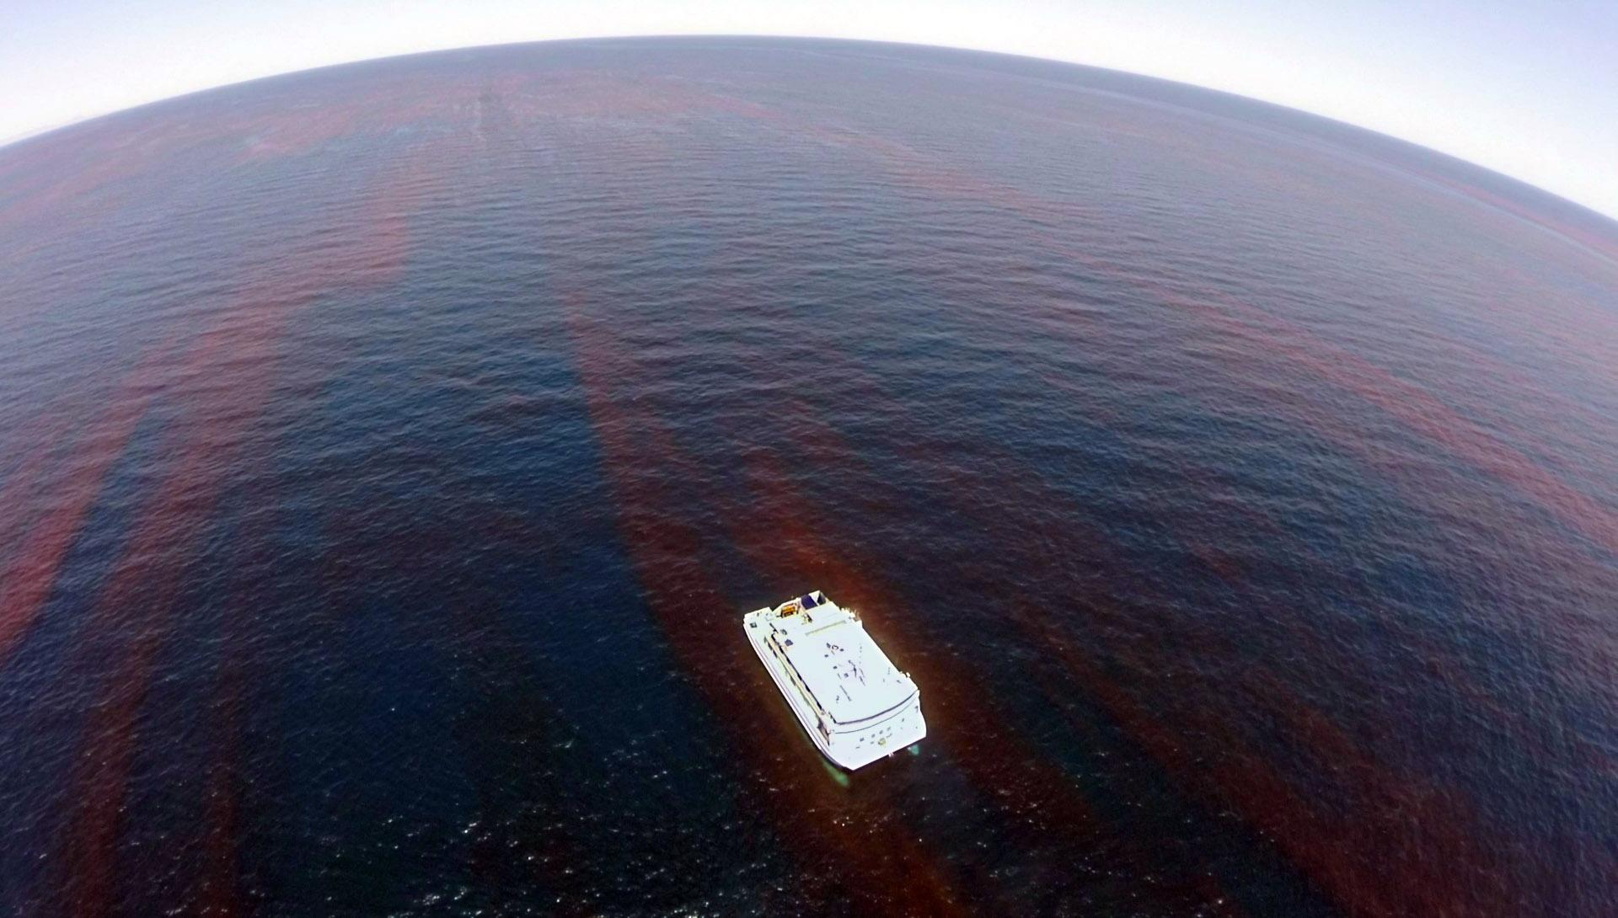
Figure 1: Dinoflagellate bloom surrounding RV Western Flyer in the Gulf of California. This natural color image was acquired by an Iris+ quadcopter UAV from about 150 meters altitude.

Satellites can obviously observe this interface as well, but UAVs have several advantages over satellites: UAVs can fly under cloud cover, provide cm-scale spatial resolution data in near-real time, and UAV revisit times are not constrained by orbital mechanics. UAVs reduce cost; they are cheaper and safer to operate than fixed-wing manned aircraft (~$250 per hour) or helicopters (~$1500 per hour), just as AUVs and ROVs are much cheaper and safer than manned submersibles. UAVs can further reduce costs by helping to locate valuable assets such as LRAUVs floating on the sea surface by radio and optical means. UAVs can provide high-bandwidth communication channels between at-sea assets and shore, in cases where satellite communications are not feasible or very expensive; short range data bursts between UAV and assets on the sea surface can support far higher bandwidths, require less energy, and work better in inclement weather. UAVs advance MBARI’s goals to increase public awareness of the ocean environment and the technology and people who explore the ocean realm. UAVs can observe wildlife in non-invasive ways, gathering imagery of animals which might otherwise be disturbed by presence of humans and ships. Likewise, aerial imagery of MBARI’s ships, facilities, and at-sea operations can provide the public with a unique perspective of the things we do at the institute.

Relevance
How does it relate/contribute to MBARI’s mission and strategic plan?
The proposal relates and contributes to MBARI’s strategic plan in several ways:
- Overarching goals: this project adapts innovative UAV technology that will enable MBARI scientists to identify and resolve important questions on population dynamics and ecology. Use of UAVs by ITD Outreach in particular will transfer knowledge to educators and the general public.
- Research themes: this project especially relates to ecosystem dynamics and ocean visualization (see Technology Roadmap, next section)
- Foster technological innovation: UAVs provide a flying test-bed platform at relatively low-cost, on which off-the-shelf or newly developed sensors that focus on the air-sea interface can be characterized and evaluated, potentially leading to new applications (Strategy 1.3).
- Collaboration: Several organizations and individuals have expressed interest to collaborate with MBARI on UAV projects including the Monterey Bay Aquarium (Wyatt Patry), CENCOOS (Henry Ruhl), the Monterey Bay National Marine Sanctuary (Andrew DeVogelaere), the Jupiter Research Foundation (Kurt Kiesow), the University of Hawaii Applied Research Lab (Margo Edwards), and UCSC (Raphael Kudela, Brandon Southall and Ari Friedlaender). MBARI has an established collaboration with UAV engineers at LSTS lab, University of Porto (João Sousa). We anticipate that a well-defined and established UAV program at MBARI will provide a springboard for collaboration with other groups in the future.
- Expand our reach: Most of the collaborators listed above extend MBARI’s reach to the public, policy makers, and the oceanographic community.

Does it relate to the Technology Roadmap? If so, please describe how.
UAV capabilities and relatively low cost contribute to relate to MBARI’s Technical Roadmap in several ways.

- Persistent ocean presence: UAVs can be rapidly deployed to monitor conditions, organisms and processes at the ocean-air interface over large areas at relatively low cost. In the very near future UAVs will be licensed to fly beyond the operator’s visual line-of-sight (eliminating the need for a support ship) and improvements in UAV design, batteries and sensor technology will further increase the aircraft range and capability. UAVs can serve as “data mules” for deployed sensors that don’t have the power budget or range to communicate with satellites or shore, enabling the creation and use of much smaller, less invasive sensors, as well as autonomous coordination between deployed assets.
- Targeted sampling: UAV-borne sensors can detect variations in ocean surface color and temperature, both of which can be indicative of biological and physical processes. Thus UAV surveys can guide the deployment of more immersive vehicles and sensors to study phenomena of interest. Payloads and sensors can be rapidly switched between flights to target different phenomena.
- Ecosystem processes: UAVs view the “top” of the biological pump; we expect that color and multispectral cameras may enable counts of individual organisms at the scale of centimeters and larger as well as plankton abundance at the surface (Problem statement #3). This project’s proposed “foraging ecology” application will provide visual and acoustic observations of foragers such as whales, pinnipeds, birds, and fish in foraging “hot spots” near the Canyon head (Problem statement #4).
- Ocean visualization: Our proposed UAV science applications will help relate observed conditions and variability at the surface to abundance, distribution and activity on the surface and throughout the water column. Our proposed monthly biological survey transects could establish a time-series of organism populations and processes at the air-sea interface at relatively low cost (Problem statement #6).

How does it relate/contribute to the Packard Foundation’s Ocean Grantmaking Program?

The Packard Foundation’s oceans grant making focuses on three interrelated objectives: restoration of ecologically important fisheries, improved coastal management, and enhanced scientific understanding of the functioning of marine ecosystems. By enhancing observational research this project would contribute to the latter two Packard Foundation foci within Monterey Bay National Marine Sanctuary.

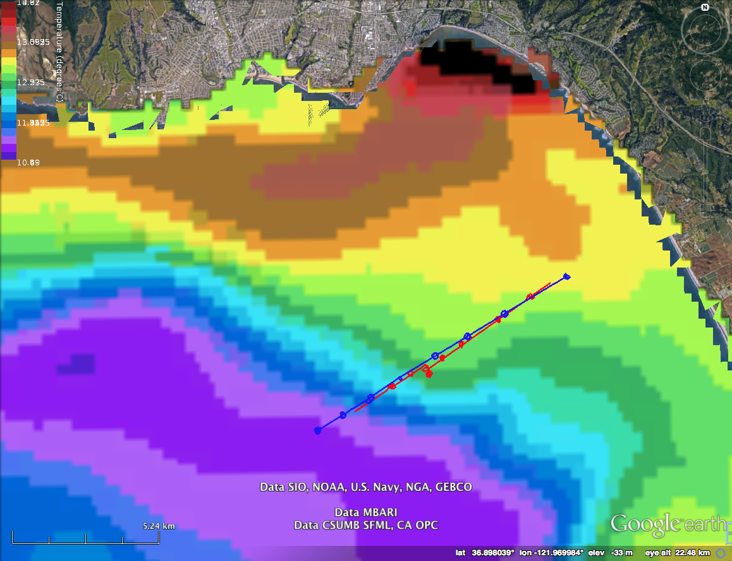
Figure 2: Flightwave Edge UAV transects across a known thermal front during Spring CANON 2017, overlaid on ROMS nowcast model for 5/10/2017 1500 UTC. The transects were flown starting on 5/10/2017 1800 UTC. NE-SW transect is shown in red, SW-NE transect in blue. RV Paragon chased the UAV during transects to keep it in sight. The loops along the transects show where the UAV loitered while RV Paragon stopped to make CTD measurements.

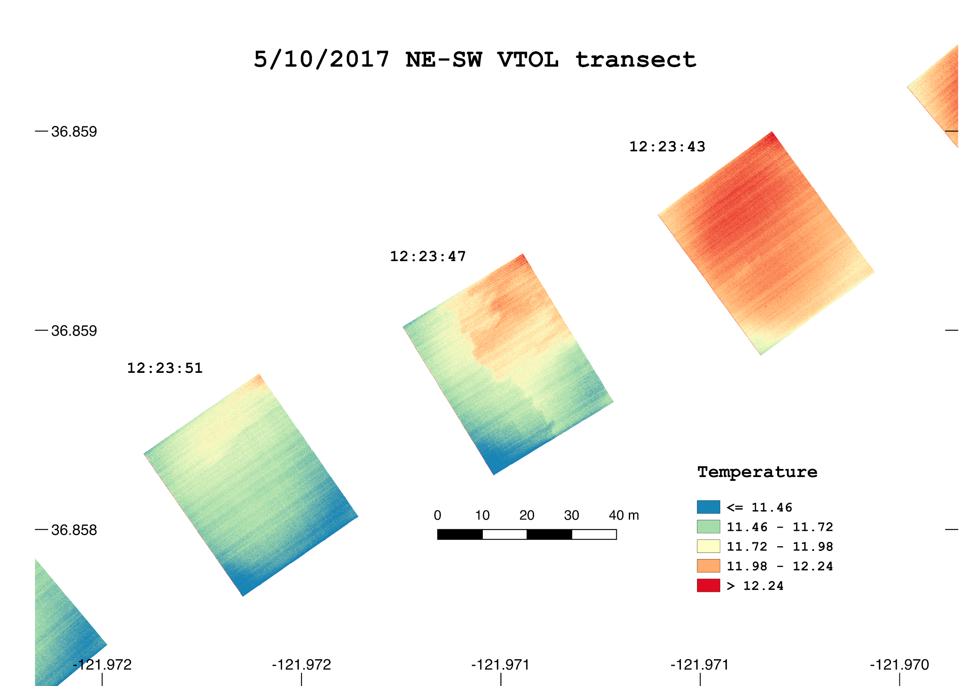

Figure 3: Thermal IR FLIR camera SST images acquired by Flightwave Edge UAV VTOL from 60 meters altitude during NE-SW transect on 5/10/2017; red and orange represent warm temperatures, green and blue are cooler. A thermal front is clearly visible in the middle frame at 12:23:47 UTC.

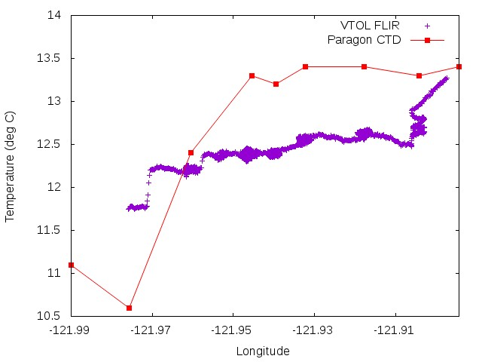
front
Figure 4: Sea surface temperatures measured during NE-SW transect across the thermal front shown in the previous figures. The UAV FLIR thermal IR camera acquired one image per second from an altitude of 60 meters; all pixel temperatures in each image were averaged (purple). RV Paragon chased the UAV during the transect and stopped occasionally to measure water temperature at ~0.5 m depth (red). The arrow indicates the thermal front shown in Figure 3.

Overall approach to the challenge: Over the complete term of the project, what is needed to address the challenge (e.g., sensors, platforms, marine operations, de novo R & D, etc.)
Research

The rules and regulations associated with operating unmanned aerial vehicles can be fairly complicated. The rapid advancements in technology as well as governmental oversight and policy, will take quite a lot of research to develop a robust program. Fortunately, the FAA, the MBNMS, US Fisheries Dept., NOAA, and the Scientific Committee for Oceanographic Aircraft Research (SCOAR), all have well defined UAV policies that we can use as a template to guide the development of our own operations and policies.
To date, we have found nothing that will prevent MBARI from operating UAVs in Monterey Bay. To the contrary, the potential for UAVs to support new MBNMS management priorities is clear. We will need to demonstrate several proficiencies with the technology and document our policies moving forward to apply for waivers and licenses where needed. A core group of MBARI UAV operators can help to ensure the policies are up to date and adhered to.
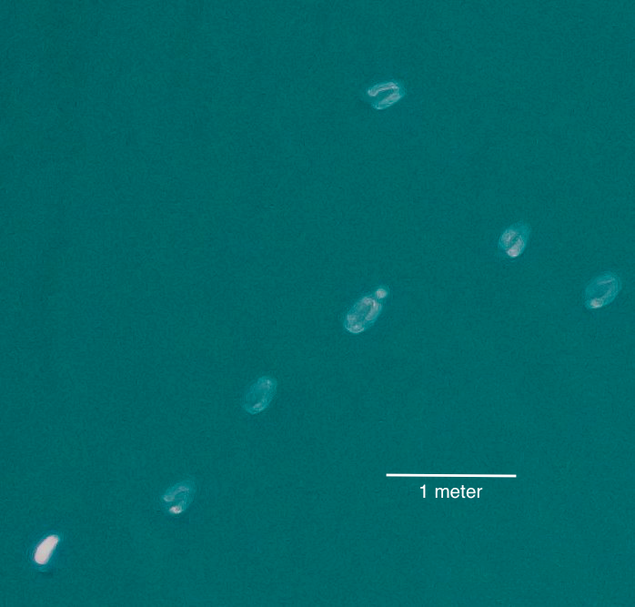
Figure 5: Cropped view of jellies, likely Aurelia aurita, photographed from 60 meters altitude by Flightwave Edge UAV during Spring CANON 2017. Camera resolution is 16MP; we propose to integrate a 25MP camera with the Edge in 2019.

Engineering/Technology Development

Much of the technology needed for the proposed applications is commercially available “off-the-shelf”. This includes visible, thermal IR, and multispectral imagers, as well as a variety of UAVs with diverse capabilities and costs. We envision that the science applications proposed at this stage will not require any new hardware development by us, but instead will utilize existing devices in innovative ways. There may however be a need for new software, or augmentations to existing software, to be developed to process the resulting data. Extensive image processing software already exists and will be investigated for use in our applications..
New technology development may be required for the asset locator application. We are currently researching various approaches to locate radio beacons from an UAV, including commercially available systems. We are also working with MBARI engineers on the Improved RDF Feasibility project (901810) to find solutions that are available now or might be developed in the near future, and with collaborator Kurt Kiesow at the Jupiter Research Foundation on potential technical approaches.

Marine Operations/Field Programs

For several applications and situations the UAV may be launched and recovered from shore without need for a ship. In other cases the aircraft can be launched and/or landed from RV Paragon.

Marine operations for the first year will mix science related research transects, with the development of a more robust UAV program. We plan to operate within visual line of sight (VLOS) rules during 2019. One of our longer term goals will be to attain FAA waivers for “beyond visual line of sight” (BVLOS) operations. These waivers will be crucial for enabling the institute to fly autonomous missions easily and regularly without the need for additional resources, like the RV Paragon.
Best-practice workflows for producing quality UAS data products have yet to be established, as noted by Manfreda et al [2018]. However the following general procedure will be followed to plan, acquire and process our UAV missions.

Preflight planning
We’ll take into account several factors when planning UAS operations:
- Mission goals
- Area of interest
- Permitting issues, as determined by items 1 and 2
- Available payload sensors
- Expected flight duration and length
- Sun angle requirements, which may constrain mission time-of-day and flight path, depending on sensors
- UAS altitude and speed to achieve needed image resolution
- Weather and sea state forecast - consistent with science goals (e.g. cloud ceiling) and vehicle safety (e.g. wind, rain, etc)
- Available pilot
- Need for other MBARI assets, e.g. RV Paragon, hydrophone buoys; if needed, reserve asset and arrange for crew support. Submit pre-cruise application for RV Paragon if needed.

Based on the above considerations, project personnel will:
- Submit “pre-flight” application to DMO in accordance with MBARI UAS operating policy, filling in all requested information.
- On the day of flight operations, the FAA will be notified via the LAANC system for flight approval. This information will also notify local pilots and other airspace users of the intent to fly in a particular airspace.
- A notification will also be sent to the MBNMS that flight ops will be conducted that day.

Assuming the mission is approved by MBARI, FAA, and MBNMS, the team will proceed to actual flight operations.

Flight operations
All procedures established by MBARI UAS operating policy and government agencies, including safety procedures, shall be followed during flight operations, whether UAS operations are shore- or ship-based. Flight and ship crew will be prepared to locate and recover aircraft in case of water landing. Operators will bring appropriate spare parts and spare batteries to the launch site in addition to the aircraft itself, ground controller, binoculars, aircraft retrieval equipment and other necessary support gear. Note that all UAV flights will be performed within visual line of sight (VLOS) unless or until we are granted FAA permission to fly beyond visual line of sight (BVLOS), and for some missions the RV Paragon will chase the UAV so that a spotter on the boat can keep the aircraft in sight.

Specific pre-flight check procedures will be specified by the aircraft manufacturer, but will include the following steps:

- Initialize onboard data storage
- Verify fully charged aircraft batteries
- Verify fully charged ground controller batteries
- Check ground controller functionality
- Check aircraft systems, e.g. rotor function, telemetry, sensors, etc
- Decide whether to proceed with launch based on latest weather and sea state forecast
- If RV Paragon will chase the aircraft and/or VLOS rules are in effect, coordinate with skipper and visual spotters to finalize aircraft speed, altitude and course based on weather and sea state
- Set flight plan with ground controller using appropriate software such as QGroundControl or Neptus
- Notify boats and ships along flight path via radio, especially if RV Paragon will chase aircraft

Detailed launch, flight, and landing procedures will depend on the aircraft being used, whether the operation is ship- or land-based, and whether the operation is approved for BVLOS.

Once launched the aircraft will execute its planned mission, either under manual pilot control, autonomous autopilot control, or a combination of both.

Following its mission the aircraft may land on a ship or on shore, either autonomously, under manual control, or some mixture of both.

If the aircraft is launched and/or landed on a ship, pilot and skipper will verbally coordinate during these operations with respect to ship/aircraft heading and speed to ensure safe takeoff and landing.

If visual-line-of-sight rules are in effect during the flight, e.g. during 2019 operations:
- Designated spotter(s) other than pilot will visually track aircraft during flight.
- If RV Paragon is chasing the aircraft, skipper will coordinate with spotters to safely follow the vehicle.

Following each mission project personnel will submit a post-flight report in accordance with MBARI UAS operating policy.

Data retrieval, processing and archiving
A variety of GIS/photogrammetry software is available to process the data. In 2019 we will evaluate free software including QGIS, GDAL, and OpenDroneMap as well as commercial products AgiSoft PhotoScan, MATLAB, and Esri ArcGIS. In addition we’ll likely develop custom scripts that utilize existing software, and possibly more elaborate custom software if needed by our applications. Note that much of the existing mapping software relies on use of ground control points (GCPs), which generally do not exist at sea.

Processing protocols will will include the following stages:

- Retrieve raw core sensor and payload sensor data files from onboard storage, copy to designated onshore storage.
- Georeference the data, which utilizes data from onboard GPS, compass, altitude, speed and attitude sensors.
- Perform radiometric/color correction and enhancement if needed
- Project data onto maps if relevant to science goals

Processing data from an hour-long mission may require several hours depending on sensor and data volume as well as required software and computer capability. In 2019, Ryan, Haddock and Benoit-Bird will be responsible to process the data from their missions, using labor and computing assets already in their labs, drawing from institutional assets such as the GeoServer (http://geoserver.mbari.org) which can handle geographically localized images.

The project will request MBARI-accessible data storage (e.g. on Atlas), and will provide data descriptions and other documentation so that others may access and use the data.
Data
What data products will be generated?

Most science data will be in the form of high resolution digital still images and video, acquired in the infrared and visible spectrum. Important results will be maps of the annotated organisms and features of interest. These will form the basis for large-scale distribution maps that will enable evaluation of trends over time. RF asset location data will likely consist of time-tagged radio direction data, signal strength, etc.

How will the data products be managed?
Raw and processed imagery from the Flightwave Edge UAV will be stored in directories on atlas and also on MBARI’s Geoserver, which provides a map-based user-interface for image retrieval. Pipelines for handling UAV images are widely available, and will be used to integrate aircraft sensor information with the image format to create GeoTIFFs which contain information on the location and size of their field of view, and other metadata.
Describe data availability outside of the project team.
Imagery will be made publicly available immediately after processing and quality control checks are complete. CeNCOOS is a partner, and we will explore image distribution and publicity through their data portal. The Sanctuary (Andrew DeVogelaere) and Save Our Shores have both expressed interest in gaining access to the images for their own research goals.

Describe data storage requirements.
Below we estimate imagery storage needs for 2019. We plan to archive 12 hours of imagery from each camera in 2019; still images from the science cameras and video from the ITD Outreach cameras.

imager | image data rate GB/hr | 2019 hours | 2019 data size GB | notes
Foxtech Map-01 | *73.4 | 12 | 881 | science, 1 fps stills
Foxeer Legend-1 | *47.0 | 12 | 564 | science, 1 fps stills
FLIR Duo R | *0.4 | 12 | 5 | science, 1 fps stills
DJI Inspire (X5s) | 540.0 | 12 | 6480 | ITD Outreach video
Phantom 4 | 45.0 | 12 | 540 | ITD Outreach video
Total |  |  | 8470

* Includes storage of level-0 (raw) and level-1 (georeferenced, color-corrected) images

Anticipated Impact

Who are the consumers of the instruments, methods, systems, and data that will be generated?

Several MBARI science PIs have shown interest in this project, including Francisco Chavez (CANON), Steve Haddock (Biodiversity), Kelly Benoit-Bird (Acoustical Ocean Ecology), John Ryan (SoundScape), and Yui Takeshita (Coastal Biogeochemical Sensing). ITD personnel will utilize UAV imagery for public outreach projects. DMO technicians and engineers will utilize UAV radio beacon data and imagery to locate assets on the sea surface. Collaborators from the Monterey Bay Aquarium will likely have a keen interest in data acquired by MBARI UAVs. CENCOOS director Henry Ruhl is interested to collaborate on UAV data processing procedures and distribution via the CENCOOS website. Other collaborators may include researchers from the UCSC including Raphe Kudela (kelp ecology), Brandon Southall and Ari Friedlaender (foraging ecology). Mara Orescanin of Naval Postgraduate School is interested in co-evaluating sensors and mapping procedures. Katherine O’Dea, Executive Director of Save our Shores, is interested in the surveys for detecting plastic debris and potentially mylar balloons in the waterways (see attached letter of support). Kurt Kiesow of the Jupiter Research Foundation has expressed interest in collaborating with this project as his time allows, especially in the asset locator application, as RF systems are his area of expertise.
UAVs will be piloted by MBARI employees with FAA Part 107 licenses, appropriate insurance and who fulfill other requirements established by DMO. Ultimately, some flights will be out of line-of-sight, upon receipt of permits, and all flights will be performed in accordance with DMO policies as well as local and federal regulations.[2]

Additionally, the research of this project is well aligned with priorities defined in the new MBNMS management plan, as described by Andrew DeVogelaere:
- Developing inexpensive ways for doing bird and mammal surveys; and monitoring them through time in Monterey Bay and over Davidson Seamount
- Using close-to-real-time data to correlate whale abundances with crab pots (reducing whale entanglement is a priority)
- Assessing abundance and location of leatherback turtles (this could perhaps correlated with the abundance of certain jellyfish and would be of great interest to NOAA Fisheries)
- Linking mammal distributions to our soundscape related works (e.g., presence of whales vs if they are making sounds)
- Assessing the impacts of UAVs on marine organisms, and developing designs to minimize any impacts

  - Continuing Projects

N/A

  - All Projects: Specific Plans for 2019

Research Activities

Research will include running different kinds of transects and examining images to determine which combinations of altitude, camera, lenses, and imaging rates give sufficient ability to identify and quantify different organisms of interest (mammals, jellies, birds, kelp). As these capabilities increase, we will be able to map the seasonality and extent of many animals for the first time. We will evaluate and refine image processing techniques.

Engineering/technology development
We will procure vehicles and payloads and develop techniques for the following applications:

Biosurvey transects of Monterey Bay (Haddock, Benoit-Bird, Ryan):
This application is the acquisition of geolocated images along repeated transect lines. The images will form a core dataset that will be processed for jellyfish quantification initially, and be made available to collaborators interested in quantifying the distributions of whales, turtles, kelp, and plastic debris. For 2019, the Biosurveys will be conducted from beachfront launch and recovery sites at the Monterey Bay Academy. This facility has an airstrip and lies outside of the bird sanctuary which constrains operations over large sections of the shoreline. Fortunately the location also happens to correspond to the boundary of the “upwelling shadow” in the northern section of the Bay. This oceanographic feature has been shown to be a driving factor in the distribution of jellyfish and of red tides, so we predict that it will be an excellent place to observe high abundances, along with rapid transitions between sparse and dense populations. Surveys will be out and back, over the water, but within line of sight and of a conservative duration. In 2019 the surveys will be conducted to optimize flight conditions, and to set the stage for eventual application for operating beyond visible line of site (BVLOS). As stated elsewhere, BVLOS requires special FAA waivers, but it is a goal of the biosurveys application to achieve these operations, thus extending our mapping capability and setting the stage for the acquisition and operation of more capable platforms in future years. Images generated during trial surveys will be posted publicly and given to our collaborators for evaluating their suitability for other applications. In the initial years, there is not a requirement for stitching the images into a continuous survey strip. We will be quantifying the density to create distribution maps of discrete points, so stitching is not necessary, and the images would actually need to be “unstitched” for counting and identifying targets.

Foraging ecology (Ryan, Benoit-Bird):
The application region is within Monterey Bay. For 2019 efforts will focus on nearshore waters around the head of Monterey Canyon, where foraging hotspots develop for whales, pinnipeds and seabirds. A mission will be triggered by detection of intensified foraging activities within eyesight of MBARI, and UAV operations will be staged from MBARI. The temporal window is spring through fall. Because foraging activity near the canyon head tends to occur during intensive periods lasting days to weeks, we will apply simple event detection using binoculars from shore to evaluate species abundance and activity. Event response will be weighed in terms of novelty (highest for species / assemblages not yet imaged by our system and for exceptionally active periods) and quality of flight conditions. Average mission frequency will be approximately once per month, however efforts will likely be concentrated within a smaller subset of months because of the nature of localized foraging hotspot development. For the first year, a single synoptic survey will be acquired during each event response. The time required for each survey will vary according to the scale of the foraging hotspot, UAV flight speed, and imaging swath width – estimated range from ~ 15 minutes to ~ 3 hours. The amount of data collected per mission will vary with flight duration and attributes of the imaging devices deployed. Image data will be processed by John Ryan using methods that the project team collaboratively develops for the selected cameras. Storage for UAV images will be within the project’s network storage space on atlas. For some surveys one additional MBARI asset would be involved, a free-drifting hydrophone deployed a safe distance from the foraging activity.
ITD application - (Cullen, Walsh): ITD, working in partnership with the Monterey Bay Aquarium (MBA), seeks support to build an archive of high-quality video and photos. One aspect of this archive will be capturing aerial footage of MBARI assets using a UAV. We anticipate collecting shots of ROV’s being launched, shipboard activities and shots of all MBARI research vessels. UAV footage from on land will be shot primarily around the Moss Landing campus. Shipboard UAV footage will be collected by piggybacking on research expeditions within Monterey Bay and by coordinating with crewmembers. We will target flight days based on desirable weather and are aiming for somewhere between one and four flights per month. This video will be made available to both MBARI and MBA staff for scientific presentations, web, annual report, and social media. ITD will also develop video products for outreach. All B-roll will be collected and stored by Video Lab staff for use as needed.

RF tag locator - The feasibility of utilizing UAVs to locate RF beacons will be researched. A collaboration with the Jupiter Foundation to evaluate various antenna designs and mounting options. We will assess the results of the MBARI Improved RDF Feasibility (901810) project, and consider their approach as well as others. If such a possibility exists we will propose the design and build of a RDF tag locator system in 2020.

Vehicle and payload selection

The UAV project group researched a very large range of aerial platforms for 2019 flight operations. It became clear that no single reasonably-priced UAV can satisfy both ITD’s cinema-quality photography requirements while simultaneously having the long range required by our science applications. For this reason, we propose to acquire two systems.
For ITD photography, specifications for a system were generated and then researched, and a modestly priced DJI Phantom 4 quadcopter was chosen. This system is self-contained, low cost, easy to fly, and contains lots of features that will benefit the capture of beautiful photographs and video. The choice for a Phantom 4 is benefitted further by the DJI company swap out program, that will allow us to send in a damaged UAV for a free or discounted replacement.
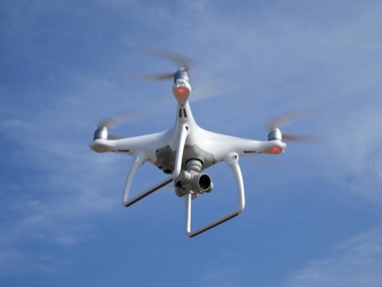
Figure 6: DJI Phantom 4 quadcopter UAV, proposed for ITD Outreach applications
For science applications, and to further the goals of establishing a long duration UAV program at MBARI, the team chose a vertical takeoff and landing (VTOL) fixed-wing aircraft called the Flightwave Edge. The aircraft was designed by our collaborator Dr Trent Lukaczyk of the University of Porto; he is also Flightwave Aero CEO. Lukaczyk brought a prototype of the Edge to MBARI for the Spring CANON 2017 field campaign. During his visit we performed ten flights, launching and landing the aircraft aboard RV Paragon. The flights included transects of a known thermal front near Soquel Canyon, during which thousands of visible color and thermal IR images were acquired. Some of the results are shown in Figures 2-5.

Several features highlight the Edge over other systems, the first being its range. To perform science missions of value, we need the ability to fly long duration missions. As a VTOL fixed-wing aircraft, the Edge is aerodynamically very energy-efficient, capable of high speed (~100 km/hr) and long range. Our research, including conversations with Edge users, indicates that the aircraft can stay aloft for about 90 minutes while carrying a 150 g payload, with a 100 km/hr cruising speed. This corresponds to a total flight range of about 125 km, or 62 km out and back, assuming 75 minutes cruising and 15 minutes taking off and landing. This far out-performs quadcopter UAVs which typically have a 20 minute endurance. While the maximum payload capacity is limited to 300 g, the Edge has flown with a number of sensor payloads that are low cost and can provide a baseline data set to assess the needs of subsequent generations of sensors. We propose to integrate sensors into two separate Edge nose cones to be used for the biosurvey transect and foraging ecology applications. In case of an unplanned landing in the water, the Edge maintains positive buoyancy for at least several minutes, but is characterized as “weatherproof” but not waterproof. A waterproof version of the aircraft is currently in development by Flightwave; in the meantime we plan to waterproof our MBARI Edge payloads. Moreover, Edge manufacturer Flightwave has been a very active participant in developing these systems for marine science applications. Flightwave engineers have collaborated with several other scientific institutions including Scripps, Schmidt Ocean Institute, MBARI, NASA, USCG, and many others to develop the tools and techniques for UAV use at sea. Two Edge UAVs were recently used in experiments aboard SOI’s RV Falkor cruise to the subtropical Pacific front in June 2018, with multiple payloads including a multispectral camera and a NASA-provided dimethyl sulfide sensor. Edge BVLOS capabilities were demonstrated on this cruise, including control via RF link out to 10 km range from RV Falkor. Finally, the Edge is reasonably priced, with the base unit costing $7500. With a price point well below other systems, we felt it was a perfect starting point to develop a fledgling UAV program, allowing us to run science missions, train a pool of pilots, and begin to address FAA waiver prerequisites.
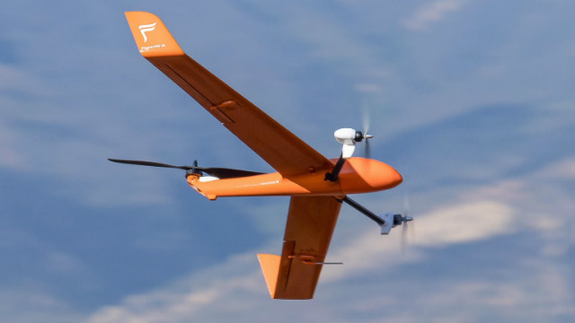
Figure 7: Flightwave Edge vertical takeoff and landing (VTOL) UAV, proposed for 2019 science applications

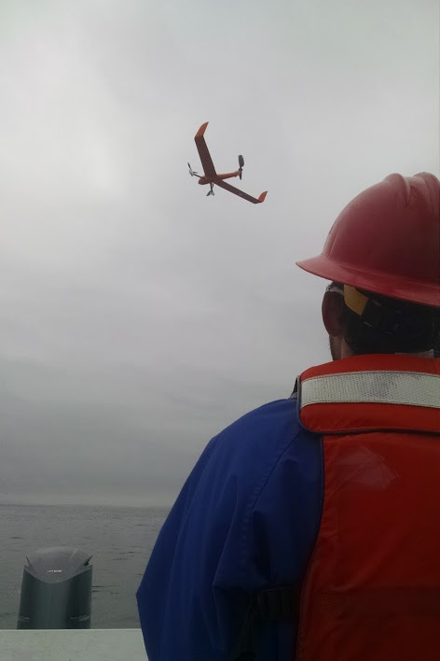
Figure 8: Dr Trent Lukaczyk landing the Flightwave Edge VTOL on the aft engine hatch of RV Falkor during Spring CANON 2017.

Sensor evaluation:
We are requesting the purchase of a few sensor and lens options to determine the optimal payload for future operations. There are trade-offs in the capabilities of color vs multispectral sensors (which distinguish certain wavelengths, for example to specifically detect chlorophyll). Other sensors can measure temperatures, but they will need to be ground-truthed to assess accuracy over water. The Flightwave team is currently performing these calibrations. We will evaluate sensor options before purchase, but the current plan is to get a 25 megapixel color camera with two lens options for the biosurveys, a lower-resolution low-cost color camera and thermal infrared camera for foraging ecology flights. We’ll also collaborate with the UCSC Kudela lab on testing/evaluating the multispectral Red Edge camera on a balloon kite, as multispectral cameras could potentially be integrated with our UAV.

Sharing vehicles between science, DMO, ITD
We propose two UAVs:- a Phantom-4 quadcopter primarily for ITD use, and a Flightwave Edge VTOL primarily for science use. DMO can coordinate with users to use either of these UAVs as needed.

Transition to beyond visual line of sight (BVLOS):
UAV’s present a quantum leap in the ability to traverse large areas while recording data. Their cost to own and maintain, their ease to operate all present very attractive prospects. Gaining the legal and technological ability to allow our UAVs to conduct an autonomous mission at sea beyond the sight of a human spotter will ensure a major cost savings, not only in personnel, but also in the utilisation of resources like the Paragon. Attaining a BVLOS waiver from the FAA is a crucial step in securing the ability to conduct long range transects without disturbing the environment, and reducing costs. In 2019, we intend to initiate the process to acquire a BVLOS waivers and accompanying airspace authorizations to fly routine transects over the Monterey Bay.
The process for gaining these waivers can last months, and requires very specific applications, documentation, and clearly defined flight operations and areas. We will research and begin this process as early as possible in 2019.

Safety:
Since flight operations will vary from platform to platform, and mission to mission, safety protocols will need to be researched, assessed, and cross referenced with MBARI insurance carrier requirements, and the law. We will then make recommendations to DMO to adopt varying levels of PPE and procedures for operations on land, at sea, near people, and over wildlife. Each pilot will be responsible for enforcing the safety of their operating environment and the rules.

Field programs (detail ship requirements/deployments/diver requirements)
Ship time and cruise plans for ITD Outreach are described separately in that project proposal (90101)

We propose the following 2019 at-sea flight program for the Flightwave Edge UAV:

4 sea-based training flights
4 biosurvey flights
9 foraging ecology flights

The above flights require about a half-day of RV Paragon support each.

In addition, we anticipate about 8 land-based flight days for biosurvey testing and protocol development - no ship support needed.

Isotope Usage
Project teams must provide details regarding any planned isotope use on shore, on ships, in the Sanctuary, etc. Please review the guidance on isotope usage at http://www.mbari.org/at-sea/cruise-planning/hazardous-materials/ and policy at http://mww.mbari.org/safety/SafetyManual/Isotope_Use_Policy.pdf, and then provide details on plans below.

NA

Specific deliverables

Flightwave Edge nose cone with integrated high-resolution color camera for biosurvey transect application (“Payload A”)
Flightwave Edge nose cone with integrated thermal IR and color cameras for foraging ecology application (“Payload B”)

Imagery from foraging ecology missions
Imagery from biosurvey transect missions

ITD-related UAV deliverables:
- Shots of ROV’s being launched
- Shots of shipboard activities
- Shots of all MBARI research vessels.
- Shots of the MBARI building
- Shots from around the Moss Landing campus

RDF white paper, with recommendation on whether to proceed with a project in 2020.

Updates to policies, procedures, documented workflow and best practices for flight operations and data processing
Permits, BVLOS waiver
Trained pilot pool

We will focus on pilot training, developing procedures, workflows (including data processing) in 2019. We plan the following flights, each flight lasting about one hour, plus mobilization/demobilization time:

- 4 biosurvey transect flights
- 9 foraging ecology flights
- up to 4 sea-based training flights (more if opportunity presents itself)

Milestones and required personnel (see personnel classification list for staff classifications)

We would like to begin working toward some 2019 milestones in 2018. Issues relating to UAV order lead times, pilot training and licensing, applications for permitting are all sufficiently time intensive that we might not be able to conduct a sufficient number of flights to update the proposal for 2020, so an early start in 2018 would be beneficial. Milestones for the scope of this proposal are as follows:

- Pilot training, Licensing, and ordering of Flightwave Edge VTOL.
- All purchased and ordered parts received, Design review of nose cone and payload, Begin rudimentary training flights over land. Build landing net for paragon flight ops.
- Conduct at least 2 training flights over water. Develop best practices for Paragon operations. Acquire 2-minute edited ITD video shots.
- Develop transect itinerary for science flights, acquire any extra permitting, engage FAA for BVLOS waivers and begin documenting pre-requisites. Conduct remaining over water training flights.
- Conduct 9 foraging ecology flights and 4 biosurvey flights. Create 4 minute long edited ITD video shots.

Since these flights will be contingent on weather and other short term factors like pilot availability, and because UAVs are so simple to fly and operate, we have decided to train a pool of pilots consisting of willing MBARI personnel that can be asked to assist in flight operations. This will significantly reduce the risk of flight cancellations due to lack of a pilot. Flight ops will not typically take an entire day to complete, and so the pilots can gauge for themselves if their schedule will allow it. Pilots are trained on a volunteer basis.

2019 Project Start Date:  MM/DD/2019 | Milestone 1 | Milestone 2 | Milestone 3 | Milestone 4 | Milestone 5 | Total Resources (in hours) for each resource category for all milestones listed here
Milestone Date | 12/2018 | 3/2019 | 7/19/2019 | 8/2019 | 12/31/2019
Milestone Description | Licensing, permits, order VTOL | Parts received, Nose Cone DR, Training flights | Training flights over water, best practices, 2 min. edited ITD video shots. | Transect itinerary, Permitting, Document flights for FAA | 9 ecology flights, 4 bioflights, 4 minutes edited ITD video shots
Electrical Engineer
Software Eng-Embedded | T.O. - 53  B.K. - 6 | T.O. - 53  B.K. - 6 | T.O. - 53  B.K. - 6 | T.O. - 53  B.K. - 6 | T.O. - 53  B.K. - 6 | T.O. - 265  B.K. - 30
Research Specialist | J.R. - 24 | J.R. - 24 | J.R. - 24 | J.R. - 24 | J.R. - 24 | J.R. - 120
Mechanical Engineer
Mechanical Eng-Division
Mechanical Eng-Mfg
Associate Engineer
Electrical Tech
Software Tech
Mechanical Tech
Machinist |  | TBD - 30
DMO | B.E. - 24 | B.E. - 24 | B.E. - 24 | B.E. - 24 | B.E. - 24 | B.E. - 120

Budget justification
We request early funding so that we can purchase the Flight Edge UAV bundle ($10725) in 2018, to get UAV delivery as early as possible.

We request a total of $19921 in capital expense items and conference attendance; justifications are listed below.

Flightwave Edge UAV bundle 10725
Flightwave Edge VTOL nose cone 536
The team selected FlightWave Edge as a reasonably priced UAV that is capable of relatively long-range transects required by science applications.

Parts for shipboard landing device 500
FlightWave Edge operated off RV Paragon in CANON 2017, during which used Paragon’s aft engine hatch as a landing pad. We propose a more secure landing “hammock” that would eliminate the risk of the aircraft sliding off the hatch into the water.

Fat Shark Dominator FPV HD headset 537
We believe that a first person viewer (FPV) headset will make piloting easier and safer, especially during landings aboard RV Paragon. The headset is not subject to the outdoor glare that can impede image visibility on a conventional screen.

Foxtech Map-01 camera 944
Foxtech 35mm F5.6 lens 204
Foxtech 25mm F5.6 lens 118
The 2017 CANON UAV payload included a low-cost 16MP color camera. Results indicated that camera resolution was not quite good enough for positive identification to the species level of jellies, birds and other organisms (e.g. see Figure 5). The Foxtech Map-01 camera has 25MP, and will be much more useful for the proposed science applications. We propose to purchase two lenses for the camera to evaluate image quality at a variety of focal lengths, altitudes and aircraft speeds.

FLIR Duo R thermal/color camera 1073
The 2017 CANON flights proved that ocean fronts can be identified in UAV-borne FLIR thermal infrared imagery; see Figure 3 and Figure 4. Thermal fronts obviously play a critical role in ecosystem dynamics and hence their identification is an important aspect of the proposed science applications.

Conference attendance by Ben Erwin 3000
UAV technology, sensors and applications are advancing rapidly. We believe it critical that we attend at least one conference in 2019 to keep us informed of latest developments as well as stay in touch with other users of the technology.

Msc cables, antennas, antennas 1000
The components included in this item will allow us to investigate approaches for the RDF locator (“vehicle finder”) application in 2019.

SanDisk Extreme Pro 16GB SDX (10) 225
These mini-SD cards will be used in the payload cameras.

4 Li ION battery packs 215
These are spare custom-made batteries for the UAV

2 pair safety goggles 20
2 pairs protective gloves 20
Basic safety gear for use during UAV landings.

Colored launch and landing pad 100
Bright colored launch and landing pad will be used for land-based operations, to keep grit out of rotors and provide a bright visual target during landings.

LACIE RAID 4TB array 429
The RAID array will be used when team members need to process image data at home or other locations that do not have fast network access to MBARI’s atlas server.

Foxeer Legend-1 camera 75
This low-cost, light-weight 16MB color camera will be used for the foraging ecology application, which doesn’t require the high resolution provided by the more expensive, heavier 25MP camera.

Cables, tools etc for payload integration 200
These will be used in building the two UAV payload nose cones.

The budget for DJI Phantom 4 UAV and accessories are specified in the ITD Outreach (901901) phase-1 proposal.

Project team
Ben Erwin: project manager, mechanical and electrical design, BVLOS, RDF application, pilot
Steve Haddock: lead scientist, biosurvey transects, pilot
John Ryan: principle investigator, foraging ecology, biosurvey transects
Tom O’Reilly: lead engineer, software engineer, pilot
Heidi Cullen: ITD outreach project lead
Kelly Benoit-Bird: foraging ecology, biosurvey transects
Todd Walsh: ITD outreach project, pilot *
Eric Fitzgerald: pilot *
Shannon Johnson: pilot *
Emery Nolasco: pilot
Bryan Schaeffer: pilot
Paul Ban: pilot *
Josh Reyes: pilot
Brian Kieft: Paragon operator, pilot

* Current FAA part-107 license holder

Project lab and office space requirements
In addition to any changes to current space usage, please also include anticipated office and lab needs for students, postdocs, collaborators, etc.

N/A

R/V Paragon Requests
If the project team will be requesting time for the R/V Paragon, please specify the operators in the group and provide estimates of their availability to operate the vessel.

Team member Brian Kieft is a certified RV Paragon operator, and has indicated that he can support the 22 planned Flightwave Edge UAV flights.

Risk matrix (development and infrastructure projects only)

 | Technical Risk | Organizational Risk | Tech Transfer Risk | Labor Estimate Risk
High | x
Medium |  |  |  | x
Low |  | x | x

  - Compliance Considerations

Export Regulation
Does the project team anticipate any foreign collaborations or international travel? If so, please identify collaborators by name, institution, and country.

None

Does the project team plan or anticipate export-controlled purchases, shipments, or transfers of items (e.g., research instruments, proprietary data, hand-carried tools or samples) outside the U.S. temporarily or permanently? If yes, please identify country or countries and indicate whether these items will remain under MBARI control while abroad or controlled by others. Will the items be exported to more than one country? Please include foreign collaborator information as described above.

None

Monterey Bay National Marine Sanctuary (MBNMS)

General Permit
Projects teams need to indicate if any work will be performed that is either: (1) currently authorized under our general permit; or (2) will require that we obtain authorization. The current permit can be viewed at http://mww.mbari.org/pco/permits/mbnms-2015-002_feb2015.pdf. Please see Mandy Allen for questions.

Is a permit with MBNMS required for your work? Yes

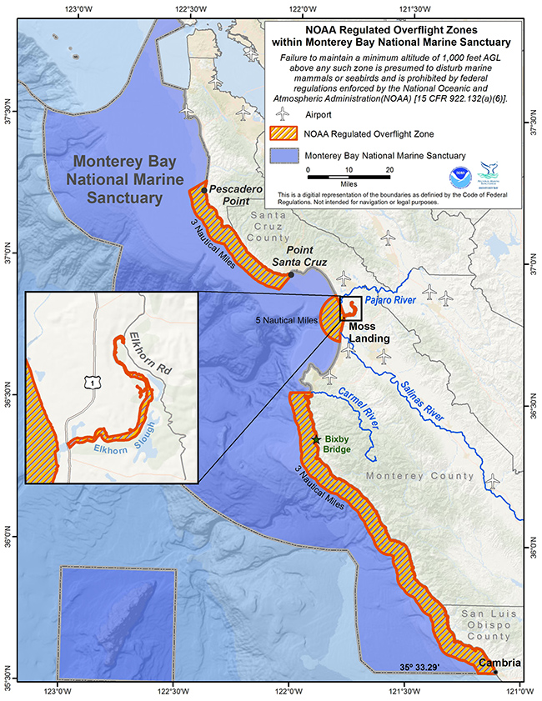
Figure 9: NOAA regulated overflight zones

NOAA identifies four regulated overflight zones in MBNMS (orange regions in Figure 9). Motorized aircraft (manned airplanes) must remain above 1000 feet within these four zones in order to avoid disturbances to marine life, but UAVs are not permitted to go above 400 feet, so these zones are inaccessible to us. Outside of regulated zones there is still the requirement to avoid such disturbances. This project has research goals in both unregulated and regulated areas. Important scientific targets in unregulated zones include high productivity areas of the northern and southern bay (upwelling shadows), which exhibit strong optical and thermal gradients that are of interest for UAV-based mapping in relation to animal distributions. Important scientific targets in regulated zones include the area around the head of Monterey Canyon, where intensive foraging activity by marine mammals is linked to dense aggregations of forage fish. Whether operating in unregulated or regulated zones, our operations will comply with regulations. MBNMS clearly identifies the questions that must be answered in applying for a permit for UAV operations in the Sanctuary, and our planning to date has already answered most of these questions. Should the project be approved for 2019, we will begin the permit application process immediately. Our strategy is to not only ensure compliance with regulations, but also to identify where our research efforts with UAVs may contribute to MBNMS research and education priorities. The project team has exchanged messages with Dr Andrew DeVogelaere of MBNMS, who tells us that the Marine Sanctuary is also very interested in this proposal’s science applications, and says he is willing help us navigate our requests through the MBNMS permitting office.

SESAs (General map)
Projects will need to indicate whether or not work will be conducted within one of the Monterey Bay National Marine Sanctuary's Ecologically Significant Areas (SESAs). An interactive map can be found on the Sanctuary's SIMoN webpages at https://sanctuarysimon.org/regional_sections/maps/mpaviewer/. If your work will be conducted in one of these areas, please indicate which area by number or name (zoom in to see names of MPAs).

None

California Department of Fish & Wildlife
A Scientific Collecting Permit will be required for biological and geological sample collections offshore California (even in Federal waters and beyond), and for many activities in State Marine Protected Areas. Please see Mandy Allen for questions.

Will you be collecting samples that require a permit?

No

Will you be working in a State Marine Protected Area?

Yes

Authorizations/Permits from other Agencies or Organizations
Is the project team aware of any other permits or authorizations that will be necessary to perform the proposed work? If so, please list below along with status of authorizations (obtained, pending, need to apply, etc.). Please see Mandy Allen if you have questions.

FAA pilot authorization, and eventual waiver approval for operating beyond line of sight.

Active Acoustics
We are keeping an inventory of acoustic instrumentation. The current list is posted here: https://mww.mbari.org/resources/2019_Proposal_Process/documents/mbari_acoustic_instruments_2018-05-29_ver_11.pdf. If you have or plan to use equipment that is not already on this list, please be sure to include that information here.

N/A

References
[1] Manfreda, Salvatore, Matthew F. McCabe, Pauline E. Miller, Richard Lucas, Victor Pajuelo Madrigal, Giorgos Mallinis, Eyal Ben Dor et al. "On the Use of Unmanned Aerial Systems for Environmental Monitoring." Remote Sensing 10, no. 4 (2018): 641. http://www.mdpi.com/2072-4292/10/4/641/htm

[2] MBARI UAS operating policy - https://mww.mbari.org/pco/UAS/MBARI_UAS_Policy_2018-05-09.pdf

[3] FAA Drone Zone website for commercial pilot registration and waivers - https://faadronezone.faa.gov/

Not all projects will require all four titles to be filled in. Please indicate individuals only for those titles that are appropriate for your project.
This category includes transfer of hardware, know-how, publications, presentations, etc.
This number should be the same number you entered on the resource requests for this particular resource.
This date and number should remain the same for the duration of the project. If your project start date for 2019 is not January 1, please indicate the start date in the first cell of the milestone chart. Format for duration example: “Year 2 of 5”.
Development and infrastructure projects must complete the risk matrix (see end of the proposal form).

