Battery pack from Electrochem pn. 3PD1848
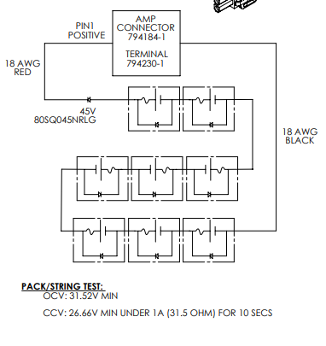

Pack is 8S1P, cells are CSC93 DD (p.n. 3B0036)
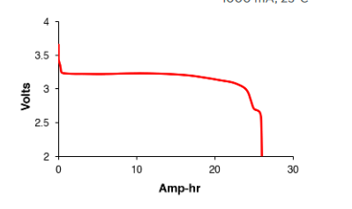
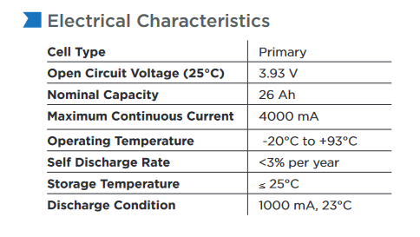

Voltage per cell = 3.25 V
Pack voltage = 3.25V * 8 cells = 26V
Capacity = 26 AHr
Total energy in pack = 26 AHr * 26 V = 676 WHr
Derate for cold 15% = 676 WHr * 0.85 = 575 WHr
Total images per pack at 1 image/hour = 575 WHr/85 mWHr = 6764 images

