Coral Observatory Image Retrieval Procedures
Nov 30,2 020

- Image Retrieval via ODI connector
  - Connect ODI to ROV via MINK10CCPL connector. Mount the ODI and mating plate on the front porch.
  - When you reach the camera tripod remove the camera side ODI from the frame and connect to the ODI mate on the ROV front porch
  - BEFORE POWERING UP THE ODI PAIR
Ensure laptop network addresses set correctly:
    - To determine the setting of the ip address you can either:
      - Open a command window (type “cmd” into the seach bar to open)
        - Type the command “ipconfig” and press return
        - Look for the Ethernet address, the one that called “IPv4 address”
        - See 1.c.ii for correct addresses
      - Go into the Control Panel -> Network Center -> Ethernet -> Properties -> Internet Protocol Version 4
        - The properties window will allow you to review and set the IP, subnet mask, and gateway as described below.
    - Ensure laptop set to:
      - IP address: 192.168.1. X (X = any number but 23, 1 is a safe choice)
      - Subnet mask: 255.255.255.0
      - Gateway: 192.168.1.1 (sometimes this does not show up on an “ipconfig” it is okay, it seems to work anyway)
    - The RaspberryPi in Camera Houing is set to
      - IP address: 192.168.1.23
      - Subnet mask: 255.255.255.0
      - Gateway: 192.168.1.1
  - Have pilots turn on power and Ethernet to the MINKLong science port connected to the ODI. It is important that both the 110 VAC and the Ethernet are on, both need to be working to talk to the tripod
  - Once power is turned on it will power up the Raspberry pi. It takes a minute to boot up
  - Test network connection by opening a command window and “ping”ing the camera IP address. (command is “ping –t 192.168.1.23” you can press ctrl+C to stop the pinging). Close this window once you have been successful.
    - If you do not get a response after 40 seconds:
      - Confirm you are plugged into the right Ethernet port in the control room that corresponds to that Science port connection
      - In command window type “ipconfig” then hit enter, check that your laptop is set at the right IP address
      - Confirm there are lights coming from the RJ45 serial to USB dongle connected to your laptop if you are using a dongle
    - If you get a reply proceed to the next step
  - Open Virtual Here software (icon on desktop says “vhui64” see pic below)
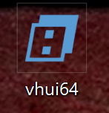
  - Ideally you see something like this: 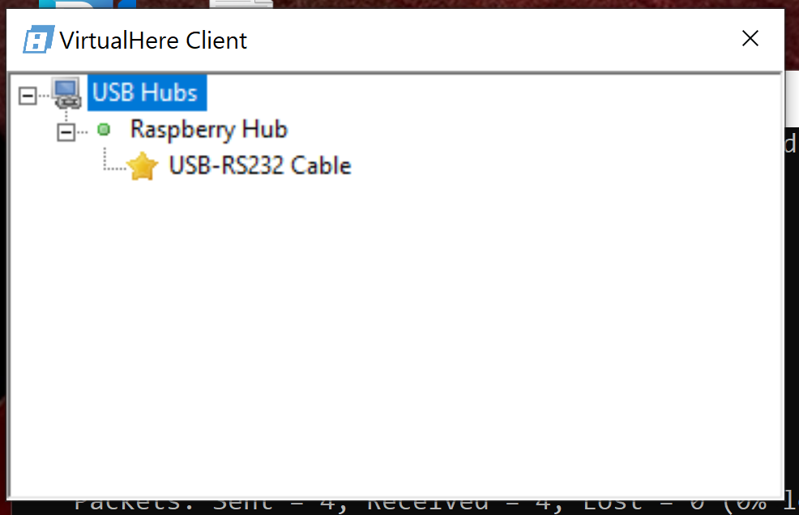
  - You should see two entries for USB-RS232 Cables. Right click on each one you see and click on “Use This Device”. One is for the camera and one is for the tilt motor
  - Open the device manager to confirm which ports the laptop is using. You can do this by typing “Device Manager” into the search bar in the lower left hand corner.
  - The Device Manager window looks like this:
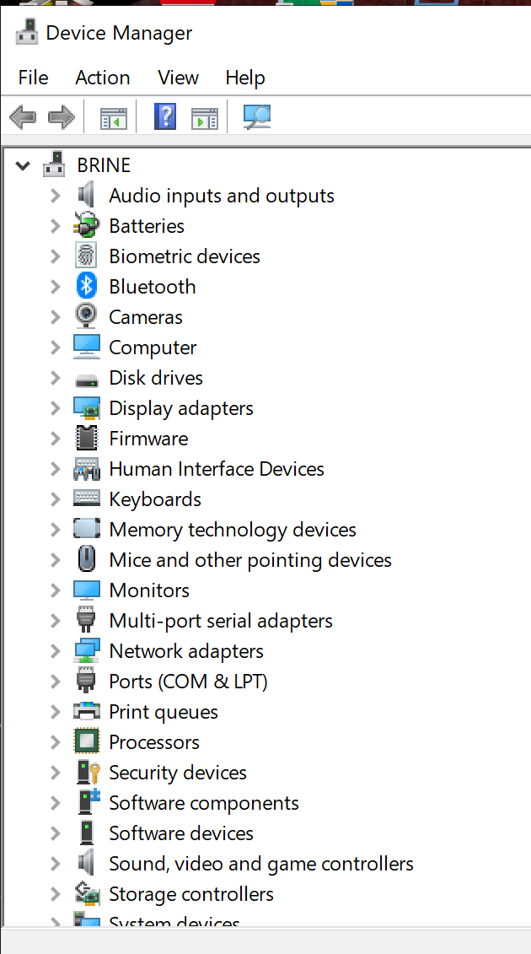

  - Click on “Ports”
  - You should see two labelled “USB Serial Port (COM X)
  - Last time Tilt was on COM 5 and Snappy was COM6
  - You need to confirm this serial ports are still configured this way to do this:
    - Open Elmo Composer
    - Inside of a large window is a small window allowing you to choose how you connect
    - 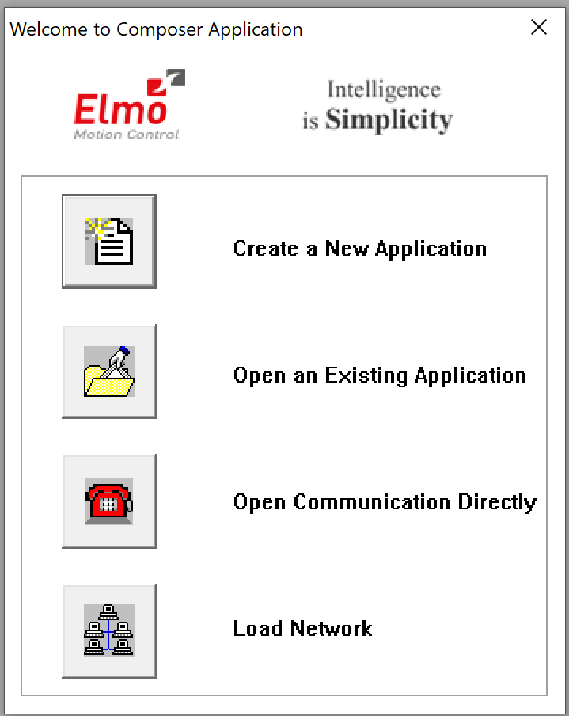
    - Select “Open Communication Directly”
    - It will bring up a window in which you can set the protocol:
    - 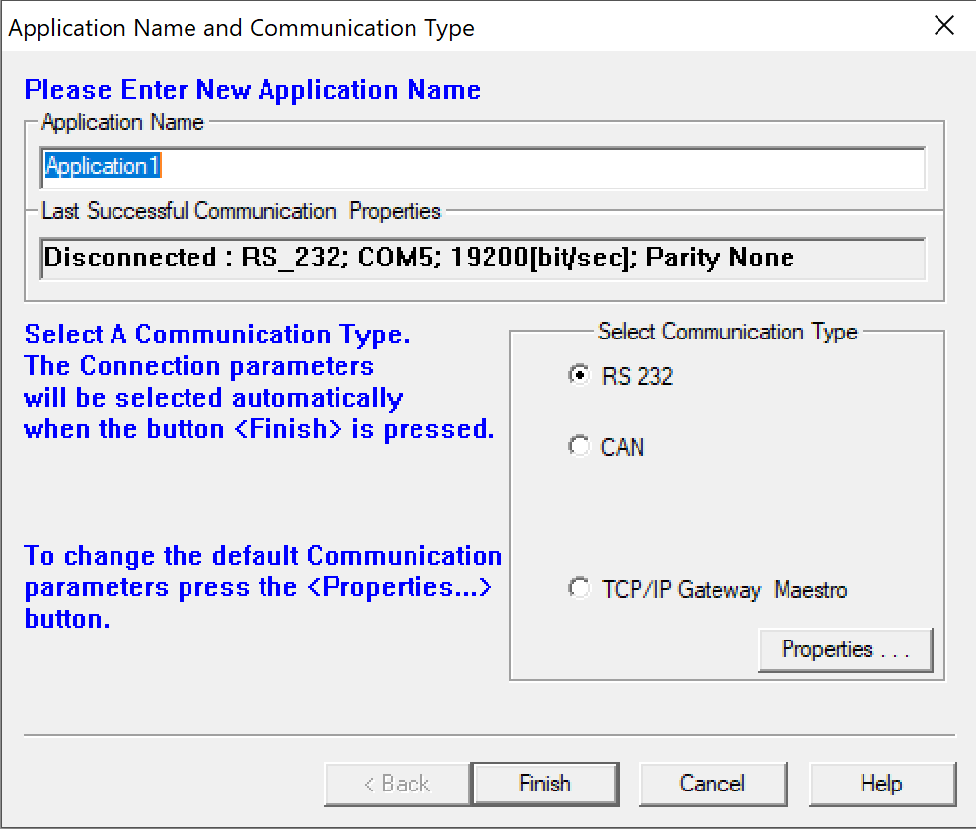
    - This display the last connection, if it comes up looking like this select “Finish” , if it does not come up with a Last Communication Property panel filled in, then click on the “Properties windown in the “Select Communication Type” panel. That will open up this window:
    - 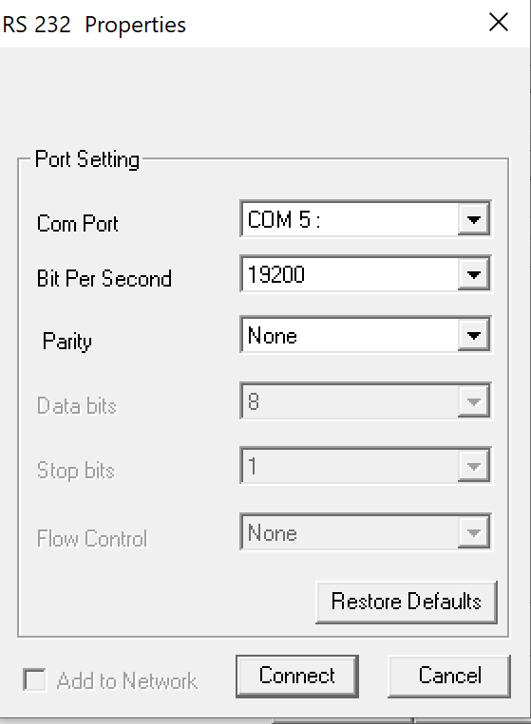
    - Above shows the settings you want to try. The Com Port should be one of the two you saw in the Device Manager. Bit per Sec must be 19200 and Parity is “None”
    - Press Connect
    - If you chose the wrong COM port you will get this message:
    - 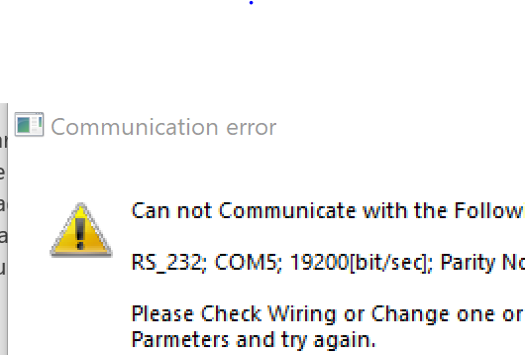

    - Try the other COM port. If you connect to the Elmo don’t press any buttons just exit the program, and write down which COM port is which. You will use the other COM port to talk to the Camera Controller and Camera.

  - Next open up the terminal software uCon or Hyperterminal. The uCon configuration window looks like this:
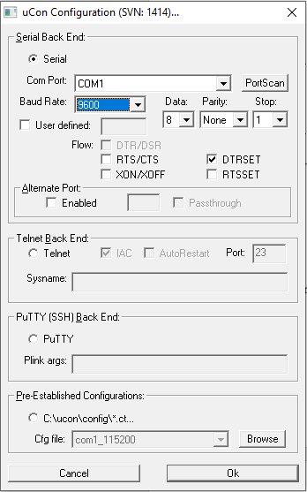
    - Under the pull down menu “Com Port” choose whichever port you determined is the camera, probably COM5. Connect at 9600,8,n,1. Press “OK” when you have selected COM port and baud rate and a terminal window will open. 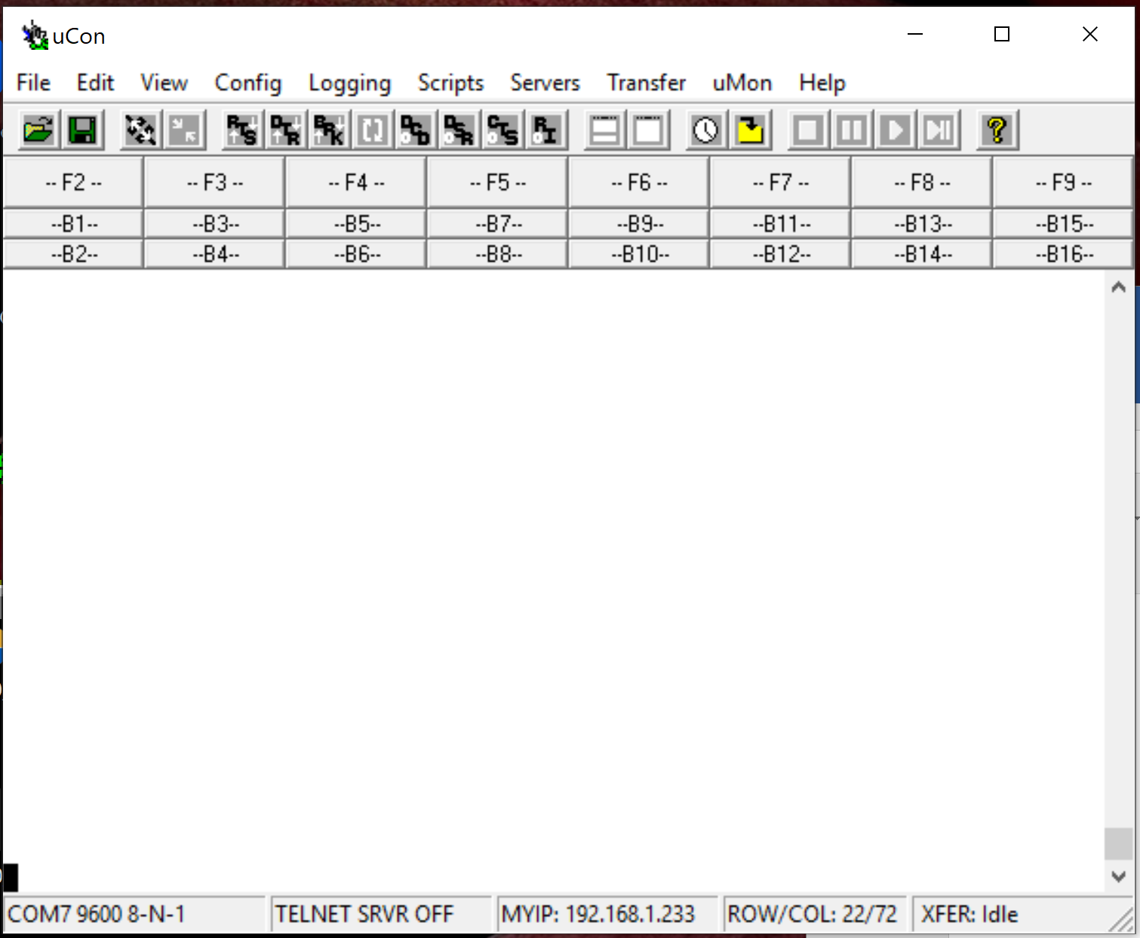
    - Turn on time-stamping and logging in ucon (ignore if not in uCon or try to log in hyperterminal) continue to step iii if no logging
      - In the Config menu select “Timestamp”
      - Select “Enabled” and “Stamp at toggle” and “Local only”
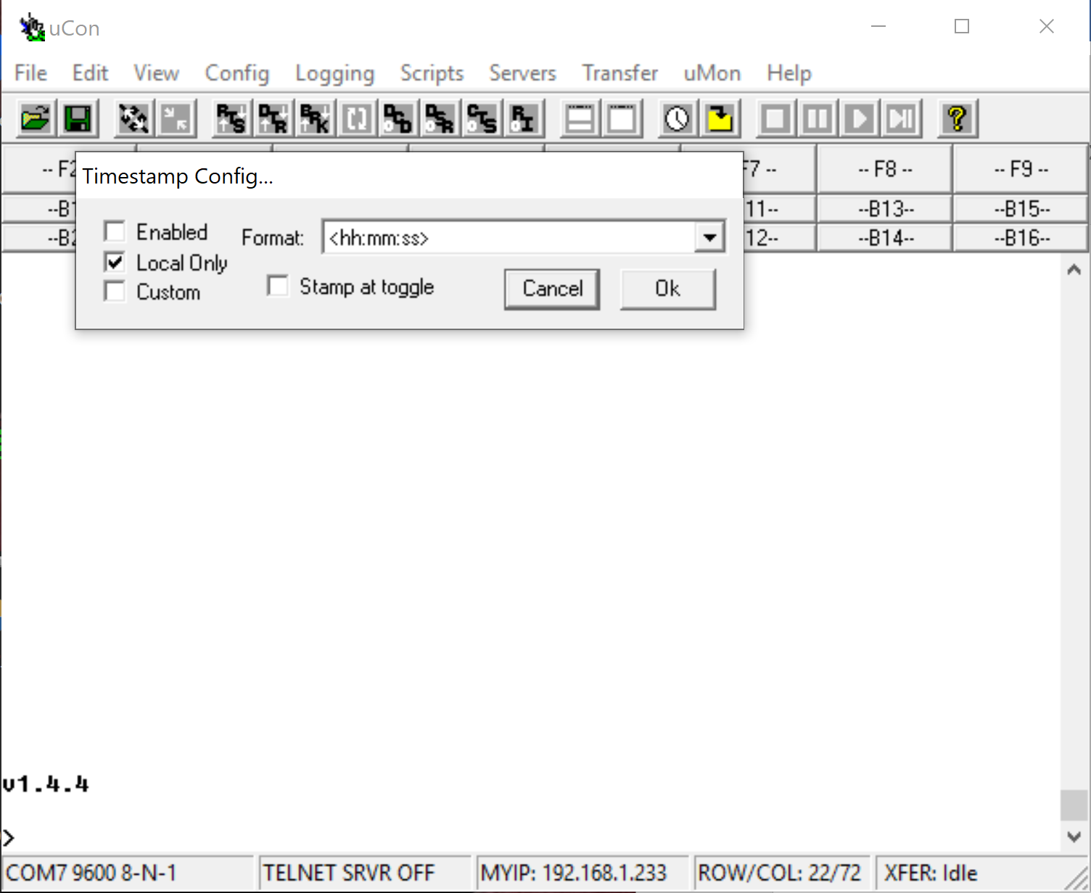

      - Press OK and continue to setting up logging
      - Under the “Logging” menu select “Standard” then you will see this window:
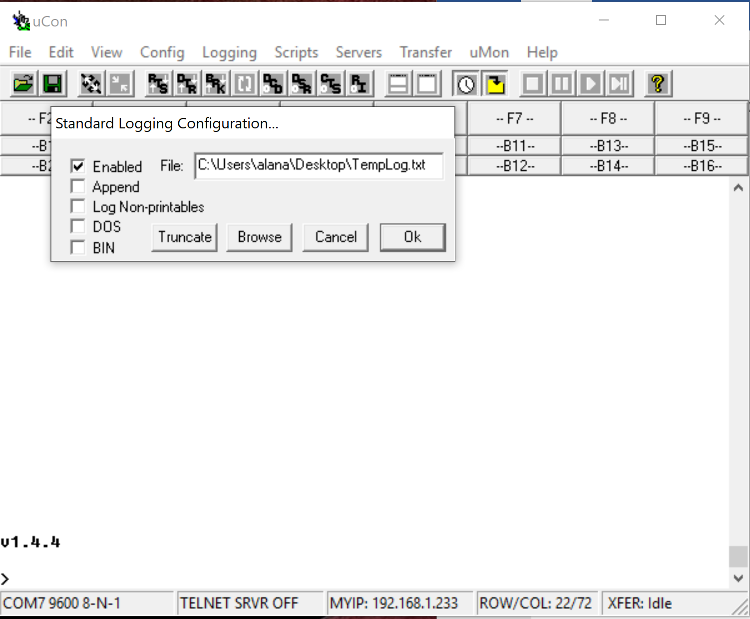
      - Select “Enabled” and then using the “Browse button” you can name and save the file in a place you won’t forget. Press Ok when finished.

    - Press Enter, most likely nothing will happen because the PIC on Snappy which you are communicating with is asleep or it is trying to take a picture. Now that you have everything configured right you will need to restart Snappy.
    - Now you must wait for Snappy to wake up
    - When Snappy wakes up you have 30 seconds to stop the program. If you miss this window you will not have another chance for 1 hour.
    - When Snappy wakes up it will display a countdown on the screen which looks like:
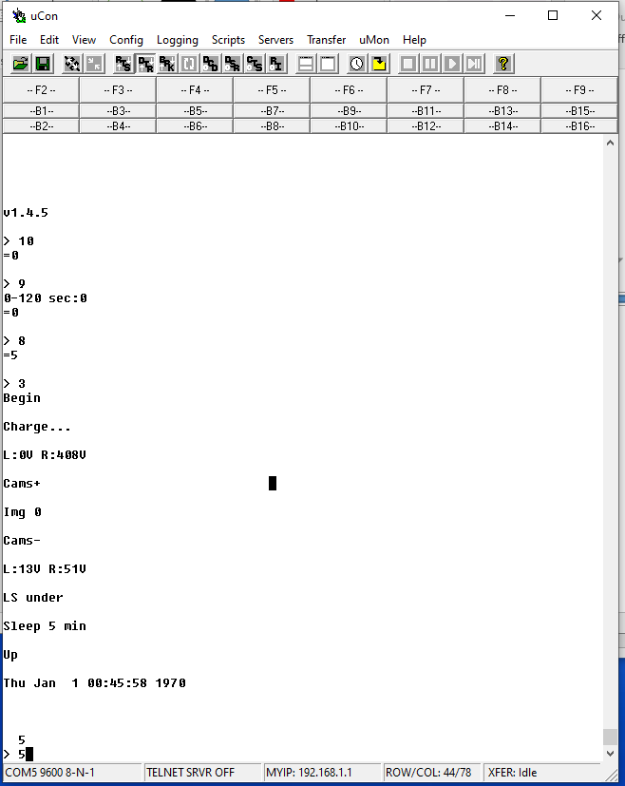
    - When the com port is connected you should see that the program is counting down, as quick as you can type “5” and press enter. This should halt the program. For good measure I always do this step 2 times.
    - Once the program is halted typing the command “36” then “Enter” will spit out the stats of the last deployments. Make sure to print out twice then you can disable logging.
  - Now that you have the strobe data, the next step is to download the images. To start this process, in the terminal window type “19”, this turns the camera on.
  - When the camera is on it should appear in the VirtualHere window: you may have to right click on it and select Use This Device,
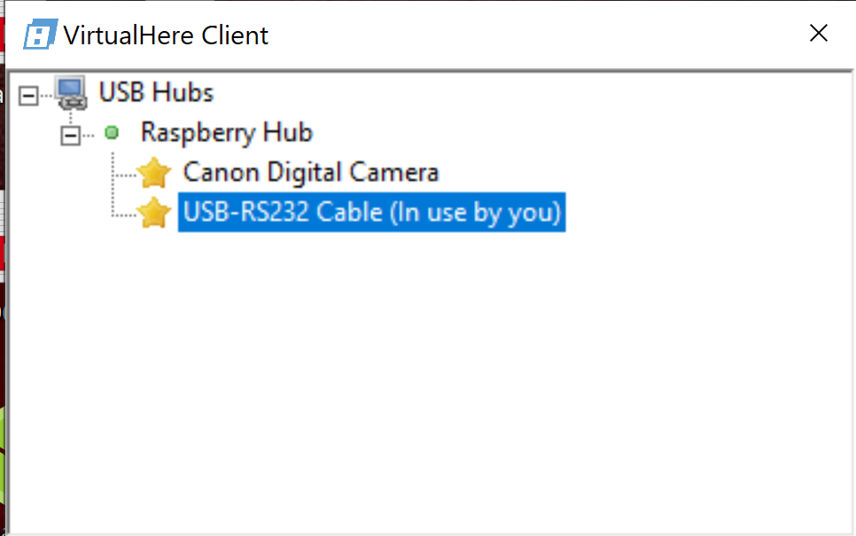

  - When you connect to the Camera it will automatically start up the Canon software, Quit out of this window.
  - The quickest way to download images is to open up file explorer and select the camera. If you do this exit out of any Canon software that may have automatically opened up.
  - In file explorer open the camera, two cards should show up. Copy images from either card, make sure you are copying not moving the images. In File Explorer use the details view to see if the images are about an hour apart. Don’t use thumbnails to look at images it will be very slow with this many. You can use “Ctrl+C” to copy files and “Ctrl +V” to paste files into a folder on the laptop.
  - After images are all downloaded back the up on another disk drive.
  - Once you have the images take a look. Look at how many images have been collected, I would expect something like 6500 images. If you are not happy with the images and want to change the ISO you can do that through the Canon remote software (see Deployment are Recovery Procedures section 2.m.3. iv.) Otherwise we will set the mission running again. Turn off camera by typing in “20”, you should see the Camera disappear from the Virtual Here USB Hub window.

- Resuming deployment
  - Starting the mission
    - Type “18”to read clock and confirm correct time. If you need to reset it type in “17”
    - Read delay enter “10”. It should be set for 120 seconds to allow a shutdown to the raspberry pi and turn off the ROV port. If the raspberry pi is powered up EVEN if the camera is not connected through the Virtual Here, it may interfere with the cameras ability to take images using the remote connection. If it is not 120 set it using command “9” +enter.
    - Read sleep: use command “8” to read the sleep. Sleep is the number of minutes between taking a picture. Set this to 1 minute less than you want the elapsed time to be. Read that it is set correctly by typing 8, should be like 59.
    - Once sleep and delay are set you can start the deployment by pressing “3”. This is the “Deploy” command. Once the deployment is started immediately return to virtual here window. Right click on com ports and select “Stop Using this device”. Then have pilots shut off power to that port (120 VAC) immediately. About 2 minutes after you started the mission you should see the strobes flash indicating you have started the mission correctly.
    - Wait until you have verification to disconnect the ODI pair. Place ODI connected to camera gently back on

Snappy command set

- Sleep
- Read Wake
- Deploy
- Resume
- Halt
- # Images
- Set sleep
- Read sleep
- Set delay
- Read delay
- Set timeout
- Read timeout
- Set batt
- Read batt
- Set SN
- Read SN
- Set clk
- Read clk
- Cam on
- Cam off
- Cam power?
- Left strb V?
- Right strb V?
- Chg Left strb
- Chg Right strb
- Left strb on
- Left strb off
- Right strb on
- Right strb off
- Trig left strb
- Trig right strb
- Trig far shut
- Trg near shut
- Snap far cam
- Snap near cam
- Get status

