- Recovery Procedures
  - Once camera tripod is on deck thoroughly rinse the system with fresh water.
  - Dry connector on battery can with towel, then disconnect the cable from the battery housing to the camera housing (blue cable). This removes power from the camera controller. Use a metal shell dummy cap to seal the connector on the battery housing, and a plastic or metal plug on the cable side to protect the connector.
  - Start up a laptop that has the following software: VirtualHere, uCon, and Canon EOS Utility. These three programs will allow you to download all data and images.
  - Connect the deck cable to the MCBH10F connector on the back of the camera housing. Secure with ziptie to the frame near the camera. In the lab, connect the RJ45 of the deck cable either directly to the laptop or to a network switch to which the laptop is already connected. DO NOT have switch attached to any external network (ship, shore, etc)
  - Network addresses:
    - RaspberryPi in Camera Houing
      - IP address: 192.168.1.23
      - Subnet mask: 255.255.255.0
      - Gateway: 192.168.1.1
    - Ensure laptop set to:
      - IP address: 192.168.1. X
      - Subnet mask: 255.255.255.0
      - Gateway: 192.168.1.1
  - Power Supply: Set up a power supply capable of +28 V and at least 3 A. If you plan to test the strobes as well, you will need a power supply capable of 5A. Confirm that voltage and current settings and then plug in banana plugs to the power supply.
  - Turn power on to deck cable. You may see an initial voltage dip, but the power supply should draw about 120 - 150 mA @28V when the pi is booted up.
  - Test network connection by opening a command window and “ping”ing the camera IP address. (command is “ping –t 192.168.1.23”, you can also “ping raspberrypi.local”)
    - If you do not get a response after 40 seconds:
      - Check deck cable is drawing correct current
      - In command window type “ipconfig” then hit enter, check that your laptop is set at the right IP address
      - Confirm there are lights coming from the RJ45 connection from the deck cable and your laptop if using a switch
    - If you get a reply proceed to the next step
  - Open Virtual Here software (icon on desktop says “vhui64”
  - Ideally you see something like this: 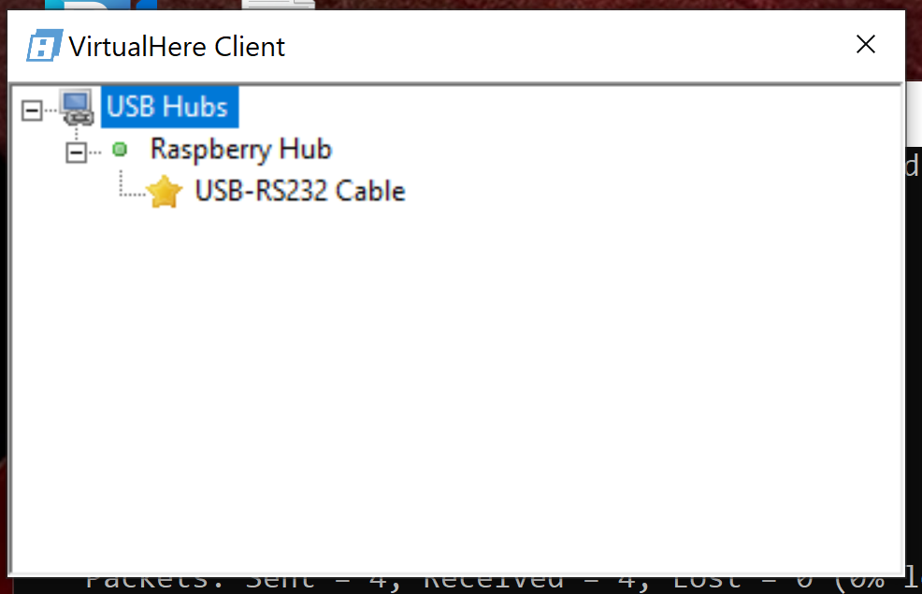
  - You may see one or two entries for USB-RS232 Cable. Right click on each one you see and click on “Use This Device”, the order you click the devices effects which com port it is assigned. The com port number also varied by laptop.
  - Now it should look like this: 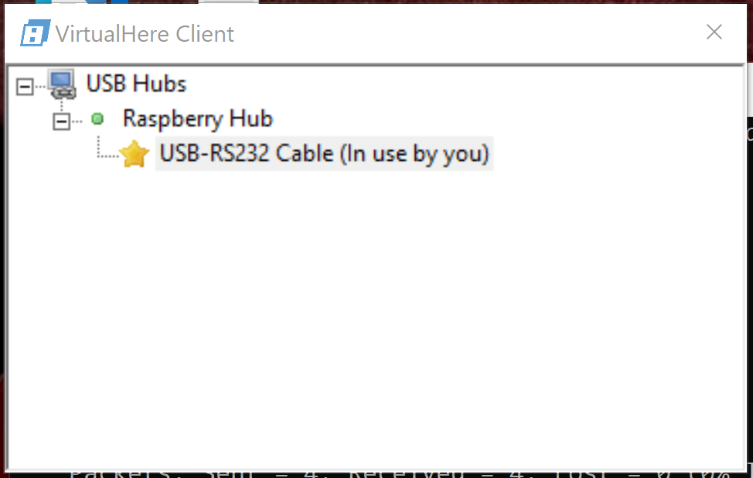
  - Next open up the terminal software uCon. The configuration window looks like this:
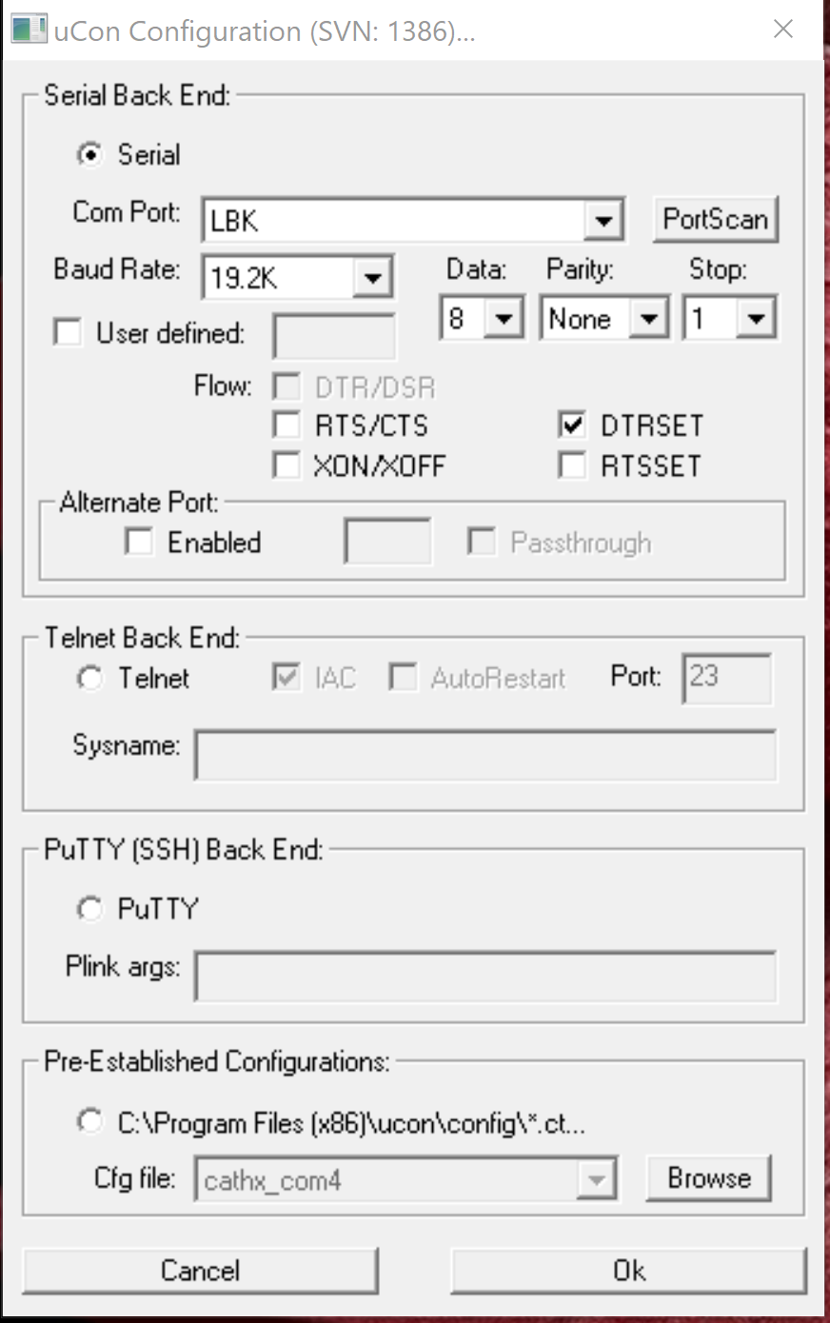
- Click the “PortScan” button to update the serial ports in the “Serial Back End” section of the configuration. You should see an unused serial port, usually COM5 or COM6. Last time Tilt was on COM 5 and Snappy was COM6 (3/2/21) this was using the laptop Brine. Disregard if not using Brine. (COM4 and COM10 on Bermuda)
    - Connect at COMX 9600,8,n,1. Alternatively check the “Pre-Estblished Configurations” at the bottom of the window for a DiSCO config file. This will have the right setup. Press OK and a terminal window will open.
    - If you press return and do not see a prompt you chose the wrong com port, to change it go into go to the configuration menu at the top of the screen, select “Backend” then “Com port” and you will be taken to a menu where you can change the port number.
    - Turn on time-stamping and logging in ucon
      - In the Config menu select “Timestamp”
      - Select “Enabled” and “Stamp at toggle” and “Local only”
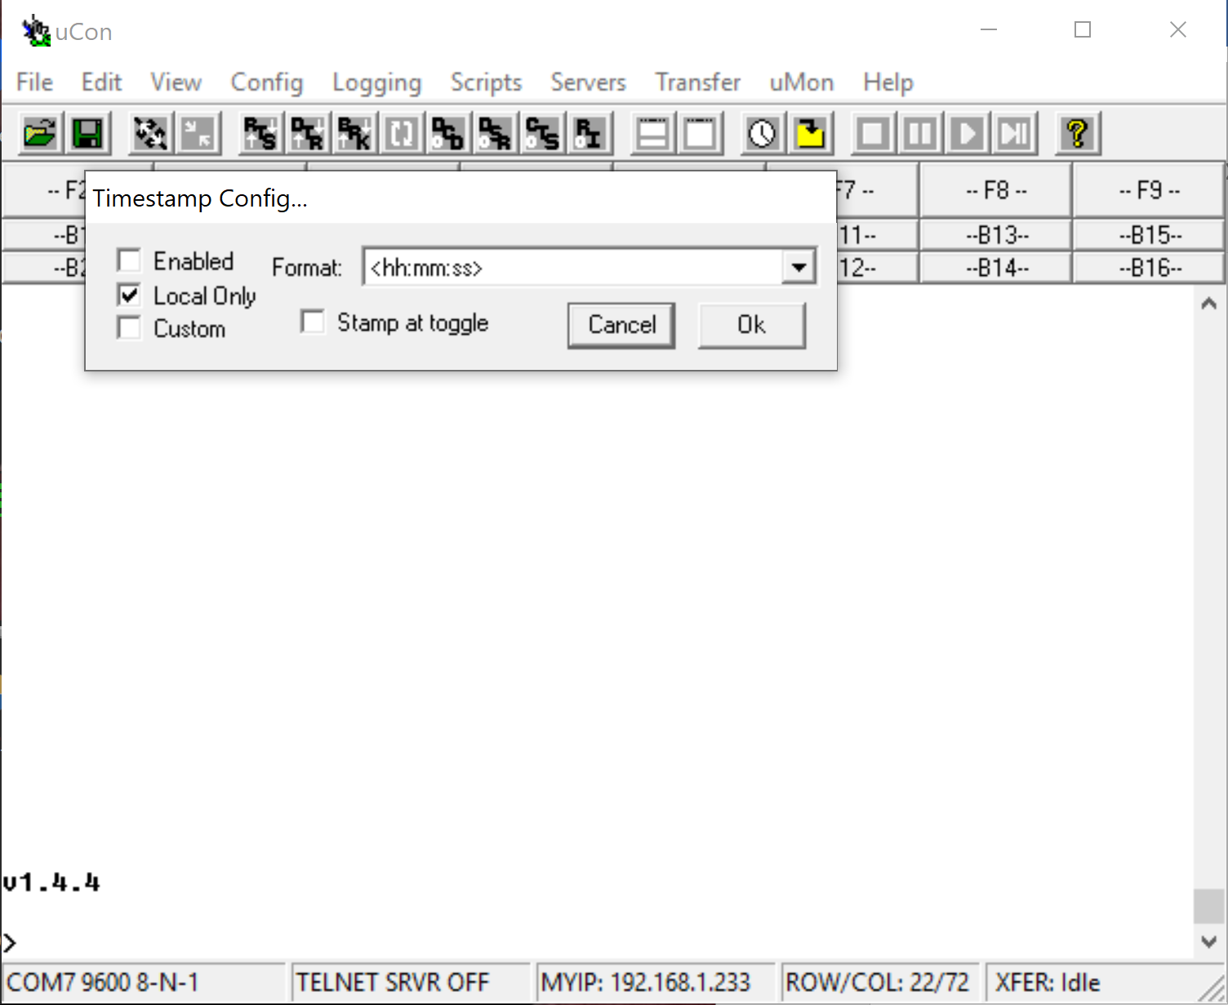

      - Press OK and continue to setting up logging
      - Under the “Logging” menu select “Standard” then you will see this window:
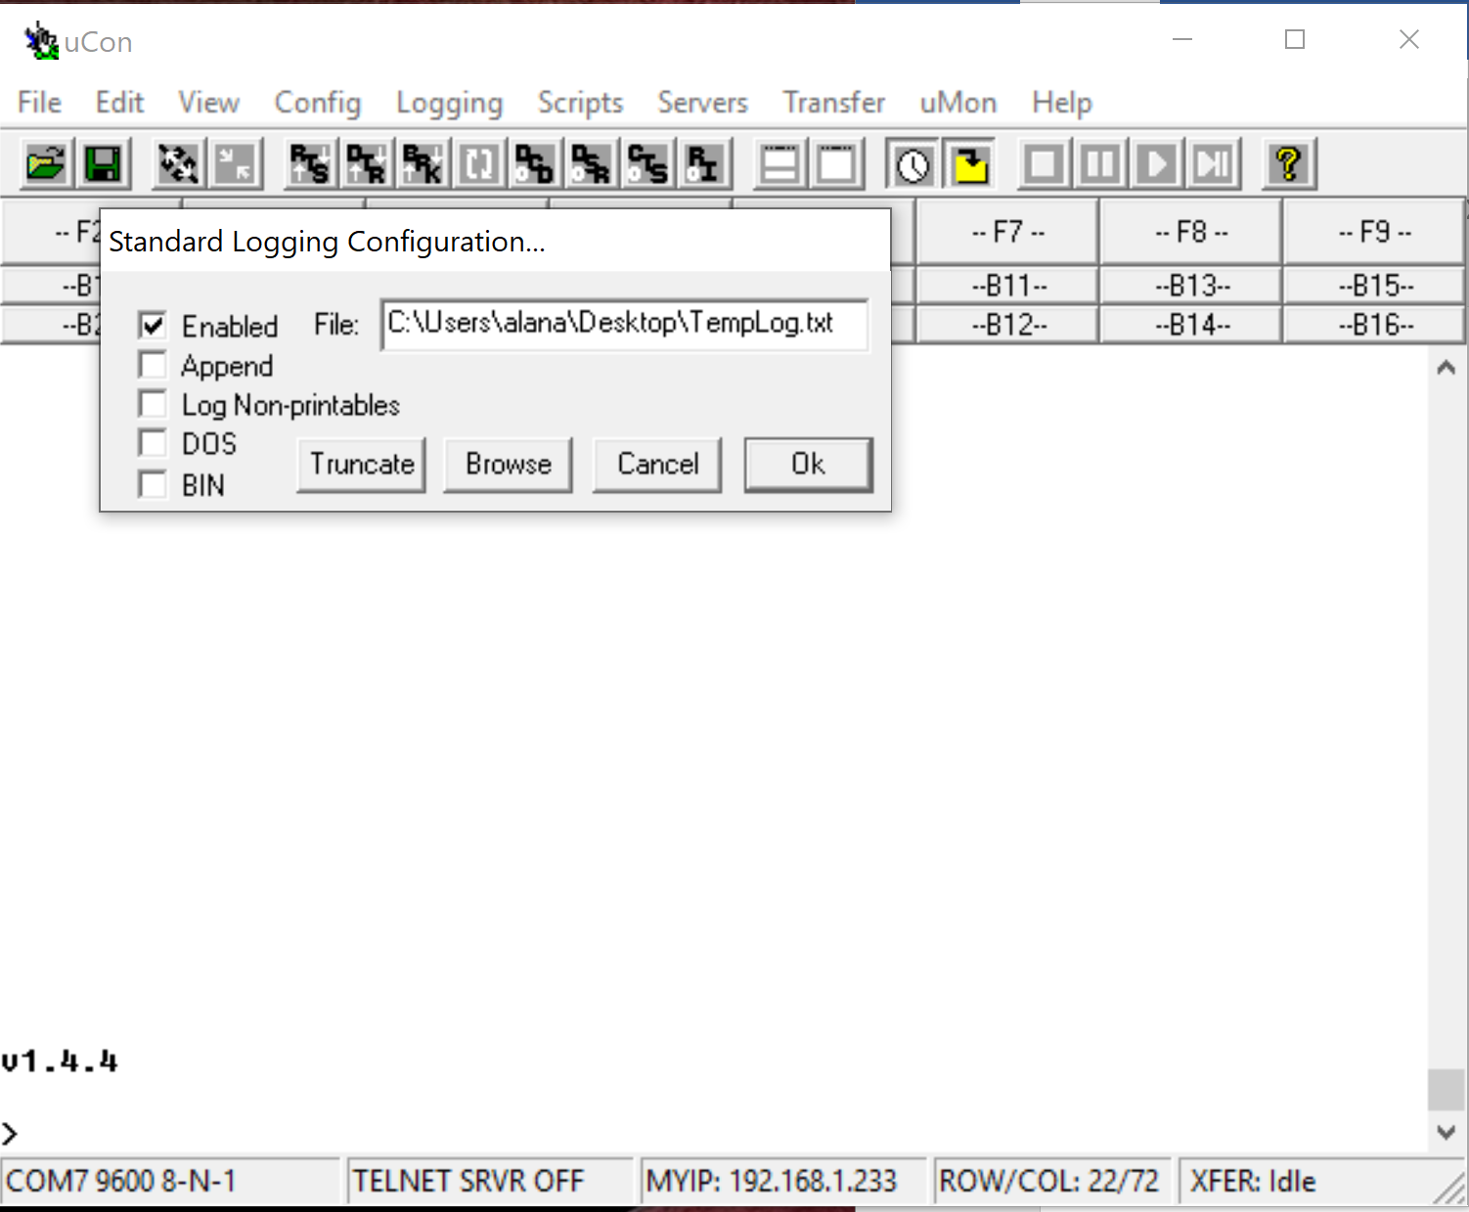
      - Select “Enabled” and then using the “Browse button” you can name and save the file in a place you won’t forget. Press Ok when finished.

    - Press Enter, most likely nothing will happen because the PIC on Snappy which you are communicating with is asleep or it is trying to take a picture. Now that you have everything configured right you will need to restart Snappy.
- Fresh restart:
    - Disconnect the serial port in the uCon window by clicking on the button with two arrows pointing away from each other. See red arrow above for help finding the button in the figure below. 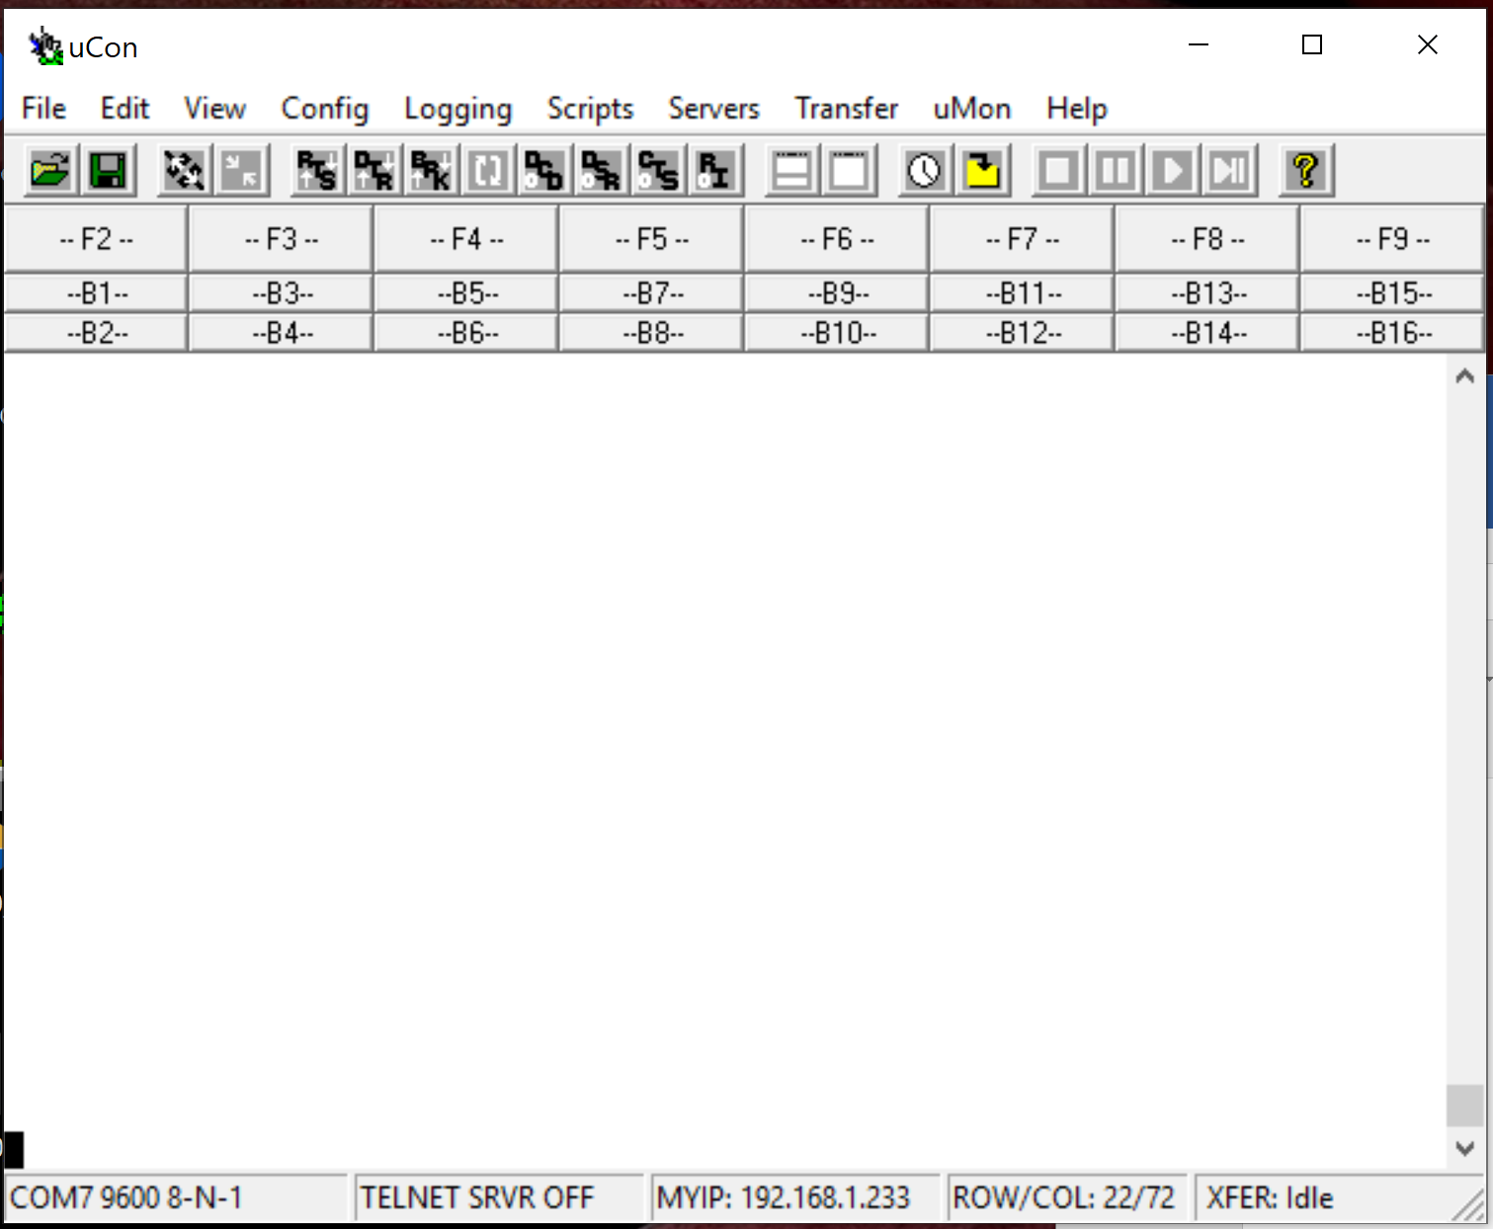
    - Turn power off to the deck cable for at least a full minute. The next steps are time critical for stopping the program so read fully before starting.
    - With ucon and VirtualHere windows open and visible start turn power supply back on.
    - As soon as the USB-RS232 Cable appears in the VirtualHere window, press the connect button on in uCon (two arrows pointing to each other)
    - When the com port is connected you should see that the program is counting down, as quick as you can type “5” and press enter. This should halt the program. For good measure I always do this step 2 times.
    - Once the program is halted typing the command “36” then “Enter” will spit out the stats of the last deployments. Make sure to print out twice then you can disable logging. Take a screen shot incase log file does not work.
- Now that you have the strobe data, the next step is to download the images. To start this process, in the terminal window type “19”, this turns the camera on.
- When the camera is on it should appear in the VirtualHere window:
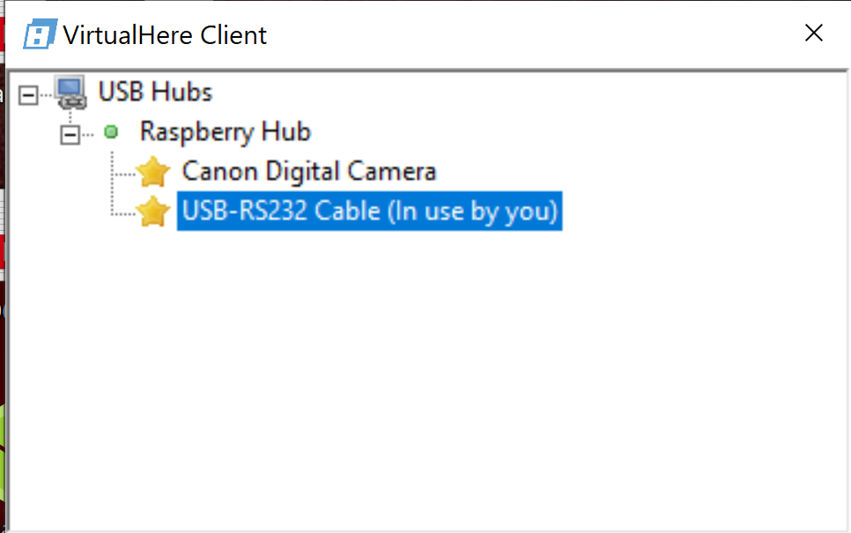

- The computer may immediately open up the Canon software to talk to the computer. There are two ways to download images. I would recommend downloading through Windows explorer, the Canon software opens Thumbnails which wastes bandwidth.
- Two ways to download:
  - Windows Explorer:
    - Close Canon software if it opens automatically
    - Open Windows explorer
    - The camera should appear on the left side as another drive
    - Navigate on the camera to the folder with the images. These cameras have 2 cards. We stored the images on both cards so they should have an equal number of images, but you only need to download one cards images.
    - A years worth of images is around 8700
    - Make sure you “View” is set to “List” so Explorer does not try to show thumbnails.
    - I would start by coping a few over and checking them, then copy them all. This will take many hours.
  - Downloading with Canon Software
    - Right click on “Canon Digital Camera” and select “Use this Device”, this should immediately start up the Canon EOS Utility Software.

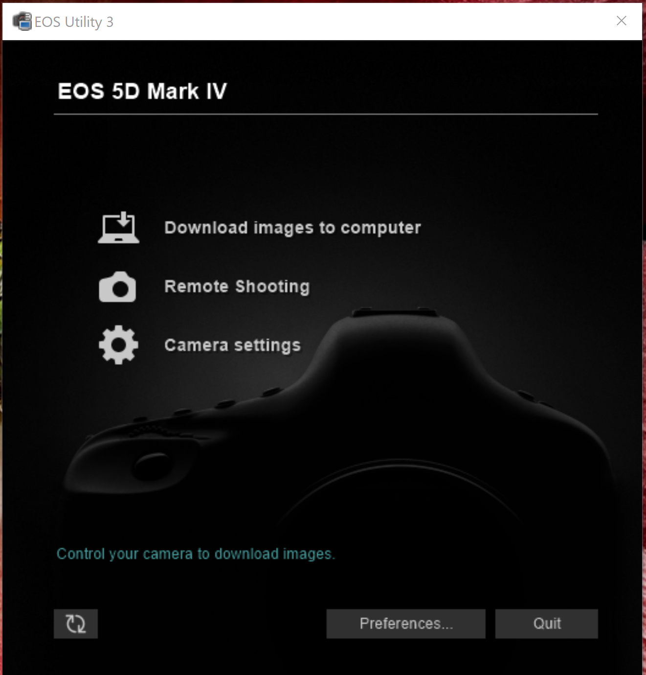

    - Select Download images to computer
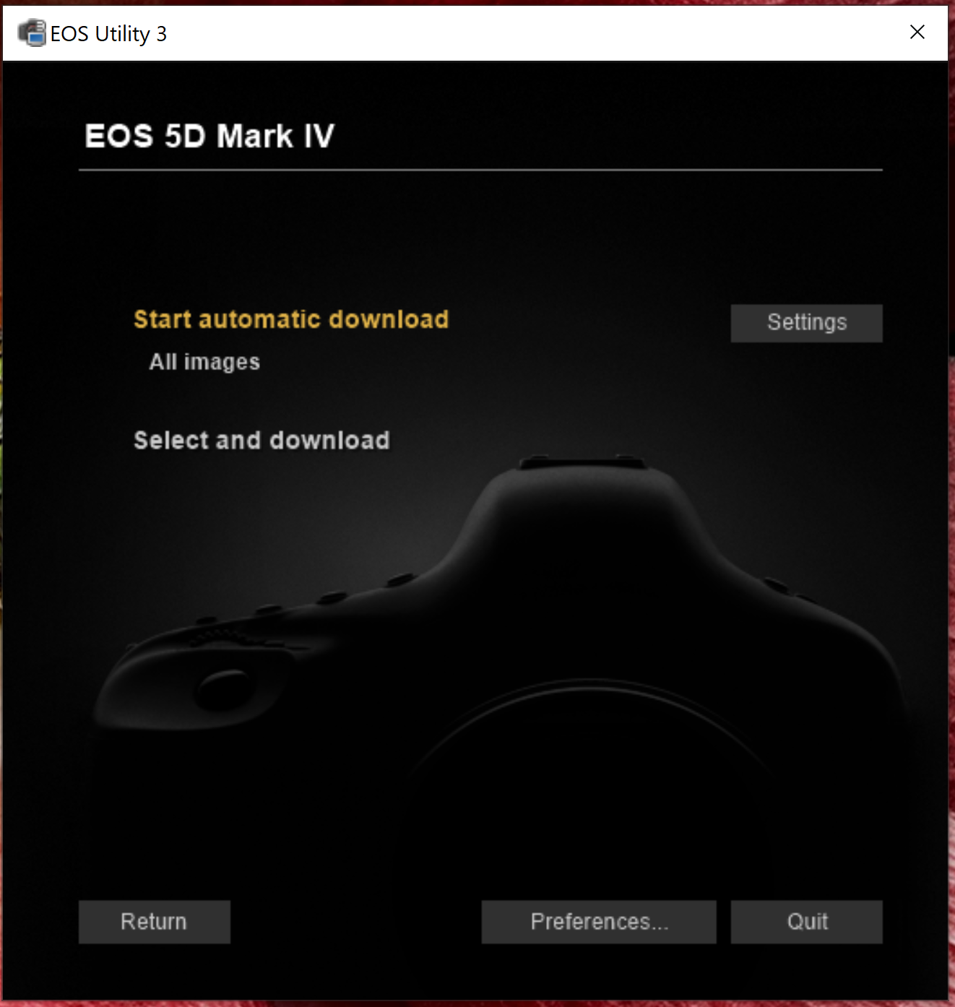

    - If you do “Start automatic download” open the “Settings” first and make sure you know which folder the images will be downloaded into.
- After images are all downloaded, which make take hours, back the up on another disk drive.
- Now you can close all the windows and turn off the power supply and disconnect the deck cable.
- To reformat and clear both flash and SD cards – there should be an option in the “Select and Download” window, maybe the lower left hand corner. Double check this.

