Dual Camera Tripod Recovery and Deployment Procedure
Alana Sherman
10/1/19

FF= Far Field Camera
NF = Near Field Camera

- Once the camera tripod is on deck and washed off the deck test cable can be plugged in to the FF camera housing and the battery cable (between the FF camera housing and the battery housing) should be disconnected.
  - Remove the cable between battery housing and FF camera and dummy off bulkhead connectors. IMPORTANT: There is power from the Li batt packs on the cable between the battery housing and the camera housing, shorting this cable will blow fuse in system. Safest thing is to dummy off the bulkhead connection on the battery housing.
  - The deck cable is a long black cable with a PU jacket. The deck cable has a subconn connector on one side and on the other side: Ethernet, serial, and power wires. The mating bulkead connector on the camera housing is a subconn 10 pin female. Make sure to use lubricant on the cable side of the connector before inserting to bulkhead connector.
- The deck cable is providing 3 things: Power, Ethernet and serial comms. It provides +28V power the Canon camera, the Silex (a USB to Ethernet converter used to talk to the camera), and the RS232 transceivers. It provides a serial connection to the Snappy microcontroller, and an Ethernet connection to the Silex. Once the cable is plugged into the camera housing, plug the serial and Ethernet cables into the computer before turning power on. Set power supply to +28V, current can be limited to 0.5A. Do not turn on until after next step!!
- The next step is to set your Local Area Connection IP (TCP/IP4) configuration to the following:
IP: 192.168.0.5
Subnet mask: 255.255.255.0
Gateway: 192.168.0.1
NOTE: FF CAMERA SILEX USB server is IP address 192.168.0.73 and NF USES A USB EXTENDER

- Open a hyperterminal session to talk to the Snappy PIC controller. The hyperterminal parameters are 9600, 8, N, 1. Very important: open a log to capture all data from the terminal session. In hyperterm logging can be started and stopped using the “Transfer” menu.
- Once you confirmed your IP address it is safe to power up the deck cable.
You should see the system use around 200 mA at +28V, this is mostly to power the Silex. Make sure to have your hyperterminal window visible as you will have 30 seconds to halt the program once power is applied. If you miss this window just power cycle again – strangely you must wait almost a minute with power off to turn on again.

Downloading strobe data

- The first step is to halt the program. This can be achieved by pressing enter in the hyperterminal session when you see the program counting down from 30. This will give you a prompt, at which point you can enter “5” and press return. Do this two or three times, there is a software bug that tries to start running the mission again. You may encounter this and it will look like the camera suddenly losing power for no reason. Usually a message will appear on the hyperterminal about it going to sleep. This command halts the program. If you miss the count down power off for one minute then turn power back on
- To offload the battery and strobe data, press “36” and enter. Make sure you are logging the session before doing this step. Save the log to an easy to find location.
- After this step, press “19” to turn on the FF camera. You can then minimize the hyperterminal session until you are ready to start testing the tripod again. A complete list of commands is available at the end of this document.

Downloading images
- If you need to open up the FF camera housing anyway skip to step 17 otherwise…
- Open up Silex software utility SX Virtual Link. Note you will open the program but usually no window pops up just a small blue icon in the hidden icons bar on the bottom of the screen (pointed to with yellow arrow below). Click on the icon and it will open the SX Virtual Link Software.
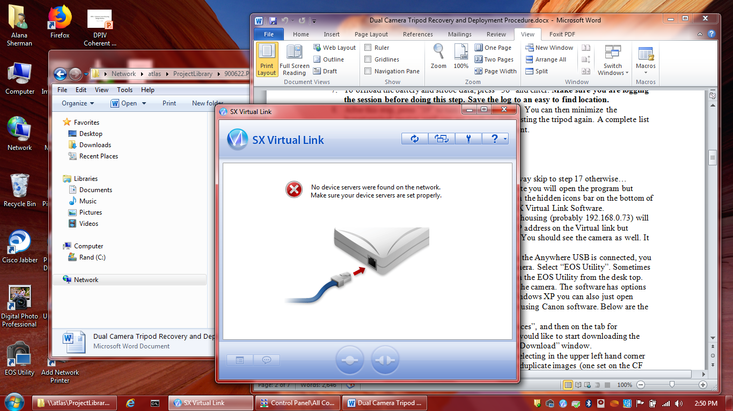

- After less than a minute the Silex in the FF camera housing will appear on the list of servers. It does not show the IP address unfortunately but you can right click the serial number of the unit and open the settings in a web page (usr: root, no password) and confirm the IP address. You should see the camera appear under the server info as well. It should be listed as “available”. You can use the refresh key (circle of arrows) to update if you are not seeing it.
- If you do not see the camera it might have turned off. You should confirm you are still talking to Snappy. If you don’t get comms with Snappy the software may have accidentally relaunched into the deployment. In this case power cycle and try again. If you can talk to Snappy turn the FF camera on “19”.
- Click on the camera name in the SX Virtual Link and then choose connect. This usually automatically opens the EOS software.
- In the EOS Utility main window click on “Preferences”, and then on the tab for “Destination Folder”. Set up the folder where you would like to start downloading the images. You can also set this up in the “Select and Download” window.
- You can choose which card to download from by selecting in the upper left hand corner card one or two. The camera is configured to store duplicate images (one set on the CF card and one set on the SD card)
- The quickest way to download the images is the “Start downloading” option on the main window because it does not try to load thumbnails before downloading. This process could easily take hours.
- If you have successfully downloaded all images you need to delete the images (on the Mark III you can’t remotely format the memory cards using the EOS Utility ). Make sure all the images are safely backed up before taking this step as they will be lost forever. In the “Select and Download” window of the EOS Utility, you can click a button to select all and there is a delete option. Remember to delete images off both the SD and the compact flash cards. If you do not need to open the camera can to change/format cards, you can now skip to “Replacing the Batteries” step XX.

- If opening FF camera can:
  - Unplug cables between the camera housing and the battery housing if not done already. The best thing to do is to dummy off all bulkhead connectors and cables. If you can’t find a dummy use a rubber glove and ziptie to protect.
  - Put protective cover over glass on camera housing endcap
  - The camera housing needs to be removed from the frame using a crane. Once the housing is off the frame place on foam cradles or somewhere stable
  - Unscrew endcaps (put screws in a bag and label them)
  - The whole internal chassis is attached to the rear endcap so remove endcap carefully! You are sliding the camera lens out of a narrow channel so please proceed with caution.
  - Remove compact flash and SD card from camera. Replace with new cards (currently we use 128 GB for both) label the cards with the pulse # and Camera position (FF or NF). Use the menu on the camera to format both cards.
  - Download images and copy images over to at least 2 places. Give Ken Smith compact flash.
  - Close up FF camera housing for redeployment.
    - Check all connections and cables
    - Replace desiccant
    - Make sure lens has not been accidentally moved (as well as knob on camera which puts it in manual mode)
    - Clean or replace orings
    - Purge with nitrogen
  - Place housing back on frame

Servicing the NF camera: this camera will always have to be opened because the battery will need to be serviced.
- Disconnect NF and FF camera cable, plug dummies into bulkhead connectors.
- Use same procedure to open camera housing
- Disconnect the Li battery from interface board
- Remove battery and label used, note the voltage remaining.
- Replace with new Li battery stick (pack # 3PD1517)
- Check battery voltage before connecting.
- Note camera will not turn on until connected to the FF controller.
- Repeat steps 17 f-i.
If you want to download the images using USB Extenders
- Plug in the USB extender deck cable to the NF camera case, this has an 8 pin MCIL8M connector attached to a rugged Ethernet cable. In the lab, the Ethernet cable should be inserted into Gefen USB extender SENDER unit. The USB cable from the Gefen should be plugged into the laptop.
- NOTE deck cable Power +28V must be on to turn on both the USB extender and the camera.
- You should see fast blinking lights when the connection is made. The Canon should appear as if plugged directly into the USB port of the laptop.
- When the Canon is connected, you may be asked to select the software to open it with. Select “EOS Utility”. This program allows you to download and control the camera. The software has options for downloading images, any will work fine. In Windows XP you can also just open Explorer and copy from the compact flash card not using Canon software.
- In the EOS Utility main window click on “Preferences”, and then on the tab for “Destination Folder”. Set up the folder where you would like to start downloading the images.
- The quickest way to download the images is “Start downloading” because it does not try to load thumbnails before downloading. This process could easily take hours.
- If you have successfully downloaded all images and saved in a back up spot you can use EOS Utility software to format the card which will erase all the images on the card. In EOS Utility main window select “Remote Trigger/Camera Settings” . Click on the tool icon in the lower right corner and then the “format” button. Make sure all the images are safely backed up before taking this step as they will be lost forever. You can now skip to replacing the batteries step 17.

Replacing the main battery packs
- Locate the Li battery pack (pn. 3PD1516) unless a short deployment in which case you may be using an Alkaline pack. If using alkaline pack the only differences to note are:
  - Each layer has its own set of wires which are fed into a diode board, take caution not to short pack when connecting to the diode board
  - The diode board has a jumper which must be connected to get the full power out of the pack
  - Check fuse is not blown on diode board- can be replaced with 10A fuse
- Steps to replace Li batteries:
  - Remove battery housing from tripod
  - Open battery housing in dry clean environment
  - Save all fasteners in baggie and label “battery housing”
  - Open battery housing: First open pressure housing VERY CAREFULLY- this housing contains Li batteries, which should vent through one-way SAE valve but still be careful! Remove fasteners from two ears on side of case.
  - The large battery pack has a two-pin molex connector which mates it to the rest of the electronics, see pack drawing for more detail.
  - Take a picture of the chassis assembled to help reassemble it correctly, not the position of any foam blocks and the diode board
  - Remove used Li batts, label “used” also good to note voltage, put in a secure place with other used Li batts for hazmat removal
  - Place the new pack in the chassis. I believe you will need
  - Either use existing cable harness to plug in the large battery pack to the diode board or strip wires from battery pack and install into screw terminal connectors on Diode board. BE VERY careful not to short wire and destroy pack DIODE BOARD NEEDS ELECTRICAL TAPE WRAPPED AROUND IT TO AVOID SHORTING ANYTHING TO METAL.
  - If housings are close together, connect battery housing to camera housing through wet cable. Then connect deck cable to camera housing and verify you can talk to Snappy through hyperterminal. If camera is hooked up you can verify you can take a picture.
- Start AnywhereUSB and open EOS utility selecting “Camera Control” verify FF camera settings:
  - ISO= 1250 (or 1600 if that was previous setting and images look good)
  - Shutter = 20 (1/20 sec)
  - White balance = AWB
  - Image quality = Large Fine
  - Check the date and time

- Is there a formatted compact flash in the camera?? Make sure you at some point did that step.
- Seal the housing by following same steps: put in new desiccant, fill with nitrogen, clean sealing surfaces and o-ring grooves with isopropol and chem wipes, and clean or replace o-rings.
- Close up housings, use aqua shield on Ti fasteners if needed
- Once both housings are closed and remounted on the frame

Testing the system pre-deployment
- Plug deck cable in, it is time to test the components through Snappy
  - open hyperterminal (9600,8,N,1) and record session
  - DO NOT Connect Silex to camera, if camera does not respond to a command to take a picture than it has autoconnected to the silex and is being controlled by the USB port (which means you cannot use the trigger signal to take an image) if this happens do the following:
    - Make sure Camera is disconnected on Silex GUI
    - Power down the camera (“20” I think)
    - Turn camera back on “19” and try “34” if strobes fire you have control of the camera again.
  - When powered up the Snappy should output its version number with a prompt
  - There is no menu option for snappy so use the command set at the end of this document
  - Before programming the mission verify the function of the following:
    - Left strobe
      - Type “24” and enter to charge the left strobe
      - Type “22” to see voltage on strobe, see if it is charged now ~375 V
      - After charge time is complete (30 seconds or so), type “30” to trigger the left strobe, type another “22” to see voltage is significantly less ~50 V
    - Right strobe
      - Type “25” to charge the strobe and “31” to trigger
      - You can type “23” to see the voltage
    - Test the near field camera
      - Type “19” plus enter to turn cameras on
      - Use command “33” to take a picture without strobes or “35” to take a picture with strobes, unless it is dark “33” is fine since the NF does not trigger the strobes (note to Alana/Rich: verify 35 works with delay)
      - Plug deck cable into the NF camera and using Anywhere USB + EOS Utility, verify that the image was good
      - Use EOS utility to verify camera settings:
        - ISO= 1250 (or 1600 if that was previous setting and images look good)
        - Shutter = 5 (200 msec) ???? is that right??
        - White balance = AWB
        - Image quality = Large Fine
        - Check the date and time
      - When you have confirmed the image and settings, disconnect Anywhere USB software then the deck cable
    - Test the FF camera
      - Type “19” plus enter to turn the cameras on
      - Use “32” or “34” to take an image with the FF camera. “34” will charge the strobes as well. Both will take images with both cameras, just so you know.
      - Connect to the Camera with Anywhere USB/EOS Utility to view the image
      - Disconnect Anywhere USB software- this is very important, if it is not totally disconnected Snappy will not be able to control the camera.
    - Read battery voltage by typing in “14” and enter. The battery pack should start out around +30V
    - Once you are satisfied that all subsystems are operational, it is time to start a mission

Programming a deployment (Rich confirm these steps)
- Set Sleep: type 7 and enter to set the sleep duration. “Sleep” is the time between images, which is usually set to 60 minutes. Type “8” and enter to read the sleep value and confirm it is set appropriately.
- Set delay: the delay is defined as the delay before the mission starts. Typically we leave this as 0. Type “9” plus enter to set delay. Type “10” + enter to read delay and confirm the proper setting
- Set clk???
- Deploy: typing a “3” plus enter will start the mission. You can halt (“5”) and resume the mission (“4”).
- Make sure anywhere USB disconnected, and then disconnect deck cable and replace dummy.
- I recommend setting it up first to take an image every 5 minutes, run that for about an hour or so. If all is working then change to 1 hour for main delay time and start the night before your deployment. The minimal power used on these pictures is small compared to a 10 month duration and you can deploy it with greater confidence.
- Final deployment
  - When satisified all systems are working disconnect deck cable and replace with lubricated dummy plug and locking sleeve.
  - Remove cover from camera glass port
- Throw it over and cross your fingers.

Snappy command set

- Sleep
- Read Wake
- Deploy
- Resume
- Halt
- # Images
- Set sleep
- Read sleep
- Set delay
- Read delay
- Set timeout
- Read timeout
- Set batt
- Read batt
- Set SN
- Read SN
- Set clk
- Read clk
- Cam on
- Cam off
- Cam power?
- Left strb V?
- Right strb V?
- Chg Left strb
- Chg Right strb
- Left strb on
- Left strb off
- Right strb on
- Right strb off
- Trig left strb
- Trig right strb
- Trig far shut
- Trg near shut
- Snap far cam
- Snap near cam
- Get status

