Coral Macro In Situ Operational Procedures
June 23, 2023
Version 6

- Deployment Checklist
  - Plug in battery cable (check o-ring)
  - Plug in lasers cable (use medium 44 grease)
  - Remove lens cap
  - Cut ziptie limiting tilt
  - Connect magnet for DSC (boomerang)
  - Make sure all tools clear
- Setting up Camera and Starting Deployment in situ via the ROV and Deepsea Connect
  - Set laptop network connection before turning system on:
    - Network addresses:
      - RaspberryPi in Camera Houing
        - IP address: 192.168.1.33
        - Subnet mask: 255.255.255.0
        - Gateway: 192.168.1.1
      - Ensure laptop set to:
        - IP address: 192.168.1. X
        - Subnet mask: 255.255.255.0
        - Gateway: 192.168.1.1
      - Camera side DSC 192.168.1.21
      - ROV side DSC 192.168.1.20
  - Plug Ethernet cable into port where the ROV pilots tell you, last was “E1”
  - Turn on the ROV Sci port providing the 120 VAC and Ethernet, to which the DSC can on the ROV is connected. Ping the ROV DSC 192.168.1.20. BE PATIENT, it take 30 sec to 1 min to boot up. To do this type “cmd” in the search window to open up a command window. Ant the prompt type >ping -t 192.168.1.20. A ctrl+C will halt the program.
  - The ROV will need to connect the two DeepSeaConnect (DSC) paddles, one from the camera tripod and one from the ROV. This is putting the “toast” into the “toaster”.
  - Check that the magnet is still aligned on the DSC housing.
  - Once DSC pair are firmly connected you should try to ping the Camera DSC 192.168.1.21, if you get a response then ping the raspberry pi 192.168.1.33 (I have noticed that sometimes the virtual here window is populated before you get a ping, so if you don’t see the ping response type “ctrl-c” and restart the ping. Again this takes a while to boot up)
  - Open up VirtualHere window, when the Raspberry Pi is booted up, you should see: (you will see the datalogger too, just ignore)
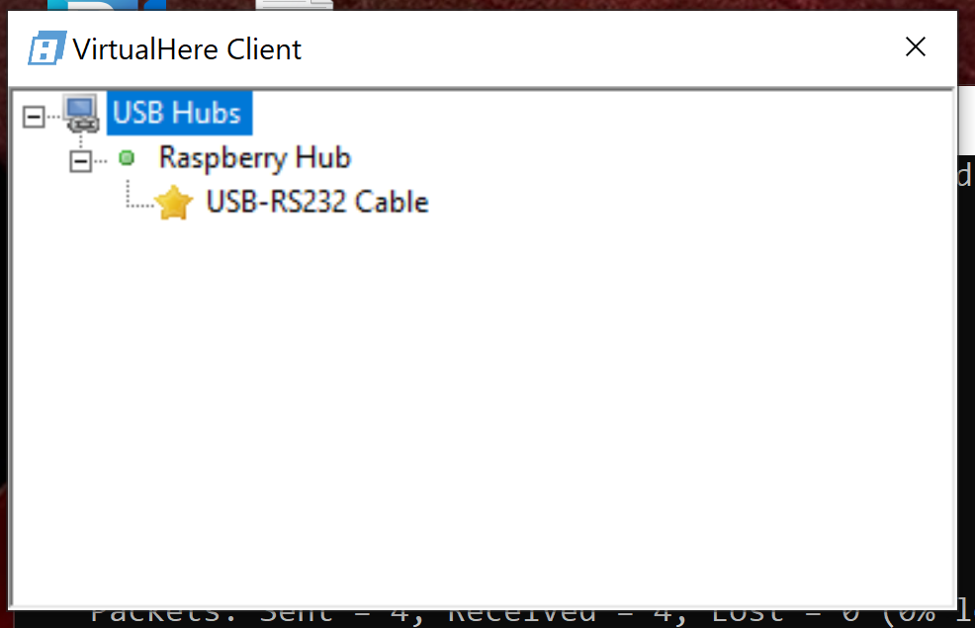
  - Right click on USB-RS232 and click on “Use This Device”
  - Now it should look like this: 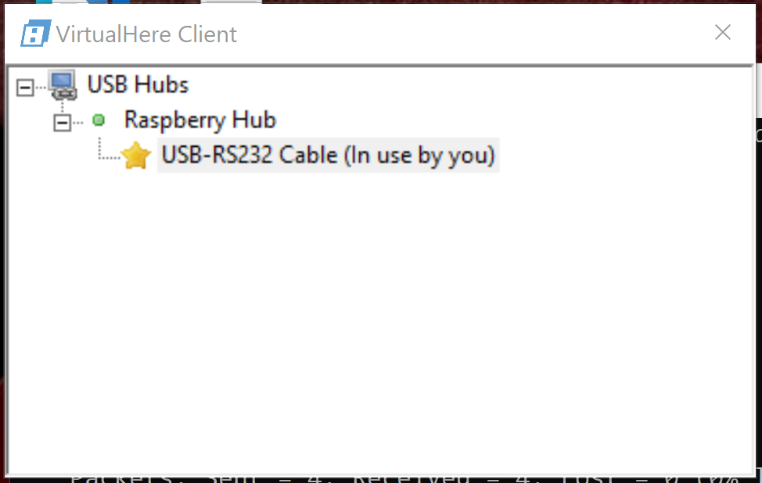

  - Next open up the terminal software like uCon to talk to the Snappy Camera controller. 9600, 8,N, 1. You can use the Portscan option in uCon or Device Manager to determine the com port added via Virtual Here. It will be the only one listed as “COMX” usually X=3. 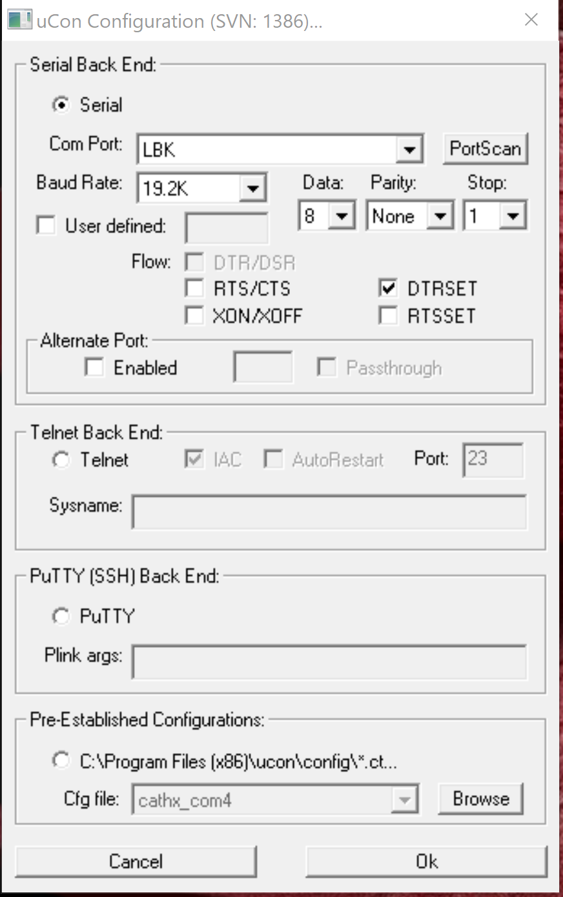
  - Turn on time-stamping and logging in ucon
      - In the Config menu select “Timestamp”
      - Select “Enabled” and “Stamp at toggle” and “Local only”
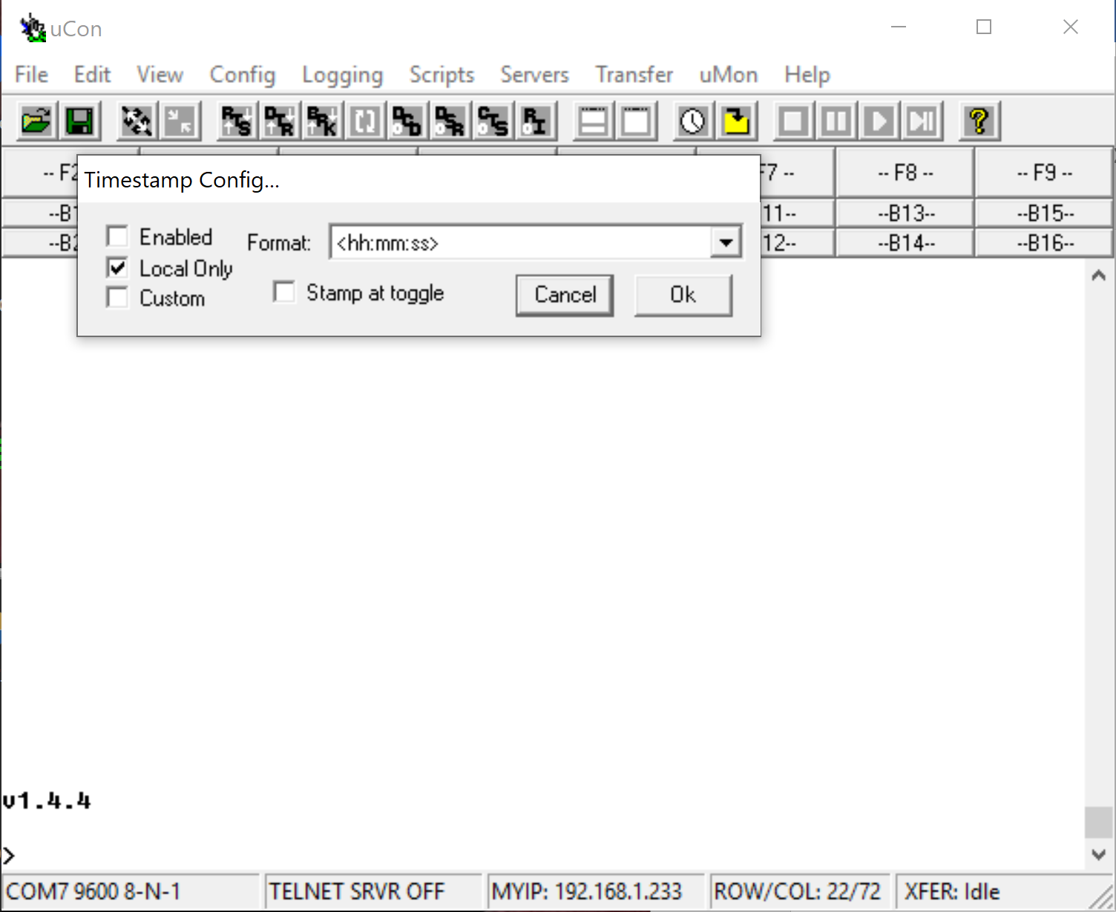

      - Press OK and continue to setting up logging
      - Under the “Logging” menu select “Standard” then you will see this window:
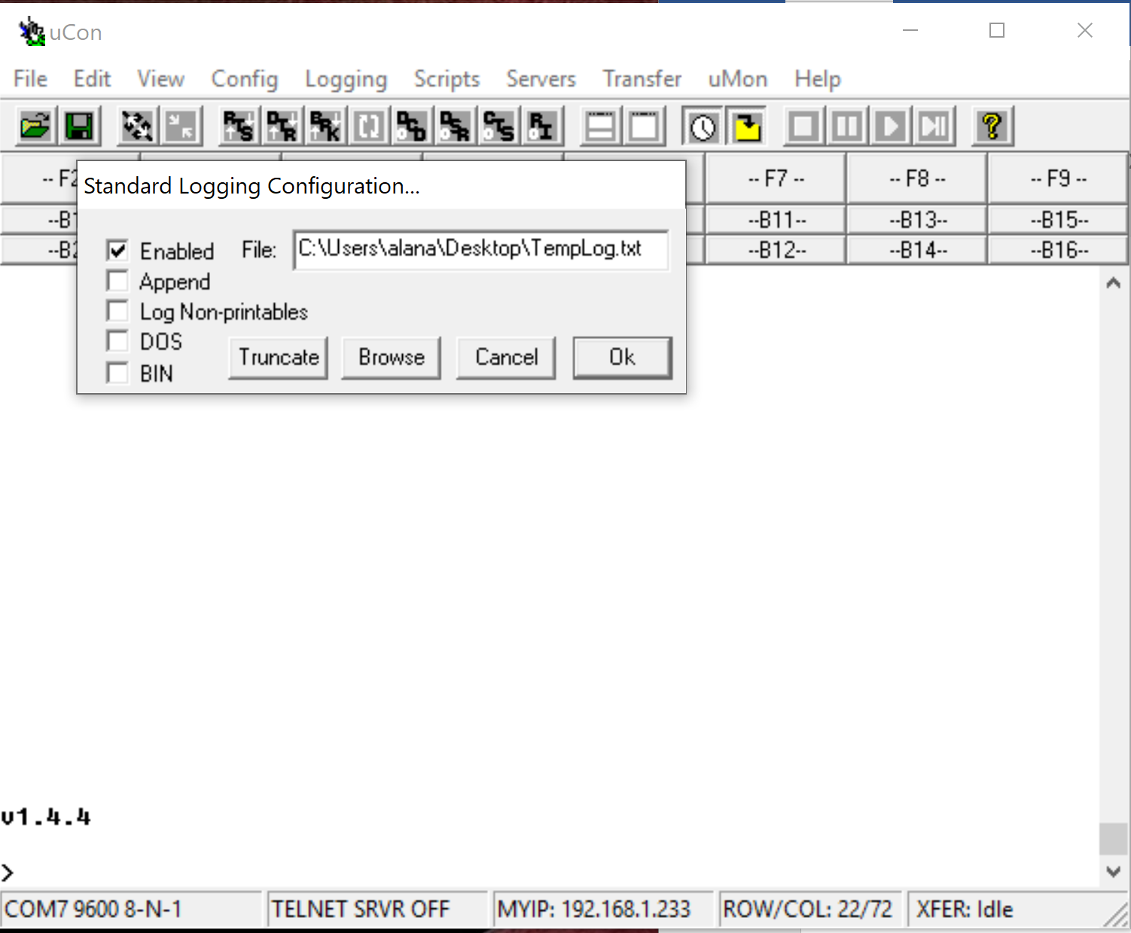
      - Select “Enabled” and then using the “Browse button” you can name and save the file in a place you won’t forget. Press Ok when finished.

  - Once uCon is open, press enter and you should see the software version on the Snappy Controller. As of Sept 20, 2021 the version is 1.4.9.
  - There is no menu option for Snappy so use the command set at the end of this document.
  - Test all functionality once you have connected to the camera in situ:
    - Test strobes
      - Type “26” to turn on charging to the strobes. Note if the battery plugged in you won’t see a change in the power supply, if not it should increase by up to 200 mA during charging – which happens over a few seconds.
      - Type “22” to see voltage on strobe, see if it is charged now ~35 V
      - Type “30” to trigger the strobes, type another “22” right after to see voltage is significantly less. These strobes charge really fast (in a few seconds) so if you wait to press “22” they will recharge before you read the voltage.
      - Type “27” to turn power to the strobes off. They will slowly discharge.type “22” to make sure the voltage is dropping.
    - Test the camera
      - Unlike other time-lapse camera systems this alone does not connect the Camera via the USB. There is a board with latching relays that has to be turned on. To do this you need to open CMD window. NOTE: the camera will put itself to sleep after a short period of time, so starting at step 6 this becomes time sensitive.
      - SSH into the raspberry pi by ssh pi@192.168.1.33
      - The password is disco123
      - Once you have a promt type USBOff (THIS IS CASE SENSITIVE see image below)
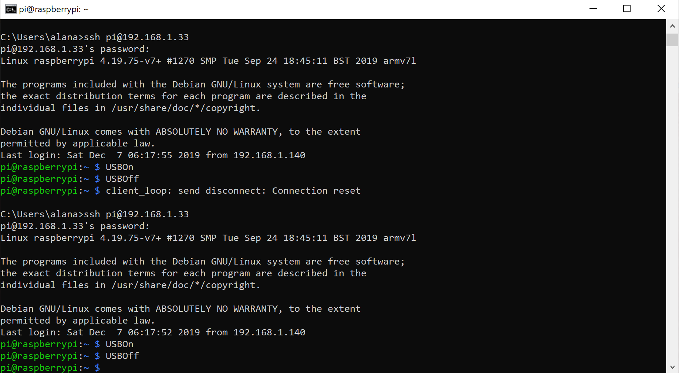

      - Return to ucon to turn camera on.
Pause before the next two steps. The next two steps are time sensitive. After you turn the camera on (step 7) you must turn the USB port on (step 8) within 30 seconds.

      - In the ucon terminal Type “19” plus enter to turn the camera on
      - Return to command window and enter USBOn (CASE MATTERS)
      - the camera is on it should appear in the VirtualHere window: 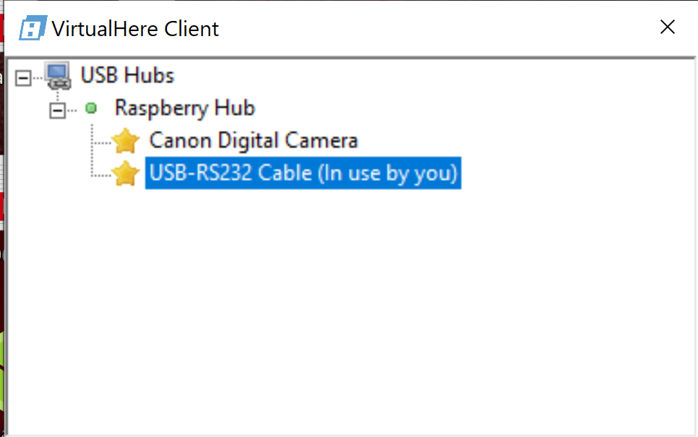
      - IF the camera does not appear in VirtualHere within about 10 sec (should be less) then you need to turn the camera off in ucon “20” then go in the cmd window and enter USBOff then WAIT FULL ONE MINUTE repeat from step 7)
      - Double click on the camera in Virtual Here and then the Canon software should automatically open to the main window: (the software can also be opened from the program menu (EOS Utility under Canon)

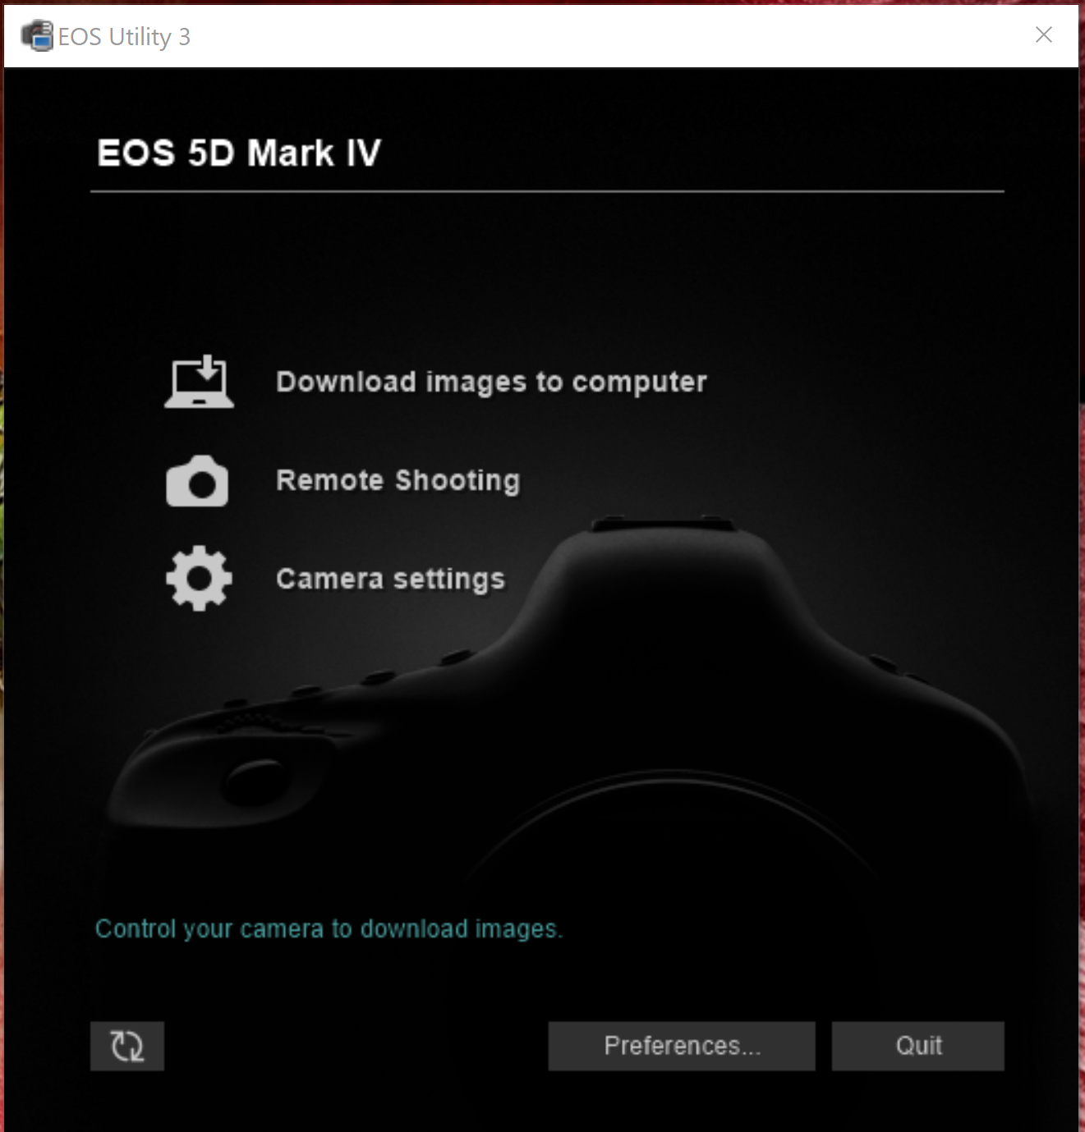

      - Click on remote shooting
      - The remote shooting window looks like this:
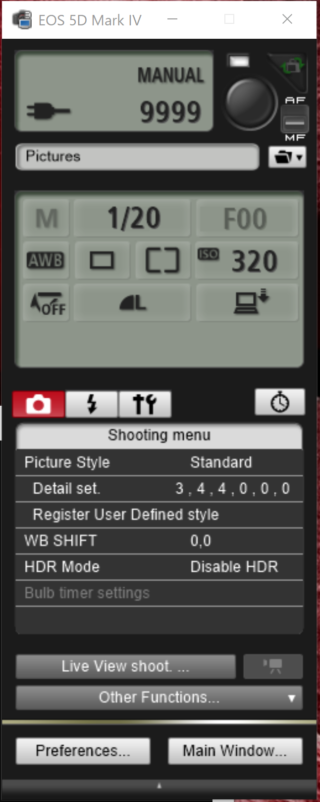
If you lose the preview window you can find it here. Use mouse click to zoom in preview window.

Now you can control the shutter both with the button on the upper right and using the commands to snappy listed below

      - Use the shutter button to take image and just turn the strobes on “26” REMEMBER TO TURN STROBES OFF WHEN DONE “27”
      - The button in the upper right hand corner takes a picture, which will be automatically uploaded. Take a picture to try out.
      - Test the live view feature as well. In LiveView select Depth of Field “On” for better video.
      - Use EOS utility to set the camera settings, some previous settings with the sony camera were (as of June 2023):
        - ISO= 1250
        - Shutter = 1/25
        - F = 22
        - Image quality = RAW
      - Once this is tested, practice taking images in the mode of an ROV dive which is to charge both strobes than use the trigger button on the EOS window to capture an image. Verify this triggers the strobes.
      - To look at images in detail also open Canon Digital Professional. It is a much better viewer than the Preview.
      - Once you have chosen your preferred settings you can close the EOS Utility window and then in the Virtual Here window right click on the camera and select “Stop Using this device”. The device will still appear in the window but will not say “(in use by you)” next to it
      - When you are happy with the images and the settings are complete you can close the Remote Utility window and then in the cmd window type in USBOff and hit enter. This should disconnect the camera from the raspberry pi. It should no longer appear in the Virtual Here window.
      - Once camera is set and tested wait one minute then type “20” to turn camera off
      - Double check the strobes are off by sending a “27”
      - Skip this step- Analog channel is not calibrated. Read battery voltage by typing in “14” and enter. The battery pack should start out around +30V
  - Starting the mission
    - Set Clk by typing “17”, this will lead you through setting the date and time. Use only 2 digits for the year.
    - Type “18”to read clock and confirm correct time.
    - Set delay: type “9” to set the delay. This is the time between sending the deploy command and starting the mission. Set it for 120 seconds to allow a shutdown to the raspberry pi and turn off the ROV cable. The Canon camera can still work even if the pi is fired up as long as the USB connection is turned off through the cmd window. Confirm delay by entering “10” to read the delay value
    - Set sleep: use command “7” to set the sleep. Sleep is the number of minutes between taking a picture. For June 23 set this to 14. Set this to 1 minute less than you want the elapsed time to be. Read that it is set correctly by typing 8
  - Start the mission type “3” to start the mission, once started Snappy will not respond to any more typed commands until delay is over.
  - In the command window type “sudo shutdown -h now” to shutdown pi nicely
  - Disconnect from the USB-RS232 ports in Virtual Here and have the pilots turn off the 120V to the Camera tripod DSC connection within that 2 minutes..
  - In about 2.5 or less minutes you should see the strobes flash which means the first image was successful
  - Have the pilots remove the DSC connector on the tripod frame
  - Have the pilots remove the magnet from the DSC housing
  - Take screen grab of ucon window with communications to snappy before closing then check your log file worked.
  - The end!

