ROVVR Real-Time Demonstration Concept

Requirements
- Must demonstrate ingestion and play of live video.
- Must be deployed at sea to evaluate possible side effects, such as nausea and sea-sickness.
- Must integrate with the ROV system in such a way as to demonstrate new control methods.
- Should demonstrate some possible real-time sensing application.

Concept Diagram
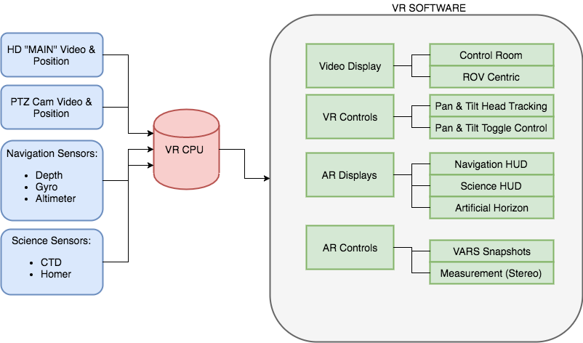

Phase 1
Core items in phase 1 (satisfying requirements) + PTZ Video & Position + Control PTZ + Video Display + All VR Controls.

Phase 2
All remaining items as prioritized by science.

