Technologies | LpR Article

A New Approach to the Design of Driverless AC LED Light Engines

Driverless AC LED light engines have now become a commonplace item of commerce in the lighting industry. Nearly all of them use high voltage integrated circuit switching chips to intelligently change the number of LEDs in a string during a power line cycle so that the voltage of the LED string matches the instantaneous power line voltage. However, customers are demanding higher efficiency, lower cost, and especially a reduction in the flicker content of the emitted light. Peter W. Shackle, president of the consulting company, Photalume, describes some new circuits for AC LED light engines [1] that provide a non-dimming solution with reduced cost, increased efficiency and better light quality as perceived by the human eye.
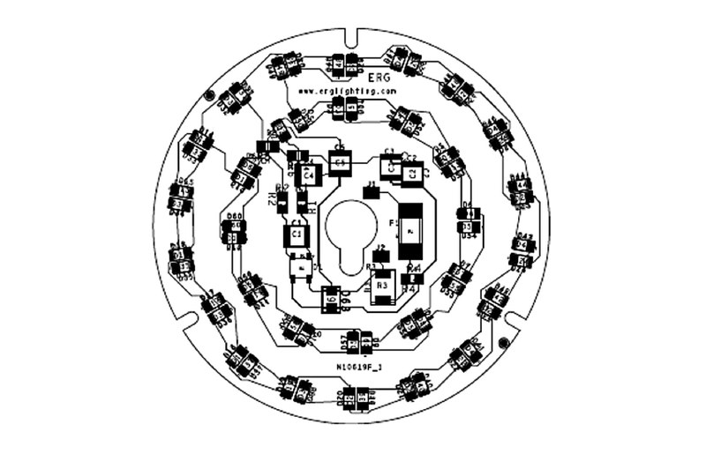
Example of a sub 5 W driverless LED light engine
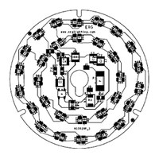
Example of a sub 5 W driverless LE…
Up until now, the principle practice for AC LED Light Engines was to use switches during the voltage variations of the power line voltage cycle to adjust the number of LEDs present to roughly equal the instantaneous power line voltage, and then use resistors and/or current limiters to keep the LED current at a desired level until the next switch operation. This principle has the disadvantage that some power is always being dissipated, limiting the efficiency to 75%- 80%, and inevitably the output current comes in the form of a series of half sinewaves. In particular with 50 Hz power, the presence of these half sinewave pulses of current at twice the power line frequency produces a flicker effect which some people can see out of the corner of their eye, and in the worst case may produce eye strain and headaches.
The alternative principle introduced here is to have the LED current limited by resistance for a part of the time, and limited by capacitance for the remainder.
Thus, in every power line half cycle there are two pulses of current through the LEDs, first a pulse of displacement current and then a pulse of galvanic current. In each complete power line cycle there are four peaks, so the resulting ripple can be mainly at four times the power line frequency. For power levels below 5 W, where the US Energy Star rules do not require a minimum power factor, it is possible to have continuous DC current with the entire ripple at four times the power line frequency. At higher power levels where a minimum power factor of 0.7 is required, the output LED current ripple has a superior flicker index compared to the conventional circuits, with 87% efficiency and without using any expensive high voltage integrated circuits.

Introduction to the Field of AC LED Light Engines IAC LED light engines are attractive because of their simplicity and relatively low cost for the luminaire designer. Today they are becoming ubiquitous in hallway lighting, decorative lighting, parking lots and an increasing host of other applications. As will be explained in detail below, most of these products are using high voltage integrated circuits which, for each part of the power line voltage cycle, automatically connect the correct number of LEDs to match the power line voltage. An electronic current limiter is used to maintain a constant current between switch operations. Commonly, three stages of switching are used, although two stage and four stage products exist. Since voltage is being dropped across the current limiter, power is being dissipated, which limits the efficiency attainable. Dimming can be achieved by varying the current level programmed for each stage of switching.

The design of AC LED light engines involves numerous compromises. For example, efficiency, power factor and light quality as measured by flicker index all trade off against each other, such that if one is optimized the others usually suffer. Including dimming capabilities requires additional compromises and usually increases cost and complexity. It has become conventional to adopt a set of trade-offs that accompany the use of a high voltage integrated circuit required to allow dimming. Typical of such a compromise in today’s marketplace would be a flicker index (see below) of 0.32, efficiency of 78% and power factor of 98%. This compromise, namely poor flicker index and average efficiency, is affected heavily by the inclusion of dimming, which is not needed for a large number of applications. Without the dimming requirement, the expensive high voltage chip can be eliminated, reducing cost, the flicker index can be reduced and the efficiency can be increased to over 90%. The power levels involved dictate the best way to accomplish this. Below 5 W of input power, Energy Star in the USA does not have a power factor requirement. In this case a solution is described which has superb light quality and over 90% efficiency. When the input power is over 5 W, the power factor for consumer products must be greater than 0.7. In this case a solution is described which also has greater than 90% efficiency and still has superior flicker performance compared to today’s conventional products.

Terminology Used in Characterizing AC LED Light Engines

In the discussion below we shall repeatedly use the terms “efficiency”, “power factor” and “flicker index”.
Efficiency = (power delivered to LEDs) / (Input power to the device)
expressed as a percentage.

Power factor = (input power) / (rms input voltage * rms input current)
This is customarily expressed as a fraction, although sometimes you may see it as a percentage. A perfectly sinusoidal power line voltage driving a resistor will have a power factor of 1.0. A perfect capacitor or inductor connected across the power line, drawing no power, would have a power factor of zero. If the power factor of a device is low, it means that the power being drawn is not commensurate with the current being drawn, because the current is out of phase with the voltage. Energy Star rules in the USA have no power factor requirement for input power below 5 W, and above 5 W the minimum that will be approved is 0.70 for residential/ consumer applications.
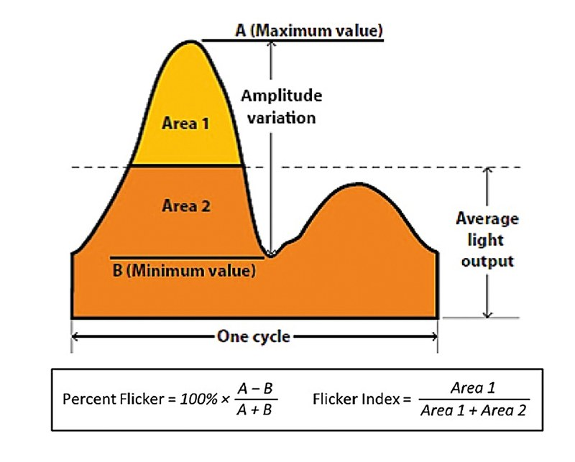
Figure 1: Definition of flicker index (modified from the IESNA handbook, 2010)
Flicker index is defined in figure 1. At low power levels the light output from LEDs is directly proportional to the LED current. A square wave light output with 50% duty cycle will have a flicker index of 0.5, whereas an LED light running off DC will have a flicker index of zero. For reference, an incandescent light bulb typically has a flicker index of 0.15. The flicker index does not have any frequency dependency, whereas the human eye has sensitivity which declines with increasing frequency. For this reason there is need for a new, frequency dependent measure of flicker, but currently none exists. For the time being the flicker index is widely used as a point of reference.

The History of AC LED Light Engines
The earliest circuit used for AC LED light engines is shown in figure 2.
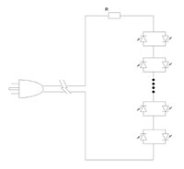
Figure 2: The earliest AC LED circuit
In this circuit the LEDs are arranged in antiparallel to each other. A sufficient number of these antiparallel mounted pairs are connected in series so that their forward voltage is comparable to the peak of the power line voltage. At the peak of the power line voltage waveform current passes through the LEDs and is limited by the resistor R. Such circuits can have high power factor because the current passes in phase with the power line voltage, and if R is relatively small then the efficiency can be as high as 95%. However the flicker index is typically up around 0.45, because most of the time no light is produced and then a brilliant flash is released at each power line voltage peak. This kind of circuit is widely used for Christmas tree lights. A disadvantage of this circuit for general lighting is that a lot of LEDs are being used, and at any one time, half of them are dark. These circuits were replaced in general lighting by the circuit
shown in figure 3.
In this second generation circuit, a bridge rectifier is used to halve the number of LEDs needed. As before, a resistor is used to limit the current at the peak of the line. The efficiency, power factor and flicker index are essentially unchanged. In this and all the AC LED circuits described in this article, it is necessary to have surge protection circuitry of some kind present to protect the LED circuit from power line surges which may arise from power line switching, lightning induced surges, etc.
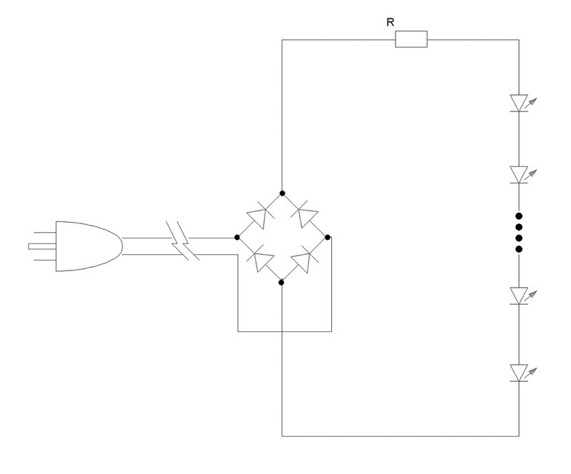
Figure 3:
The second generation of AC LED circuits

