Shedding light on video measurements of ocean animals

We humans tend to think of the ocean as a blue, shadowy world. The animals and plants that live there, however, are bathed in light coming from all directions, in a way we land-dwellers have never experienced. Animals use light, either that found in the environment or that they create themselves, to hunt, confuse and startle, hide, communicate, find conspecifics, and more. Light frames life in the sea. Animals in the ocean possess specially adapted visual systems and accompanying behaviors that are tuned to respond to changes in the light field. Unfortunately, to observe these animals using visual techniques, we must often rely on artificial illumination, dramatically disrupting important environmental cues. Not surprisingly, this affects our view of life in the ocean as many animals avoid the light (and thus our imaging systems) while still others are attracted to the light. Our ability to understand the ecosystem using cameras is affected by both our disruption of the habitat and our ability to understand the responses of the animals to our measurement attempts.

Our goal is to understand the effects of different wavelengths and intensities of light on animal responses to platforms in order to 1) facilitate the design of less invasive imaging systems applicable to the animals in Monterey Bay and 2) understand the effects of our video observations on the measurements of animal presence and abundance. To achieve these objectives requires that we experimentally examine the responses of animals to artificial lighting of various colors and intensities under a range of conditions. Preliminary experiments have suggested that avoidance of light by anchovies is reduced with red light relative to white, increased with blue light, and reversed to attraction with green. We propose to develop a drop camera video system with lights that can be remotely modulated to change their color and intensity. We envision that this camera would be deployable from small boats (e.g., Paragon) to facilitate experimentation of a wide range of animals and behavior at modest cost, however, results could quickly be applied to data and deployment strategies of other video platforms and, based on those results, light/camera designs adapted for use on other systems. In the experiments, observations of the camera’s descent will be made remotely using echosounders to assess changes in the distribution of animals around the camera system both before and after the lights are illuminated at varying levels and wavelengths (e.g., Benoit-Bird et al., 2012).

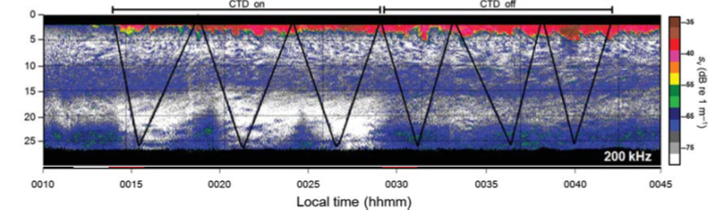

Similar to the approach proposed here, avoidance of an open-path fluorometer on a CTD profiler were demonstrated experimentally by observing the distribution and abundance of acoustic scatterers throughout the descent of the profiling package both with (left 3 profiles) and without (right 3 profiles) the emission of light (Benoit-Bird et al., 2012). Copepods in Monterey Bay were found to strongly avoid the blue light emitted by the fluorometer at distances of 10-15 m, resulting in up to 15-fold decreases in zooplankton abundance measured from point sensors on the profiler relative to those measured in the absence of the light.

MBARI has a long and storied history of using video to describe the distribution and behavior of animals in the ocean from ROVs and, increasingly, from autonomous platforms. Building on this experience, nearly every idea pitched at the recent ideation workshop relied on visual imaging, with the underlying assumption that if animals were present, they would be imaged. While it has long been inferred that avoidance and attraction are occurring, we are just beginning to quantify these behavioral responses to light in Monterey Bay. This work expands on those efforts while providing new opportunities to experimentally manipulate the light used for imaging. This work will establish the understanding necessary to develop more effective, less invasive imaging systems to facilitate new science in a range of platforms.

