Multi-Spectral SmartCam Concept

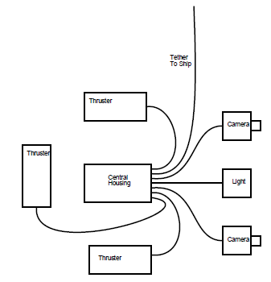

Cameras
Stereo pair
Resolution: 1080 @ 60p ?
Live video topside
Recording of video topside
Real time control of the cameras (settings: iso, shutter speed, zoom, focus, etc... )
In separate housings for deployment specific orientations ?

Light
Multi-spectral LED capability
Real time control of the LED (color and brightness)
In separate housing

System Physical Properties
Housings mounted in an open frame (80/20 material ?)
Ability to rotate the system underwater (two horizontal thrusters ?)
Ability to raise/lower the system underwater (one vertical thruster ?)
300 meter depth rating
Small vessel compatible (R/V Paragon or similar)
Physical size small enough for one person to launch/recover
Midwater operation
Tethered system (better if it's load bearing)

System Parameters (TBD)
Camera(s) field of view
Intended target(s)
Target imaging distance (from camera sensor)
Light launch angle (and camera FOV overlap)

Power and Comms
Fiber optics used for comms
AC or DC power ?
Electrical power : Light + Thruster (x3) will be bulk of power usage
Where to locate OE converters (central housing or in each camera housing ?)
Types of underwater connectors ?

Other Instrumentation
Depth sensor ?
Compass ?
Temperature ?

