Project Number: | 902000

Project Start: Jan. 1, | 2020 | Project Duration (in years): | Year 1 of 3 ¹

Please indicate if proposal includes requests for any of the following (mark all that apply).

 | X
Ship Time |  |  | ROV |  |  | AUV |  |  | Wave Glider |  |  | Mini ROV

Please indicate what type of project is being proposed (mark only one).

 |  |  |  | X
Feasibility/Scoping  [Less than 100 days effort] |  |  | Development |  |  | Research |  |  | Infrastructure² |  |  | Education |  |  | Time Series |  |  | Institute Initiative

Project Manager: Chad Kecy
Principal Investigator: Kakani Katija
Lead Scientist: Kelly Benoit-Bird
Lead Engineer: Chad Kecy

Project Title: Multi-Spectral StealthCam

Please indicate which category best describes the project theme (mark only one).

 |  |  |  |  |  |  | X
Ocean  biogeochemistry |  |  | Ecosystem dynamics |  |  | Ocean visualization |  |  | Exploration & discovery

Please indicate percentage of effort on this project anticipated for 2020 toward these three highest institutional goals (percentage total should equal 100%).

Goal | Developing/adapting innovative technologies | Utilizing developments to explore and understand ocean systems | Technology/knowledge transfer
Percentage | 70 | 20 | 10

- ABSTRACT (new projects only)

Project Description: Our goal is to understand the effects of different wavelengths and intensities of light on animal responses to platforms in order to 1) facilitate the design of less invasive imaging systems applicable to the animals in Monterey Bay and 2) understand the effects of our video observations on the measurements of animal presence and abundance. To achieve these objectives requires that we experimentally examine the responses of animals to artificial lighting of various colors and intensities under a range of conditions. Preliminary experiments have suggested that avoidance of light by anchovies is reduced with red light relative to white, increased with blue light, and reversed to attraction with green. Whether these behavioral responses are consistent across a range of organisms, and how environmental conditions serve to mediate this behavior, is largely unknown. To address this need, we propose to develop a StealthCam video system with lights that can be remotely modulated to change their color and intensity. We envision that this camera system would be deployable from small boats (e.g., R/V Paragon), and when coupled with boat-mounted echosounder measurements, will facilitate experimentation of a wide range of animals and behavior at modest cost. Results from these experiments could quickly be applied to data and deployment strategies of other video platforms and light/camera designs adapted for use on other optical systems.

In addition to the project description above, please provide one (1) paragraph addressing each of the following topics:

Fundamental Problem (What’s the grand challenge this work addresses? Why should we care? What makes this work relevant to MBARI?)

We humans tend to think of the ocean as a blue, shadowy world. The animals and plants that live there, however, are bathed in light coming from all directions, in a way we land-dwellers have never experienced. Animals use light, either that found in the environment or that they create themselves, to hunt, confuse and startle, hide, communicate, find conspecifics, and more. Light, no matter the color and intensity, frames life in the sea. Animals in the ocean possess specially adapted visual systems and accompanying behaviors that are tuned to respond to changes in the light field. Unfortunately, to observe these animals using visual techniques, we must often rely on artificial illumination, dramatically disrupting important environmental cues. Not surprisingly, this affects our view of life in the ocean as many animals avoid the light (and thus our imaging systems), while still others are attracted to the light. Our ability to understand the ecosystem using cameras is affected by both our disruption of the habitat and our ability to understand the responses of the animals to our measurement attempts. By developing StealthCam, and coupling these optical observations with bioacoustics measurements, we can not only understand how organismal behaviors are mediated by differing lighting conditions, we can also inform the design of future, truly non-invasive, underwater imaging systems.

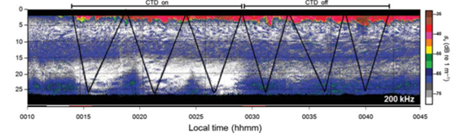
Figure 1. Similar to the approach proposed here, avoidance of an open-path fluorometer on a CTD profiler were demonstrated experimentally by observing the distribution and abundance of acoustic scatterers throughout the descent of the profiling package both with (left 3 profiles) and without (right 3 profiles) the emission of light (Benoit-Bird et al., 2012). Measurements from the shipboard echosounders showed that copepods in Monterey Bay were found to strongly avoid the blue light emitted by the fluorometer at distances of 10-15 m, resulting in up to 15-fold decreases in zooplankton abundance measured relative to those measured in the absence of the light.

Technology [What engineering & technology is needed to move forward (e.g., sensor, platform, ship, de novo R&D)?]

The core of the StealthCam will consist of a pair of monochromatic stereo cameras and a wavelength-tunable LED housing. The multi-spectral LED will be controllable in real time from the ship as well. The StealthCam is intended to be deployed from smaller vessels such as the R/V Paragon. Portability and size will be important design factors as deployments will need to be performed by only one or two science crew.

Data (What data will be generated? How will they be managed? Visualization and IP considerations?)

The primary product of the StealthCam will be high-definition video. Video will be compatible with existing MBARI/VARS formats. Given that deployments within the scope of this proposal will initially be conducted to test the StealthCam rather than conduct science, we anticipate the amount of video collected will be modest.

Impact (What is the expected impact? Who are the consumers of the instruments, methods, technology, and data that will be generated within and beyond MBARI? Will the project create tangible connections with other organizations (e.g., academic, NGO, MBA, MBNMS, state or federal agency)?

MBARI has a long and storied history of using video to describe the distribution and behavior of animals in the ocean from ROVs and, increasingly, from autonomous platforms. Building on this experience, nearly every idea pitched at last year’s ideation workshop relied on visual imaging, with the underlying assumption that if animals were present, they would be imaged. While it has long been inferred that avoidance and attraction are occurring, we are just beginning to quantify these behavioral responses to light in the ocean. This work expands on those efforts while providing new opportunities to experimentally manipulate the lighting used for imaging, and coupling these observations with bioacoustics. This work will establish the understanding necessary to develop more effective, less invasive imaging systems to facilitate new science on a range of platforms. As a result, this work will be relevant to video/image sampling by a range of camera systems on all observation platforms, thereby informing sampling design and data interpretation for imaging studies of mobile animals. The Acoustical Ocean Ecology and Bioinspiration Labs will lead the field efforts and will publish the results to make our findings broadly available to the oceanographic community to facilitate the design of imaging systems and field sampling approaches.

Please provide an overall, high-level estimate of resources envisioned for this project in 2020 to help give a sense of the size of the proposed effort. Detailed scoping is not needed at this stage. Simply mark the appropriate box below.

Budget Category | Minimal | Medium | Significant
Labor | X
Expense | X
Ship/Assets | X

If you anticipate a large ramp-up or increase in resource requests in future years of the project, please include that information below.

- PROPOSAL

  - All Projects

Statement of the challenge, why it is important

Most current imaging systems, both at MBARI and at other institutions, rely on high intensity white-colored LEDs for illumination. While these bright lights help improve the image quality of the recorded video, they may also be directly affecting the intended biological targets. We propose to develop an imaging system that utilizes a light module which is tunable in both wavelength (color) and intensity (brightness). The simultaneously recorded video and echo-sounder measurements will both help understand the behavior of the target species being illuminated as well as aid with the design of future imaging systems.

Relevance
How does it relate/contribute to MBARI’s mission and strategic plan?

Objective 1: Foster technological innovation
Strategy 1.3: Support feasibility studies by providing access to resources for scoping new ideas or directions, particularly for potentially transformational or disruptive technologies.

Does it relate to the Technology Roadmap? If so, please describe how. (See http://mww.mbari.org/oed/TechnologyRoadmap.pdf.)

Ocean visualization
Exploration and discovery

This research is aimed at understanding ecosystem processes, specifically aligning with the Technology Roadmap goal of enhancing “understanding of the fluctuations and fate of forage species”. The Multi-Spectral StealthCam allows new ways to visualize life in the ocean, fitting the Technology Roadmap focus to “relate water-column conditions and variability of the abundance, distribution, and activity of biota.”

How does it relate/contribute to the Packard Foundation’s Ocean Grantmaking Program? (See https://www.packard.org/what-we-fund/ocean/ and documents therein.)

The Packard Foundation seeks to help the United States and other countries ensure that fishing and marine aquaculture are sustainable and to protect places that are vital to maintaining biodiversity and wild fish stocks. A key part of the US stock assessments strategy is accurately identifying acoustic targets to estimate allowable takes. This work seeks to develop a new, in situ approach to taxa identification in conjunction with acoustic sampling at a relatively low cost that can contribute to addressing this key data need.

Overall approach to the challenge: Over the complete term of the project, what is needed to address the challenge (e.g., sensors, platforms, marine operations, de novo R & D, etc.)
Research

Year one efforts in 2020 are primarily aimed at development and testing. The Acoustical Ocean Ecology and Bioinspiration research teams will contribute to those efforts, leveraging their experience with deployment of instruments from small boats including the Paragon, instrumentation available in their respective labs, and experience with taxonomic identification from video. Rapid analysis of video data collected during test missions will be critical to finalization of the StealthCam system and deployment set up. We hope to leverage efforts in Big Ocean, Big Data (902002 FathomNet) to aid in the video data analysis process.

Engineering/Technology Development
We do not expect any major technical hurdles with the StealthCam project. With the exception of the custom tunable LED module, the rest of the system will be comprised of off-the-shelf components. The planned ship-to-subsea power and communications methods have been tested and deployed on BOSS. The work on the custom LED module has already begun in 2019 and we anticipate a prototype to be completed by the fourth quarter of 2019.

The StealthCam will be a portable system that can be deployed and operated by one or two researchers. Therefore, throughout the design process, all stages of deployment (e.g., mobilization, launch & recovery, and de-mobilization) will affect design decisions.

Marine Operations/Field Programs

The team intends to utilize the R/V Paragon for initial testing in year one and for field deployments in year two. Jared Figurski will be the boat operator for the entirety of the project. We don’t anticipate deploying the StealthCam in 2020, but hope to begin shipboard integration by the end of the year. Operations on the Paragon will begin in 2021.

Data
What data products will be generated?

The generated data will be video clips with simultaneous acoustic data. The duration of the files will range from minutes to tens of minutes at a time.

How will the data products be managed?
Raw acoustic and video data will be archived on Atlas, following existing protocols for acoustic and other large data sets. Data products include images of acoustic amplitude as a function of location – echograms and time series of behavioral observations. StealthCam video will be integrated with the VARS database. We hope to utilize developments in 902002 FathomNet for rapid identification of animals in DropCam video data.
Describe data availability outside of the project team.

Raw data will be available to internal users via Atlas and external users on request after the standard embargo period.

Describe data storage requirements.

Based on projected recording rates, we should generate ~7.2GB of video data per hour. A typical deployment day should generate no more than 4 hours of video (~30GB). Our topside recorder will be utilizing solid state drives ranging in capacity from 2TB to 8TB. Acoustic data is collected at a rate of 25 GB per hour. In 2020, we anticipate less than 1 terabyte of total data will be generated.

Anticipated Impact

Who are the consumers of the instruments, methods, systems, and data that will be generated?

The ultimate goal is to facilitate the future design of imaging systems, both at MBARI and externally. The Acoustical Ocean Ecology and Bioinspiration Labs will lead the effort in publishing the experimental results and disseminating the information to the greater oceanographic community. Potential projects that will benefit from our findings and spectral results include the 800139 EyeRIS, i2MAP, Mesobot, as well as the three ROVS: Doc Ricketts, Ventana, and MiniROV.

  - Continuing Projects

If the proposed project includes multiple individual projects, please list each of these projects as a subheading in the proposal. For each subheading, please address the following:

Current status of project and results to date

[Click here to enter text]

What percentage of labor and budget have been used through the 1st half of year?

[Click here to enter text]

Will you complete the current year’s scheduled work?

[Click here to enter text]

If you are at less than 50% resource usage, what is the plan to complete, or what work won’t be done this year?

[Click here to enter text]

Significant changes from previous project proposal

[Click here to enter text]

Over the past two years, what peer-reviewed publications, education and/or outreach activities have resulted directly from this project? Please be brief.

[Click here to enter text]

  - All Projects: Specific Plans for 2020

Research Activities

As 2020 will be focused on the development of the StealthCam, we do not anticipate any significant research occurring. The field deployments will begin in year two.

Engineering/technology development

Overview
The StealthCam will be a tethered video imaging system with modular interconnected subsea housings: the camera modules, the tunable LED module, and a control electronics housing. Live video and real-time control of the system will be available onboard the ship. Video will be recorded topside. The LED module will be able to emit light at a wavelength range from 350nm to 850nm (UV to near-IR). A ship-mounted, downward-looking echosounder will provide simultaneous acoustic data. The separate StealthCam system housings allow the science user to configure the physical orientation of the camera and lights to meet the imaging needs of the particular scenario. The system will operate down to 300 meters and will be deployed by a winch with an electro-optical slip ring.

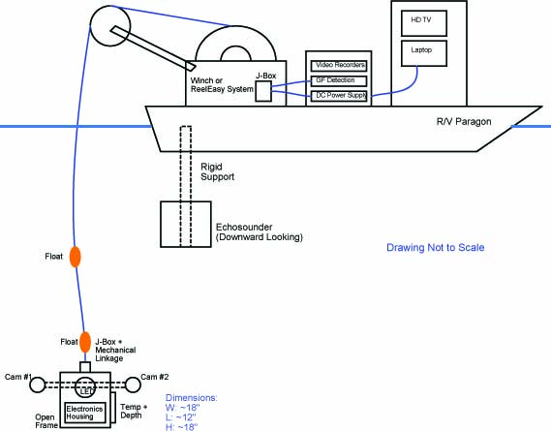
Figure 2: A conceptual drawing of the StealthCam being deployed from the R/V Paragon. The Stealthcam will be launched into the echosounder’s field of view.

Subsea hardware
The subsea frame will consist of a pair of stereo cameras, the tunable light source, a control electronics housing, a temperature and depth sensor, and an interface junction box. The frame will be constructed from 80/20 or similar material, mimicking the capabilities and form factor of the MiniROV’s SmartClump. This will allow for easy physical re-configuration of the components based on scientific goals. The tether will consist of multiple copper wires and a pair of single mode optical fibers. The electronics housing will produce low DC voltages for the various devices as well as perform optical-to-electrical conversion for the video and telemetry data. The stereo cameras will be controllable in real-time, and will transmit the live video to the ship where it will be recorded topside. The LED will also be tunable in real-time from the ship. The live video from the cameras will give the science user immediate biological responses based on the wavelength and intensity chosen. An RBR temperature and depth sensor will provide basic contextual data alongside the recorded video. The mechanical support of the frame will be with the use of a load bearing mechanical fitting. Football floats may be used to prevent interference from the tether.
The LED is a custom built MBARI module. A prototype LED board has already been fabricated and it is anticipated that by the end of 2019 we’ll have a working deployable tunable LED module.

A pair of the machine vision Manta series cameras from Allied Vision will provide the stereo imagery. We hope to leverage the same hardware and electrical architecture as the Mesobot project.

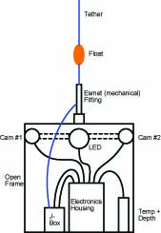
Figure 3: A conceptual block diagram of the StealthCam. The mechanical linkage as well as the power and communications to the electronics will be identical to those on the BOSS experiment.

Shipboard Control
The topside electronics will provide power and communications to the subsea unit. A high voltage DC power supply will provide 400Vdc to the subsea unit with a previously designed and deployed ground fault detection module (utilized on the Kelp Forest Array and FOCE experiments). An optical-to-electrical conversion module will provide Ethernet communication to the subsea unit. A pair of deck recorders will capture the stereo video. We plan to use a laptop with a LabView GUI to control the StealthCam. A high definition monitor will display the real time video.

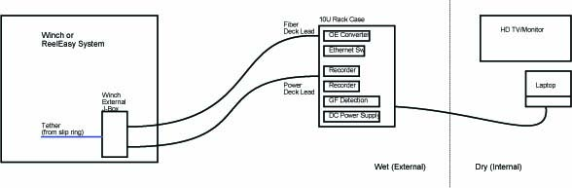
Figure 4: A conceptual drawing of the topside components. A single waterproof case will help to maximize the limited deck space of the Paragon as well as limit cabling clutter.

Shipboard Launch and Recovery

For launch and recovery of the StealthCam, we have identified three possible options: a simple line hauler and storage tote, Reel-Easy system, or modification of the Paragon’s existing winch. Each of the three options will be discussed below. In all three cases, a custom tether will need to be ordered, and a custom slip ring will be needed for options two and three.

Option One: Line Hauler and Tether Storage
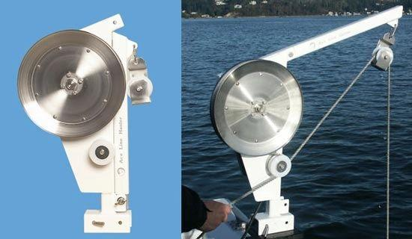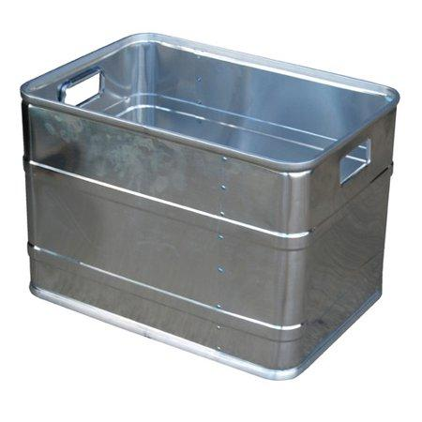
Figure 5: Line hauler and storage tote. The line hauler would have to be chosen with an appropriate pulleys in order to accommodate the minimum bend radius of the fiber based tether.

This option is the simplest and cheapest, but is also the most labor intensive. A motorized (or manual) line hauler can be used to launch and recover the StealthCam. The tether would be stored in a rectangular or circular storage tote. An upside to this method is that a slip ring will not be needed. However, it is very labor intensive and not convenient for multiple drops in a single day.

Option Two: Easy-Reel “Jumbo” Reeling System
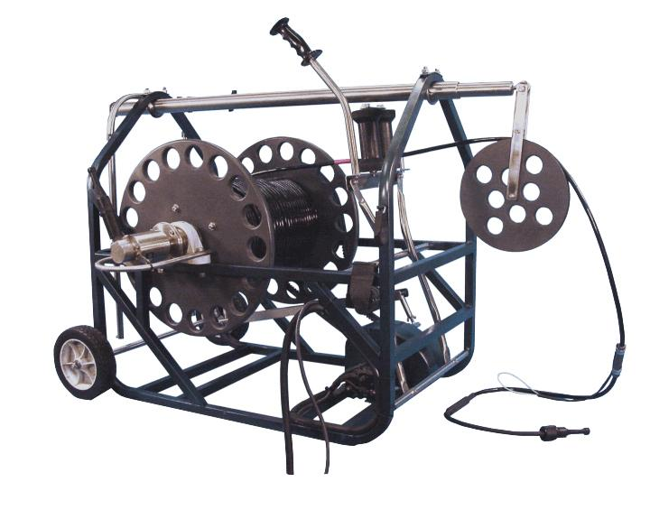
Figure 6: The ReelEasy reel system is essentially a self-contained portable winch. The Jumbo version can hold up to 500 meters of half inch diameter cable.

The Reel-Easy models are self-contained reeling systems which are designed for use with small to medium sized towfish systems. These can be modified by the manufacturer to accommodate user supplied slip rings and tethers. The motorized drum can lift up to 500 pounds. With this option, both a slip ring and tether will need to be purchased. The dimensions of the Jumbo unit are approximately 3 feet (L) x 2 feet (W) x 3 feet (H) and weighs around 110 pounds.

Option Three: Modification of the Paragon’s Winch

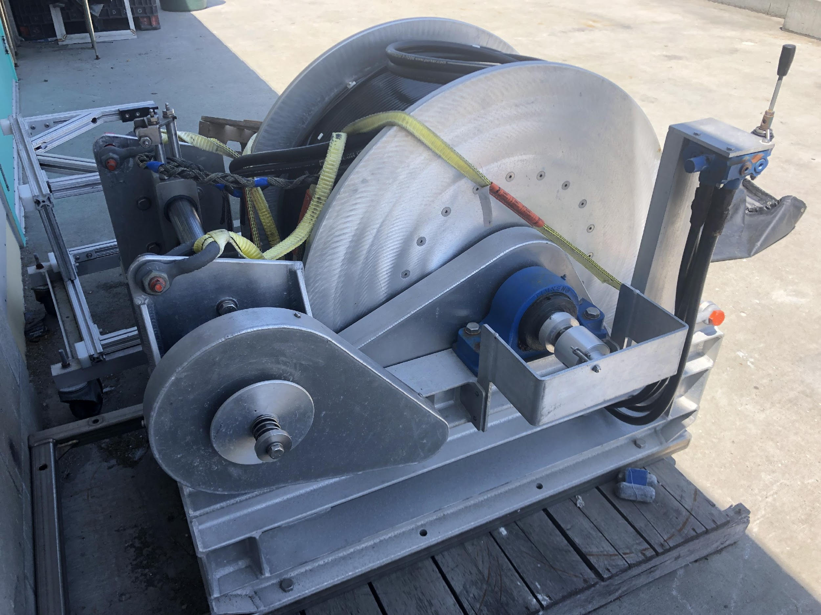
Figure 7: The R/V Paragon’s CTD winch.

The Paragon has a dedicated CTD winch that is infrequently used. With this option, we would order a tether and slip ring combination that is not only appropriate for our project but will also be usable for CTD casts as well as any future Paragon-based experiments. This winch has a detachable sheave (not shown in picture above) and has been field tested as is on the Paragon previously. The winch specifications meet or (in most cases) exceed our requirements. One potential issue with using the winch with this system is the noise generated by the Paragon’s hydraulic system, both acoustical and electrical. We have not yet quantified the effect of this noise on the Acoustic Ocean Ecology Lab’s echosounder.

Field programs (detail ship requirements/deployments/diver requirements)
In addition to describing anticipated field programs, please be sure to include requirements for specific platforms and equipment (Dorado AUVs, LRAUVs, Wave Glider, mini ROV, etc.) for each proposed field program so that expectations are clear. Requests must also be entered in the budget entry system.

We plan to use the R/V Paragon for all testing and deployments. The first tests on the Paragon will commence during the first quarter of 2021. Jared Figurski is a StealthCam team member so we will coordinate with him when we get close to the testing stage.

Isotope Usage
Project teams must provide details regarding any planned isotope use on shore, on ships, in the Sanctuary, etc. Please review the guidance on isotope usage at http://www.mbari.org/at-sea/cruise-planning/hazardous-materials/ and policy at http://mww.mbari.org/safety/SafetyManual/Isotope_Use_Policy.pdf, and then provide details on plans below.

[Click here to enter text]

Safety Disposal Needs
So the Safety office can plan and budget accordingly, please respond to the questions below regarding any anticipated safety disposal needs for the coming year. Budget for cost of such removal will be captured by the safety office based on responses received.

Will this project generate more than 1 gallon (4 liters) of battery waste per year?

No

If yes, please indicate the type of batteries (alkaline, NiCad, NiMH, lithium ion or lithium metal) and the approximate amount of each to be generated.

N/A

Will this project generate more than 15 gallons (60 liters) of hazardous liquid waste per year?

No

If yes, please indicate the composition of the waste(s) and the quantity of each to be generated.

N/A

Specific deliverables
Our deliverable for year one will be a complete and tested StealthCam system. Our deliverable for year three will be a comprehensive table detailing organismal response versus wavelength. Depending on the performance of the LED module, we may modify the design during year two.

Milestones and required personnel (see personnel classification list for staff classifications)

M1: Design, build, and test the subsea electronics
M2: Launch & Recovery System
M3: Design, build, and test the topside electronics
M4: System level integration & testing
M5: Test tank testing

2020 Project Start Date:  01/01/2020 | Milestone 1 | Milestone 2 | Milestone 3 | Milestone 4 | Milestone 5 | Total Resources (in hours) for each resource category for all milestones listed here
Milestone Date | Q3 | Q2 | Q3 | Q4 | Q4
Milestone Description | Subsea  Electronics | Launch &  Recovery  System | Topside  Electronics | System Level  Integration | Test Tank
Electrical Engineer | CK: 160 | CK: 120 | CK: 160 | CK: 80 | CK: 40 | CK: 560
Software Eng-Embedded | TM: 180 |  | TM: 20 | TM: 20 |  | TM: 220
Software Eng-Info Eng
Mechanical Engineer | FC: 100 | FC: 30 | FC: 30 | FC: 20 | FC: 20 | FC: 200
Mechanical Eng-Division
Mechanical Eng-Mfg |  |  | DG: 120 |  |  | DG: 120
Associate Engineer
Electrical Tech | 120 |  | 80 |  |  | 200
Software Tech
Mechanical Tech | Aaron: 120 | Aaron: 40 | Coenen: 80 |  |  | PC: 80  AS: 160
Machinist | 120 | 40 | 40 |  |  | 200
DMO Observatory  Support |  | JF: 40 |  | JF: 40 |  | JF: 80

Budget justification

Detailed listing is entered into the budget system.

Camera Housings (2) $4,900.00
LED Housing $4,250.00
Central Node $5,750.00
Junction Box $950.00
Interconnection Cables $2,800.00
Topside Elec Rack $10,550.00
Topside, Other $4,025.00
Fiber Termination Kit $1600
Subtotal $34,825

Project total based on Launch & Recovery (L&R) options:

 |  | L&R Cost | Base Cost | Total Cost
Option 1 | Line Hauler | $5,450.00 | $34,825.00 | $40,275.00
Option 2 | ReelEasy | $15,150.00 | $34,825.00 | $49,975.00
Option 3 | Winch | $15,350.00 | $34,825.00 | $50,175.00

Project team
Kakani Katija, Principal Investigator
Kelly Benoit-Bird, Lead Scientist
Chad Waluk, Research Specialist
Chad Kecy (CK), Electrical Engineer, Project Manager
Dale Graves (DG), Mechanical Engineer
Franҫois Cazenave (FC), Mechanical Engineer
Thom Maughan (TM), Software Engineer
Jared Figurski (JF), R/V Paragon Pilot

Project lab and office space requirements
In addition to any changes to current space usage, please also include anticipated office and lab needs for students, postdocs, collaborators, etc.

We will utilize lab space in B124 as well as Thom Maughan’s lab space.

R/V Paragon Requests
If the project team will be requesting time for the R/V Paragon, please specify the operators in the group and provide estimates of their availability to operate the vessel. DMO staff have extremely limited availability to be operators and only with advanced budgeting and planning.

Jared Figurski is a StealthCam team member and will be the pilot.

Risk matrix (development and infrastructure projects only)

 | Technical Risk | Organizational Risk | Tech Transfer Risk | Labor Estimate Risk
High
Medium
Low | X | X | X | X

  - Compliance Considerations

Export Regulation
Does the project team anticipate any foreign collaborations or international travel? If so, please identify collaborators by name, institution, and country.

N/A

Does the project team plan or anticipate export-controlled purchases, shipments, or transfers of items (e.g., research instruments, proprietary data, hand-carried tools or samples) outside the U.S. temporarily or permanently? If yes, please identify country or countries and indicate whether these items will remain under MBARI control while abroad or controlled by others. Will the items be exported to more than one country? Please include foreign collaborator information as described above.

N/A

Monterey Bay National Marine Sanctuary (MBNMS)

General Permit
Projects teams need to indicate if any work will be performed that is either: (1) currently authorized under our general permit; or (2) will require that we obtain authorization. The current permit can be viewed at http://mww.mbari.org/pco/permits/mbnms-2015-002_feb2015.pdf. Please see Mandy Allen for questions.

Is a permit with MBNMS required for your work?

Yes; our activities will be covered by MBARI’s existing permit.

SESAs (General map)
Projects will need to indicate whether or not work will be conducted within one of the Monterey Bay National Marine Sanctuary's Ecologically Significant Areas (SESAs). An interactive map can be found on the Sanctuary's SIMoN webpages at https://sanctuarysimon.org/regional_sections/maps/mpaviewer/. If your work will be conducted in one of these areas, please indicate which area by number or name (zoom in to see names of MPAs).

None

California Department of Fish & Wildlife
A Scientific Collecting Permit will be required for biological and geological sample collections offshore California (even in Federal waters and beyond), and for many activities in State Marine Protected Areas. Please see Mandy Allen for questions.

Will you be collecting samples that require a permit?

Yes, Scientific Collecting Permits have already been obtained.

Will you be working in a State Marine Protected Area?

No

United States Coast Guard
If your project will deploy or maintain moorings, the project team must ensure proper compliance and notification of these activities to the US Coast Guard. DMO does not automatically do these notifications on behalf of projects. Two common types of permits and notifications that may apply to your project are Private Aid to Navigation (PATON) authorizations (required for buoys deployed for six (6) months or longer) and Notice to Mariners, which must be submitted for temporary PATONs (less than 6-month deployments). Other science operations may submit a request for a Local Notice to Mariners and are useful for missions or deployments with risk of 3rd Party Liability such as the Wave Glider.

Will your project require a PATON?

No

If yes, have you obtained a PATON? (Please provide a copy to Mandy Allen.)

N/A

Will your project require submission of a Local Notice to Mariners?

No

If yes, please indicate who will be submitting request and provide a copy of the submission to Mandy Allen.

N/A

Authorizations/Permits from other Agencies or Organizations
Is the project team aware of any other permits or authorizations that will be necessary to perform the proposed work? If so, please list below along with status of authorizations (obtained, pending, need to apply, etc.). Please see Mandy Allen if you have questions.

None

Active Acoustics

We are keeping an inventory of acoustic instrumentation. The current list is posted here: https://mww.mbari.org/resources/2019_Proposal_Process/documents/mbari_acoustic_instruments_updated_july_2018_ver_12.xlsx. If you have or plan to use equipment that is not already on this list, please be sure to include that information here.

All acoustic instruments are included in the current inventory.

This date and number should remain the same for the duration of the project. If your project start date for 2020 is not January 1, please indicate the start date in the first cell of the milestone chart. Format for duration example: “Year 2 of 5”.
Development and infrastructure projects must complete the risk matrix (see end of the proposal form).
Not all projects will require all four titles to be filled in. Please indicate individuals only for those titles that are appropriate for your project.
This category includes transfer of hardware, know-how, publications, presentations, etc.
This number should be the same number you entered on the resource requests for this particular resource.

