11/05/2024 Notes from SN002 Assembly (Paul Roberts)

- The mechanical linkage for the 2X extender was sicky and struggled to work consistently with the original actuator. Replacing the actuator with higher force version (PQ12-100-12-S) resolved this issue.
- The ribbon cable that connects the Canon lens display to the Canon lens controller has two rows of contacts. Make sure both are mated securely, otherwise the display will not function properly and the servo encoder adjustment can not be completed.
- The Canon lens has a zoom speed adjustment knob that scales the rate control provided by the camera controller. It is nominal set at the detent value but can be accidentally changed during assembly. Make sure this is set back to the nominal position. Wide<->Tele should take ~ 2 seconds

Camera Chassis assembly Instructions.
- Assemble the lens 2X actuator as per the assembly drawing 100221414-56-A-ASM_2XActuatorAssembly.pdf. Need to machine 0.030” from McMaster spacer PN 92510A016 so that final length is 0.437” so that the mechanism has proper alignment. Assembly is easiest if you start with the long arm parts and slide joint first. Adjust the pivot screws to remove side-play but also make sure that the completed assembly moves through its entire travel range without any binding.
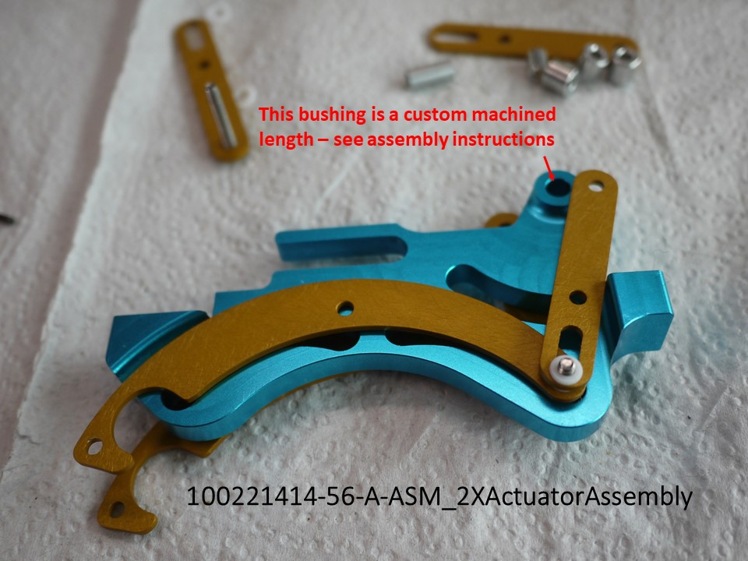
- Fasten the 2X actuator assembly to the top plate as shown on assembly drawing 100221414-10-A-ASM_ChassisTopPlateAssembly. Use low strength Loctite on these two fasteners.
- Assemble base plate by installing dowel pins, heatsink pad and cable clamp in baseplate as shown in 100221414-03-A-ASM_BasePlateAssembly drawing. Check fit of 100221414-25-A_OpticalBlockMount, 100221414-15-A_FrontChassisPlate and 100221414-45-A_RearChassisPlate on dowel pins to verify hole alignment and assemble.
- Assemble 100221414-44-A-ASM_RearChassisAssembly. Install the cooling fan rubber vibration damping grommets first, then Press in Torlon bushings MBARI PN 100221414-95-A_RearChassisBushing, and retain with snap rings. Install the two fan screws that are beneath the 100221414-59-B_RearPinPlate and then install entire spring assembly. When tightening the shoulder bolt nut on the slotted end of the 100221414-59-A_RearPinPlate make sure that the bolt is centered in the slot. Units 1-3 have a wider slot and need special care when tightening so that the shoulder bolt is evenly supported. It’s best to do the final tightening in a jig or on the mill table with the springs compressed about 0.1 – 0.2 “. Test the spring assembly to ensure that there is no binding.
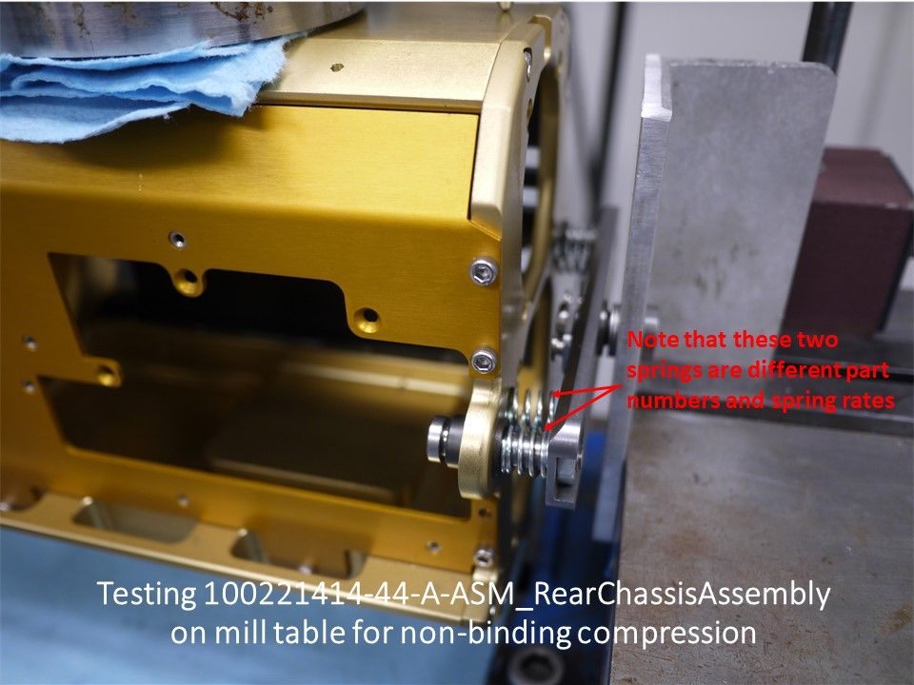
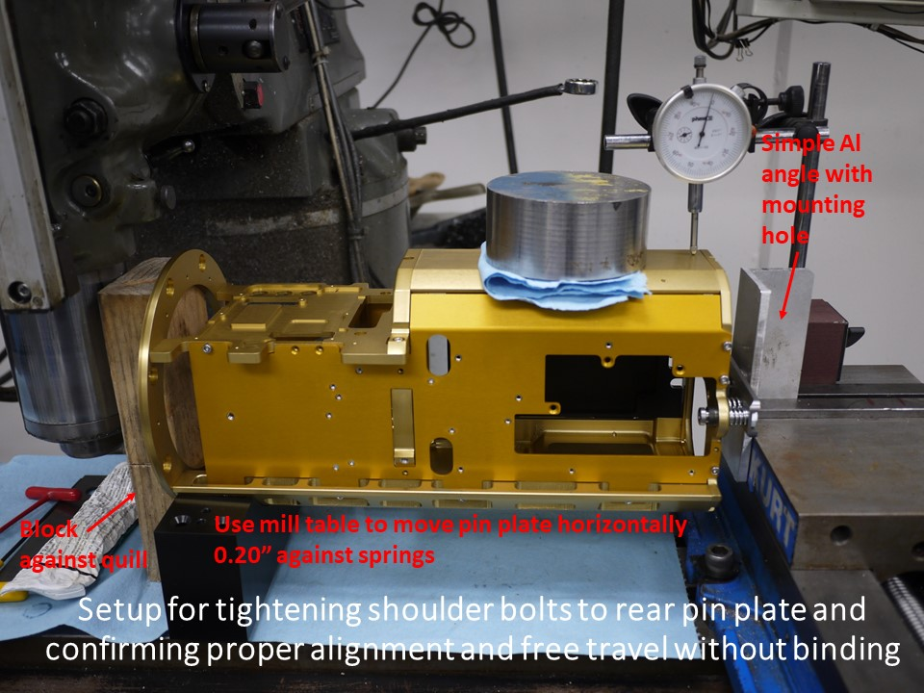
Install the Pabst 612FH fan, including handmade plastic cable retaining taps shown in the illustration. These keep the cabling between the fans and away from the rotors. Remove Sony fan from chassis and install with wiring facing direction shown in illustration. Leave foam vibration damping around Sony fan except where it is covering the mounting holes – cut off these tabs. Tighten fan fasteners only enough to hold in place but not so much as to over-compress the vibration absorbing mounting grommets. Make sure that the fans are oriented to exhaust out the rear of the chassis. Fan exhaust is over the spinner support arms. Drill out water alarm electrical connectors for #4-40 screw clearance. Pre-wire water alarm connectors with pigtails before installation according to drawing 100221507-01-A_4kROVCameraInternalWiring.
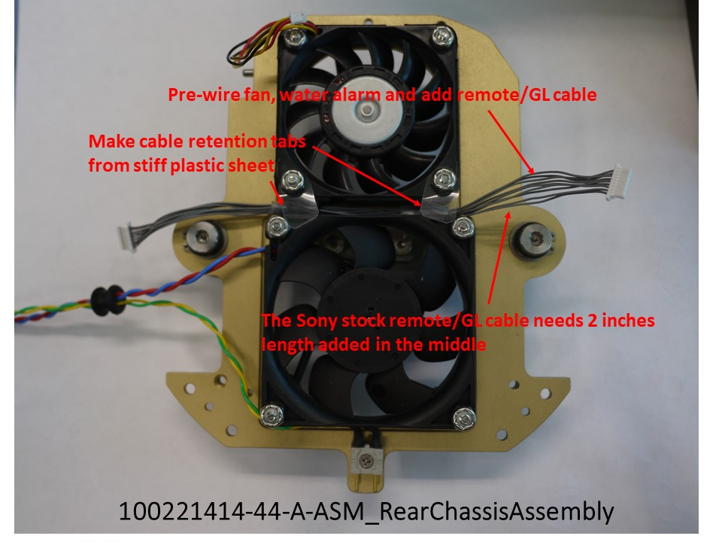
NOTE: All of the following operations that involve electronic assemblies, including the Sony optical block MUST take place at a grounded anti-static workstation with a wrist band being worn.
- While referring to and following the instructions in the Sony HDC-P50_Rev.1_ServiceManual.pdf, carefully disassemble the Sony camera. Take special care removing the Sony DPR-393 board from the Sony “Outside Assembly” when peeling away from the thermal pads so that you do not flex and damage the DPR-393 board. Store fasteners in cups organized by the major camera assembly. Take extra care with the high-density multi-coax connectors and the miniature coax connectors. For removing coax connectors use the special removal tool (Hirose PN D.FL75-LP-N). There are two similar types of miniature coax connectors/cables in the design and there are NOT interchangeable. Attempting to cross mate in-compatible connectors will damage the PCB and/or connector. Retain the original fasteners and extra parts in case the Sony camera must be re-assembled in its original chassis for service. With few exceptions, the new MXD 4K camera chassis uses new fasteners.
- Carefully remove the Sony optical block plastic cover and modify the optical block plastic cover as shown in the photograph. After carefully removing all residue from the plastic cover, place black cloth tape over the opening as illustrated. This is both a light shield and to maintain proper cooling air flow.
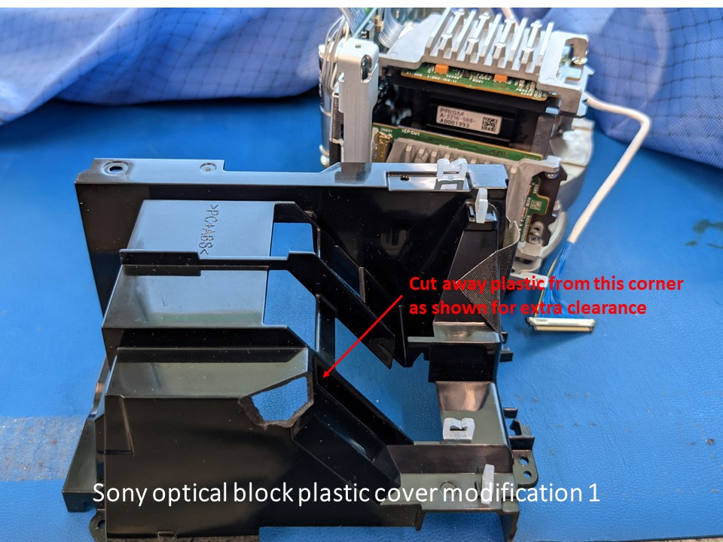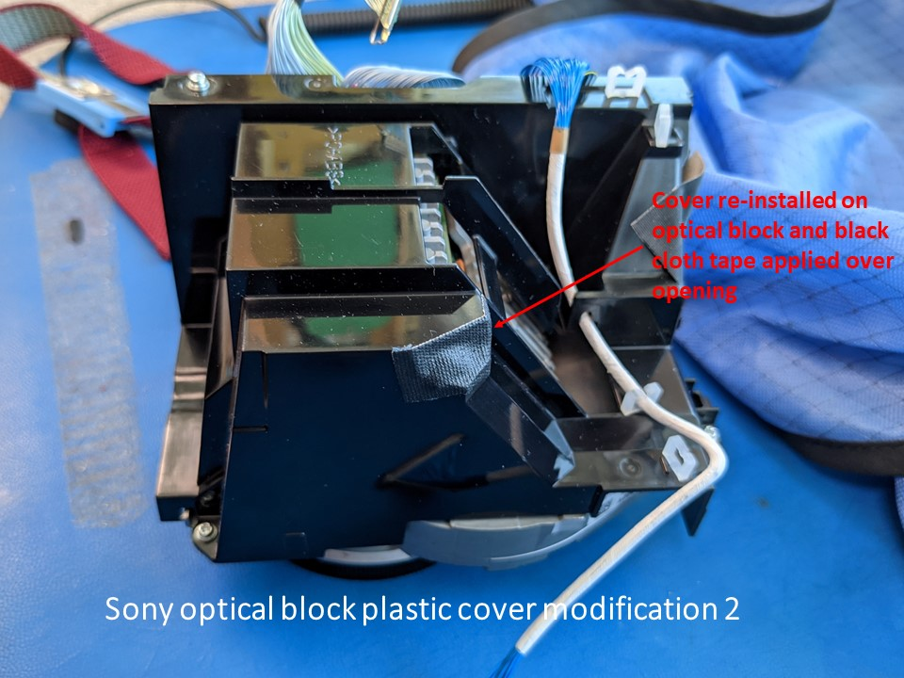
- Remove the chassis 100221414-25-A_OpticalBlockMount from the chassis test fit assembly created in steps 1-4 above and install the 100221414-22-B_OpticalBlockFlange and hold in place by evenly tightening adjustment screws to mechanically center the flange as closely as possible. This will speed later optical calibration steps. Make sure that the top adjustment screw is in the detent recess in the optical block flange.
- Carefully install the Sony optical block into the optical block flange. With careful maneuvering, it WILL fit without having to modify or remove anything from the Sony optical block.
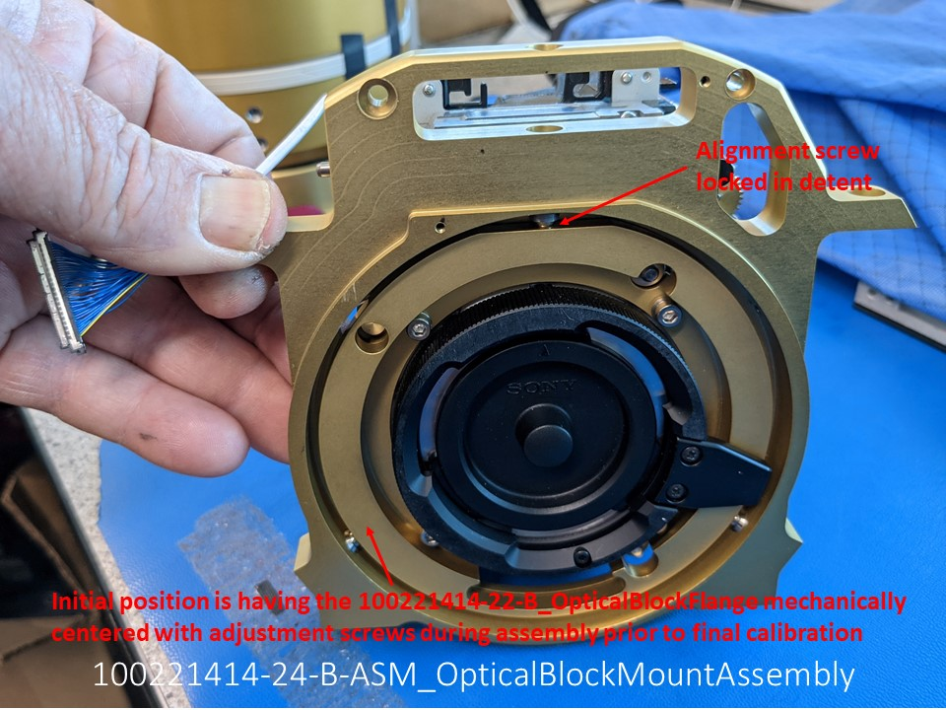
- Install the complete 100221414-24-B-ASM_OpticalBlockMountAssembly back on the baseplate. Check the clearance fit between the upper part of the Sony optical block assembly and the 100221414-19-A-ASM_CameraTopPlateAssembly before final tightening the 100221414-24-B-ASM_OpticalBlockMountAssembly mounting screws.
- Install the Sony lens connector panel on the 100221414-24-B-ASM_OpticalBlockMountAssembly as per the assembly drawing and route the Sony lens connector panel and high speed video wiring as shown in the illustration.
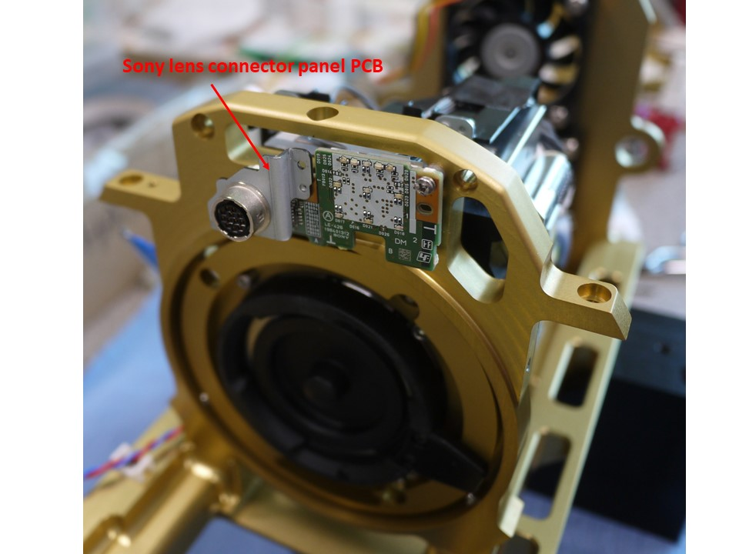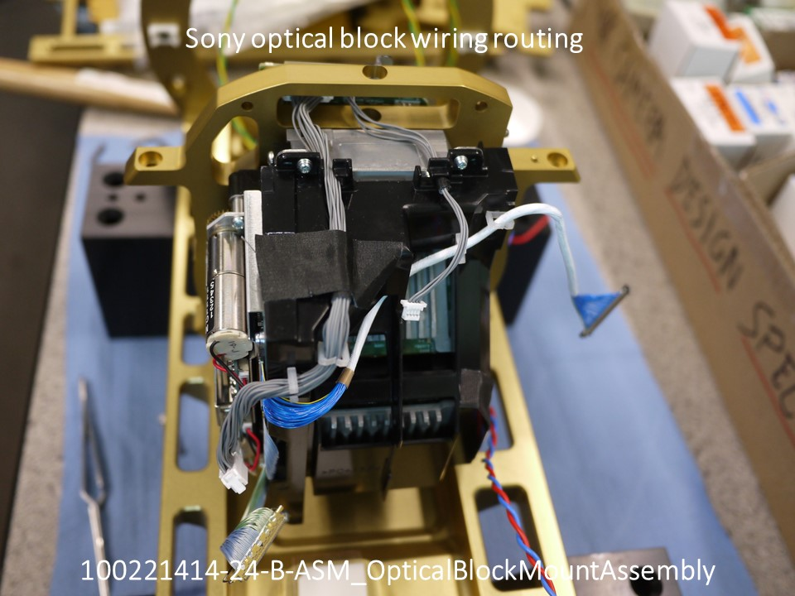
- Install the dowel pins and heat sink pad on the 100221414-19-A-ASM_CameraTopPlateAssembly as per the drawing. Install the small Sony WiFi PCB on the camera top plate as shown in the assembly drawing. On camera #’s 1-3 (Rev. A camera top plate), place a #2 plastic washer under the WiFi PCB as a spacer during installation. Cameras after #3 use the Rev. B camera top plate which has a machined boss that eliminates the need for the washer under the WiFi PCB. Carefully install the Sony “center PCB and heatsink module” on the camera top plate, making sure that the board-to-board connector to the WiFi PCB mates properly.
- Carefully install the camera top plate assembly into the chassis. Make sure that the heat sink pad is in place on the camera base plate. You will need to press the assembly down into the heat sink pad to align the 100221414-19-A-ASM_CameraTopPlateAssembly mounting screw holes.
- Video wiring. Remove the green and red cables from the Sony center PCB using the special removal tool (Hirose PN D.FL75-LP-N). Replace the yellow cable on the PCB with the longer green cable previously removed. NOTE: there are two types of miniature coax connectors/cables in the design and there are NOT interchangeable. Attempting to cross mate will damage the PCB and/or connector. Pay close attention to the video cable routing and connector installation.
- Remove the power cable and armor with a single layer of cloth tape. Cable tie the rest of the cable. Re-install the cable as shown, by-passing the lower cable clamp.
- Add 2” of length to the remote/GL cable.
- Completely build up the 100221414-44-A-ASM_RearChassisAssembly and the 100221414-36-A-ASM_LeftSideChassisPanelAssembly and place wiring as shown in illustration. Remove the Sony camera power cable from the Sony chassis holders and tie the power cable to the rear of the Sony chassis sheet metal to keep it from interfering with the fan blades as shown.
- Insert the 100221414-36-A-ASM_LeftSideChassisPanelAssembly in place on the baseplate and use a string or tie cord strap to hold in position where the wiring will reach the Sony PCB connectors but leaving room to reach in and attach the panel cables/connectors to the appropriate Sony PCB receptacles. Careful folding of the flex cables is necessary, but it WILL all fit. Attach all connectors to their PCB mates. Gently move the left side panel into its final location and fasten in place with at least one or two screws. Check that all the cables are still mated and have good position. Note the proper orientation of the flex cable. Carefully connect the blue/green micro coax to the monitor BNC on the left panel. Use the BNC connector strain relief.
- Position the 100221414-44-A-ASM_RearChassisAssembly and tie up in a position where you can connect the remote/GL cable to the Sony PCB. Carefully move the end panel into place on the dowel pins and install fasteners.
- Install grommets on the coax and remote/GL wiring that extends out to the right side panel (grommets may have to be split). Make sure that all of the Sony internal connectors accessible on the right side are connected such as the Sony fan connection and the Monitor coax cable (to the left panel) and the SDI-1 and SDI-2 coax cables (to right panel).
- Temporarily install the 100221414-26-A-DWG_RightConnectorBracket on the 100221414-38-A-ASM_RightChassisPanelAssembly to use as a handle during panel installation.
- Build up the 100221414-38-A-ASM_RightChassisPanelAssembly as per drawing. Note that the original Sony heatsink pads between the Sony DPR-393 board and the Sony “Outside Assembly” must be carefully removed from the Sony “Outside Assembly” and placed on the 100221414-38-A-ASM_RightChassisPanelAssembly where shown.
- Position the entire MXD chassis top down on the bench with the 100221414-38-A-ASM_RightChassisPanelAssembly positioned as shown in the illustration. Carefully mate the Sony high density connector and place a piece of Kapton tape over the cable exactly as shown to prevent strain on the CN103 connector.
- Using the temporarily installed 100221414-26-A-DWG_RightConnectorBracket to help hold the panel, carefully move the RightChassisPanelAssembly into place first slotting in the tabs on the top side (normally bottom). As you are moving the RightChassisPanelAssembly into position install the grommeted wires in the slots as shown. Be extremely careful to not put any strain on the Sony high-density cable and CN103 connector and to carefully align the Sony MB-1259 board to DPR-393 board connector on the bottom. Note that this connector and the RightChassisPanelAssembly alignment pins should be the final mate, i.e. with the connector aligned, and parallel, try and slide the bottom of the panel into position, feeling for proper connector alignment. There are guides and the connector itself has a small amount of float so if the chassis assembly is correct, mating should require little force. When you are satisfied with the mate install all of the 100221414-38-A-ASM_RightChassisPanelAssembly fasteners.
- Install the Sony SDI-1/SDI-2/remote/GL PCB on the 100221414-26-A_RightConnectorBracket and carefully connect the wiring exiting the MXD chassis.
- Temporarily remove the 100221414-15-A_FrontChassisPlate and install the modified Canon lens assembly (see Canon Lens Modification Instructions below). Make sure that the B4 lens mount clamp is very tight. Re-install the FrontChassisPlate. Install the 100221414-05-A_ChassisAlignmentConeAssembly with the nominal shim spacing, guided by the assembly drawing.
- Buildup and install the 100221414-21-A_LensServoPanelAssembly according to the drawing and illustrations.
- Prior to completing the final wiring, temporarily connect a 12V 5A power supply to the Sony HDC-P50 camera power connector mounted on the chassis and power up the camera and lens. Connect a 4K capable video monitor to the SDI-1 video output. Using the Sony RCP plugged into the chassis mounted remote connector and verify the camera function by setting to “BARS”.
- Perform a “back-focus” adjustment on the lens/camera assembly while the back-focus adjustment ring on the lens assembly is still accessible.
- With the major chassis assemblies completely assembled, install the 100221507-03-A_4KROVCameraPCB on the 100221414-09-B_ChassisTopPlate and the Focal and Deep Sea multiplexors. Referring to the relevant assembly drawings, note proper thermal pad placement.

Canon Lens Modification Instructions
- Remove the tiny cover over the 2X extender cable way. Note: be careful not to strip screw – Canon uses ample thread locker on many fasteners, including this one. Remove the small 2X extender connector.
- Remove the entire servo unit from the lens.
- Remove the large flex cable from the lens side PCB connector. Remove cable ties carefully.
- Remove small flex cable to display PCB.
- Unscrew the PCB on the handgrip side.
- Remove all of the drive motors and encoders from the servo body. Take careful note of any shims that are installed.
- Remove the AUX and MEMO switches from the servo body.
- Protect remaining servo components with tape and plastic leaving the areas to be removed exposed.
- Use abrasive saw to cut off edges of servo body casting as shown. File off any sharp edges and clean the servo body very carefully.
- Re-install the modified servo body shell on the Canon Lens, installing the 2X connector as you put the shell in place.
- Re-install encoders and motors in sequence shown. During assembly make sure that the drive train clutches for the zoom and focus are engaging properly. Adjust during mounting for minimum backlash and smooth gear engagement. Add small Kapton tape strip to hold focus switch wire away from gear train as shown.
- Install lens in optical block and tighten well. It helps final tightening to position chassis vertically resting on the lens.
- Remove mini-display and button board from the removed outer lens servo shell. Access mounting screws by carefully prying outer cover/bezel from shell. Remove rubber button grommet and install rubber button grommet in the new lens servo panel. Install display PCB using the Canon screws. One screw hole did not line up. Rev. B? panel has better hole alignment. See illustration. Install new flex cable.
- After top chassis plate is installed, install Canon connector PCB on chassis top plate with new flex cable attached.
- Place Canon PCB as shown and connect wires. Cut off AUTO/Manual IRIS cable from hand side of shell and solder (short) two ends together to force AUTO IRIS mode. Very carefully dress wiring so that it folds easily without getting near any gear trains. Use Kapton tape to hold down wire bundles. Cut off grommet from the lens-to-camera cable and carefully cut back wire shielding. Insulate shielding with suitable tape. Install this cable as shown. Route lens-to-camera and front water alarm cables – you may have to remove front plate to put them in place.
- Install all servo wire to connectors on Canon PCB.
- Set lens focus and zoom drive clutches in MANUAL position and perform final back focus adjustment as per Canon operation manual. After setting back focus tighten focus adjustment clamp screw firmly. MAKE SURE and set clutches back in AUTO position when complete.

NOTES:
- Add lock on lens collar to future builds.
- Hole for lens display needs revision (drawings revised).
- Holes for Canon lens connector PCB need revision (drawings revised).
- Need longer flex cables for lens PCB interconnects.
- On units 1-3, countersink lower holes for flathead screws on lens servo panel (man. Error).
CAMERA 01 BUILD LOG:
- Assembled and performed auto calibration of lens position encoders. 6/18/2021.
- Set lens drive clutches in manual position. Set back focus adjustment. 6/18/2021.
- Tested lens focus and zoom analog servo inputs. All good. 6/21/2021

First three MBARI build chassis use rev. 100221414-22-B_OpticalBlockFlange part to correct a machining defect in the first three builds of 100221414-25-A_OpticalBlockMount. Additional builds shall use built-to-print 100221414-25-A_OpticalBlockMount and rev. 100221414-22-C_OpticalBlockFlange.
Suitable replacement thermal pads of the correct durometer could not be identified so the original pads must be carefully removed from the Sony “Outside Assembly” chassis part and re-installed in the MXD 100221414-38-A-ASM_RightChassisPanelAssembly.

