2019 NAB Notes
Mark Chaffey, April 10, 2019
Here’s my notes on several topics I pursued while attending NAB:
4K Cameras suitable for deep ocean housings.
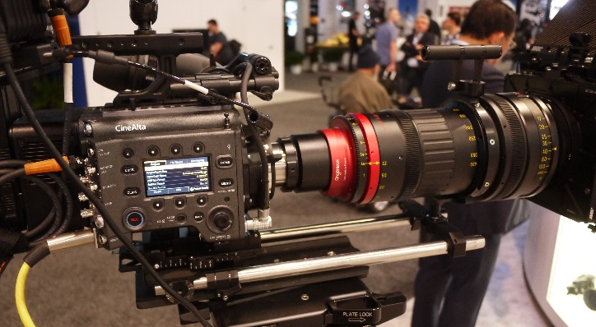
I looked at the latest offerings from Sony, Ikegami, Panasonic, Black Magic, Grass Valley and several smaller brands. Discussion and specifications confirmed that we really want a 2/3” 3-chip imager format with a B4 lens mount as opposed to the very popular large format (super 35 and above) Bayer arrays with PL mount lenses. The smaller imager gets us more depth of field and a much smaller lens size for a given field of view and zoom potential, and the 3-chip design has more sensitivity then a single-chip 2/3” design. Sensitivity is an issue with 4K because you are already going to be down 2dB or so from the same imager in HD format. So in the 2/3” format what I found is that only Sony has a suitable camera in this format. The current generation is the HDC-P50 which has a 3-chip 2/3” format and a global shutter.
Figure 1. Example of an 8x zoom in a PL mount. A very large lens.
Ikegami
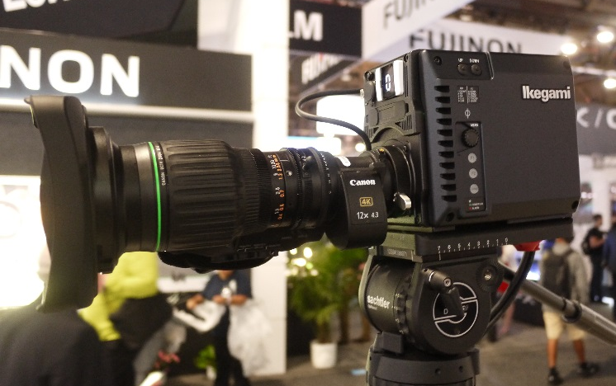
The new Ikegami 4K box camera now has a form factor which makes it unsuitable for putting in a pressure housing. See image. The optical block is not centered in the camera body unlike the previous versions of this camera so the housing must be very large in diameter.
Figure 2. Ikegami new 4K POV camera with B4 mount. Bad form factor for UW use. Note smaller size of the lens from PL mount camera.

Panasonic
Panasonic has a 4K box or POV camera in the B4 2/3” format. They use a large imager however and a lens system to expand the B4 mount to fill the imager. This is the same approach taken by Black Magic Designs. This method suffers from poor sensitivity, F-6 at 2000 Lux in 1080 60p mode. Sony P50 is F10 at 2000 Lux.
Black Magic Designs
See Panasonic discussion above.
Grass Valley
This is the old Thompson video division. Camera is too large for UW use and quite expensive.
Camera Lens Controls
One of our big issues is that we want professional quality lens controls, known as follow focus or follow zoom systems. The Fujinon lens system had really great control feel. Their system now uses digital control with the user controls being digitized in the housing and sent to the lens using the RS485 electrical protocol. The data protocol is proprietary and not usually available. The lens does have a 20 pin Hirose connector however that can be used for user control and has a published API that can be obtained from Fujinon. It is possible that Fujinon and Canon use the same or a very similar API for user lens control. The Fujinon hand controls have really great feel with just the right amount of friction. Use those as input devices and extend the 485 link? There were several tele-operated systems that used similar controls – but not quite as nice. They were Protech (Chinese company?), Telemetrics and Preston Cinema Systems. Preston uses their own drive motors which they claim are much more robust than Fujinon’s.
LTO Tape Storage
Video Encoding
Video Consulting

