Project Number: | 902001

Project Start: Jan. | 1, 2021 | Project Duration (in years): | Year 1 of 1 ¹

Please indicate if proposal includes requests for any of the following (mark all that apply).

 |  |  |  | X
Ship Time |  |  | ROV |  |  | AUV |  |  | Wave Glider |  |  | Mini ROV

Please indicate what type of project is being proposed (mark only one).

 |  |  |  | X
Feasibility/Scoping  [Less than 100 days effort] |  |  | Development |  |  | Research |  |  | Infrastructure² |  |  | Education |  |  | Time Series |  |  | Institute Initiative

Project Manager: Mark Chaffey
Principal Investigator: Jim Barry
Lead Scientist: Steve Haddock
Lead Engineer: Mark Chaffey

Project Title: 4K ROV Camera Development

Please indicate which category best describes the project theme (mark only one).

 |  |  |  |  |  |  | X
Ocean  biogeochemistry |  |  | Ecosystem dynamics |  |  | Ocean visualization |  |  | Exploration & discovery

Please indicate percentage of effort on this project anticipated for 2021 toward these three highest institutional goals (percentage total should equal 100%).

Goal | Developing/adapting innovative technologies | Utilizing developments to explore and understand ocean systems | Technology/knowledge transfer
Percentage | 90% | 0% | 10%

- ABSTRACT (if submitted during abstract phase)

Project Description: This project is to provide high quality 4K imaging capability for MBARI’s ROV’s by developing a state-of-the-art camera system. Note that this work is now taking place in the project 902001, however this one-year project ends in 2020. The camera build effort is currently several months behind the original schedule of completion in the fall of 2020. While every effort will be made to complete the build and sea-trials in 2020, this abstract is being submitted to propose extending the project in the event that additional time to complete is necessary in early 2021.

The status is that the design phase of the most challenging of the major camera systems is complete and we are entering the fabrication phase. The optical system design for adapting the camera lens to the hemispherical optical dome is complete and 20 optical domes are currently on order. The size of the camera housing is fixed and the final housing and dome support design is complete including final finite element analysis (FEA) stress strain modeling.

The camera system internal chassis design (MBARI responsibility) is complete and fabrication is about to start.

The last two remaining major MBARI components are the telemetry system and the in-can electronics for power management and lens control. These systems have been fully defined at the systems level and detailed design has started. Software development is taking place on proxy hardware while the electronics are completed.

The upshot is that while the project is behind the original timeline, the most challenging work is complete and the remaining design (and fabrication) work of the telemetry and electronics is not as complex and will move quickly.

- PROPOSAL

  - All Projects

Statement of the challenge, why it is important

MBARI has consistently been at the forefront of underwater imaging, and the visual images from our ROV systems are indelibly associated with the culture of MBARI itself. Our images are used extensively by nearly all research groups at the institute and are provided to high quality producers for public education including the Monterey Bay Aquarium and the BBC Nature unit. These images form a truly unique data record of the deep ocean environment and inform research applications as diverse as identifying new biological species to recording the behavior of liquid carbon dioxide at depth. Often the visual record is the ONLY returned data of the phenomenon of interest.

Relevance

How does it relate/contribute to MBARI’s mission and strategic plan?

This project contributes to MBARI’s mission by advancing research and education through technical innovation and development. The specific goal is to increase our knowledge of the marine environment by improving MBARI’s on-ROV imaging quality, allowing the capture of more detailed observations and records.
Visual images are also a powerful way to communicate MBARI’s knowledge and discoveries to the the public. Our partner, the Monterey Bay Aquarium, makes extensive use of our visual products and is very interested in the highest resolution possible as they move to larger displays, such as video walls, to display information and images of species that are not feasible to display as live specimens.

Does it relate to the Technology Roadmap? If so, please describe how. (See http://mww.mbari.org/oed/TechnologyRoadmap.pdf.)

The development of advanced imaging capabilities advances the MBARI Technology Roadmap goal of fostering technological innovation.

How does it relate/contribute to the Packard Foundation’s Ocean Grantmaking Program? (See https://www.packard.org/what-we-fund/ocean/ and documents therein.)

This project contributes to the general theme of the Packard Foundation’s Ocean Grantmaking Program by increasing our scientific understanding of the oceans. It also directly supports public educational efforts to increase awareness of the importance and vulnerability of the deep ocean environment and to develop support for ocean conservation.

Overall approach to the challenge: Over the complete term of the project, what is needed to address the challenge (e.g., sensors, platforms, marine operations, de novo R & D, etc.)

Research

There is no direct research effort associated with this proposal.

Engineering/Technology Development
The project proposes to begin the transition to 4K video acquisition on MBARI’s ROV’s by providing a single camera system that is compatible interchangeably with the current Doc Ricketts and Ventana ROV systems.
Marine Operations/Field Programs

The field program requires dockside testing and one at-sea trial. A specific ROV day is not requested for the sea trial because we will plan on scheduling the trial to run concurrently with other missions either scientific or operational.

Data
What data products will be generated?

This project will generate large volumes of video records.

How will the data products be managed?

The video and associated data records will be processed identically to MBARI’s current video processing pipeline using the MBARI Media Management (M3) system. Analysis of MBARI’s current and planned video streams has shown that while there is an increase in file sizes for 4K video, the large savings in tape cost with the transition to file based video in the M3 upgrade, offsets the cost of the additional storage volume required for 4K video files.

For more detail on data management, please refer to the 2019 902001 project proposal.
Describe data availability outside of the project team.

The video data is available institute wide and to outside organizations and individuals consistent with MBARI’s currently in-force video policy.

Describe data storage requirements.

For details on data volumes, please refer to the 2019 902001 project proposal.

Anticipated Impact

Who are the consumers of the instruments, methods, systems, and data that will be generated?

The results of this development project will place MBARI firmly back in the position of producing the highest quality images from the deep sea. Every program at MBARI that makes use of video imagery for research and outreach will benefit.

Anticipated Outreach

What outreach assets might you need to better reach the audience/consumers you are targeting? Specify how you might like to reach your audience (published paper, seminar, conference, social media, etc.) and what type of assets (graphic, animation, video, etc.) you might need ITD to help generate.

This project has no unique requirements for ITD. The dissemination of 4K video products would fold into their current programs and projects.

Intellectual Property (IP) Considerations

Do you anticipate a need for a cooperative research and development agreement or licensing arrangement with an external entity?

MBARI currently has an R&D license agreement with Deep Sea Power & Light incorporated.

Will novel IP be created, and how might it be disseminated (e.g., open-source, royalty-free license, commercial license agreement)?

MBARI’s design work is considered proprietary and is being disseminated through a commercial license agreement with Deep Sea Power & Light Inc. MBARI retains the right to provide systems to not-for-profit institutions, although DSP&L is much better suited to provide systems and after sales support. For this reason, we have been directing third parties to DSP&L for procuring cameras.

Will the work potentially result in a patentable product or service?

MBARI’s design work on this project is not likely to be patentable.

For additional guidance please review MBARI’s intellectual property internal web page: https://mww.mbari.org/itd/ip/.

NA

  - Continuing Projects

Current status of project and results to date

While technically a new project, this project proposal is a requested extension to the 2020 902001 4K ROV Camera Project and is therefore being documented as a continuing project.

What percentage of labor and budget have been used through the 1st half of year?

43% of the labor and 76% of the 2020 budget has been used.

Will you complete the current year’s scheduled work?

We are expecting to complete the project in 2020 a few months later than the Fall 2020 date scheduled, however we are about to begin the fabrication phase and there may be unanticipated delays due to Covid-19 impacts and other factors. Every effort is being made to complete in 2020.

If you are at less than 50% resource usage, what is the plan to complete, or what work won’t be done this year?

We are pretty close to our resource targets and we anticipate increased resource usage as we enter the build phase of the project where the machine shop and other resources will be charging time.

The current project status is that the design of the three most challenging components of the camera system are complete. These include the optical system design for adapting the Canon camera lens to the hemispherical optical dome, the pressure housing/optical dome and the camera chassis systems.

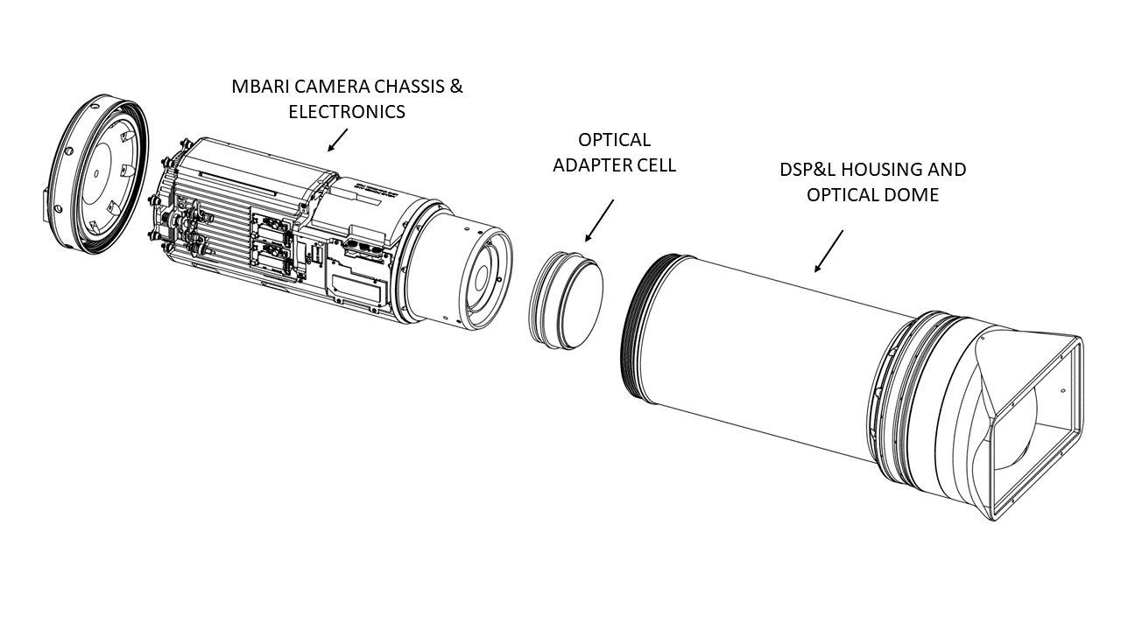
Figure 1. Major 4k ROV camera system components.

The first critical element is the collection of carefully spaced optical lenses necessary to transform the extremely distorted image passing through the hemispherical optical dome to a coherent image for the Canon professional camera lens. This group of lenses is referred to as the adapter cell. This assembly is part of the housing and dome assembly and is the responsibility of DSP&L. The design of the optics for the exacting requirements of 4k imaging and a professional 15x zoom lens has been a significant challenge and the initial results required five individual lens elements. After several months of modeling, the specification of lens designs made from exotic specialty glasses, and the creative thinking by the highly skilled optical engineer on the team (Dr. Paul Remijan), the final design now has been reduced to three optical lenses (including a cemented doublet). The modeled performance is very good and is fully optimized to our unique viewing environment. For example the optical system allows full zoom at the minimum object distance of 0.3 meters (from the camera imager) while preserving the full image quality at the widest viewing angles. The predicted optical performance far exceeds any underwater optical imaging system available today. This high level of effort in the optical system design is critical for bringing the full potential of 4K imaging to the screen. The adapter cell design is now complete and the lens elements and mounting systems are ready for fabrication. DSP&L is subcontracting with Myriad Optical Systems, a company specializing in precision optics for assembling this critical element.

The second critical element is design of the camera pressure housing and the associated optical dome. This work is also the responsibility of our development partner Deep Sea Power & Light (DSP&L). The challenge here is the survivability of the glass dome and specifically the interface between the dome and the Titanium housing. The mechanical support problem is made more difficult by the size specification of 208mm (8”) diameter outside diameter for the glass dome. This larger dome diameter is required to solve the adapter cell design problem, but also raises the challenge for the dome support. DSP&L has extensive experience in building dome supports dating back to the first manned Titanic expedition in 1986 and has developed a proprietary interface design. The design and specification of the optical domes and the dome support interface is complete. Twenty optical domes have been ordered and five of these units have been received. These are to be final polished, chemically strengthened and anti-reflection coated with magnesium fluoride.

The Titanium housing design and the associated finite element modeling have also been completed. We have mated the DSP&L housing models with the MBARI designed camera chassis (see below) and are finalizing the details on this interface. In order to conduct reliability testing of the housings, domes and the dome support system DSP&L has constructed a new dedicated pressure chamber and long duration cycle testing is to begin shortly on the dome support.
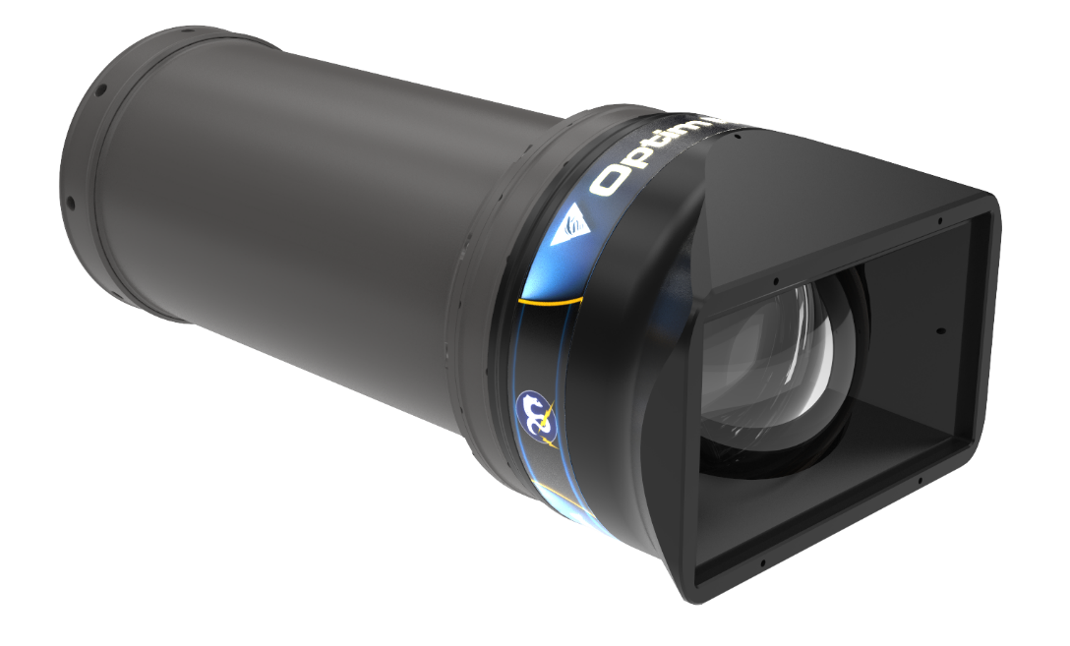
Figure 2. Rendering of the final housing design. Graphical treatment incudes both MBARI and DSP&L names and logos representing the contributions of both organizations.
The third critical element of the camera system is the internal chassis design (MBARI responsibility). The two major challenges for the chassis have been maintaining the optical alignment of the system and fitting the camera, lens and peripheral hardware into the smallest possible housing size. The critical optical alignments are the Canon camera lens to the adapter cell and the adapter cell to the housing dome, each of which requires precision centering and tilt adjustment to preserve the best optical performance. The motivation for working hard to reduce the overall camera size (and weight) is to maximize the operational flexibility of the system. Our experience has been that large camera systems such as the Japanese Super Harp system and MBARI’s first HDTV camera make routine operations more difficult and have less user acceptance. In addition, the Ricketts pan & tilt units have maximum weight limits of 100 lbs. that we cannot exceed. Another important consideration for the chassis design is thermal management. Thermal modeling has shown that surprisingly, the largest factor in transferring heat from the camera system to the environment is the air to housing boundary on the inside housing surface and not the titanium housing wall. Therefore, design incorporates elements to increase this surface area with the target of operating continuously in 25 degree C tropical surface waters. The full design of the camera chassis is complete and drawing completion and fabrication is pending.

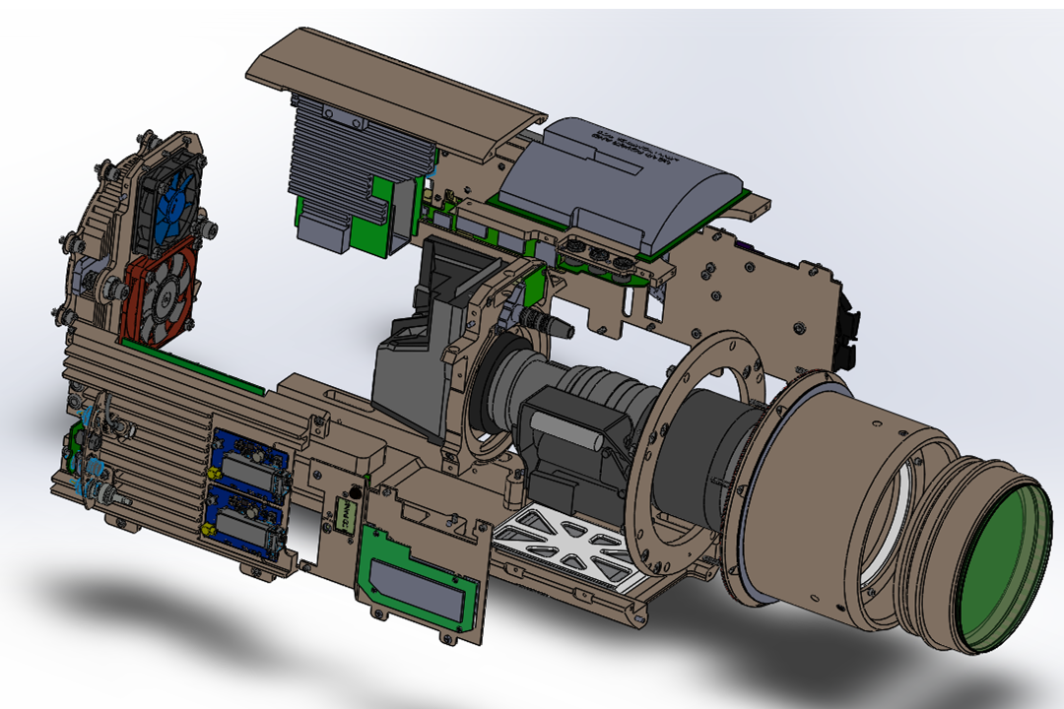
Figure 3. Exploded view illustration of the 4K camera internal chassis design. Optical alignment, compact packing and thermal management are important considerations.
The last two remaining major components are the telemetry system and the in-can electronics for power management and lens control. These elements have been fully defined at the systems level and detailed design and testing has started. Software development is currently taking place on proxy hardware while the final telemetry and lens control hardware is under development.

The upshot is that the project is several months behind the original timeline, however the most challenging work is nearing completion and the remaining design (and fabrication) work of the telemetry and electronics is not as complex and will move quickly.

We have a great team and all partners are fully committed to making this camera a great success.

Significant changes from previous project proposal

There are no significant changes to the previous project proposal aside from completion schedule.

Over the past two years, what peer-reviewed publications, education and/or outreach activities have resulted directly from this project? Please be brief.

None

To date has any novel intellectual property been developed and/or disseminated?

The design of the compact chassis repackaging the Sony HDC-P50 camera is considered intellectual property and is being treated as such.

  - All Projects: Specific Plans for 2021

Research Activities

There are no research activities.

Engineering/technology development

There is no technology development proposed in 2021.

Will novel intellectual property be developed and/or disseminated?
Dissemination includes patenting, licensing, and collaboration agreements.

All intellectual property development is will be completed in 2020. We have an on-going licensing and royalty agreement with Deep Sea Power & Light for MBARI intellectual property developed by this project.

Field programs (detail ship requirements/deployments/diver requirements)

In addition to describing anticipated field programs, please be sure to include requirements for specific platforms and equipment (Dorado AUVs, LRAUVs, Wave Glider, mini ROV, etc.) for each proposed field program so that expectations are clear. Requests must also be entered in the budget entry system.

We plan on coordinating sea trials with MBARI Operations and conducting trials by utilizing existing test or science days by a ride-along agreement.

Isotope Usage
Project teams must provide details regarding any planned isotope use on shore, on ships, in the Sanctuary, etc. Please review the guidance on isotope usage at http://www.mbari.org/at-sea/cruise-planning/hazardous-materials/ and policy at http://mww.mbari.org/safety/SafetyManual/Isotope_Use_Policy.pdf, and then provide details on plans below.

NA

Safety Disposal Needs

So the Safety office can plan and budget accordingly, please respond to the questions below regarding any anticipated safety disposal needs for the coming year. Budget for cost of such removal will be captured by the safety office based on responses received.

Will this project generate more than 1 gallon (4 liters) of battery waste per year?

No

If yes, please indicate the type of batteries (alkaline, NiCad, NiMH, lithium ion or lithium metal) and the approximate amount of each to be generated.

NA

Will this project generate more than 15 gallons (60 liters) of hazardous liquid waste per year?

No

If yes, please indicate the composition of the waste(s) and the quantity of each to be generated.

NA

Specific deliverables

4K camera system designed for ROV use.

Milestones and required personnel (see personnel classification list for staff classifications)

Note that the current project schedule has completion in the end of 2020, however there may be slippage into 2021. The milestones and resources shown below anticipate some extension into 2021.
For the current project detailed schedule also see Gantt chart below.

2021 Project Start Date:  01/01/2021 | Milestone 1 | Milestone 2 | Milestone 3 | Milestone 4 | Milestone 5 | Total Resources (in hours) for each resource category for all milestones listed here
Milestone Date | 1/15/2021 | 2/15/2021
Milestone Description | Final camera system lab testing | Sea trials on Ventana and Ricketts complete
Electrical Engineer | 120 | 120 |  |  |  | 240
Software Eng-Embedded | 40 | 10 |  |  |  | 50
Software Eng-Info Eng
Mechanical Engineer
Mechanical Eng-Division
Mechanical Eng-Mfg
Associate Engineer
Electrical Tech
Software Tech
Mechanical Tech
Machinist
Divers

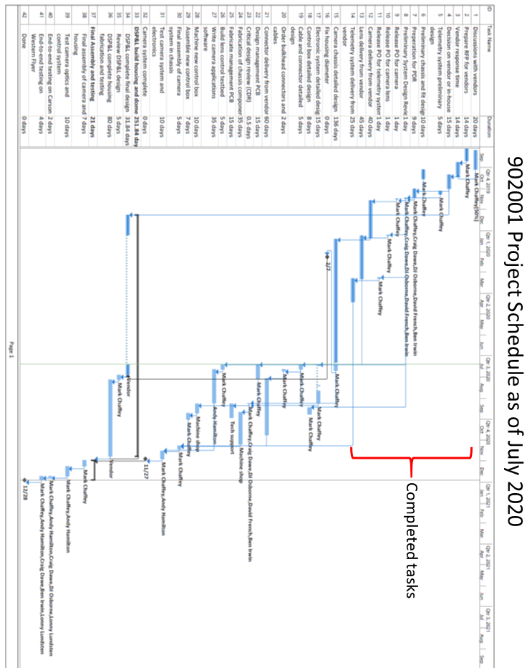

Budget justification

The project does not require any funds in 2021.

Project team
The project team consists of an engineering team of:
Jim Barry and Steve Haddock who will provide guidance on science requirements and user concerns.
Andy Hamilton is writing the lens control and telemetry software.
Mark Chaffey will act as project manager and designing the camera chassis and control electronics.
Lonny Lundsten representing the video lab will support the topside file capture and ensure compatibility with the M3 system.
We also will have an operations team of Ben Erwin representing the Doc Ricketts and DJ Osbourne representing the Ventana and Dave French in technical support to ensure operational compatibility with current systems and to provide guidance and advice.

Project lab and office space requirements
In addition to any changes to current space usage, please also include anticipated office and lab needs for students, postdocs, collaborators, etc.

Project will utilize existing allocated office space.

R/V Paragon Requests
If the project team will be requesting time for the R/V Paragon, please specify the operators in the group and provide estimates of their availability to operate the vessel. DMO staff have extremely limited availability to be operators and only with advanced budgeting and planning.

NA

Risk matrix (development and infrastructure projects only)

 | Technical Risk | Organizational Risk | Tech Transfer Risk | Labor Estimate Risk
High
Medium | X |  | X | X
Low |  | X

  - Compliance Considerations

Export Regulation
Does the project team anticipate any foreign collaborations or international travel? If so, please identify collaborators by name, institution, and country.

No

Does the project team plan or anticipate export-controlled purchases, shipments, or transfers of items (e.g., research instruments, proprietary data, hand-carried tools or samples) outside the U.S. temporarily or permanently? If yes, please identify country or countries and indicate whether these items will remain under MBARI control while abroad or controlled by others. Will the items be exported to more than one country? Please include foreign collaborator information as described above.

No

Monterey Bay National Marine Sanctuary (MBNMS)

General Permit
Projects teams need to indicate if any work will be performed that is either: (1) currently authorized under our general permit; or (2) will require that we obtain authorization. The current permit can be viewed at https://mww.mbari.org/pco/permits/mbnms-2020-006_exp28feb2025.pdf. Please see Mandy Allen for questions.

Is a permit with MBNMS required for your work?

No

SESAs (General map)
Projects will need to indicate whether or not work will be conducted within one of the Monterey Bay National Marine Sanctuary's Ecologically Significant Areas (SESAs). If your work will be conducted in one of these areas, please indicate which area by number or name.

No

Anchors
For activities conducted under MBARI's permit for the Monterey Bay National Marine Sanctuary, Paragraph 16, we are required to recover anchors weighing less than 500 pounds. Project proposals, which involve anchors weighing less than 500 pounds, shall specifically indicate cruise time allocated to anchor recovery. Lack of cruise time is not an acceptable reason for deeming an anchor less than 500 pounds “unrecoverable” under Paragraph 17 of MBNMS permit. Also under Paragraph 17, ALL anchors not recovered during the year must be reported detailing location, description of anchor, and reason not recovered. (Mandy Allen will collect this information from project teams to submit as part of the annual report to the Sanctuary.) Each ship will be tracking anchors deployed, duration of attempted anchor recovery, and anchors abandoned on the seafloor with the intent that they be recovered in the future as per MBNMS permit requirements.

Will you be deploying equipment that will require anchoring? If so, please indicate approximate weight of anchors to be used and recovery plans.

No

California Department of Fish & Wildlife
A Scientific Collecting Permit will be required for biological and geological sample collections offshore California (even in Federal waters and beyond), and for many activities in State Marine Protected Areas (MPAs). Please see Mandy Allen for questions.

Will you be collecting samples that require a permit?

No

Will you be working in a State Marine Protected Area?(See link above for Statewide MPAs or this link for Central California MPAs.)

No

United States Coast Guard

If your project will deploy or maintain moorings, the project team must ensure proper compliance and notification of these activities to the US Coast Guard. DMO does not automatically do these notifications on behalf of projects. Two common types of permits and notifications that may apply to your project are Private Aid to Navigation (PATON) authorizations (required for buoys deployed for six (6) months or longer) and Notice to Mariners, which must be submitted for temporary PATONs (less than 6-month deployments). Other science operations may submit a request for a Local Notice to Mariners and are useful for missions or deployments with risk of 3rd Party Liability such as the Wave Glider.

Will your project require a PATON?

No

If yes, have you obtained a PATON? (Please provide a copy to Mandy Allen.)

NA

Will your project require submission of a Local Notice to Mariners?

NA

If yes, please indicate who will be submitting request and provide a copy of the submission to Mandy Allen.

NA

Authorizations/Permits from other Agencies or Organizations
Is the project team aware of any other permits or authorizations that will be necessary to perform the proposed work? If so, please list below along with status of authorizations (obtained, pending, need to apply, etc.). Please see Mandy Allen if you have questions.

No

Active Acoustics
We are keeping an inventory of acoustic instrumentation. The current list is posted here: https://mww.mbari.org/resources/2021_Proposal_Process/mbari_acoustic_instruments_updated_may_13_2020_ver_13.xlsx. If you have or plan to use equipment that is not already on this list, please be sure to include that information here.

No

This date and number should remain the same for the duration of the project. If your project start date for 2021 is not January 1, please indicate the start date in the first cell of the milestone chart. Format for duration example: “Year 2 of 5”.
Development and infrastructure projects must complete the risk matrix (see end of the proposal form).
Not all projects will require all four titles to be filled in. Please indicate individuals only for those titles that are appropriate for your project.
This category includes transfer of hardware, know-how, publications, presentations, etc.
This number should be the same number you entered on the resource requests for this particular resource.

