4K ROV Camera Development 902001
Mark Chaffey/Paul Roberts
This project has completed the 4K camera (major milestone!) and our commercial partner, Deep Sea Power & Light is in the process of creating a commercial product from the MBARI design.
Recent activities include:
- The final assembly and the critical calibration of the camera optical path was completed.
- The 4K camera has been installed on Ventana and is currently operating. A successful series of dives have fully tested the MBARI end-to-end 4K video processing chain from field acquisition through annotation to archival.

- 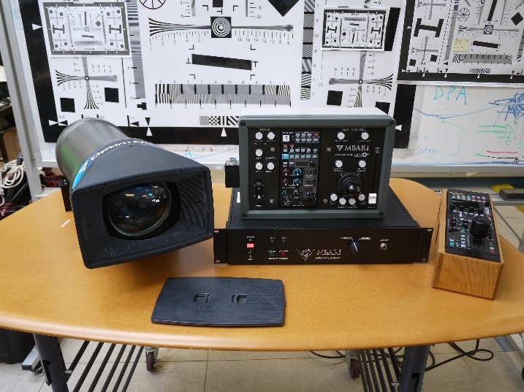
Figure 1. The complete MBARI 4K camera system showing the camera housing, deck interface box and camera controls. As a modern broadcast camera, there are numerous controls and settings to provide the tools for creating the best possible image in different scene settings.
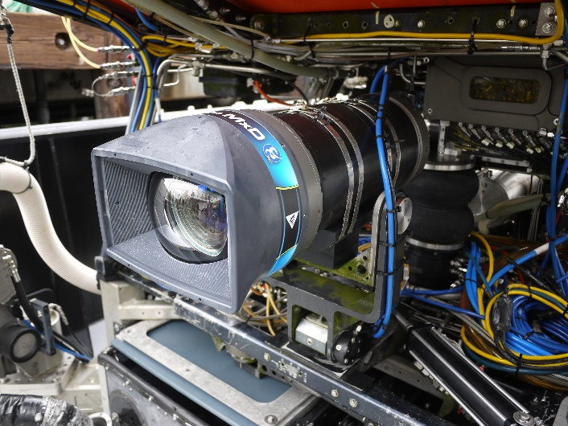
Figure 2. The 4K camera installed on the ROV Ventana. A significant effort went into designing as compact a system as was possible to allow for easy integration into day-to-day ROV operations.

Figure 3. Example of a single frame from the 4K camera. The camera optics maintain 4K resolution across the entire image area. An optical zoom capability of up to 30x allows the observation of numerous small macro organisms in addition to the larger image features.
- The achieving of operational status of the MBARI 4K camera on the ROV Ventana elevates MBARI’s undersea video acquisition to the highest technical level possible. While directly advancing MBARI’s research interests, this also provides high quality material for MBA video projects and builds a library of images for video productions that is of the highest quality.
- The construction of a second camera is underway to provide both of MBARI’s ROV’s with this state-of-the-art imaging capability.

