Research and Development: Engineering
Project Highlights

902001 4K ROV Camera Development – Mark Chaffey
Activities from April 2020 through September 2020

Professional activities:

- The project partnered with commercial company Deep Sea Power & Light (DSP&L) to co-develop state-of-the-art imaging capability for MBARI’s ROV’s.
  - MBARI is developing the camera chassis including optical alignment structure, the control system, telemetry system and user interface.
  - DSP&L is designing the housing, optical dome and relay optics. This partnership builds on the strengths of both participants and divides the labor and risk.
  - Initial installation is on MBARI ROV’s and the vendor pays royalty for additional commercial sales.
- Progress to date has the overall system design complete and tested and detailed design about 95% complete. The remaining design work is the detailed electrical design of the user control box and the completion of mechanical manufacturing drawings.
  - The critical design of the optical dome port and relay lens system is complete. This is an extremely important element of the overall camera system. The promise and motivation of developing this camera is providing the unparalleled image quality that the ultra-high definition video format allows. There are no commercially available deep ocean systems that do this. To fulfill this promise the optical relay from water to camera lens must be precisely designed and carefully executed. The optical modeling effort has taken over six months, but is now complete and the glass components have been delivered from the manufacturer. Upon receipt the domes have been final polished, chemically hardened and anti-reflection coated on both surfaces. A test article dome is currently undergoing verification testing of the glass, mount and sealing system and has undergone over 1700 pressure cycles to 7000 meters without degradation.
  - The mechanical design is complete, both for the pressure housing as well as the camera chassis and the housing has passed detailed finite element modeling verification. A short test housing has been manufactured and used for the glass dome verification testing. A detailed heat transfer analysis has been completed on the camera/housing system.
  - The telemetry system that transmits the camera high resolution video signal – 12 Gb per second – and control signals over optic fiber has been constructed, and successfully tested over 10km of optical fiber.
- The original completion date for this effort was the Fall of 2020. Currently early to mid-2021 is the completion date. We are very excited about this project and eager to install and test the camera on one of our ROV’s!

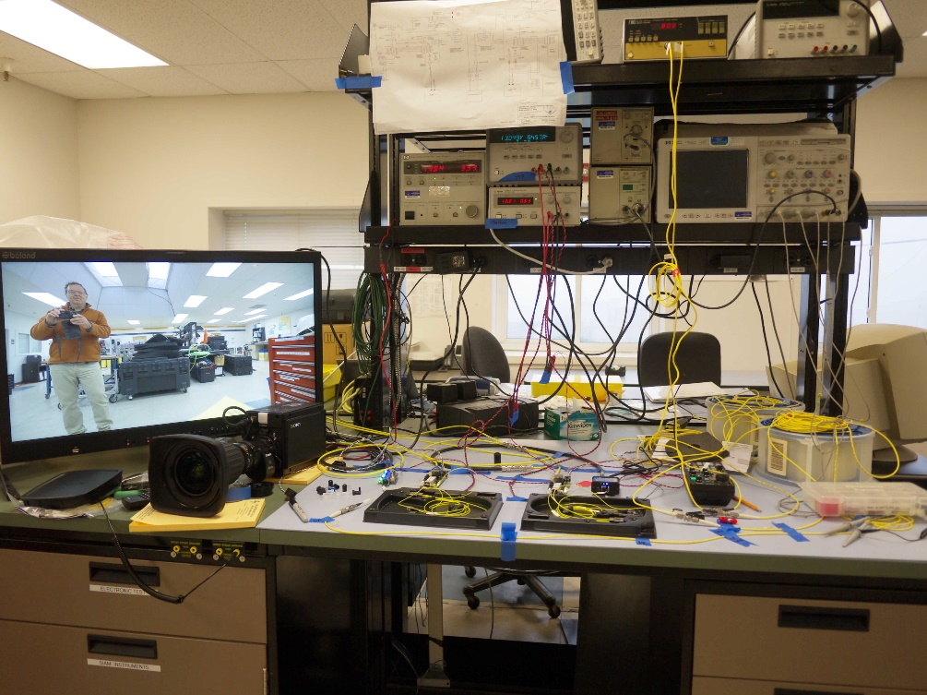
Figure 1. Successful test of the telemetry system operating over 10km of optical fiber.

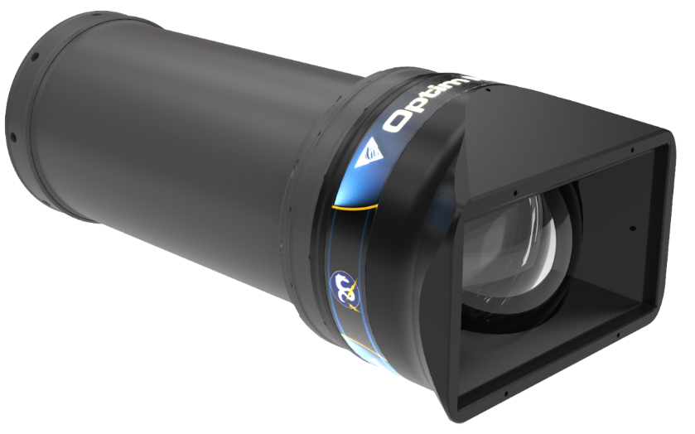
Figure 2. Rendition of the completed housing mechanical design.
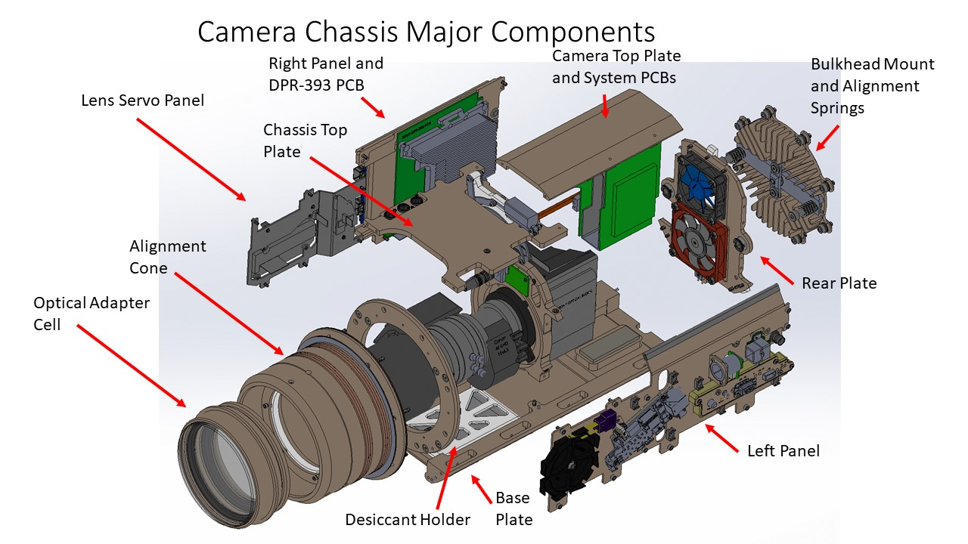
Figure 3. The major components of the completed chassis design.

