Research and Development: Engineering
Project Highlights

902001 4K ROV Camera Development – Mark Chaffey
Activities from November 2020 through January 2021

Professional activities:

- Project refresher: The project collaborated with commercial company Deep Sea Power & Light (DSP&L) to co-develop state-of-the-art imaging capability for MBARI’s ROV’s.
  - MBARI is developing the camera chassis including optical alignment structure, the control system, telemetry system and user interface.
  - DSP&L is designing the housing, optical dome and relay optics. This partnership builds on the strengths of both participants and shares the labor and risk.
  - Initial installation is on MBARI ROV’s and the vendor pays royalty for additional commercial sales.
- Progress to date has the overall system design complete and the components for the camera system in fabrication.
  - The fabrication of the components of the relay lens system is complete and they are awaiting final assembly and optical testing at a specialty optical house in Massachusetts. Verification testing utilizes laser based shearing interferometry to confirm the alignment of the multiple optical elements.
  - A chemically hardened test article optical dome has survived thousands of pressure cycles to 7000 meters without damage to the dome or seat, verifying the dome, seal, and mechanical seat design. This was one of the higher risk areas of the project.
  - A second dome test article has been chemically hardened and then vapor deposition coated with Magnesium Fluoride on the outer seawater exposed surface and Silicon Dioxide on the inside and optically tested, confirming the proper application and performance of the anti-reflection coatings. The application of the coatings to the final article domes is in progress.
  - The fabrication of the camera housing is complete and about to undergo pressure testing.
  - Over 70 fabrication drawings are completed and all of the camera chassis components are in manufacture at MBARI and outside facilities.
- The original completion date for this effort was the Fall of 2020. Currently early to mid-2021 is the completion date. Designing the camera system to bring all of the promise of true 4K imaging to the deep sea has been a challenging effort in both the optical and mechanical arenas and we remain very excited and eager to install and test the camera on one of our ROV’s soon!

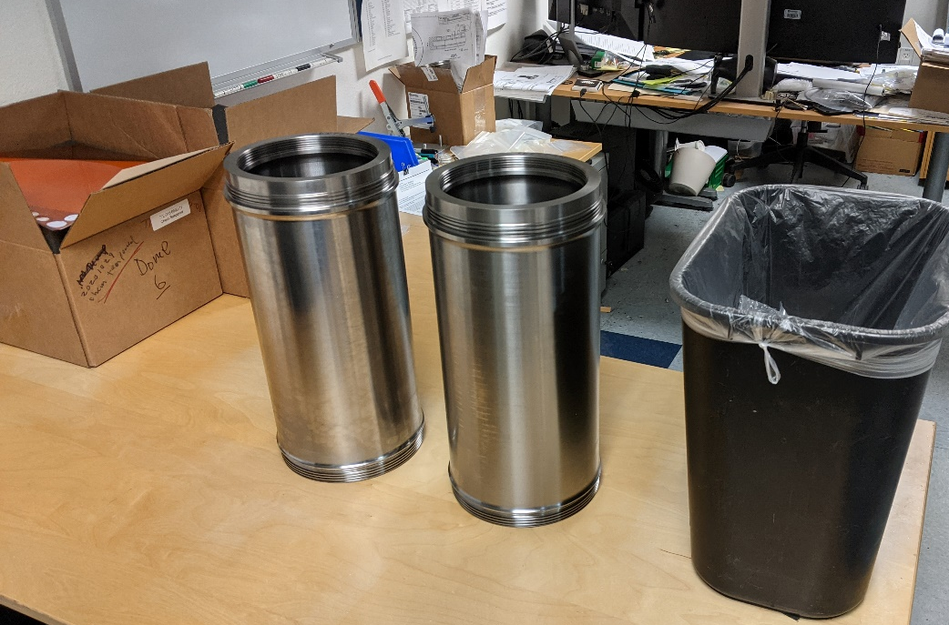
Figure 1. Two completed Titanium camera housing barrels before applying "Tiodize" protective surface treatment.

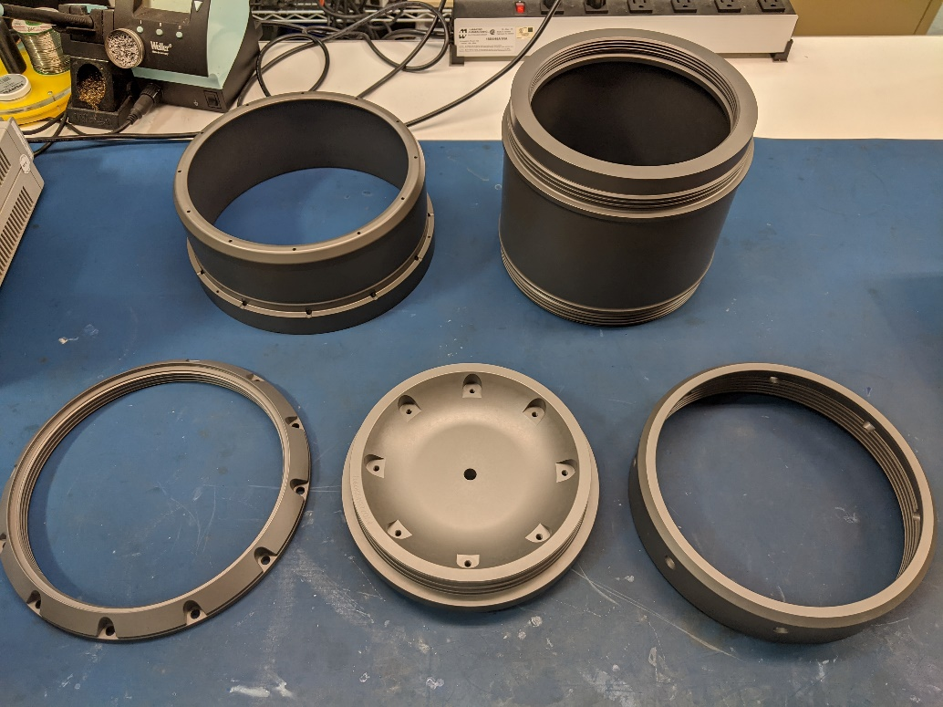
Figure 2. Housing components after the application of Tiodize treatment.
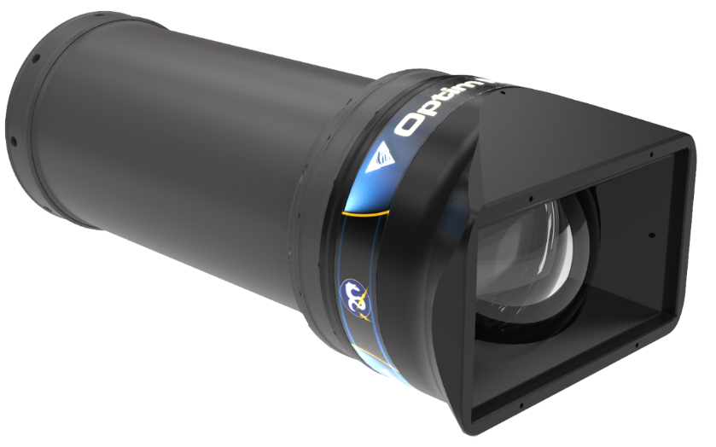
Figure 3. Rendition of the completed housing mechanical design.

