MBARI 4K ROV Camera System Request for Proposals

rev. A 20SEP19 Mark Chaffey. Initial release.
rev. B 20SEP19 Mark Chaffey. Included MBARI performing pressure test option.

Contact for questions and responses:
Mark Chaffey, MBARI, 7700 Sandholdt Road, Moss Landing CA USA 95039
chma@mbari.org (831) 775-1708

Discussion and summary. The request for proposals consists of two documents, this request for proposals, (RFP) and the controlling camera system detailed requirements described in the separate document MBARI 4K ROV Camera System Requirements, (“requirements”), Doc. # 100221373.
The purpose of this RFP is to solicit proposals from commercial underwater camera manufacturers (“vendor”) to provide the underwater housing, adapter optics and pressure dome port for a “4K” or Ultra-high definition camera system for MBARI Remotely Operated Vehicles (ROV’s). MBARI would provide the balance of the camera system as described in detail below. The MBARI requirements document includes all of the requirements for both the vendor and the MBARI supplied components of the camera system.
The production, processing and archival of high quality video imagery has been an important part of MBARI’s mission since our founding. We have consistently worked toward incorporating the highest standard of video that is technically feasible in our vehicles and this visual record has contributed significantly to numerous areas of scientific investigation while providing valuable material for outreach and public education. This has been accomplished both by building our own camera systems in collaboration with specialized vendors or by purchasing complete off-the-shelf systems that meet our requirements.
With the cameras and infrastructure now available to support 4K or Ultra-High Definition video, MBARI is upgrading our camera systems to this standard. The total number of HDTV ROV camera systems at MBARI that are to be replaced with the new 4K cameras are two field units and one spare for a total of three units.
The overall requirement is to provide a professional level 4K camera system suitable for ROV use that has an optical dome and adapter optics that maintain a 4K resolution and a high MTF across the image plane at all zoom and focus settings.
MBARI has tested all currently available commercial ROV 4K/UHD camera systems and found that they do not meet our requirements. We are now seeking a commercial partner who will provide the camera housing, optical dome port, and relay optics to house an MBARI provided camera and telemetry system. In exchange for a favorable pricing arrangement to MBARI for up to three camera housing units from a vendor, MBARI will provide a non-fee license and full design data for our contribution to the overall system as described in detail below. The vendor maintains proprietary ownership of their contributions to the housing and optics design.
- Breakdown of work.
  - The vendor will provide hardware described below that meets the requirements of MBARI 4K ROV Camera System Requirements document # 100221373, (“requirements”).
    - Optical design including dome port, relay lenses and associated lens mounting hardware. Prior to beginning actual fabrication, the contractor shall provide MBARI with the following design products for evaluation and approval. This information will be kept strictly proprietary and used by MBARI only for evaluation. MBARI reserves the right to cancel the purchase from the vendor prior to the start of fabrication based on poor optical design performance.
      - Optical layout of the dome port and relay lenses with rim rays.
      - Polychromatic MTF curves at three focal lengths, minimum, mid-length and maximum focal length.
      - Ensquared energy plot.
      - Field curvature-distortion plot.
      - Polychromatic spot diagrams at three focal lengths, minimum, mid-length and maximum focal length.
    - Optical dome port, relay lenses and lens mounting hardware meeting the specifications of requirements document, section 1.6.
    - Solid model of the camera housing to be used for the chassis to housing interface control including the camera/lens setback positioning.
    - Camera housing fabricated in 6AL4V Titanium with the following properties:
      - Meets environmental specifications of requirements, section 3.
      - Internal dimensions suitable for a camera module of the properties and dimensions in requirements, section 3. Final internal dimensions by mutual agreement between the contractor and MBARI.
      - Includes mounting points for the camera module of type and locations determined by mutual agreement between the contractor and MBARI.
      - Two connector and one vent port opening of the location and type to be determined by agreement between the contractor and MBARI.

  - MBARI will provide the following for the initial camera system construction (and future MBARI units) and a non-fee license for the design. All MBARI supplied components will conform to the doc. # 100221373, (“requirements”).
    - Camera module including:
      - Chassis and all internal housing parts for a Sony HDC P-50 camera and associated lens.
      - Sony HDC P-50 camera modified for smaller housing ID.
      - Fujinon UA13x4.5 BERD lens or UA14X4.5BERD lens
      - The underwater optical and electrical bulkhead connectors and associated cables.
      - The “follow focus” and zoom lens drive system.
      - Electronics for all camera and lens control functions and internal housing environmental monitoring.
      - Internal power supply to allow the submerged camera system to operate from 18-36VDC.
      - Engineered camera cooling system using forced air and ducted plenums.
      - Camera to shipboard control room telemetry system utilizing one single mode optical fiber. Video delivery will be baseband Quad 3G-SDI (SMPTE 424M) signal.
      - Shipboard control room camera control interface including focus and zoom controls, iris control, the manufacturers camera control unit (RCP), alarm notification, etc.
      - Mechanical and electrical drawings, solid models, operating documentation and any other engineering documentation or computer files necessary to reproduce the camera system and operate it.

- Systems Integration. Final system integration and end-to-end testing will take place at the MBARI facility at 7700 Sandholdt Road, Moss Landing, California.
  - MBARI will be responsible for the final assembly of the camera chassis and electronics into the camera housing.
  - MBARI will conduct the in-water optical acceptance testing and the end-to-end electronics testing.

- Important dates and delivery schedule. The following dates reflect the current schedule. They are advisory and may change, but the plan is to adhere to this schedule if possible.
  - First release RFP to potential vendors. September 20, 2019.
  - Deadline for initial vendor response. October 10, 2019.
  - Final vendor selection. October 31, 2019.
  - MBARI releases final housing internal diameter and internal length. January 24, 2020.
  - Critical design review (CDR) of complete design including vendor optical and housing design and MBARI camera system. Final review of all interfaces, connector ports, lens alignment fixtures, chassis to housing interface, etc. February 20, 2020.
  - Release to fabrication following the resolution of any issues raised in the CDR. ASAP following CDR.
  - Final assembly of all camera system components (MBARI and vendor) August 12, 2020.
  - At-sea testing completed. September 4, 2020.

- Vendor selection. The MBARI selection of a suitable vendor will be based on the following criteria ranked in order of importance. Note that any material provided by the vendor in support of their proposal will be held in strict confidence and not disclosed to any third party.
  - Confidence in the vendor’s ability to produce a top quality optical design. This evaluation can be supported by direct evidence such as;
    - Proven results from previous complex optical designs.
    - Optical modeling results from previous similar designs.
    - End to end optical test pattern results from previous similar designs.
    - The professional reputation of the optical engineer (if disclosed).
  - Pricing quoted by vendor for three (3) units of the housing, dome and relay optics in the following detail;
    - Price for One (1) unit to be delivered in August 2020.
    - Price for option for one or two units to be delivered in 2021.
    - Price for option for one unit to be delivered in 2022.

- Acceptance testing.
  - Acceptance of the optical dome, relay optics and housing shall be qualified by the followings tests;
    - Successful pressure test of the fully assembled camera housing (including dome port) to 6,380 p.s.i. (110% of 4000 meters seawater equivalent) with 10 cycles from 0 to full pressure and one soak at 6,380 p.s.i of at least 1 hour duration.
    - Successful pressure test of the optical dome port only with one cycle to 7,250 p.s.i. with a 15 minute soak at full pressure (125% of 4000 meters seawater equivalent).
    - The maximum rate of change for pressure cycling testing shall be less than or equal to 200 p.s.i per minute. Pressure qualification testing will be performed by the vendor unless other arrangements are made. Note that MBARI does have a 9.4" x 31” pressure vessel suitable for qualification testing and can perform the acceptance testing if requested.
    - Successful results in end-to-end test of optical performance in filtered seawater using a standard test target and examining resolution, contrast, chromatic aberration (lateral color), and geometric distortion in the following picture areas shown in figure 1 below. Optical performance will also be compared to a current 4K camera underwater optical system with excellent performance. The test target result to be used as an evaluation reference is available on request. End-to-end optical testing will be performed at MBARI in a test tank of filtered seawater at our facility.
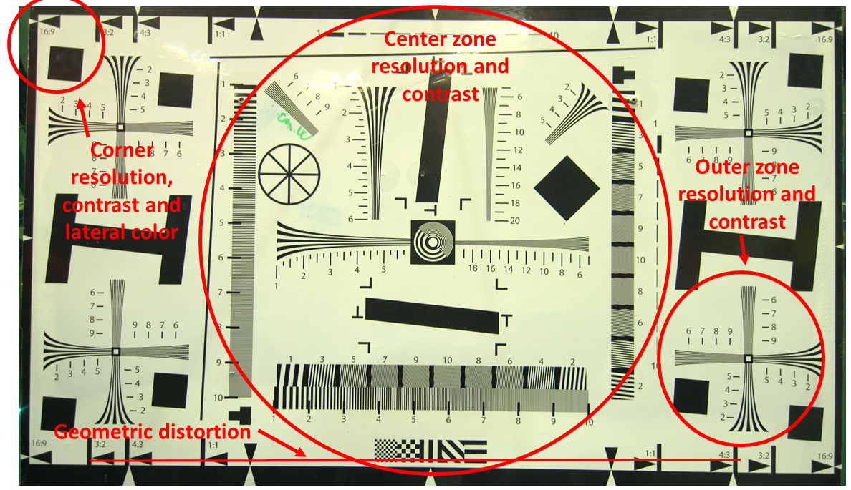
Figure 1. Test target picture quality test areas.

The resolution of “4K” video is 4096 x 2160 pixels and is a digital cinema standard. “Ultra-High Definition” or UHD video is 3840 x 2160 pixels and is a consumer and broadcast standard. For general quality of image purposes they can be considered nearly equivalent.
Modulation Transfer Function or contrast ratio.

