First iteration, aka ‘Rev1’, Standalone Planktivore Battery Pack
Thom Maughan, 17 Oct 2021
Document version v1

Rev1 Planktivore Standalone Battery Requirements:

- Safe to take onboard ship / boat
- ‘Off the Shelf’ and readily available (Oct/Nov 2021) battery will determine housing diameter and influence the length.
  - DCB210 Dewalt battery
  - Inspired Energy
- Readily available materials / components for the battery pack design
- Depth rating: at least 100m. 200m preferred.
- Scalable design by length of housing. Design goal for 1, 2, 3, 4, 5 batteries.
- Buoyancy: Fully assembled battery pack should be near neutral with some positive buoyancy (125g or so).
- Electrical:
  - Voltage: 14v to 20v
  - Energy: 200 Wh to 1000 Whr
  - Max current: 1A
  - 10 pin connector (or adapter). Wiring is identical for the Spray - Planktivore cable. 10 pin chosen due to Spray.
- Recharging the batteries will be done by removing them from the battery housing and using an off the shelf charging station.
- Test platforms: Pier, Coastal profiling float or downrigger off Paragon.
- Constraints:
  - Chip shortage (Pandemic and Tradewar with China) is affecting semiconductor, connector and battery availability
  - Limited Engineering and fabrication availability.
    - ME has ~40 hrs of design / fab drawing time, what can we get in 2021?
    - Holiday season / pandemic effects on fabrication availability
- Schedule
  - Housing fabricated by mid December 2021 (goal)

-------------------------------------------------------------------------------------------------------------------------------

Paul has previously built a 500Wh battery pack using Inspired Energy. A number of the components needed are on severe backorder (> 40weeks).

Using Dewalt power tool batteries satisfy several requirements. Mike Kelly, DMO director, indicated he would be fine with Dewalt batteries being brought on the ship due to the consumer safety protocols.

Notes on DCB210 10AH 20v:
- diagonal is 4.1” schedule 80 5” pipe (non-standard diameter) could be used to get near 200m https://www.pvcfittingsonline.com/5-schedule-80-pvc-pipe-8008-050ab-5ft.html
- Battery could be trimmed to 3.84” (97.5 mm) which would be a tight squeeze in 4” schedule 80. Would like to avoid modifying the battery pack.
- Connectors are readily available from Amazon for the battery pack.
- Battery ship time was a week, from Mexico. Net weight: 2.108KG according to box, gross weight is 2.246 kg. Shipping may have been slow due to amount of Lithium when ordering a 2 pack.
- Weight Estimate on DeWalt DCB210 battery is 1.05kg for 20v 10AHr. Weight estimate based on shipping info.
- Size DeWalt DCB210 battery
  - housing base is 5.4” L x 3.4” W x 2.3” H with a 3.4 L x 2.3 W x 0.95”H connector riser on tob and a sloping 1.1 L x 2.3W x (0.95” sloping to 0”) H Release button detail.
  - Measuring diagonal, 4.1”.
  - If top ‘lip’ is trimmed, diagonal can be 3.84” (would like to avoid battery mod)

- Battery connector fits flush to the top of the connector riser.

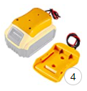

Question: Can we adjust housing length to yield approx.125 grams positive for five configurations of pvc pipe lengths (including weight of end caps, electronics, wiring, vent, frame, etc).
- Electronics + wiring + connector weight estime = TBD
- PVC Pipe lengths (positive buoyancy) for five variants:
- 1 battery (200Whr), est. 1.05kg
- 2 battery (400Whr), est. 2.10kg
- 3 battery (600Whr), est. 3.15kg
- 4 battery (800Whr), est. 4.20kg
- 5 battery (1000Whr), est. 5.25kg
- Note: if five variants is too time consuming, estimate for 4 battery only.

- Thoughts on trimming neutral.
  - 80% of weight added internally, 20% weight added external to trim neutral

https://www.archtoolbox.com/materials-systems/plumbing/standard-pipe-dimensions.html
Polyvinyl Chloride (PVC) Pipe Sizes - Schedule 80
Chlorinated Polyvinyl Chloride (CPVC) has the same dimensions as PVC, but weighs slightly more than PVC
NPS | OUTSIDE DIAMETER (IN) | INSIDE DIAMETER (IN) | WALL THICKNESS (IN) | WEIGHT (LB/FT)

3 | 3.500" | 2.900" | 0.300" | 2.10 lb/ft
3-1/2 | 4.000" | 3.364" | 0.318" | 2.45 lb/ft
4 | 4.500" | 3.826" | 0.337" | 2.94 lb/ft
5 | 5.563" | 4.813" | 0.375" | 4.08 lb/ft
6 | 6.625" | 5.761" | 0.432" | 5.61 lb/ft

Battery Pack Electrical Safety requirements (pulled from LG 21700 spec)
- The protection circuit should be installed in the battery pack, charger.
- Charger or pack should have voltage sensing system to control over charge or discharge in order to maintain the battery’s normal operating mode and protect cell imbalance.
- Charger or pack should have warning system for over temperature, over voltage and over current
- When battery packs for any applications are assembled with cells, the following functions must be designed into the battery packs and/or in the charger or charging adapter.
  - (1) Over voltage protection circuit [dewalt bms]
  - (2) Under voltage protection circuit [dewalt bms]
  - (3) Over Charge current protection circuit [dewalt bms]
  - (4) Over Discharge current protection circuit [dewalt bms]
  - (5) Short circuit protection [dewalt?] [added fuse, 5A]
  - (6) Over Temperature protection circuit [dewalt]
  - (7) 2nd over voltage protection [?]
  - (8) FET failure protection (in case FET is out of order) [fuse, 5A]
  - (9) Cell imbalance protection circuit (only for battery packs assembled with more than one cell) [dewalt]
  - (10) Cell Voltage balancing function (only for battery packs assembled with more than one cell) [dewalt]

-------------------------------------------------------------------------------------------------------------------------------
-------------------------------------------------------------------------------------------------------------------------------
Notes:

https://www.dewalt.com/products/accessories/batteries-and-chargers/20v-max-xr-100ah-lithium-ion-battery-2-pk/dcb210-2

3D model of a smaller dewalt battery (dcb201) that has the same connector as dcb210
https://www.stlfinder.com/model/dewalt-dcb201-b3-20v-1-5ah-ion-litio-battery-approximate-volume-model-iqIyRxra/1749696/

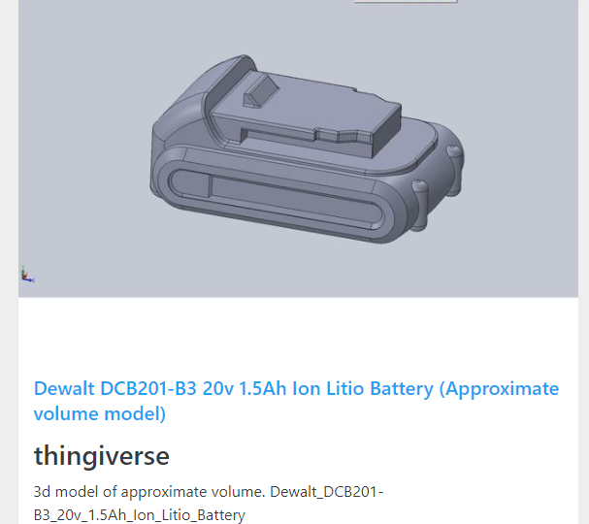

A low profile connector for the Dewalt battery:

https://www.thingiverse.com/thing:2435964

