Planktivore – In-Situ Microscope Instrument 902004
Francisco Chavez, Henry Ruhl, Steve Haddock, Thom Maughan, Paul Roberts, Brent Jones, Jon Erickson, Denis Klimov, Jose Rosal

The Planktivore team has developed two in-situ microscope instruments. The first, Planktivore v1, was developed for the Spray Glider. The second, Planktivore v2 has been developed for the LRAUV. Planktivore v2 has longer microscope tubes to extend the imaging volume ahead of the bow wake of the LRAUV and improved lighting for faster vehicle speed. Both instruments consist of a low magnification, 100um to 2cm, and high magnification, 10um to 200um, imaging pipelines that use computer vision to select and store regions of interest that are in focus. Both versions of Planktivore can be used on other platforms and have battery packs for standalone operation.

Engineering activities:

- The project team has supported 4 deployments since Feb 2025. The most recent deployments are in support of the following projects:
  - 3/31/2025: Targeted sampling using real-time detections for adaptive yo-yo and coordinated sampling with i2map (See Figure 1)
  - 4/07/2025: MBTS with Plankton Proxies
  - 4/14/2025: Synchro Off Shore Wind (OSW) study, transects out past M2
  - 4/21/2025: CFE Lab sediment trap tracking
- The benthic Planktivore system will be deployed as part of the Barry Lab operation on May 9 and recovered on May 12.
- CeNCOOS and MBARI are working together to develop models for automatic classification of Planktivore images. Data set generation is underway using ai-enabled tools developed by Danelle Cline and manual classification and review of automated classification is being supported by the CFE lab and CeNCOOS.
- Optical and electrical design for the shadowgraph version of Planktivore are underway and targeting testing in the Fall of 2025.
- Assembly and testing of a second Planktivore v2 system will begin next month (June 2025) with first deployment aimed at the mesopelagic LRAUV.

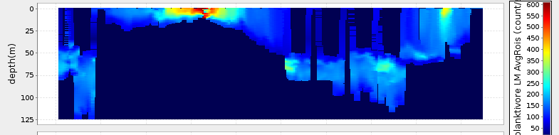
Figure 1: Plot of Planktivore low-mag camera counts from adaptive yoyos. The algorithm was set to adjust the min and max yoyo depth in real-time to sample the peak and 50% of peak depths while also remaining aware of maximum depth limits to avoid the shelf. Note that the behavior enabled more densely sampling a layer between 75 and 85 m when the vehicle entered deeper plankton-rich water.

