Project Number: | 902004

Project Start: Jan. 1, | 2020 | Project Duration (in years): | 4/4

Please indicate if proposal includes requests for any of the following (mark all that apply).

 |  |  |  |  |  |  | x |  |  | x
Ship Time |  |  | ROV |  |  | AUV |  |  | Wave Glider |  |  | Mini ROV

Please indicate what type of project is being proposed (mark only one).

 |  |  |  | X
Feasibility/Scoping  [<100 days effort] |  |  | Development |  |  | Research |  |  | Infrastructure² |  |  | Education |  |  | Time Series |  |  | Institute Initiative

Project Manager: Thom Maughan
Principal Investigator: Francisco Chavez
Lead Scientist: Steve Haddock
Lead Engineer: Paul Roberts

Project Title: Planktivore: A modular, wide magnification range, multi-illumination mode, long deployment duration, plankton imaging microscope with onboard processing

Please indicate which category best describes the project theme (mark only one).

 |  |  |  |  |  |  | X
Ocean  biogeochemistry |  |  | Ecosystem dynamics |  |  | Ocean visualization |  |  | Exploration & discovery

Please indicate percentage of effort on this project anticipated for 2023 toward these three highest institutional goals (percentage total should equal 100%).

Goal | Developing/adapting innovative technologies | Utilizing developments to explore and understand ocean systems | Technology/knowledge transfer
Percentage | 50 | 25 | 25

- ABSTRACT (all projects)
Briefly provide a high-level summary of the project (ideally no more than 1/2 page).

The scientific requirements for observing the full gamut of life in the sea over the needed time and space scales have been well described. Here we propose to develop an instrument that will image particles in the ocean from 20 μm to 2 cm that can be deployed broadly on platforms like profiling gliders or floats to MBARI ROVs. This size range fills in an observing gap at MBARI between microbes and large zooplankton.

We propose to build an enhanced plankton microscope that leverages an existing glider based microscope (Scripps Zoocam / Zooglider1). Zoocam is a miniaturization and power optimized variant of the ISIIS2 plankton imaging system.

Scripps Zoocam Features:
- Anti-fouling wiper and UV LEDs for long deployments.
- Red LED illumination to minimize copepod avoidance.
- A telecentric lens (for size invariance in the optical path), 500 µm to 2 cm.
- Shadowgraph illumination in a second housing.
- Free-space, free-flow imaged volume minimizes avoidance and size exclusion.
- Image processor for ROI statistics.
- Requires only vehicle power and serial comms.
- Minimized SWAP (size, weight, and power)

MBARI Planktivore Enhancements to Zoocam
- Enhanced size range, 20 µm to 2 cm
- Expanded size range by addition of a second 5x telecentric lens and camera
- Additional illumination modes
- Shadowgraph. Monochrome, large DOF (depth of field), accurate size
- Darkfield. Color, smaller DOF, excellent contrast
- Holographic. Monochrome, large DOF, accurate size
- USB3 Machine Vision Camera with a size / formfactor / standard c-mount lens that enables a range of image sensor price/performance options, see reference below.
- Embedded compute module providing image processing
- Real-time data reduction (~1000:1) by image processing and storing ROI (regions of interest)
- Real-time particle size spectra
- Plankton identification leveraging machine learning and drawing on CANON HiPP / waveglider towbody microscope.
- Deployable on any MBARI asset: Glider, LRAUV, Profiling Float, Waveglider, Dorado, ROV.

Note: Concept and Design sketch credit to Paul Roberts.
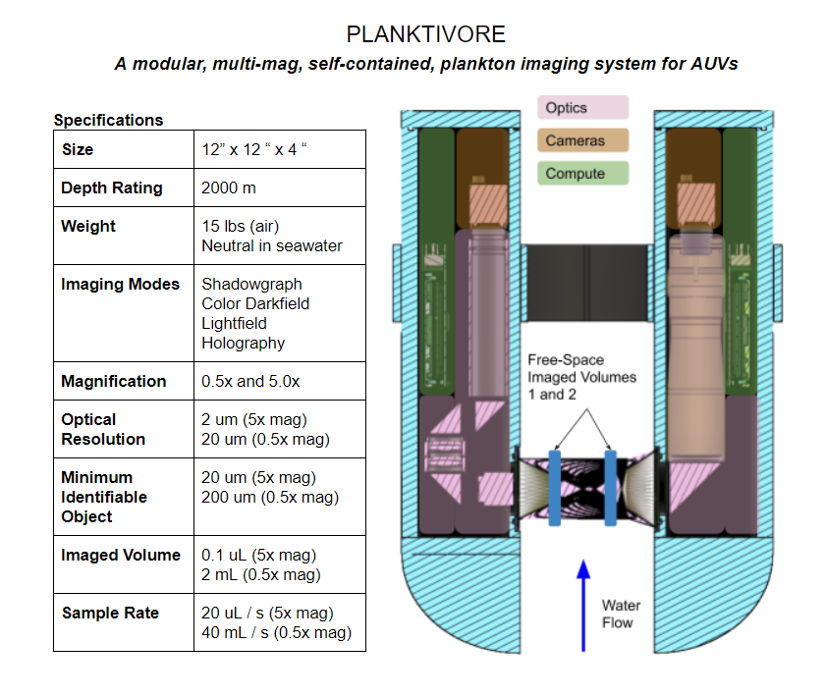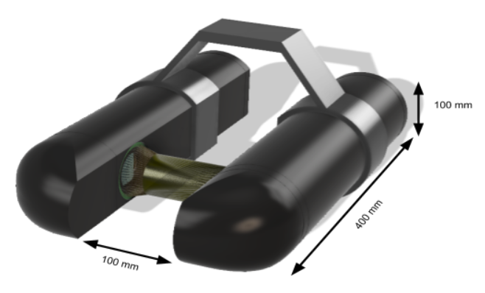
Note: the optical path is free flow. The diagram above shows ray tracing along with blue rectangles as a cartoon of the imaging volume associated with the optics. There is only a bracket between the tubes and no physical structure in the optical path.

Science Motivation:
- Many oceanographic efforts take the form of developing proxies for biological communities, such chlorophyll or bioluminescence for phytoplankton, acoustic backscatter for zooplankton, eDNA for ecosystems, and molecular probes for harmful algae. These proxies all focus on a subset of the community, and are only roughly quantitative to varying degrees.
- MBARI is a leader in the imaging of larger zooplankton (>2cm) yet we have limited capabilities for studying the base of the food chain (phytoplankton) or important prey for forage species (copepods and other zooplankton).
- Persistent presence would let us document vertical migration and the flux of biomass both up and down the water column.
- Visibility into hot spots. Plankton distribution is heterogeneous - ship based methods miss these hot spots, glider / LRAUV would ‘illuminate’ the hot spots with clarity on what is present rather than bulk measurements provided by fluorometer with backscatter.
  - Contextual mapping of the bio signatures would provide triggers for CANON / ESP sampling or other similar eco-system studies.
- As an instrument, it would provide distribution of plankton in space and time. This would enhance ocean sampling beyond salinity and temperature to the biological signals.

- PROPOSAL (all projects)

Background
Provide context for the project, being sure to address these questions:
- What fundamental problem does this project address, and why is it important?
- What makes this work relevant to MBARI and the Packard Foundation?

The scientific requirements for observing the full gamut of life in the sea over the needed time and space scales have been well described. We propose to develop an instrument that will image particles in the ocean from 20 µm to 2 cm that can be deployed broadly on platforms like profiling gliders or floats to MBARI ROVs. This size range fills in an observing gap at MBARI between microbes and large zooplankton.

- Is this effort linked to other internal or externally funded projects or collaborative efforts?

This project is linked to CENCOOS (702103) which has provided over $60K in funds for materials and supplies for the development of the first Planktivore version for a Spray Glider and plankton image workflow processing computer.

This project is synergistic with SINKER (shared opto-mechanical design and image acquisition software) and builds off existing pressure housing designs from AyeRIS.

- Where does this work fit into the ~5–10 year plan for your group, at MBARI, and in the field?

In-situ Plankton imaging (20um to 2cm) is complementary to in-situ eDNA and provides a tool in the coordinated and targeted sampling themes of CANON that could provide visual identification of plankton to validate proxies and toxin analyses from spot samples.

Nature and Scope of the Proposed Project
Please provide a sense of the scale and scope of the proposed work. Is this a large de novo R&D effort, modest platform/sensor integration, targeted science investigation with minimal or no engineering needs, extension of current program, small-scale scoping exercise expected to lead to a larger effort, or other? If the project is intended to be multiple years, how will the anticipated level of effort likely change over time?

The Planktivore in-situ microscope contributes to several research themes within the Strategic Plan:
- Exploration and Discovery (observation of plankton leading to the discovery of new species, patterns, and phenomena)
- Ocean Visualization (species abundance and distribution patterns)
- Ecosystem Dynamics (establishing biodiversity baselines).

Does this activity relate to one or more 2023 proposals your team is submitting?
If so, provide a list of relevant projects by project/DQ # and provide a brief description of how they are related. Since resources are limited and cuts during Phase 1 are likely, please indicate where this project fits in the hierarchy of your priorities. Does this proposal take precedence over other ongoing or planned activities?

[Click here to enter text]

Anticipated Shared Resource Needs
What staffing is required to advance the work in 2023 (e.g., is this a multi-faceted engineering development or a targeted science investigation that does not require significant use of shared personnel)? Is in-house or contract manufacturing needed? What level of ship/ROV/AUV (DMO) support is likely? If this is intended to be a multi-year effort, please provide a rough indication of anticipated shared resource needs over the duration of the project (e.g., will stay flat, will significantly increase in Year X, will significantly decrease by Year Y).

Continued use of lab space in the ‘Rock Lab’ or consolidation into a dedicated imaging system space with related projects such as SINKER and EyeRIS.

Anticipated Expenses
What rough order of magnitude direct expense budget is anticipated annually over the course of the project? Is procurement of specialized capital equipment or outside contractors required? Will there be annual travel?

~$70K for materials and outside services, ~1750 hrs of engineering labor. Lucendi flow cytometer eval potentially adds an additional $25K, though we do not have a quote and are working to get a loaner / demo.

There is a risk on availability of Mechanical Engineering resources that may require funds for outside services if an MBARI ME resource is not available.

Travel to a conference

Intellectual Property (IP) Considerations
Do you anticipate a need for a cooperative research and development agreement or licensing arrangement with an external entity? Will the work potentially result in a patentable product or service? Will novel IP and/or custom-made equipment be created, and how might it be disseminated (e.g., license agreement and/or collaborations)?

For additional guidance please review MBARI’s intellectual property internal web page: https://mww.mbari.org/itd/ip/.

Zoocam cad files have been shared by Scripps. These files have been helpful for integration with the Spray Glider however we have designed our own housing, vehicle mount, electronics, optics and software.

Using open source hardware and software (embedded Linux, NVidia, etc.), much of which was created by Paul Roberts / Guatek in his personal time outside of MBARI.

Data
What data will be generated? How will they be managed/stored? Are any special data visualization needs anticipated?

Cropped (region of interest) plankton images as well as periodic storage of full frame images for quality control of cropped images are the data products generated by Planktivore. Ten to Fifteen frames per second with an estimated average of five plankton cropped images per frame.

Data will be stored on DeepRip and select data sets copied to Atlas. CENCOOS is scoping the workflow for plankton image processing by Axiom with assistance and guidance by the Planktivore engineering team.

Data will be made available to CENCOOS for dissemination. DeepRip has 32TB of RAID storage and hosts the Planktivore image ingest software RIMS.

2021: 500GB
2022: 1.5 TB
2023: 2.5 TB

Anticipated Impact
Who are the consumers of the instruments, methods, technology, and data that will be generated within and beyond MBARI? Will the project create tangible connections with other organizations (e.g., academic, NGO, MBA, MBNMS, state or federal agency)?

2021: CENCOOS - essential ocean variables, plankton biomass and diversity
photogrammetrically defined data quality, closer to the metrology of physical oceanography.
2023: EcoHAB - Spot sampling of HAB species to corroborate with water sample analyses
2023: AyeRIS - Contextual information about constituents of marine snow aggregates to inform sources of particle counts.
2023: Carbon Flux Ecology Lab - Free-space images of small zooplankton and phytoplankton to determine sources of organic material collected in drifting sediment traps

Anticipated Outreach Needs
Thinking about the audiences/consumers you highlighted in the question above, do you anticipate needing to create outreach assets to help increase your impact? If so, please specify whether you anticipate needing to work with ITD and also specify what type of asset (story, graphic, animation, video, etc.) you might need.

Some assistance with graphics for presentations and poster / paper publishing.

Continuing Projects Only: Status Report
Briefly provide an update of the current project relative to what was proposed for 2022 by responding to the prompts below. If the project includes multiple subproject projects, please list each of these under a subheading as you deem appropriate.

Current status of project and results to date

First version of Planktivore was fabricated, assembled, lab tested, and tested at sea for 20 minutes on a Spray Glider on 11 May 2022. The first test resulted in 171K images.
More deployments on the Spray are planned and we are working around the schedule of other users of the Spray as one of the gliders was out of commission since February due to a corroded pressure case. We anticipate Spray deployments starting in August.

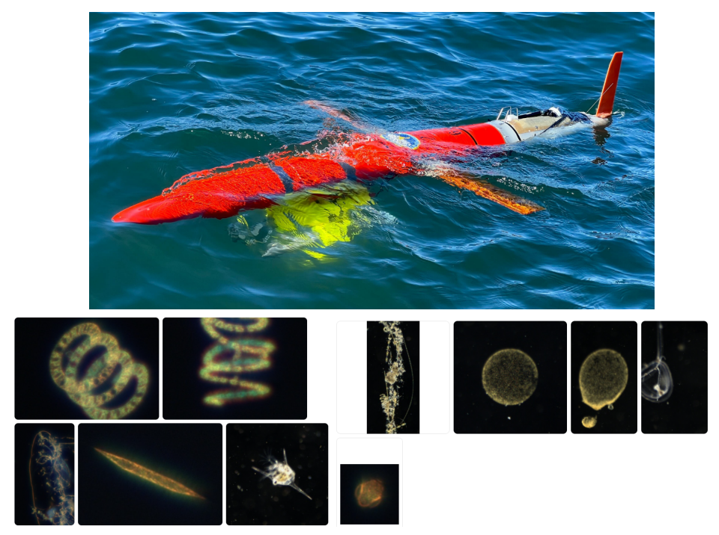

We have an image / lighting benchtop setup called Aquavore as well as a particle/plankton flow setup (Fluum). Fluum has an upgraded imaging section planned for completion this year.

Custom strobes, strobe electronics and camera control electronics have been developed. We have an external pressure transducer integrated with the camera control board

Two Neutral buoyancy housings aka, Noot, have been designed, assembled and tested. These enable standalone deployments on pier, ctd cast, etc. Noot is 20v 30ah (600 W-hr) rated to 200m.

A bracket has been fabricated that ties one to two Noots to Planktivore for deployments off Paragon, on CTD rosette, piers, etc.
Field tests are planned to assess flight characteristics of the Spray + Planktivore. Longer missions with the goal of sampling C1 to M1. We have brackets for testing off the Paragon, Pier and CTD Rosette and are planning a coastal profiling float bracket.

We have 125hrs ME resources remaining and will focus that effort on an updated and more modular housing design towards the goal of improved Spray and adding LRAUV integration. Estimates on ME resources for 2023 assume this work in 2022 is not performed as the individual is on 17 projects.

What percentage of labor and budget have been used through the 1st half of year?

Engineering Labor: ~75% used, 25% remaining

Function |  | alloc | used
ENG-Machinist |  | 120 | 91
ENG-Electrical Tech | McClure, James - 1167 | 80 | 19
ENG-Electrical Engineer | Jones, Brent - 0996 | 100 | 48
ENG-Mechanical Tech | Schnittger, Aaron - 0857 | 40 | 68
ENG-Electrical Tech | Coenen, Paul - 0491 | 80 | 0
ENG-Research Engineer | Roberts, Paul - 1107 | 200 | 173
ENG-Mechanical Engineer | Erickson, Jon - 0191 | 200 | 73
ENG-Software Eng-Info Eng | Edgington, Duane - 0233 | 180 | 41
ENG-Electrical Engineer | Klimov, Denis - 0566 | 160 | 235
ENG-Software Engineer-Embedded | Maughan, Thomas - 0774 | 560 | 530

Budget: 60% used, 40% remaining (with a 2022 spend plan).

Will you complete the current year’s scheduled work?

We have fabricated the first revision of the Planktivore housing. This took longer than anticipated and was completed at the end of March 2022.

We were able to engineer and test the strobe lighting, camera, camera controller and integration with Xavier NX by creating 3D printed proxies of the housing which enabled parallel development.

Our plan for biofouling mitigation was deprioritized.

We have done investigation of lower power compute platforms as alternatives to Xavier NX. Preliminary numbers look like we can save up to 40% power.

We are on track to fielding planktivore with deployments on Spray Glider as well as on CTD Rosette, Pier, Aquarium, etc.. We are also looking into attaching Planktivore to the Waveglider towbody late in 2022. This is dependent on DMO resource availability.

In 2021, we had proposed Wire Walker and Mini ROV as candidates for deployment. Mini ROV is not an option for 2022 due to scheduling and the Wire Walker profiling speed is not ideal for imaging. We are exploring the Chavez lab coastal profiling floats as an option.

Significant changes from previous project proposal

The most significant change is that we have created and fielded the first version of a working in-situ microscope.

First deployment successfully recorded 171K plankton images and were uploaded into the plankton image management software (RIMS) on DeepRip, our 64 core Threadripper based server with 256GB RAM, GPU’s and 32 TB storage.

We have successfully created a functional first version 2000m housing, optics, electronics and embedded compute software with image ingest and hosting on DeepRip. We have learned lessons and are proposing to address those in a second revision of the housing.

Over the past two years, what peer-reviewed publications, education and/or outreach activities have resulted directly from this project? Please be brief.

None

All Projects: Specific Plans for 2023

Research Activities

What we are proposing for 2023 is

A) Planktivore integration with LRAUV / Deep LRAUV by leveraging re-use of AyeRIS components (housing, lrauv software integration).

B) Rev. 2 Planktivore integration on Spray Glider. Changes for modularity, re-use of components from LRAUV integration and greatly reduced drag by integrating with a modified nose cone. Housing design for the compute node and camera control would follow the same design as the AyeRIS housing for LRAUV.

C) Evaluation of Lucendi Flow cytometer for integration on LRAUV. We did not have a quote from Lucendi in time for phase 1, though we did meet with them. We have entered $25K as a placeholder.

Engineering/technology development

Utilize power over ethernet for camera interface instead of USB3. This enables bulkhead connections and follows the trend of other camera based projects at MBARI.

Software re-use from EyeRIS for sending engineering data, particle size statistics, and real-time classification of ROIs into functional groups.

Time, Depth, Motion based Plankton imaging triggers via camera controller along with rudimentary Spray 1 software integration (start, stop, status).

Field programs (detail ship requirements/deployments/diver requirements)
In addition to describing anticipated field programs, please be sure to include requirements for specific platforms and equipment (Dorado AUVs, LRAUVs, Wave Glider, mini ROV, etc.) for each proposed field program so that expectations are clear. Requests must also be entered in the budget entry system.

Spray

LRAUV

EcoHAB

Specific deliverables

Planktivore Rev. 2 integrated on LRAUV / Deep LRAUV
- Aluminum compute housing (re-use from EyeRIS)
- Aluminum microscope housings similar to Rev 1 with minor improvements
- PoE cameras replacing USB3 cameras, but essentially the same optics and lighting as rev. 1 Planktivore.

Planktivore Rev. 2 integrated on Spray
- Re-use modular housing design from LRAUV integration.

Performance analysis of Lucendi holographic lens-free flow cytometer module. Imaging, Power, Size, Pressure, flow stream, etc. Pseudo-nitzschia is the target organism. Investigate integration feasibility with ESP payload or other on LRAUV for EcoHAB.

Deployments of rev 1 Planktivore.

Milestones and required personnel (see personnel classification list for staff classifications)

2023 Project Start Date:  MM/DD/2023 | Milestone 1 | Milestone 2 | Milestone 3 | Milestone 4 | Milestone 5 | Total Resources (in hours) for each resource category for all milestones listed here
Milestone Date | Housings | Electronics and optics | Integration LRAUV | Integration Spray | Lucendi Cytometer
Milestone Description | Design and fab of modular housings | Electronics and optics update, test | Integration on LRAUV | Integration on Spray Glider | Performance eval of Lucendi Cytometer
Electrical Engineer | 40 pldr | 60 pldr  80 dk | 60 pldr  20 dk  60 bj | 60 pldr  20 dk  60 bj | 80  120 dk | 300 pldr  240 dk  120 bj
Software Eng-Embedded | 80 tm | 160 tm | 100 tm | 100 tm | 120 tm | 560 tm
Software Eng-Info Eng |  |  | 60 de | 60 de |  | 120 de
Mechanical Engineer | 400 je |  |  |  |  | 400 je
Mechanical Eng-Division
Mechanical Eng-Mfg
Associate Engineer
Electrical Tech |  |  | 20 | 20 |  | 40
Software Tech
Mechanical Tech |  |  | 100 | 100 |  | 200
Machinist | 160
Divers
Video Lab
(Add other categories/rows as needed)

Budget justification

Item | Amount | Notes
Housing Materials | 8000
Cameras, Optics | 14000
Electronics fab and assembly | 18500
Connectors and cables | 4500
Outside services machine shop, 3D printing | 5500 | 3D printing and $3.5K outside machining in the event of schedule challenges.
Lab supplies and tools | 7500
DeepRip storage / backup | 2800
Lucendi flow cytometer | 25000
Operations cost (Spray Batteries) | 12000
Travel | 4000
 | -------------------------
Total | 101800 | $76,800 + $25,000

Project team

Paul Roberts, lead engineer, mechanical, optics, electrical, software
Jon Erickson, housing design
Brent Jones, Spray integration, test and deployment
Denis Klimov, optics, test and measurement
Duane Edgington, plankton image management, integration with MBARI systems
Aaron Schnittinger, mechanical design and fab
Roman Marin, mechanical design and fab
Jose Rosal, electronics assembly
James McClure, electronics assembly
Jim Montgomery, electronics assembly
Thom Maughan, project management, electrical, embedded software

External consultants/contractors
If you propose to engage an external consultant/contractor, please attach a sufficiently detailed SOW and budget proposal from the vendor. If approved, a fully executed Independent Contractor Agreement must be in place before work can begin.

For Phase 1, MBARI ME resources are requested. The work we are planning can be outsourced and we would then identify a contractor and get an estimate in the case MBARI ME resource is not available

Project lab and office space requirements
In addition to any changes to current space usage, please also include anticipated office and lab needs for students, postdocs, collaborators, etc.

Continued use of the Rock Lab

Risk matrix (development and infrastructure projects only)

 | Technical Risk | Organizational Risk | Tech Transfer Risk | Labor Estimate Risk
High
Medium |  | X | X | X
Low | X

Compliance Considerations
Please respond “Yes” or “No” to each line item below, and provide details as necessary.

CATEGORY | Yes/No | DETAILS
Isotope Use (see policy and cruise planning)  Will the project use stable or radioisotopes? | No
Battery waste over 4 liters (1 gallon)  Indicate type and amount. | Yes | Spray Batteries, primary lithium
Liquid hazardous waste over 60 liters (15 gallons)  Indicate composition and quantity. | No
Export Regulation  Foreign collaborations or international travel? | No
Technology access  Any potential exposure to proprietary information about export controlled equipment? | No
Export controlled purchases  Items purchased/in possession or to be purchased that are not on list? | No
Export controlled items (hardware, software, tech data)  Items to be transferred outside US (temporarily or permanently)? To what countries (including International Waters)? | No
Encryption Items  Use of non-commercial (specially licensed, non-mass-market) encryption or information security software? | No
Work covered by Marine Sanctuary permit?  Yes, if work falls under blanket authorization. | Yes
Work conducted in SESAs?  ID # for Sanctuary Ecologically Significant Areas | No
Equipment deployed with anchors?  Give details for deployment; recovery if < 500lbs | No
CA Fish & Wildlife permit required for samples? | No
Working in State Marine Protected Area? | Yes
Require Coast Guard PATON for buoys?  Private Aid to Navigation. Permit in hand? | No
Require Local Notice to Mariners  Indicate who will be submitting | Yes | Brent Jones / Chris Wahl
Permits from other agencies? | No
Use of active acoustics not already on list? | No

Appendix:
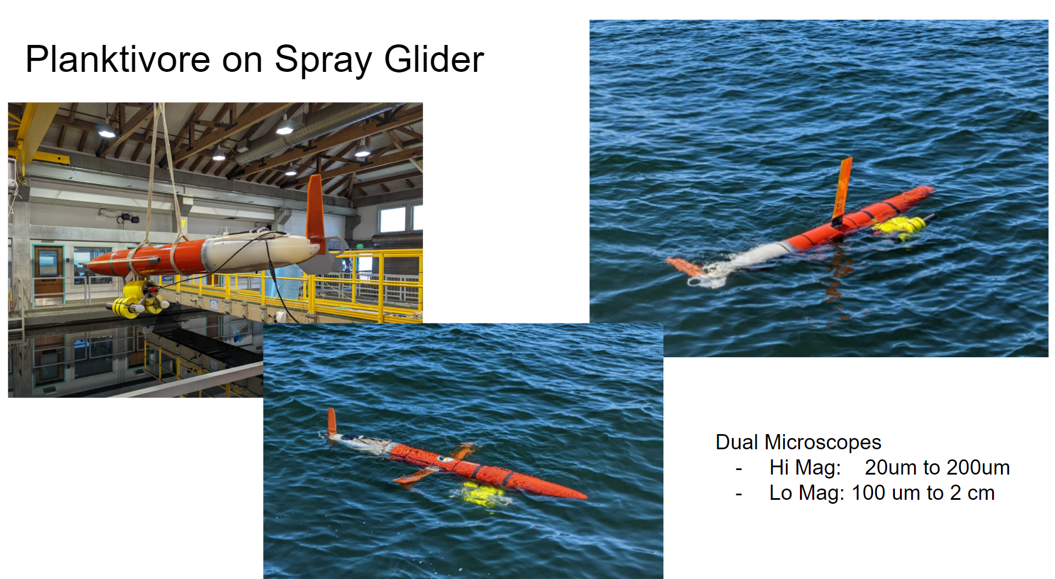
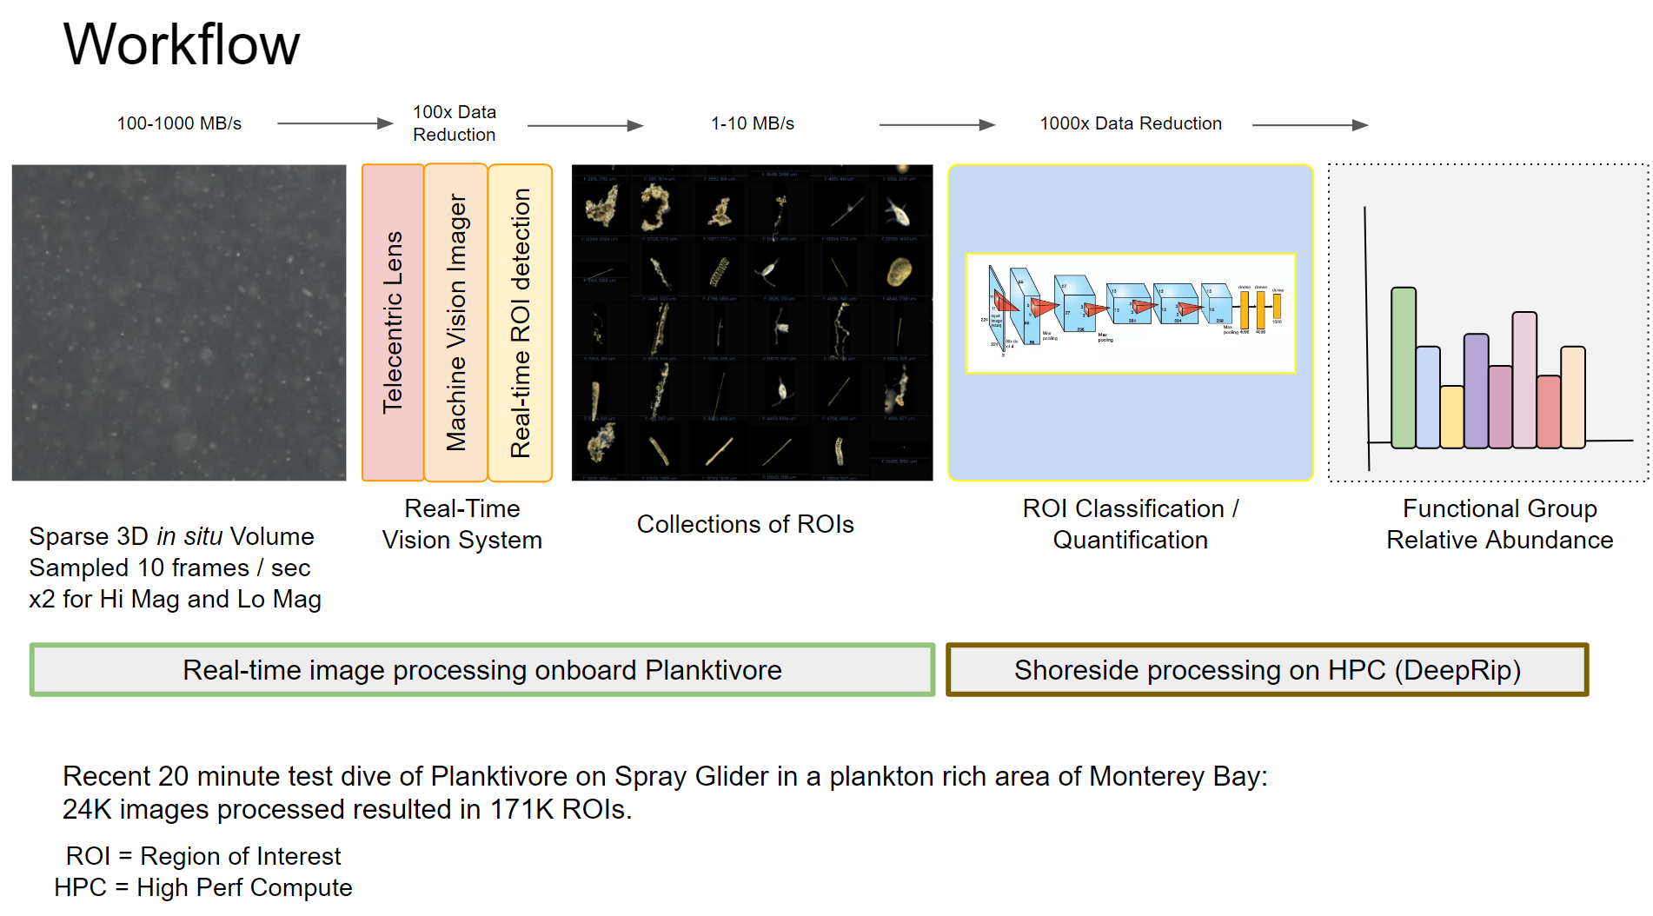
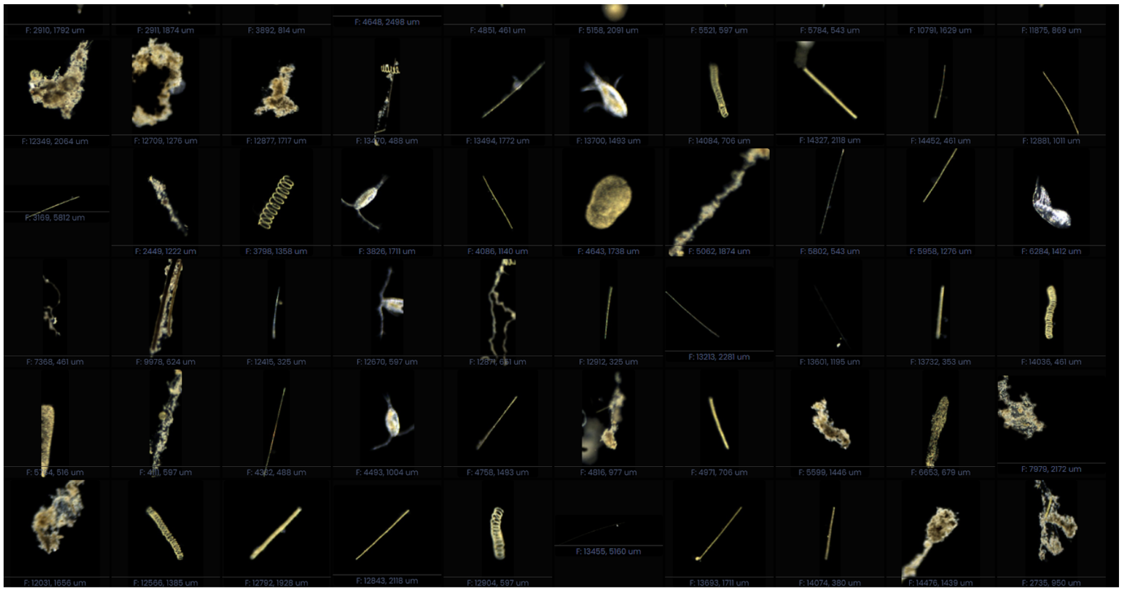
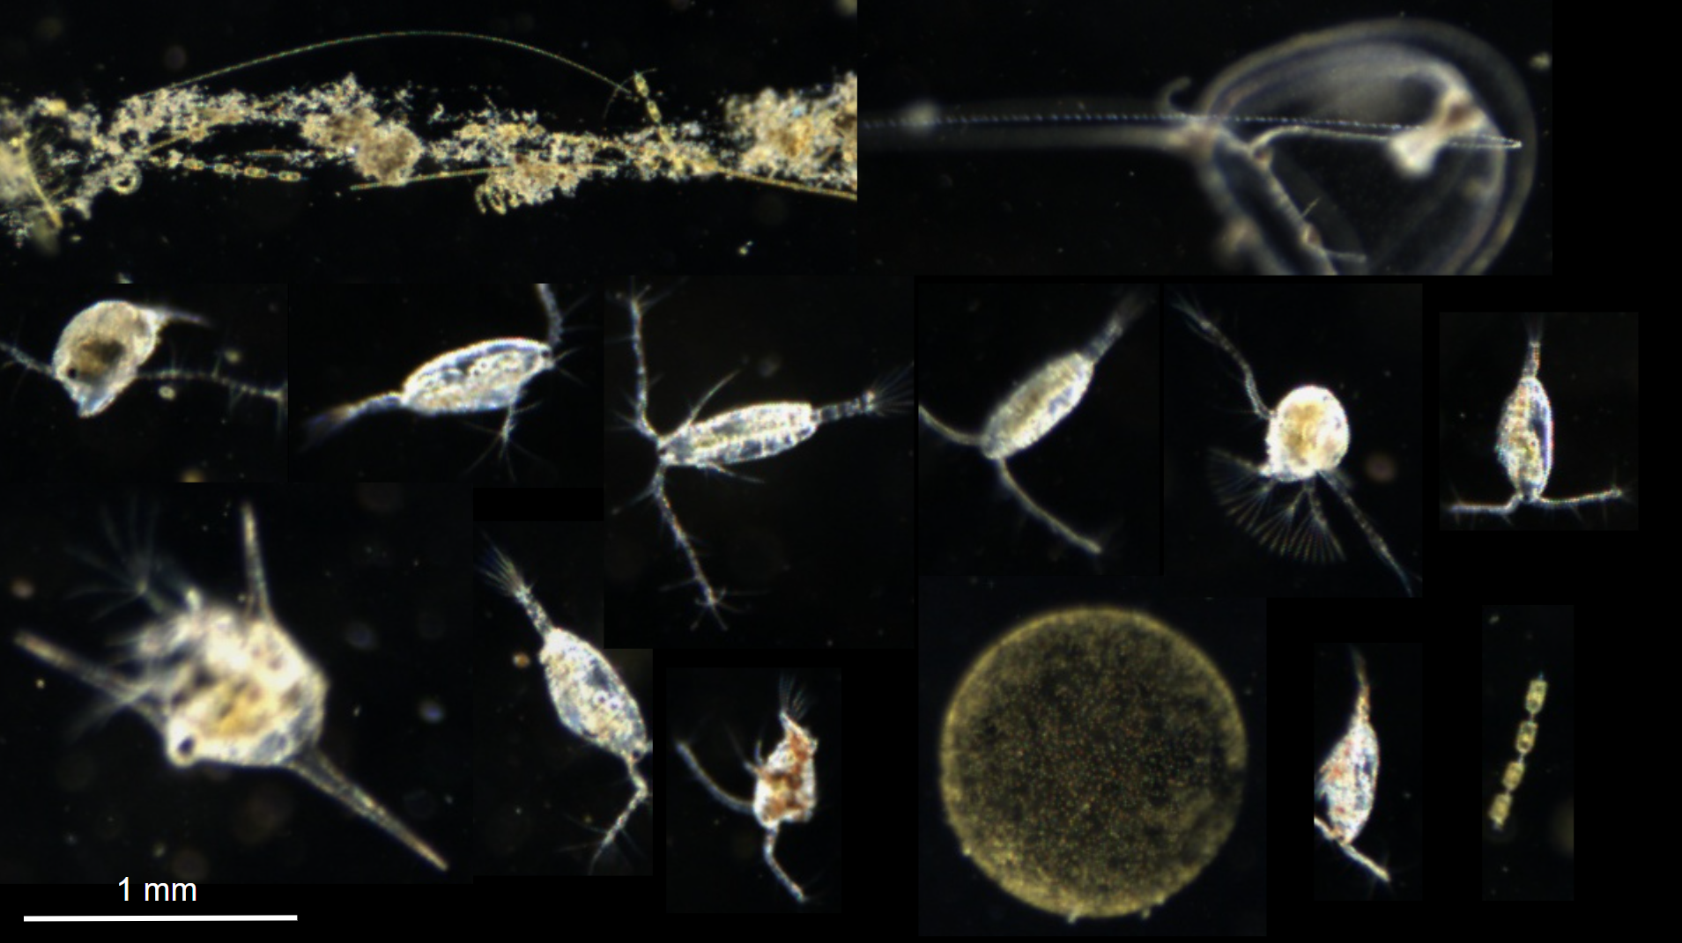
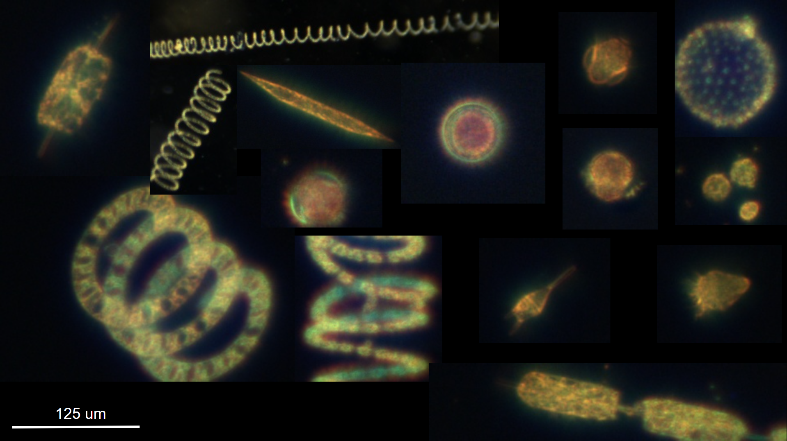
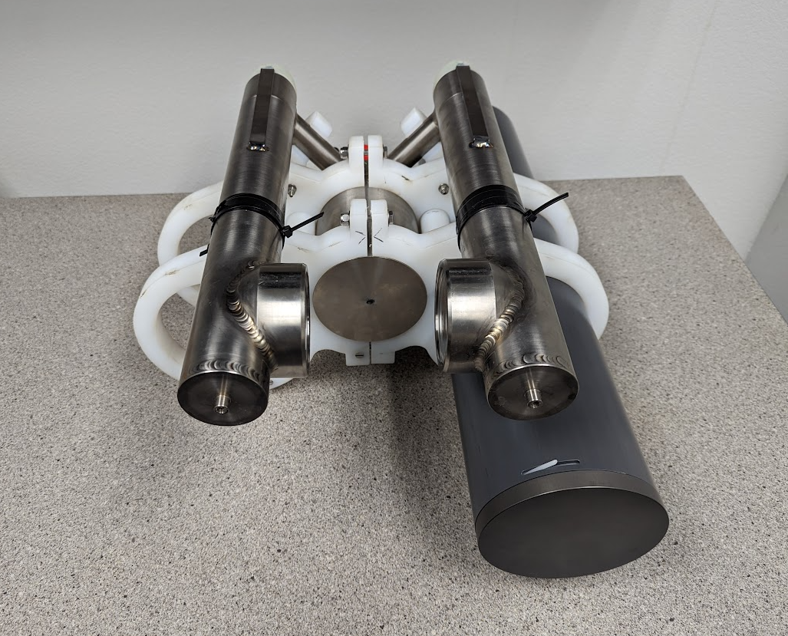

Development and infrastructure projects must complete the risk matrix (see end of the proposal form).
Not all projects will require all four titles to be filled in. Please indicate individuals only for those titles that are appropriate for your project.
This category includes transfer of hardware, know-how, publications, presentations, etc.
This number should be the same number you entered on the web budget resource requests for this particular resource.

