Project Number: | 902004

Project Start: Jan. 1, | 2024 | Project Duration (in years): | Year 2 of 3¹

Please indicate if proposal includes requests for any of the following (mark all that apply).

 |  |  |  |  |  |  | X
Ship Time |  |  | ROV |  |  | AUV |  |  | Wave Glider |  |  | Mini ROV

Please indicate what type of project is being proposed (mark only one).

 |  |  |  | X
Feasibility/Scoping  [<100 days effort] |  |  | Development |  |  | Research |  |  | Infrastructure² |  |  | Education |  |  | Time Series |  |  | Institute Initiative

Project Manager: Thom Maughan
Principal Investigator: Francisco Chavez
Lead Scientist: Steve Haddock
Lead Engineer: Paul Roberts

Project Title: Plankton Microscope for Deep Ocean Robots

Please indicate which category best describes the project theme (mark only one).

 |  |  |  | x |  |  | x
Ocean  biogeochemistry |  |  | Ecosystem dynamics |  |  | Ocean visualization |  |  | Exploration & discovery

Please indicate percentage of effort on this project anticipated for 2025 toward these three highest institutional goals from the Strategic Roadmap (percentage total should equal 100%).

Goal | Innovate and Build | Explore and Protect | Inspire and Engage
Percentage | 40 | 50 | 10

- ABSTRACT (all projects)
Briefly provide a high-level summary of the project (ideally no more than 1/2 page).

Planktivore is an in-situ microscope covering the size range 20µm to 2cm designed for use on autonomous vehicles and other mbari ocean research platforms. The motivations for Plankton imaging are comprehended in the Ocean Visualization portion of the MBARI Tech Roadmap. Science users of a Planktivore microscope are provided with particle size spectra, statistics, and region of interest (roi) images of plankton, marine snow and other suspended material.

Planktivore v1 is designed for 2000m depth and water speeds up to 0.4 m/s.
Planktivore v2 is designed for 1500m and speed through water up to 1 m/s. Power consumption is ~15W.

First phase was development, fabrication and field testing of two versions of Planktivore for autonomous underwater vehicles. This second phase of the project is for deploying Planktivore on LRAUV and other vehicles for documented science usage scenarios (use cases). Engineering resources will be used for workflow automation, machine learning for classification, machine learning for targeted in-situ identification. Example: detect pseudo-nitzschia. We will provide support for data processing to best understand the requirements and usage of plankton size statistics and image data.

Science use cases defined by working with researchers interested in LRAUV+Planktivore:
Steve Haddock
Francisco Chavez / Katie Pitz
Colleen Durkin, Crissy Hufford, Sebastian Sudek
Yanwu Zhang
Monique Messie
Jim Barry, Steve Litvin
John Ryan
Henry Ruhl / Jason Adelaars

- PROPOSAL (all projects)

Background
Provide context for the project, being sure to address these questions:
- What fundamental problem does this project address, and why is it important?
- What makes this work relevant to MBARI and the Packard Foundation?
- Is this effort linked to other internal or externally funded projects or collaborative efforts?
- Where does this work fit into the ~5–10 year plan for your group, at MBARI, and in the field?

The Planktivore project aims to develop in situ optical imaging tools to answer foundational ecological questions about planktonic ecosystems. Key to this effort is to establish routine data products that quantify the distributions of plankton taxa in the water and how these distributions change in space and time. MBARI continues to lead the development of optical imaging systems to answer these questions for plankton in larger size classes in the range of centimeters to meters, yet thus far has leveraged proxy methods to quantify abundance of plankton in the range of 10s of microns up to centimeters. This size range represents a vast collection of primary and secondary producers who play essential roles in the ecosystem. By adding optical imaging tools to MBARI’s collection of data products the Planktivore project can both provide actionable abundance data for a significantly wider range of size classes of plankton, while also providing ground truth data for plankton proxy measurements.

Nature and Scope of the Proposed Project
Please provide a sense of the scale and scope of the proposed work. Is this a large de novo R&D effort, modest platform/sensor integration, targeted science investigation with minimal or no engineering needs, extension of current program, small-scale scoping exercise expected to lead to a larger effort, or other? If the project is intended to be multiple years, how will the anticipated level of effort likely change over time?

The Planktivore engineering development effort finished in 2023. In that time, the Planktivore project had designed, fabricated, and deployed two autonomous-vehicle-capable imaging systems that have collected spectacular images of plankton in the range of 10s of microns to several centimeters. An overview of the resulting instruments and capabilities is shown in Figure 1. Planktivore V1 has been deployed on the Spray Glider and in the bay.. Planktivore V2 has been deployed off the Paragon and on a mooring located near the Power Buoy where it recorded over 20 million Regions of Interest (ROIs) during the three-day deployment. It has also been successfully ballasted, integrated, and deployed on an LRAUV for multi-day missions.

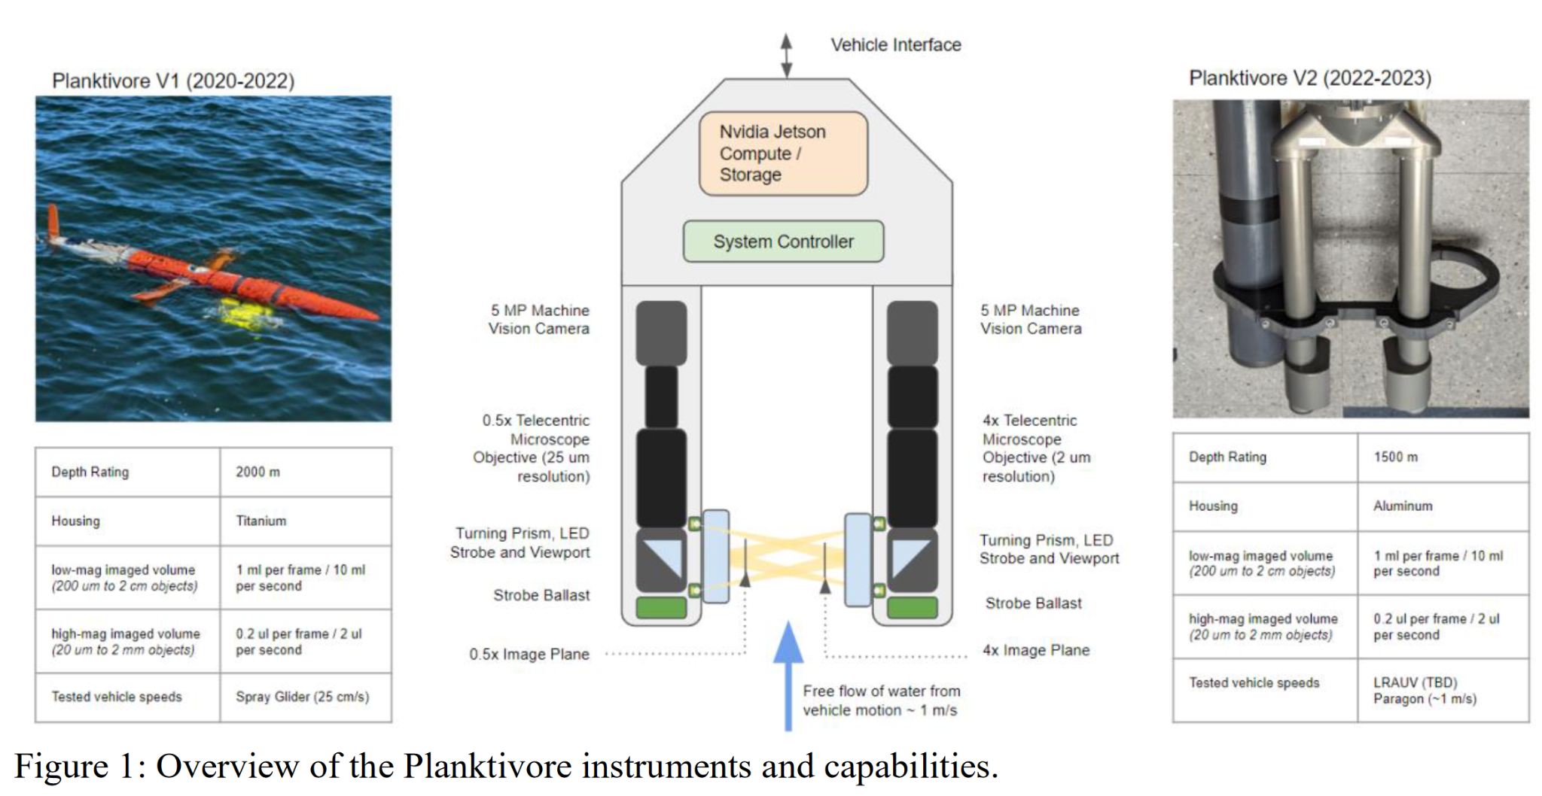

Here we propose to continue the transition from an engineering project to a regularly deployed asset — part of the standard tools that can be used without significant engineering resources. In 2025, the project aims to:

- Increase the imaged volume of the system by a factor of 10x in the lox-mag camera and 2x in the high-mag camera to enable operations in lower concentrations of plankton.
- Reduce the power consumption of the system by at least a factor of 2 to enable deployments on the LRAUV that can last for two weeks.
- Increase the frequency, duration, and depth of deployments to enable participation in a wider range of science use cases.
- Demonstrate in-situ plankton detection of a target organism such as pseudo-nitzschia and publish these detections in real-time to inform targeted sampling.

The first two goals are engineering focused and tackle fundamental challenges with broad impact to plankton imaging. Preliminary evaluation of compute hardware and complementary optical imaging modalities have shown promise to address these challenges without a substantial redesign of the systems.

Having achieved many of 2024’s priorities, the primary 2025 goal is to deploy Planktivore frequently throughout the year on the LRAUV and if possible on the 1500 m rated LRAUV. There is an increasing demand from the MBARI user base for regular and coordinated deployments at least once per month and also during collaborative field campaigns such as Synchro and CANON.

For data analysis, we will continue to leverage the compute capabilities of Planktivore to detect targeted functional groups of plankton in real-time and ultimately publish these detections from the vehicle to shore.

Does this activity relate to one or more 2025 proposals your team is submitting?
If so, provide a list of relevant projects by project/DQ # and provide a brief description of how they are related. Since resources are limited and cuts during Phase 1 are likely, please indicate where this project fits in the hierarchy of your priorities. Does this proposal take precedence over other ongoing or planned activities?

Science users requesting Ahi+Planktivore V2:
901103 Haddock Lab, Steve Haddock
901009 CANON, Francisco Chavez / Katie Pitz
902111 Carbon Flux Ecology (Durkin) Lab, Colleen Durkin, Crissy Hufford, Sebastian Sudek
901513 Targeted Sampling, Yanwu Zhang
901910 Plankton Proxies, Monique Messie
800153 Synchro, Henry Ruhl / Jason Adelaars
Science users requesting Planktivore V1
901904 Coral Ecology, Jim Barry, Steve Litvin
Collaborating on Low Power Compute for machine vision and machine learning:
902304 Piscivore, Jared Figurski

Anticipated Shared Resource Needs
What staffing is required to advance the work in 2025 (e.g., is this a multi-faceted engineering development or a targeted science investigation that does not require significant use of shared personnel)? Is in-house or contract manufacturing needed? What level of ship/ROV/AUV (DMO) support is likely? If this is intended to be a multi-year effort, please provide a rough indication of anticipated shared resource needs over the duration of the project (e.g., will stay flat, will significantly increase in Year X, will significantly decrease by Year Y).

2025:
- Engineering support for Science Deployments ~0.3 FTE
- Engineering development ~0.3 FTE

2026:
- Engineering support for Science Deployments: ~0.1 FTE
- Engineering development ~0.3 FTE

Breakout the Science deployment support vs the engineering development and maintenance

Anticipated Expenses
What rough order of magnitude direct expense budget is anticipated annually over the course of the project? Is procurement of specialized capital equipment or outside contractors required? Will there be annual travel?

2025: ~50K
2026: ~20K

Intellectual Property (IP) Considerations
Do you anticipate a need for a cooperative research and development agreement or licensing arrangement with an external entity? Will the work potentially result in a patentable product or service? Will novel IP and/or custom-made equipment be created, and how might it be disseminated (e.g., license agreement and/or collaborations)?

For additional guidance please review MBARI’s intellectual property internal web page: https://mww.mbari.org/itd/ip/.

Planktivore uses and enhances open-source software developed outside MBARI.

Data
What data will be generated? How will they be managed/stored? Are any special data visualization needs anticipated?

The Planktivore cameras generate large numbers of regions of interest on the order of millions to tens of millions per deployment. These data are typically stored locally on the instrument and then archived after recovery. Despite the large number of regions of interest, the total data burden is typically modest, on the order of 5 TB/year. We currently have a workflow that will ingest raw data from the instrument and render visualizations of plankton images that can be searched by size, shape, and time. This is all running on the HPC Server DeepRip. By the end of 2024 we will add the capability to train models, to label images at the functional group level, and sort images by label. For 2025 we will continue to improve our workflow and incorporate models trained by Danelle Cline / Duane Edgington working in the Carbon Flux Ecology project.

In addition to archival data collection and storage, a key component of the planktivore system is the ability to detect and classify plankton images during a deployment. In 2025 we will continue to improve this capability developed in 2024 by customizing detectors and publishers on the LRAUV to provide specific abundance data during surface comms that are targeted to a given use case. The workflow pattern:

- Develop a preliminary model based on existing images that is targeted on a specific science question. For example detection of diatom chains, or detection of copepods.
- Deploy the model on the embedded compute hardware on planktivore.
- Adjust the backseat communications and dash settings to make published abundance data available during deployment.
- After recovery of the vehicle, review and retrain models to improve performance where possible.
- Add the developed model to a collection of models that are available for deployment.
- CeNCOOS, Synchro and Ocean Vision AI will contribute to datastream planning and documentation to illustrate data collection/processing towards facilitating onward use of data, such as in assessing the applicability of AI/ML processed data in ocean monitoring for use by MBNMS, BOEM et al.
An overview of the proposed data workflow and software resources is shown in the figure below:

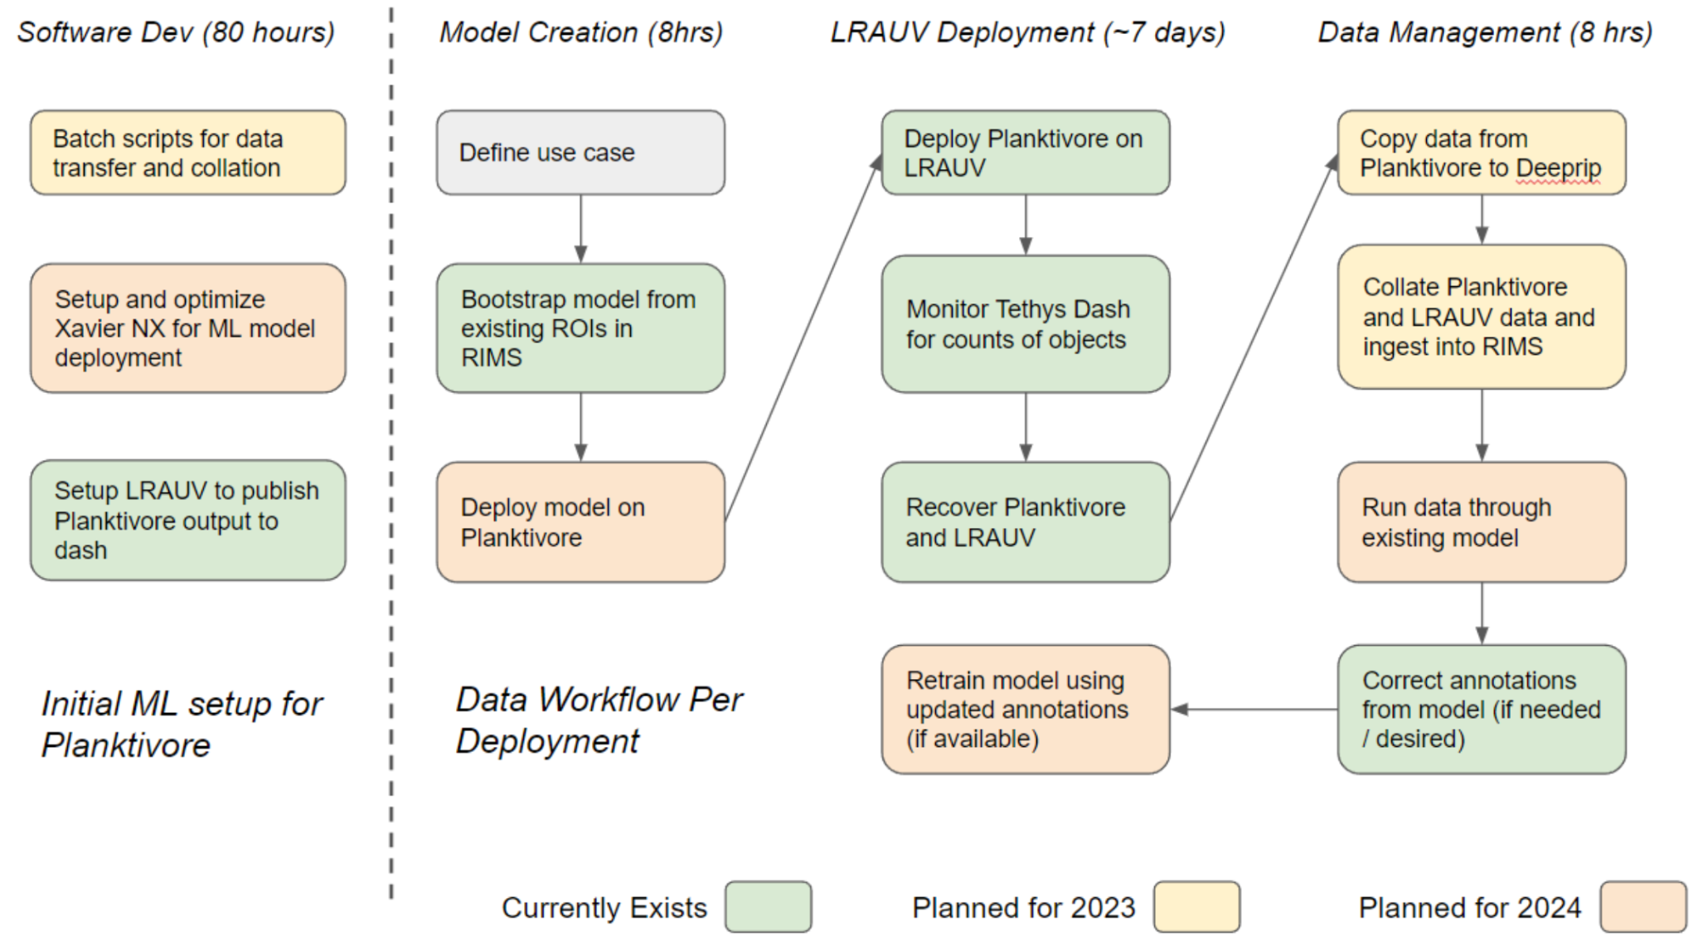

Anticipated Impact
Who are the consumers of the instruments, methods, technology, and data that will be generated within and beyond MBARI? Will the project create tangible connections with other organizations (e.g., academic, NGO, MBA, MBNMS, state or federal agency)?

Consumers of the data are MBARI researchers and CENCOOS. The data will be shared
internally and externally without embargo.

Anticipated Outreach Needs
Thinking about the audiences/consumers you highlighted in the question above, do you anticipate needing to create outreach assets to help increase your impact? If so, please specify whether you anticipate needing to work with ITD and also specify what type of asset (story, graphic, animation, video, etc.) you might need.

A video about the importance of plankton and MBARI’s innovative methods for plankton sampling
would be wonderful. Time frame for producing the video would be the latter half of 2024 or 2025.

We would also request a web page and a link to it from https://www.mbari.org/our-work/technologies/

Continuing Projects Only: Status Report
Briefly provide an update of the current project relative to what was proposed for 2024 by responding to the prompts below. If the project includes multiple subproject projects, please list each of these under a subheading as you deem appropriate.

Current status of project and results to date

LRAUV Ahi + Planktivore V2 deployments:

Engineering test deployment
- Completed prep for science deployments, worked out software integration with LRAUV.

Haddock Lab
- First run of A+PlanktivoreV2 following I2MAP. LRAUV limited depth of 300m
- The deployment for our Chief Scientist started off well, however, the LRAUV elevators failed. The mission was completed after creative work by the LRAUV team using an experimental approach.

Plankton Proxies, Messie
- Completed Ahi+Planktivore V2 following Daphne+ESP Water Sampler.

Synchro Wind Farm Study
- Completed Planktivore to M2 and various locations in the Bay.
  - The requested waypoint was out past M2 but was scaled back due to Planktivore drain on LRAUV battery capacity.

Carbon Flux Ecology, Durkin Lab
- Completed Ahi+Planktivore V2 following Sediment trap.
  - Problems were encountered, Ahi struck the bottom, damage was minimal.
EcoHAB / Targeted Sampling
- Planned for September 2024. Machine learning models for detecting pseudo nitzschia are in development and on track.
CANON
- Planned for September 2024 (not overlapping EcoHAB).

Low Power Compute exploration
- Engaged vendors at the consumer electronics show. Identified Leopard and Rhonda Software as candidates for an Ambarella based design. Also looking into Qualcomm offerings and Texas Instruments Jacinto7 platform. Working collaboratively with the Piscivore team as we may both be able to use the same compute platform.

Planktivore V3 Shadowgraph
- Work planned for 2H2024.

What percentage of labor and budget have been used through the 1st half of year?

<20%

Will you complete the current year’s scheduled work?

We are on track to complete the planned science deployments of Ahi + Planktivore V2.

Machine learning models are in progress for pseudo nitzschia detection to support the Targeted Sampling project and EcoHAB in September.

Planktivore project management and hardware upgrade of the camera controller and strobes for both V1 and V2 microscopes has been affected by personnel changes in the GoBGC / SOCCOM program. The electronics have been designed, built and assembled. The electronics have not yet been bench tested or integrated into the housings. Test and integration is delayed/deferred until 4Q2024, possibly 2025. Desktop development setup for Brent / Paul is also delayed.

Planktivore V3 Shadowgraph benchtop prototype has not started as of July 10. It is planned to be complete by the end of 2024 barring supply chain issues or other personnel changes that may happen in 2H2024.

Microscope toolsled for the CTD Rosette is a work in progress planned to complete by 3Q2024. Planktivore V1 needs to have strobe updated for 1 m/s capability.

Planktivore V1 deployment for Barry Lab and CTD Rosette. Deep battery housing has been pressure tested and pressure vent revised for improved safety during charging. Battery wiring and testing is staffed by Denis Klimov and should be completed by 3Q2024. Denis is also responsible for finishing mechanical assembly and checkout of benchtop test system, Fluum.

Significant changes from previous project proposal

We are investigating low power processors to replace the NVidia processing board and collaborating with the Piscivore team. We were not able to get a quote for having an outside contract firm do the work. For custom hardware and software, it’s in the range $70K to $120K.

Over the past two years, what peer-reviewed publications, education and/or outreach activities have resulted directly from this project? Please be brief.

None

All Projects: Specific Plans for 2025

Research Activities

2026 LRAUV Ahi + Plantivore v2 Deployments requests by Science Research projects:
(CCD=Candidate for Combined Deployment):

- 901009 CANON, Francisco Chavez / Katy Pitz. LRAUV Ahi + Planktivore v2 for CANON (Chavez / Pitz). One week deployment (1x) with flexible dates but during IFCB/Power Buoy deployment. [CCD]

- 901103 Haddock Lab. LRAUV Ahi + Planktivore v2 in joint day+night ops with Dorado i2MAP vehicle. Full-scale (10µm to 2m) plankton time-series to 1000m. (10x overnight monthly). [CCD]

- 902111 Carbon Flux Ecology Lab, Colleen Durkin / C. Huffard / S. Sudek. LRAUV Ahi + Planktivore v2 accompanied by LRAUV Galene + Chiton. Three week long deployments (3x).

- 901910 Plankton Proxies, Monique Messie, alongside Monterey Bay Time Series. LRAUV + Planktivore v2 flying in the same track as LRAUV Daphne (C1 to M2 transect down to 200m); intercomparison with MBTS eDNA data. 11x (monthly except January) deployments. Minimum deployment is 2 days. [CCD]

- 901513 Targeted Sampling, Yanwu Zhang. One weeklong (1x) deployment. Targeted sampling by in-situ plankton detection. In-situ, onboard machine learning model trained for specific plankton detection. [CCD]

- 800153 Synchro offshore Wind Case Study Plankton Characterization, Henry Ruhl / Jason Adelaars. Three weeklong (3x) deployments running the LRAUV along the upwelling gradient in the northwest Monterey Bay, which is expected to be augmented from joint operation of passive acoustics on glider, Aquasens plankton imaging, and CTD cast sampling including plankton and particle sampling. Results will be shared with Synchro stakeholders including BOEM, DOE, NOAA, and related California agencies.

2026 Planktivore V1
- 901904 Coral Ecology, Jim Barry, Steve Litvin. Coral Food Supply imaging Deep battery + Planktivore v1. Deployed Sur Ridge 1300m study location. Duty cycle operation for months along with MacroCam.

Engineering/technology development

- Field testing Planktivore V3 (Shadowgraph imaging)
- Low power processor development. Hardware and Software prototype development. Goal is 50% reduction in power consumption with the same or better image rates and quality.

Field programs (detail ship requirements/deployments/diver requirements)
In addition to describing anticipated field programs, please be sure to include requirements for specific platforms and equipment (Dorado AUVs, LRAUVs, Wave Glider, mini ROV, etc.) for each proposed field program so that expectations are clear. Requests must also be entered in the budget entry system. Note that AUV deployment numbers and diver requirement questions are also included in the Compliance and Planning Considerations Form described at the end of this proposal form.

LRAUV Ahi+Planktivore V2 is participating in field campaigns orchestrated by other projects. Two deployments of LRAUV Ahi have been requested for field testing Planktivore V3 (Shadowgraph).

Piloting/Watchkeeping
If you plan to use a platform that requires piloting/watchkeeping, please provide a high level staffing plan, including who will be responsible for these duties.

Engineering deployments will be staffed by Paul Roberts, Brent Jones, Thom Maughan

Science deployments are staffed by members of the Science Labs that are using Ahi+Planktivore V2.

We are on track to having payload pre-deployment checklists and docs with script automation for post deployment data management for DMO and Science lab users. We are working with DMO, Chris Wahl and team. We are recommending to Science users that deployments be limited to the work week and improving advance notification for LRAUV Ahi to aid DMO in planning.

Specific deliverables

- Documentation and software automation to enable science use of Planktivore.
- Plankton images and size data for each deployment with access methods to enable science labs to process and analyze the data.
- Machine learning models for automated detection. Examples: Plankton Proxies project is requesting Dinoflagellate and Diatom detection, Target Sampling is requesting Pseudo-nitzschia detection.
- RIMS software for plankton ROI access, sorting, tagging.
- Field deployable Planktivore V3 with shadowgraph imaging.
- Benchtop development system with compute and optical system that can serve as spares in case of flooded housing.
- Spare housing and 2nd improved nose shell for development and to mitigate risk in case of lost or critically damaged planktivore.

Milestones and required personnel (see personnel classification list for staff classifications)

Milestone 1: Complete planned Planktivore V2 (ptvr2) Ahi LRAUV deployments for science.
Milestone 2: Benchtop development (used for Milestone 3)
Milestone 3: Enhanced In-situ plankton detection to support targeted sampling on LRAUV
Milestone 4: Field deployment of Shadowgraph Planktivore V3 (ptvr3)
Milestone 5: Demonstrate at least 50% reduction in power consumption on benchtop setup

2025 Project Start Date:  MM/DD/2025 | Milestone 1 | Milestone 2 | Milestone 3 | Milestone 4 | Milestone 5 | Total Resources (in hours) for each resource category for all milestones listed here
Milestone Date | Oct 2025 | Sep 2025 | Oct 2025 | Nov 2025 | Jul 2025
Milestone Description | Ptvr2 Ahi  Science | Bench Dev | In-situ Plankton Detection | Ptvr3 Ahi  Eng Test | Power Reduction
Electrical Engineer | 60 bj  40 pr | 80 bj  40 pr  160 dk  80 ih | 80 pr | 20 bj  120 pr  40 dk  40 ih | bj 140 | 320 bj  280 pr  200 dk  120 ih
Software Eng-Embedded | 80 tm | 80 tm | 20 tm | 60 tm | 100 tm | 320 tm
Software Eng-Info Eng
Mechanical Engineer
Mechanical Eng-Division
Mechanical Eng-Mfg
Associate Engineer |  | 200 as |  | 100 as |  | 300 as
Electrical Tech
Software Tech
Mechanical Tech
Machinist |  |  |  | 100 tbd |  | 100 tbd
Divers
Video Lab
(Add other categories/rows as needed)

Budget justification

Labor:
- Paul Roberts. 280 hours for system engineering for Planktivore V3 (Shadowgraph), machine learning, RIMS software updates, deployment support and automation, low power platform.
- Brent Jones. 320 hours for working with Paul Roberts on embedded linux on NVidia and coming up to speed on gstreamer for low power processor candidates. Deployment support.
- Denis Klimov. 200 hours for building benchtop systems Aquavore and Fluum. Optics characterization for dark field and shadowgraph. Engineering and support for battery system used on Sur Ridge deployments.
- Aaron Schnittger. 300 hours for mechanical engineering and design improvements for 'optics housing tubes’', aka flashlights. 1) Shadowgraph, 2) Corrosion - eliminate snap ring to address corrosion problem, 3) 'clocking' to ensure optical precision of opposing flashlights.
Faceplates for deep (2000m) long (up to 1 year) deployments (Barry Lab) of Planktivore V1
Improved hydrodynamics shape for bow wake minimizers. Explore use of syntactic.
Update the design of LRAUV nose shell for Planktivore V2. Design foam pack for Ahi+Planktivore with spares.
- Thom Maughan. 320 hours. Electrical engineering for camera controller, strobe electronics, firmware for camera controller. Design of low power platform hardware and assist with embedded software.
Project Management.
- Irene Hu. 120 hours. Work with Thom on electrical engineering and firmware for camera controller and strobe electronics. Participate in low power platform design.
- Machine learning resources were not requested due to over subscription.

Expense:

Total requested for 2025 is $43,650.
- Benchtop Development and test setup. $16,500
- Spare compute housing to replace the one used for Planktivore V3. $5,000
- Planktivore V2 maintenance. New nose shell ($7K), Updated imaging housings to address corrosion and clocking. $10,800
- DeepRip maintenance. Drives, UPS battery. $2350
- Lab supplies and tools. $3000
- Low power platform hardware and software. $6000

Project team

Paul Roberts, system engineering, technical lead.
Brent Jones, embedded linux, lrauv expertise
Denis Klimov, test bench design, optics characterization
Aaron Schnittger, mechanical engineering
Thom Maughan, project manager, electrical design, embedded controller software
Irene Hu, electrical design, firmware

External consultants/contractors
If you propose to engage an external consultant/contractor, please attach a sufficiently detailed SOW and budget proposal from the vendor. If approved, a fully executed Independent Contractor Agreement must be in place before work can begin.

None

Project lab and office space requirements
In addition to any changes to current space usage, please also include anticipated office and lab needs for students, postdocs, collaborators, etc.

Continued use of B222 lab space. ESB for storage and work on Fluum. ESB has been problematic for use in development - impacts efficiency.

Risk matrix (development and infrastructure projects only)

 | Technical Risk | Organizational Risk | Tech Transfer Risk | Labor Estimate Risk
High
Medium | x
Low |  | x | x | x

Compliance and Planning Considerations

All responses must be recorded in the Google form linked below. A form must be submitted for every project.

Link to Google Compliance and Planning Considerations form -OR- https://forms.gle/mRYKKEztAPYaiTz7A

Development and infrastructure projects must complete the risk matrix (see end of the proposal form).
Not all projects will require all four titles to be filled in. Please indicate individuals only for those titles that are appropriate for your project.
This category includes transfer of hardware, know-how, publications, presentations, etc.
This number should be the same number you entered on the web budget resource requests for this particular resource.

