Project Number: | 902005

Project Start: Jan. 1, | 2020 | Project Duration (in years): | Year 2 of 3 ¹

Please indicate if proposal includes requests for any of the following (mark all that apply).

Ship Time |  |  | ROV |  |  | AUV |  |  | Wave Glider |  |  | Mini ROV

Please indicate what type of project is being proposed (mark only one).

 |  |  |  | X
Feasibility/Scoping  [Less than 100 days effort] |  |  | Development |  |  | Research |  |  | Infrastructure² |  |  | Education |  |  | Time Series |  |  | Institute Initiative

Project Manager: Lonny Lundsten
Principal Investigator: Brian Schlining
Lead Engineer: Danelle Cline

Project Title: VARS Annotation Assistance (VARS AA)

Please indicate which category best describes the project theme (mark only one).

 |  |  |  |  |  |  | X
Ocean  biogeochemistry |  |  | Ecosystem dynamics |  |  | Ocean visualization |  |  | Exploration & discovery

Please indicate percentage of effort on this project anticipated for 2021 toward these three highest institutional goals (percentage total should equal 100%).

Goal | Developing/adapting innovative technologies | Utilizing developments to explore and understand ocean systems | Technology/knowledge transfer
Percentage | 70% | 20% | 10%

- ABSTRACT (if submitted during abstract phase)

[Paste abstract here]

- PROPOSAL

  - All Projects

Statement of the challenge, why it is important

It is indisputable that the Video Lab’s (VL) continued efforts to provide high-quality annotation and the resulting VARS database system is a priceless asset to MBARI. However, sustaining the current level of annotation output with the pressures of adding new imaging platforms, advancing imaging systems, flat staffing levels, and the diversity of tasks expected of VL staff will be challenging in the coming years. We see automation as the key to allowing us to continue to operate within the constraints of our budget while continuing to provide high-quality annotations that are processed in a timely fashion. Machine learning integration with VARS, therefore, is necessary to achieve MBARI’s long-term goal of augmenting manual annotations with machine learning generated assistance.

Relevance
How does it relate/contribute to MBARI’s mission and strategic plan?

VARS Annotation Assistance is a vital component in advancing MBARI’s goal of being a world leader in ocean research. The use of machine learning to enhance human-generated annotations will be a necessity as increasingly complex imaging systems, analysis techniques, and sheer volumes of imagery data continue to increase, inundating MBARI’s Video Lab. Machine learning integration with VARS will also allow for novel analytic techniques on past and future video sets that enable discovery of distribution, species interaction, and habitat characteristics not previously possible. VARS Annotation Assistance will enable and/or enhance several of MBARI’s Strategic themes including Exploration and discovery, Ocean visualization, and Ecosystem dynamics.

Does it relate to the Technology Roadmap? If so, please describe how. (See http://mww.mbari.org/oed/TechnologyRoadmap.pdf.)

Automated detection using ML will improve our ability to process ever-increasing volumes and types of visual data collected by MBARI research platforms. Machine learning will aid in understanding the relationships between biota and the physical ocean environment (seafloor & midwater habitats, water chemistry, seasonal and spatial variation) and will enhance aspects of ocean visualization, exploration, and discovery, contributing to the following MBARI technology priorities: Ocean visualization, Exploration and discovery, and Ecosystem processes.

How does it relate/contribute to the Packard Foundation’s Ocean Grantmaking Program? (See https://www.packard.org/what-we-fund/ocean/ and documents therein.)

Machine learning will enhance MBARI’s ability to process large volumes of video and imagery to better understand our ocean environment. At a larger, more impactful scale, machine learning technologies integrated into VARS will be transferred to and used by the greater ocean science community as has already been demonstrated by VARS. These novel machine learning tools will revolutionize our ability to monitor and assess changes in marine biological community structure, fisheries health, and status of endangered or recovering ecosystems, whether impacted by climate change, over-harvesting, or direct/indirect exploitation.

Overall approach to the challenge: Over the complete term of the project, what is needed to address the challenge (e.g., sensors, platforms, marine operations, de novo R & D, etc.)

The general approach for this effort is to derive engineering requirements from discussion with the Video Lab staff, compiling user-stories and developing based on those findings. There is a team understanding that this is uncharted territory and new design paradigms are needed to incorporate ML into our day-to-day workflows. The team continues to work closely with the VideoTAG to monitor new ML developments as deemed necessary for the project's success.

The three year plan outlined is as outlined below:

Year 1 - 2020
- Refine user and system requirements.
- Engage with external partners at the UCSC Creative Coding Lab on Human-ML interaction to evaluate e.g. timeline-based visualization for annotating.
- Determine cost/benefit analysis for cloud versus in house compute (CPU/GPU), model storage, ML lifecycle tools.
- Develop back-end and front-end support for job and queue management
- Complete architectural/infrastructure design and begin detailed design of system components.
- Interface modifications needed for validating ML annotations.
- ML output integration through the VARS REST system.
- Share software and data with the community through open-source portals
Year 2 - 2021
- Continued improvement of model pipelines
- Support user interface design changes.
- Continued VARS integration
- Support VideoTAG project test cases
Year 3 - 2022
- Develop back-end and front-end support for custom ML pipelines
- Add support for scaling resources needed for use cases, e.g. data mining for rare examples, sampling for time-series study, and 4K processing.

Research

No research is expected.

Engineering/Technology Development
Engineering

The second year of development will focus on improvements to existing ML pipelines and ongoing support to improve the ML use. We expect to focus on improvements to human-ML interactions based on VideoLab feedback, improvements to the pipeline design to reduce cost and improve performance and to expand integration with VARS and/or VARS microservices as needed. Lastly, coordination with the VideoTag will occur to test any novel ML developments, e.g. Continuous Learning, Semi-supervised learning, Calibration, etc.

For community outreach and engagement, we will continue to export our code and our video track sequences (see anticipated outreach MBARIVideoNet) for academic ML challenges and a Kaggle hosted competition. We envision the Kaggle competition being a great opportunity to get external exposure to our interesting domain, and in return get a winning solution that we can include in our pipelines. Data from the 2020 summer intern program will seed this effort.

Video Lab

Video Lab resources will be needed to work closely with the software engineers to guide software implementation, user interface changes, and label generation for expanding training and validation data.

Marine Operations/Field Programs

None

Data
What data products will be generated?

Human-entered and ML-proposed localizations will be tracked within the VARS database and visualized within VARS, as appropriate. A newly-designed database for tracking-style localizations may be created for this purpose. Machine learning models will be developed and these will be tracked within an internal repository for preserving and tracking changes to developed models.

How will the data products be managed?
Localization data will be catalogued either alongside existing VARS annotation data or within a ML-annotation database; however, these should not present unusual storage challenges when compared with the existing VARS annotation database. Enhanced video products will be generated temporarily for editing/review, thus,should require only minimal temporary storage on a staging share. Localization visualization will be drawn within the VARS GUI and will not alter or duplicate the underlying imagery.
Describe data availability outside of the project team.

The primary mechanism for releasing data products to the wider MBARI community through open source on http://github.com/mbari-org. Data provenance will be managed through versioning of the data and models and data will be hosted on AWS and made available through DVC https://dvc.org/ and/or FTP and an external facing web page (see anticipated outreach).

VARS modifications for integrating machine learning will be released to the wider ocean science community through the continued release and development of the VARS open source project, which is used around the world by numerous marine research agencies including CSIRO, HURL, NOAA, MLML, CSUMB, etc.

Describe data storage requirements.

Negligible database management and image archiving, well within the normal IS standards for database and network backup and archiving. 1TB needed for model and training data storage.

Anticipated Impact

Who are the consumers of the instruments, methods, systems, and data that will be generated?

The development of tools and methodologies for applying machine learning techniques to identify, classify, and track marine organisms will greatly benefit MBARI by reducing staff resources needs and the time to complete expert video and image annotations and analysis. These tools and methodologies will be made available to the public as open-source software. Shared methodologies and curated data, as demonstrated by VARS, DSG and other related projects, will no doubt have a positive impact upon the external marine science research community. The lack of automated detection and classification of video annotation tools is an immensely important, widespread problem in all sectors of ocean science face, and this effort would make a significant contribution. If successful, the developed machine learning algorithms could be used for real-time annotation and data augmentation of ROV (see ROVVR project), AUV [see I2MAP, Mesobot, EyeRIS, StealthCam (pending abstract)], and lander (see Deep Sea Coral Observatory, M1 Time Lapse Camera, Benthic Rover) video and camera feeds, in addition to aiding Video Lab annotation workflow.

Anticipated Outreach

What outreach assets might you need to better reach the audience/consumers you are targeting? Specify how you might like to reach your audience (published paper, seminar, conference, social media, etc.) and what type of assets (graphic, animation, video, etc.) you might need ITD to help generate.

Develop MBARI external website explaining the project (VL/Lonny), instructions for use (VL/Lonny), and data export of trained video tacks (MBARIVideoNet) as inspired by https://tracking-net.org/ and https://research.google.com/youtube8m/.

Intellectual Property (IP) Considerations

Do you anticipate a need for a cooperative research and development agreement or licensing arrangement with an external entity?

No

Will novel IP be created, and how might it be disseminated (e.g., open-source, royalty-free license, commercial license agreement)?

No

Will the work potentially result in a patentable product or service?

No

For additional guidance please review MBARI’s intellectual property internal web page: https://mww.mbari.org/itd/ip/.

N/A

  - Continuing Projects

If the proposed project includes multiple individual projects, please list each of these projects as a subheading in the proposal. For each subheading, please address the following:

Current status of project and results to date

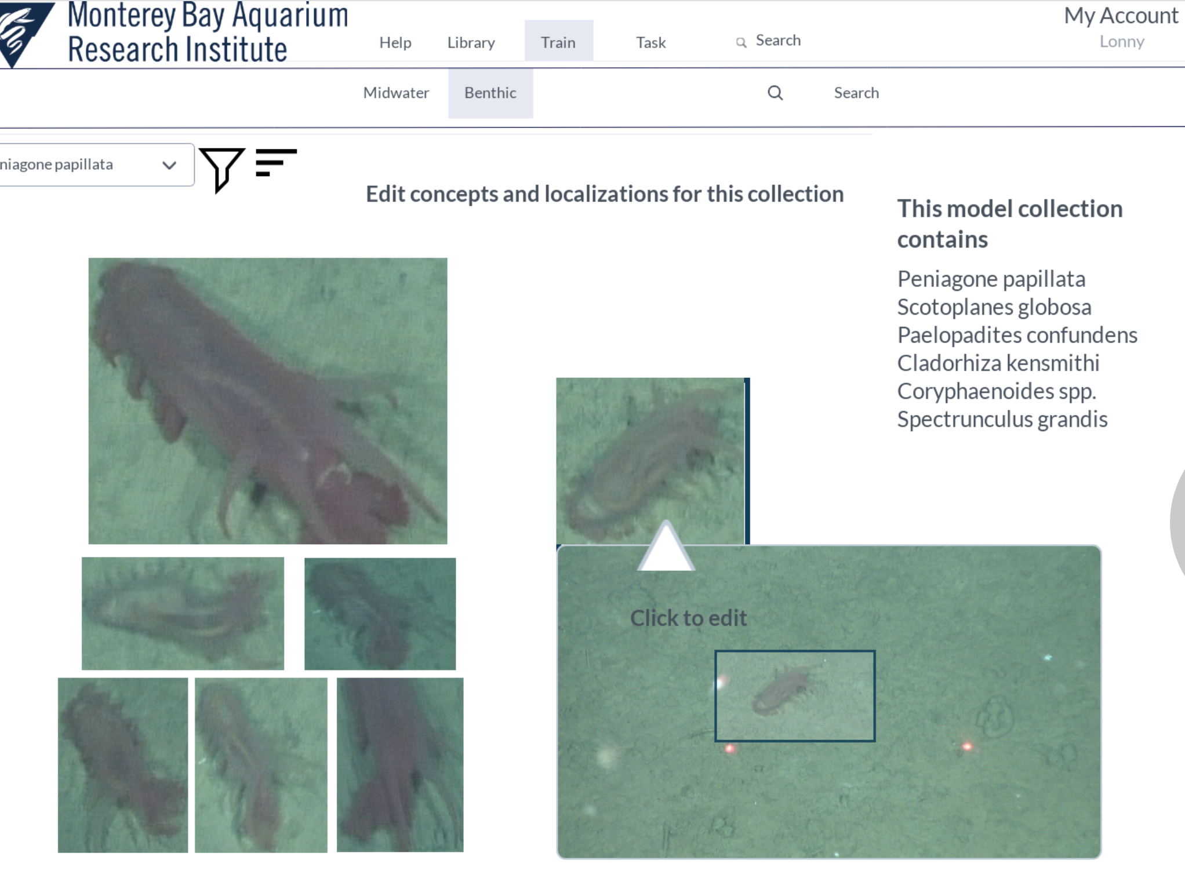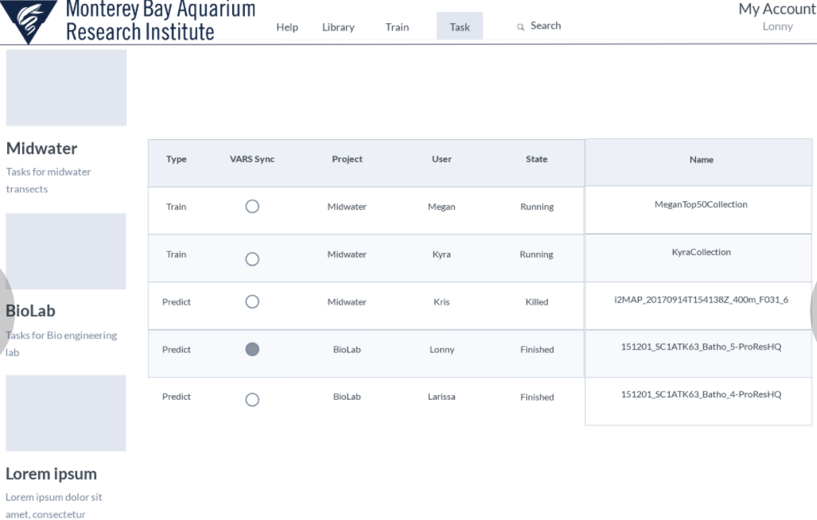
Figure 1. Mach-up of a few of the web pages in development.

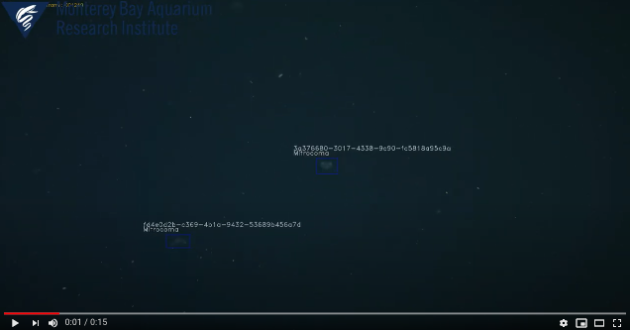
https://www.youtube.com/watch?v=cMZ8vr0aAYI&feature=youtu.be
Figure 2. Example output from the ML pipeline (click to preview)

Progress-to-date year 2020
- Use-cases and requirements milestone completed.
- System architecture design: estimated 50% complete
  - Web application mock-up: complete and Vue/GraphQL design in progress
  - Database design: in development with GraphQL/Prisma.
- Install and test system components milestone: estimated 20% complete
  - VARS video player modifications: completed and deployed.
  - VARS integration.
  - Workflow components for all stages of the video processing pipeline: completed.
  - Machine learning model development server: deployed in the cloud.
  - Multiple object performance metric evaluations. 25% complete. This will inform the best workflows for performance/cost considerations using GPUs and cloud resources.Verify improved annotation performance milestone: 0% complete.

Plans to the end of the first year 2020
- Complete VARS integration. Estimated time 160 hours
- Complete web-app prototype. Estimated time 120 hours
- Complete database development. Estimated time 20 hours
- Verified improved annotation performance. Estimated time: engineering TBD, video lab time TBD.

Code:
http://bitbucket.org/mbari/deepsea-track/https://github.com/mbari-org/deepsea-track
https://bitbucket.org/mbari/deepsea-tfdetect/https://github.com/mbari-org/deepsea-tfdetect
https://bitbucket.org/mbari/deepsea-kclassify/https://github.com/mbari-org/deepsea-kclassify
https://bitbucket.org/mbari/deepsea-frameextractor/https://github.com/mbari-org/deepsea-track
https://bitbucket.org/mbari/deepsea-tfrecord/https://github.com/mbari-org/deepsea-track
https://bitbucket.org/mbari/vaa-localize-clean
https://bitbucket.org/mbari/registry-benthic2017
https://bitbucket.org/mbari/vaa-benthic-notebook

What percentage of labor and budget have been used through the 1st half of year?

55%

Will you complete the current year’s scheduled work?

Yes

If you are at less than 50% resource usage, what is the plan to complete, or what work won’t be done this year?

[Click here to enter text]

Significant changes from previous project proposal

User interface plans moved to 2020 as deemed necessary for a useful system. Danelle has received training on web development to move this task forward. 200 hours of Carlos Rueda’s time is requested to help with this task in year 2 - 2021.

Some delay in milestones due to Covid-19 disruption and user interface task shift to year 1. Expect shift of engineering design of job management/container orchestration and registration to shift to year 2.

Over the past two years, what peer-reviewed publications, education and/or outreach activities have resulted directly from this project? Please be brief.

To date has any novel intellectual property been developed and/or disseminated?

No

  - All Projects: Specific Plans for 2021

Research Activities

[Click here to enter text]

Engineering/technology development

The bulk of the engineering development will be:

- Ongoing support for VAA system, including:
  - Improved web app user interface
    - Improved model visualization
    - Improve validation of processed data
    - Improve editing capabilities
  - Improved workflows
    - Optimize the compute efficiency. e.g. parallel GPU training, auto-GPU scaling.
    - Enable operation on multiple hosts: AWS, on-premise GPU. Here, we are thinking forward to running the system on the boats in 2022.
- Improve Cthulhu design
  - Improved performance for jogging
  - Improved visualization and editing capabilities, e.g. add/remove taxa, color-code taxa
- Support VideoTAG test cases (see VideoTAG proposal for details)

Will novel intellectual property be developed and/or disseminated?
Dissemination includes patenting, licensing, and collaboration agreements.

None

Field programs (detail ship requirements/deployments/diver requirements)
In addition to describing anticipated field programs, please be sure to include requirements for specific platforms and equipment (Dorado AUVs, LRAUVs, Wave Glider, mini ROV, etc.) for each proposed field program so that expectations are clear. Requests must also be entered in the budget entry system.

No

Isotope Usage
Project teams must provide details regarding any planned isotope use on shore, on ships, in the Sanctuary, etc. Please review the guidance on isotope usage at http://www.mbari.org/at-sea/cruise-planning/hazardous-materials/ and policy at http://mww.mbari.org/safety/SafetyManual/Isotope_Use_Policy.pdf, and then provide details on plans below.

No

Safety Disposal Needs
So the Safety office can plan and budget accordingly, please respond to the questions below regarding any anticipated safety disposal needs for the coming year. Budget for cost of such removal will be captured by the safety office based on responses received.

Will this project generate more than 1 gallon (4 liters) of battery waste per year?

No

If yes, please indicate the type of batteries (alkaline, NiCad, NiMH, lithium ion or lithium metal) and the approximate amount of each to be generated.

[Click here to enter text]

Will this project generate more than 15 gallons (60 liters) of hazardous liquid waste per year?

No

If yes, please indicate the composition of the waste(s) and the quantity of each to be generated.

[Click here to enter text]

Specific deliverables

Demonstrable assistance with current benthic detailed annotation workload.
Publication on design concept at TBD conference.

Milestones and required personnel (see personnel classification list for staff classifications)

2021 Project Start Date:  01/01/2021 | Milestone 1 | Milestone 2 | Milestone 3 | Milestone 4 | Milestone 5 | Total Resources (in hours) for each resource category for all milestones listed here
Milestone Date | Q1 | Q2 | Q3 | Q4
Milestone Description | Improved workflows & VARS integration | UI Improvements web app and Cthulhu | VideoTAG test case(s) | Kaggle competition | Overhead  /project mgmt and conferences
Electrical Engineer
Software Eng-Embedded
Software Eng-Info Eng | 220 (Schlining)  180 (Cline)  160 (Bernard) | 200 (Schlining)  40 (Cline)  200 (Rueda) | 320 (Edgington)  70 (Cline) | 40 (Cline) | 40 (Schlining)  120 (Cline)  60 (Edgington) | 480 - B.Schlining  350 D. Cline  380 D. Edgington  160 K.Bernard
Mechanical Engineer
Mechanical Eng-Division
Mechanical Eng-Mfg
Associate Engineer
Electrical Tech
Software Tech
Mechanical Tech
Machinist
Divers

Budget justification

Competition entry fees: We request $2000 to enter Kaggle competition to foster community engagement. A prize fee would be better, but not necessary to start a competition.

Conferences: VisApp 2021 Conference: We request $8000 to allow two MBARI staff to attend this application-focused conference. Marine Imaging Workshop TBD: We request $8000 for two MBARI staff to attend this marine imaging workshop.

Cloud compute estimation. $3K support for cloud compute and storage. We don’t have a full estimate on this just yet but are actively working in 2020 on tagging cloud resources to track those costs.

Video annotation management.

We request 1610 hours for D.Cline (350), D. Edgington (380), B.Schlining (480), C.Rueda (200), K. Barnard (200) for this work.

Project team

Principal Investigator: Brian Schlining
Project Manager: Lonny Lundsten
Lead engineer: Danelle Cline
Additional team members: Duane Edgington, Nancy Jacobsen Stout, Carlos Rueda, Kevin Barnard.

Project lab and office space requirements
In addition to any changes to current space usage, please also include anticipated office and lab needs for students, postdocs, collaborators, etc.

None required

R/V Paragon Requests
If the project team will be requesting time for the R/V Paragon, please specify the operators in the group and provide estimates of their availability to operate the vessel. DMO staff have extremely limited availability to be operators and only with advanced budgeting and planning.

None required

Risk matrix (development and infrastructure projects only)

 | Technical Risk | Organizational Risk | Tech Transfer Risk | Labor Estimate Risk
High |  |  |  | X
Medium | X
Low |  | X | X

  - Compliance Considerations

Export Regulation
Does the project team anticipate any foreign collaborations or international travel? If so, please identify collaborators by name, institution, and country.

No

Does the project team plan or anticipate export-controlled purchases, shipments, or transfers of items (e.g., research instruments, proprietary data, hand-carried tools or samples) outside the U.S. temporarily or permanently? If yes, please identify country or countries and indicate whether these items will remain under MBARI control while abroad or controlled by others. Will the items be exported to more than one country? Please include foreign collaborator information as described above.

No

Monterey Bay National Marine Sanctuary (MBNMS)

General Permit
Projects teams need to indicate if any work will be performed that is either: (1) currently authorized under our general permit; or (2) will require that we obtain authorization. The current permit can be viewed at https://mww.mbari.org/pco/permits/mbnms-2020-006_exp28feb2025.pdf. Please see Mandy Allen for questions.

Is a permit with MBNMS required for your work?

No

SESAs (General map)
Projects will need to indicate whether or not work will be conducted within one of the Monterey Bay National Marine Sanctuary's Ecologically Significant Areas (SESAs). If your work will be conducted in one of these areas, please indicate which area by number or name.

None

Anchors
For activities conducted under MBARI's permit for the Monterey Bay National Marine Sanctuary, Paragraph 16, we are required to recover anchors weighing less than 500 pounds. Project proposals, which involve anchors weighing less than 500 pounds, shall specifically indicate cruise time allocated to anchor recovery. Lack of cruise time is not an acceptable reason for deeming an anchor less than 500 pounds “unrecoverable” under Paragraph 17 of MBNMS permit. Also under Paragraph 17, ALL anchors not recovered during the year must be reported detailing location, description of anchor, and reason not recovered. (Mandy Allen will collect this information from project teams to submit as part of the annual report to the Sanctuary.) Each ship will be tracking anchors deployed, duration of attempted anchor recovery, and anchors abandoned on the seafloor with the intent that they be recovered in the future as per MBNMS permit requirements.

Will you be deploying equipment that will require anchoring? If so, please indicate approximate weight of anchors to be used and recovery plans.

[Click here to enter text.]

California Department of Fish & Wildlife
A Scientific Collecting Permit will be required for biological and geological sample collections offshore California (even in Federal waters and beyond), and for many activities in State Marine Protected Areas (MPAs). Please see Mandy Allen for questions.

Will you be collecting samples that require a permit?

No

Will you be working in a State Marine Protected Area?(See link above for Statewide MPAs or this link for Central California MPAs.)

No

United States Coast Guard
If your project will deploy or maintain moorings, the project team must ensure proper compliance and notification of these activities to the US Coast Guard. DMO does not automatically do these notifications on behalf of projects. Two common types of permits and notifications that may apply to your project are Private Aid to Navigation (PATON) authorizations (required for buoys deployed for six (6) months or longer) and Notice to Mariners, which must be submitted for temporary PATONs (less than 6-month deployments). Other science operations may submit a request for a Local Notice to Mariners and are useful for missions or deployments with risk of 3rd Party Liability such as the Wave Glider.

Will your project require a PATON?

No

If yes, have you obtained a PATON? (Please provide a copy to Mandy Allen.)

No

Will your project require submission of a Local Notice to Mariners?

No

If yes, please indicate who will be submitting request and provide a copy of the submission to Mandy Allen.

[Click here to enter text]

Authorizations/Permits from other Agencies or Organizations
Is the project team aware of any other permits or authorizations that will be necessary to perform the proposed work? If so, please list below along with status of authorizations (obtained, pending, need to apply, etc.). Please see Mandy Allen if you have questions.

None

Active Acoustics
We are keeping an inventory of acoustic instrumentation. The current list is posted here: https://mww.mbari.org/resources/2021_Proposal_Process/mbari_acoustic_instruments_updated_may_13_2020_ver_13.xlsx. If you have or plan to use equipment that is not already on this list, please be sure to include that information here.

[Click here to enter text]

This date and number should remain the same for the duration of the project. If your project start date for 2021 is not January 1, please indicate the start date in the first cell of the milestone chart. Format for duration example: “Year 2 of 5”.
Development and infrastructure projects must complete the risk matrix (see end of the proposal form).
Not all projects will require all four titles to be filled in. Please indicate individuals only for those titles that are appropriate for your project.
This category includes transfer of hardware, know-how, publications, presentations, etc.
This number should be the same number you entered on the resource requests for this particular resource.

