Project Number: | 902009

Project Start: Jan. 1, | 2020 | Project Duration (in years): | 2 of 3 ¹

Please indicate if proposal includes requests for any of the following (mark all that apply).

 | X |  |  |  |  |  | X
Ship Time |  |  | ROV |  |  | AUV |  |  | Wave Glider |  |  | Mini ROV

Please indicate what type of project is being proposed (mark only one).

 |  |  |  | X
Feasibility/Scoping  [Less than 100 days effort] |  |  | Development |  |  | Research |  |  | Infrastructure² |  |  | Education |  |  | Time Series |  |  | Institute Initiative

Project Manager: Brian Kieft
Principal Investigator: Brian Kieft
Lead Scientist: Steve Haddock
Lead Engineer: Ben Raanan

Project Title: AUV User Experience Design

Please indicate which category best describes the project theme (mark only one).

 |  |  |  |  |  |  |  |  |  | X40
Ocean  biogeochemistry |  |  | Ecosystem dynamics |  |  | Ocean visualization |  |  | Exploration & discovery

Please indicate percentage of effort on this project anticipated for 2021 toward these three highest institutional goals (percentage total should equal 100%).

Goal | Developing/adapting innovative technologies | Utilizing developments to explore and understand ocean systems | Technology/knowledge transfer
Percentage | 40% | 40% | 20%

- ABSTRACT (if submitted during abstract phase)

N/A

- PROPOSAL

  - All Projects

Statement of the challenge, why it is important

MBARI operates autonomous platforms at sea well over 300 days per year around the clock. However, many of our systems require an expert, who is deeply familiar with the platform, to determine the vehicles’ state and overall plan. This makes the AUV very limited in their extensibility and exportability. For instance, an MBARI PI new to the LRAUV system noted the following during operations this month: “I watched for 2 days w/o realizing that the drop weight was already _not_ on the vehicle.” and added that a more intuitive way to convey vehicle state would be helpful.

Through a collaboration with Dr. Leila Takayama (http://www.leilatakayama.org/wp/about-leila/) we have an opportunity to more holistically address our user interface tools by using User Experience (UX) research methods to prioritize scientific use cases, learn from existing users, and make design recommendations for future versions of MBARI’s AUV user interfaces.

Relevance

How does it relate/contribute to MBARI’s mission and strategic plan?

This project provides benefits to nearly all the four research themes in the strategic plan. Most notably though is exploration and discovery. As our fleet of autonomous systems grows to support further research and discovery, it must do so in a way that is extensible, limits operational overhead, and optimizes for tech transfer.

Does it relate to the Technology Roadmap? If so, please describe how. (See http://mww.mbari.org/oed/TechnologyRoadmap.pdf.)

Yes. As our autonomous platforms increase their persistent presence offshore it’s important for stakeholders to be able to quickly understand the state of the entire observational system, the providence of data, and have access to holistic mission planning. As more targeted sampling happens onboard autonomous platforms, it becomes even more important to convey appropriate vehicle state information and guarantee the necessary contextual data to make the observation or sample as efficient and as rich as possible. As more operations require multi-vehicle coordination, an investment in an effective user experience with our autonomous systems will provide a high return in years to come for both the human resources and also the scientific value of our observations.

How does it relate/contribute to the Packard Foundation’s Ocean Grantmaking Program? (See https://www.packard.org/what-we-fund/ocean/ and documents therein.)

As all of life on earth depends on the health of our ocean, being able to effectively and holistically manage the tools we use to observe and measure our oceans is essential.

Overall approach to the challenge: Over the complete term of the project, what is needed to address the challenge (e.g., sensors, platforms, marine operations, de novo R & D, etc.)

Research

First, the user experience researcher will work with MBARI science teams to identify their highest priority use cases and pain points experienced when operating the LRAUVs. This will be done through a combination of contextual inquiry field observations (i.e., riding along with science teams on LRAUV missions), follow-up interviews, and observing science team communication logs (e.g., reviewing Slack channel chat logs). Research fields notes will be used in combination will photos, video recordings, screen captures, and audio recordings of interviews (when permitted by study participants).
- High priority use cases will be identified via these observations. We will then iterate upon them through interviews with science, operations, and engineering team members.
- High priority pain points will be identified through field observations, communication logs, and interviews with science team members, considering both severity and frequency of issues.

Second, this project team will use the research findings from Phase 1 to ground a design workshop that will be used to generate design guidelines for the next version of LRAUV user interfaces. This will be a half or one-day time commitment. The user research team will share a summary of findings from the initial round of data collection and conduct a generative product-design style workshop with members of the science, operations, and engineering teams.

Third, this project team will work with a professional designer to produce user experience storyboards that guide the design of the next version of the LRAUV user interfaces that better support the needs and alleviate the pain points of science team end-users. The design specifications document will be driven by the design guidelines specified in Phase 2.

If time permits in Year 1, then the user research team will run evaluative user studies (e.g., cognitive walkthroughs and/or user studies with low fidelity user interface prototypes) to gather end-user feedback on the initial round of designs from Phase 3.

Engineering/Technology Development
Based on the year one deliverables, the project will be able to determine future steps directly aimed at UI development and implementation within the LRAUV command and control interface.
Marine Operations/Field Programs

N/A

Data
What data products will be generated?

A minimal volume of data will be generated. The data that will be generated will largely be reports and statistical analysis of existing data.

How will the data products be managed?
Project library
Describe data availability outside of the project team.

Data will be limited to the project team with the exception of publications.

Describe data storage requirements.

<10Gb

Anticipated Impact

Who are the consumers of the instruments, methods, systems, and data that will be generated?

The project team and stakeholders

Anticipated Outreach

What outreach assets might you need to better reach the audience/consumers you are targeting? Specify how you might like to reach your audience (published paper, seminar, conference, social media, etc.) and what type of assets (graphic, animation, video, etc.) you might need ITD to help generate.

Outreach will be direct communication with our stakeholders. A website highlighting the features of the UI would be helpful.

Intellectual Property (IP) Considerations

Do you anticipate a need for a cooperative research and development agreement or licensing arrangement with an external entity?

No

Will novel IP be created, and how might it be disseminated (e.g., open-source, royalty-free license, commercial license agreement)?

Novel IP will be created by our external collaborators and will be provided open source

Will the work potentially result in a patentable product or service?

No

For additional guidance please review MBARI’s intellectual property internal web page: https://mww.mbari.org/itd/ip/.

  - Continuing Projects

If the proposed project includes multiple individual projects, please list each of these projects as a subheading in the proposal. For each subheading, please address the following:

Current status of project and results to date
The project has been iterating through the design process and is turning the corner towards “concepts”. The observation phase began immediately led by Kevin Weatherwax. Prior to the covid shutdown, he and his team collected 6 hours of audio/video across 5 individual interviews with science and engineering team members.
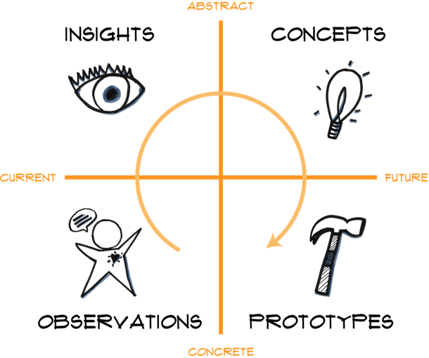

The team highlighted the interface tools and found that operations are augmented with many tools external to the dash including Matlab, Google Earth, wind nowcast/forecast sites, ODSS etc. Pain points were also identified with the most egregious being situational awareness. The most important areas for heightening awareness were identified as:
- Representing comm channels (sat v cell v acoustic)
- Tracking commands stack
- Location, trajectory, orientation, and depth of LRAUVs
- Health and status of the LRAUV/instruments

We also met with the design team from Sliced Bread to discuss the initial design process slated for the end of 2020.

Initial concepts at this time include a basic layout in figma showing flow between various parts of the UI. This includes Steve’s vehicle state widget below.

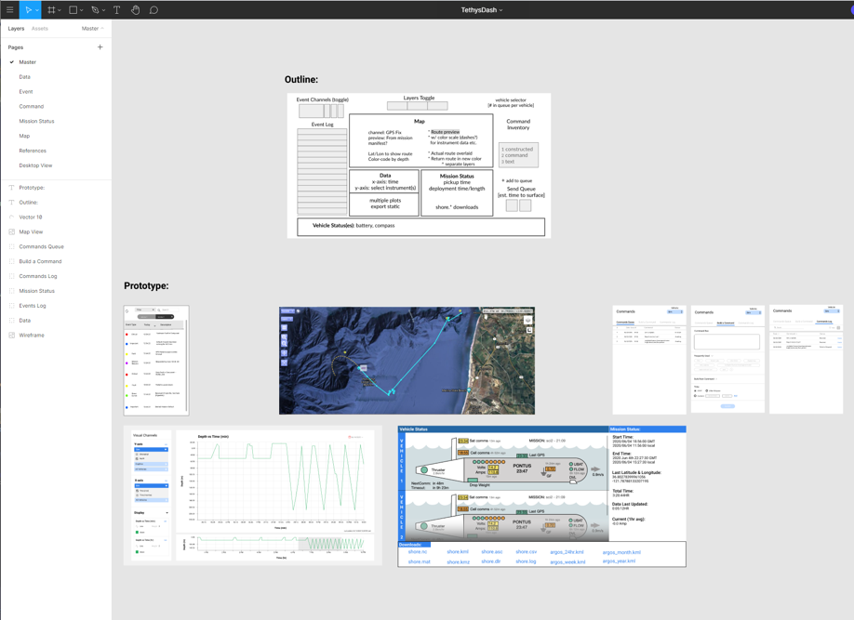

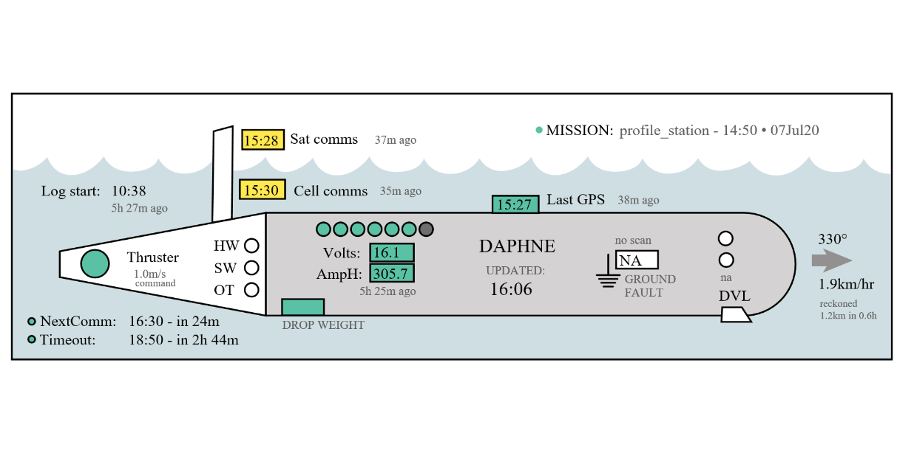

What percentage of labor and budget have been used through the 1st half of year?

8% labor, 0% budget

Will you complete the current year’s scheduled work?

yes

If you are at less than 50% resource usage, what is the plan to complete, or what work won’t be done this year?

The plan is to burn the budget in Q4 for outside services (see 2020 proposal)

Significant changes from previous project proposal

None

Over the past two years, what peer-reviewed publications, education and/or outreach activities have resulted directly from this project? Please be brief.
Outreach has included 2 PhD students and 7 research assistants from UCSC.

To date has any novel intellectual property been developed and/or disseminated?
No

  - All Projects: Specific Plans for 2021

Research Activities

Engineering/technology development

Understanding users: We will continue to do more field observations and interviews with science and operations teams at MBARI as they are using the LRAUVs. In 2020, we focused on experienced users doing vehicle state monitoring for ongoing missions. In 2021, we will expand this focus to also observe less experienced users so we can gain insight into ways of making the onboarding and learning process smoother. We will also expand our scope to include mission planning work process, tools, and interfaces.

Design prototyping: In 2021, our plans are to move from the high-level storyboards and design ideas from 2020 to more concrete interface design prototypes (e.g., wireframes, low-fidelity prototypes, and functional prototypes). This will be done in collaboration with Sliced Bread Design, whose Interaction Designers offer the professional design skills that we do not have in-house.

Evaluating and iterating on the designs: Using the interface design prototypes, we will conduct evaluative user studies with LRAUV users (or potential users) to systematically test our design ideas, measuring both task performance (e.g., Did the user correctly diagnose the problem with the AUV?) and user experience (e.g., How difficult was it for the user to diagnose the problem?). Based on the results of these behavioral user studies, we will make design recommendations about how to improve upon the prototypes over time. Using those design recommendations, we will produce measurably better performing interfaces over time. This will require close collaboration between the LRAUV team, Carlos, Leila, and Sliced Bread Design.

Outcomes: By the end of 2021, we will produce better user interfaces for supporting LRAUV vehicle state monitoring and mission planning.

Will novel intellectual property be developed and/or disseminated?
Dissemination includes patenting, licensing, and collaboration agreements.

We will have a renewed collaborator’s agreement with Sliced Bread. If Leila stays at UCSC in 2021, then we will also renew that collaborator’s agreement with UCSC.

If the lessons learned from the user studies with the LRAUV interfaces are more broadly useful for the AUV engineering research, human-computer interaction, or human-robot interaction communities, then we will write up the results of those studies for scientific publication in the venue where the work would have the most impact.

The updated designs to the LRAUV dashboard (and other tools that may be developed in this process) will be released via shareable repositories like GitHub so that we will be ready to share our most current interfaces with collaborators and other LRAUV users.

Field programs (detail ship requirements/deployments/diver requirements)

In addition to describing anticipated field programs, please be sure to include requirements for specific platforms and equipment (Dorado AUVs, LRAUVs, Wave Glider, mini ROV, etc.) for each proposed field program so that expectations are clear. Requests must also be entered in the budget entry system.

The project will make use of routine LRAUV deployments

Isotope Usage
Project teams must provide details regarding any planned isotope use on shore, on ships, in the Sanctuary, etc. Please review the guidance on isotope usage at http://www.mbari.org/at-sea/cruise-planning/hazardous-materials/ and policy at http://mww.mbari.org/safety/SafetyManual/Isotope_Use_Policy.pdf, and then provide details on plans below.

N/A

Safety Disposal Needs

So the Safety office can plan and budget accordingly, please respond to the questions below regarding any anticipated safety disposal needs for the coming year. Budget for cost of such removal will be captured by the safety office based on responses received.

Will this project generate more than 1 gallon (4 liters) of battery waste per year?

No

If yes, please indicate the type of batteries (alkaline, NiCad, NiMH, lithium ion or lithium metal) and the approximate amount of each to be generated.

N/A

Will this project generate more than 15 gallons (60 liters) of hazardous liquid waste per year?

No

If yes, please indicate the composition of the waste(s) and the quantity of each to be generated.

N/A

Specific deliverables

See section C under development

Milestones and required personnel (see personnel classification list for staff classifications)

Please note that MBARI is requesting minimal labor hours for this project and aims to support the research of Dr. Takayama and her team. Since there are no staff with UX/UI design experience in house, we’re relying on experts in the field to guide our design process. Additionally, a collaboration agreement exists between MBARI and Dr. Takayama.

2021 Project Start Date:  MM/DD/2021 | Milestone 1 | Milestone 2 | Milestone 3 | Milestone 4 | Total Resources (in hours) for each resource category for all milestones listed here
Milestone Date | Q1 | Q2 | Q3 | Q4
Milestone Description | Final Obs and interviews | Wireframes and Lo-Fi | User Studies | Design Recommendations Complete
Electrical Engineer
Software Eng-Embedded | 50 | 50 | 50 | 50 | Kieft (80)  Raanan (80)  O’Reilly (40)
Software Eng-Info Eng | 25 | 25 | 25 | 25 | Rueda (100)
Mechanical Engineer
Mechanical Eng-Division
Mechanical Eng-Mfg
Associate Engineer
Electrical Tech
Software Tech
Mechanical Tech
Machinist
Divers

Budget justification

Up to $10k for outside services for wireframes and low fidelity prototype iterations.

Project team

- Brian Kieft
- Ben Raanan
- Brett Hobson
- Carlos Rueda
- Tom O’Reilly
- Steve Haddock
- Leila Takayama (UCSC)
- 1 PhD Student (TBD)
- 3-5 grad students (TBD)

Project lab and office space requirements
In addition to any changes to current space usage, please also include anticipated office and lab needs for students, postdocs, collaborators, etc.

Occasional visiting science office and/or LRAUV lab usage by our collaborators from UCSC/TUM

R/V Paragon Requests
If the project team will be requesting time for the R/V Paragon, please specify the operators in the group and provide estimates of their availability to operate the vessel. DMO staff have extremely limited availability to be operators and only with advanced budgeting and planning.

Any Paragon operations will be handled by captains on the project team.

Risk matrix (development and infrastructure projects only)

 | Technical Risk | Organizational Risk | Tech Transfer Risk | Labor Estimate Risk
High
Medium | X |  |  | X
Low |  | X | X

  - Compliance Considerations

Export Regulation
Does the project team anticipate any foreign collaborations or international travel? If so, please identify collaborators by name, institution, and country.

Does the project team plan or anticipate export-controlled purchases, shipments, or transfers of items (e.g., research instruments, proprietary data, hand-carried tools or samples) outside the U.S. temporarily or permanently? If yes, please identify country or countries and indicate whether these items will remain under MBARI control while abroad or controlled by others. Will the items be exported to more than one country? Please include foreign collaborator information as described above.

No

Monterey Bay National Marine Sanctuary (MBNMS)

General Permit
Projects teams need to indicate if any work will be performed that is either: (1) currently authorized under our general permit; or (2) will require that we obtain authorization. The current permit can be viewed at https://mww.mbari.org/pco/permits/mbnms-2020-006_exp28feb2025.pdf. Please see Mandy Allen for questions.

Is a permit with MBNMS required for your work?

No

SESAs (General map)
Projects will need to indicate whether or not work will be conducted within one of the Monterey Bay National Marine Sanctuary's Ecologically Significant Areas (SESAs). If your work will be conducted in one of these areas, please indicate which area by number or name.

None

Anchors
For activities conducted under MBARI's permit for the Monterey Bay National Marine Sanctuary, Paragraph 16, we are required to recover anchors weighing less than 500 pounds. Project proposals, which involve anchors weighing less than 500 pounds, shall specifically indicate cruise time allocated to anchor recovery. Lack of cruise time is not an acceptable reason for deeming an anchor less than 500 pounds “unrecoverable” under Paragraph 17 of MBNMS permit. Also under Paragraph 17, ALL anchors not recovered during the year must be reported detailing location, description of anchor, and reason not recovered. (Mandy Allen will collect this information from project teams to submit as part of the annual report to the Sanctuary.) Each ship will be tracking anchors deployed, duration of attempted anchor recovery, and anchors abandoned on the seafloor with the intent that they be recovered in the future as per MBNMS permit requirements.

Will you be deploying equipment that will require anchoring? If so, please indicate approximate weight of anchors to be used and recovery plans.

None

California Department of Fish & Wildlife
A Scientific Collecting Permit will be required for biological and geological sample collections offshore California (even in Federal waters and beyond), and for many activities in State Marine Protected Areas (MPAs). Please see Mandy Allen for questions.

Will you be collecting samples that require a permit?

No

Will you be working in a State Marine Protected Area?(See link above for Statewide MPAs or this link for Central California MPAs.)

No

United States Coast Guard

If your project will deploy or maintain moorings, the project team must ensure proper compliance and notification of these activities to the US Coast Guard. DMO does not automatically do these notifications on behalf of projects. Two common types of permits and notifications that may apply to your project are Private Aid to Navigation (PATON) authorizations (required for buoys deployed for six (6) months or longer) and Notice to Mariners, which must be submitted for temporary PATONs (less than 6-month deployments). Other science operations may submit a request for a Local Notice to Mariners and are useful for missions or deployments with risk of 3rd Party Liability such as the Wave Glider.

Will your project require a PATON?

No

If yes, have you obtained a PATON? (Please provide a copy to Mandy Allen.)

N/A

Will your project require submission of a Local Notice to Mariners?

No

If yes, please indicate who will be submitting request and provide a copy of the submission to Mandy Allen.

N/A

Authorizations/Permits from other Agencies or Organizations
Is the project team aware of any other permits or authorizations that will be necessary to perform the proposed work? If so, please list below along with status of authorizations (obtained, pending, need to apply, etc.). Please see Mandy Allen if you have questions.

None

Active Acoustics
We are keeping an inventory of acoustic instrumentation. The current list is posted here: https://mww.mbari.org/resources/2021_Proposal_Process/mbari_acoustic_instruments_updated_may_13_2020_ver_13.xlsx. If you have or plan to use equipment that is not already on this list, please be sure to include that information here.

This date and number should remain the same for the duration of the project. If your project start date for 2021 is not January 1, please indicate the start date in the first cell of the milestone chart. Format for duration example: “Year 2 of 5”.
Development and infrastructure projects must complete the risk matrix (see end of the proposal form).
Not all projects will require all four titles to be filled in. Please indicate individuals only for those titles that are appropriate for your project.
This category includes transfer of hardware, know-how, publications, presentations, etc.
This number should be the same number you entered on the resource requests for this particular resource.

