Project Number: | 902009

Project Start: Jan. 1, | 2020 | Project Duration (in years): | 3 of 3

Please indicate if proposal includes requests for any of the following (mark all that apply).

 | X |  |  |  |  |  | X
Ship Time |  |  | ROV |  |  | AUV |  |  | Wave Glider |  |  | Mini ROV

Please indicate what type of project is being proposed (mark only one).

 |  |  |  | X
Feasibility/Scoping  [<100 days effort] |  |  | Development |  |  | Research |  |  | Infrastructure² |  |  | Education |  |  | Time Series |  |  | Institute Initiative

Project Manager: Brian Kieft
Principal Investigator: Brian Kieft
Lead Scientist: Steve Haddock
Lead Engineer: Ben Raanan

Project Title: AUV User Experience Design

Please indicate which category best describes the project theme (mark only one).

 |  |  |  |  |  |  |  |  |  | X
Ocean  biogeochemistry |  |  | Ecosystem dynamics |  |  | Ocean visualization |  |  | Exploration & discovery

Please indicate percentage of effort on this project anticipated for 2022 toward these three highest institutional goals (percentage total should equal 100%).

Goal | Developing/adapting innovative technologies | Utilizing developments to explore and understand ocean systems | Technology/knowledge transfer
Percentage | 40% | 40% | 20%

- ABSTRACT (all projects)
Briefly provide a high-level summary of the project (ideally no more than 1/2 page).

N/A

- PROPOSAL (all projects)

Background
Provide context for the project, being sure to address these questions:
- What fundamental problem does this project address, and why is it important?
- What makes this work relevant to MBARI and the Packard Foundation?
- Is this effort linked to other internal or externally funded projects or collaborative efforts?
- Where does this work fit into the ~5–10 year plan for your group, at MBARI, and in the field?

[Click here to enter text]

Nature and Scope of the Proposed Project
Please provide a sense of the scale and scope of the proposed work. Is this a large de novo R&D effort, modest platform/sensor integration, targeted science investigation with minimal or no engineering needs, extension of current program, small-scale scoping exercise expected to lead to a larger effort, or other? If the project is intended to be multiple years, how will the anticipated level of effort likely change over time?

[Click here to enter text]

Anticipated Shared Resource Needs
What staffing is required to advance the work in 2022 (e.g., is this a multi-faceted engineering development or a targeted science investigation that does not require significant use of shared personnel)? Is in-house or contract manufacturing needed? What level of ship/ROV/AUV (DMO) support is likely? If this is intended to be a multi-year effort, please provide a rough indication of anticipated shared resource needs over the duration of the project (e.g., will stay flat, will significantly increase in Year X, will significantly decrease by Year Y).

[Click here to enter text]

Anticipated Expenses
What rough order of magnitude direct expense budget is anticipated annually over the course of the project? Is procurement of specialized capital equipment or outside contractors required? Will there be annual travel?

[Click here to enter text]

Intellectual Property (IP) Considerations
Do you anticipate a need for a cooperative research and development agreement or licensing arrangement with an external entity? Will the work potentially result in a patentable product or service? Will novel IP and/or custom-made equipment be created, and how might it be disseminated (e.g., license agreement and/or collaborations)?

For additional guidance please review MBARI’s intellectual property internal web page: https://mww.mbari.org/itd/ip/.

[Click here to enter text]

Data
What data will be generated? How will they be managed/stored? Are any special data visualization needs anticipated?

[Click here to enter text]

Anticipated Impact
Who are the consumers of the instruments, methods, technology, and data that will be generated within and beyond MBARI? Will the project create tangible connections with other organizations (e.g., academic, NGO, MBA, MBNMS, state or federal agency)?

The project team and LRAUV end users.

Anticipated Outreach Needs
Thinking about the audiences/consumers you highlighted in the question above, do you anticipate needing to create outreach assets to help increase your impact? If so, please specify whether you anticipate needing to work with ITD and also specify what type of asset (story, graphic, animation, video, etc.) you might need.
No

Continuing Projects Only: Status Report
Briefly provide an update of the current project relative to what was proposed for 2021 by responding to the prompts below. If the project includes multiple subproject projects, please list each of these under a subheading as you deem appropriate.

Current status of project and results to date

User research and prototyping
- Conducted 5 in-situ, exploratory interviews with LRAUV watch standers
- Prototyped different visualizations of the log, resulting in JDash
- Conducted 7 remote, structured interviews with LRAUV watch standers
  - Discussed both Dash3 and JDash user interfaces, using a previous mission’s logs
- Shadowed 3 watch standing sessions during the Fall 2020 CANON mission

We have synthesized these findings into a set of user needs, which we was used to ground and inspire a brainstorming session via Miro board. This ultimately resulted in a concept design by the end of the year. User needs were summarized as follows:

- Understand vehicle state
- Handoff smoothly
- Build confidence
- Collaborate effectively

And a concept design was drafted that included a new look to the landing page:

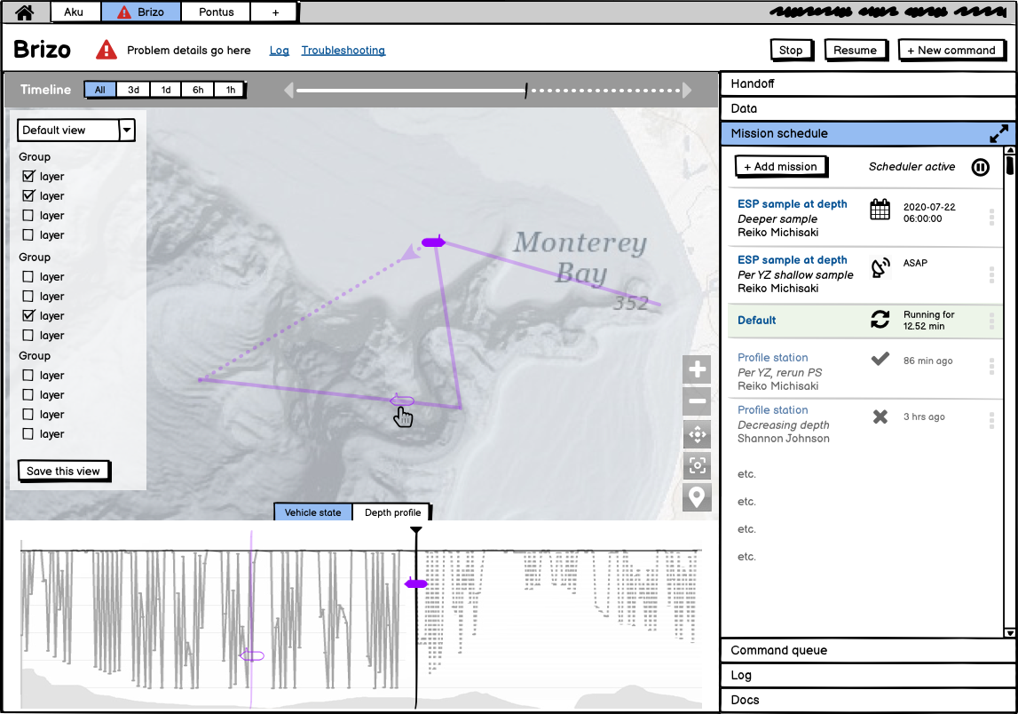

And more intuitive menus for scheduling missions.

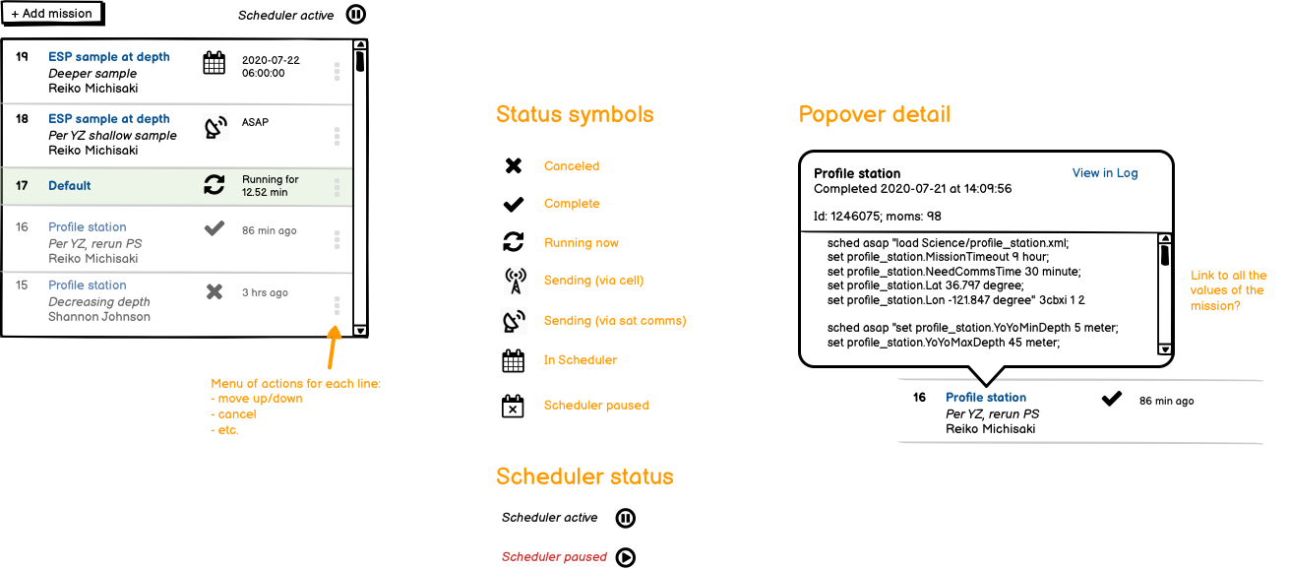

A full presentation of the concept design can be found on the project library server for this project here:
\\atlas.shore.mbari.org\ProjectLibrary\902009-LRAUV-UX\SlicedBread\project_page

What percentage of labor and budget have been used through the 1st half of year?

6% labor and 0% budget have been used

Will you complete the current year’s scheduled work?

Yes

Significant changes from previous project proposal
Changes have occurred on this project due to the departure of Dr. Leila Takayama from UCSC. While work continued during covid, the project elected to delay spending of the $10k in outside services while awaiting the decision from the MBARI hiring committee on whether or not Leila would be hired in house. She was not and subsequently we no longer have access to the 2 PhD students nor the 7 research assistants. Thus we plan to use the outside services to finish the project with Sliced Bread.

Over the past two years, what peer-reviewed publications, education and/or outreach activities have resulted directly from this project? Please be brief.
Outreach has included 2 PhD students and 7 research assistants from UCSC.

All Projects: Specific Plans for 2022

Research Activities
The research phase of the project has completed.

Engineering/technology development

The final year of this project will focus on implementation. Implementation consists of 3 areas:

Front End
For this work, we propose Jim Jeffers on the front end. https://www.linkedin.com/in/jimjeffers
Jim works closely with Sliced Bread and he has previous experience working with MBARI on the eDNA web based interface (Elif Demir-Hilton). Jim will be a sub through Sliced Bread and all scoping and billing will continue to be with Sliced Bread Designs.

Back End
Implementation of the front end requires backend (dash and database) changes. For this work, Carlos will lead the implementation effort working closely with the front-end development team. His work with Leila’s team on various topics from user research to the widget provide the context for successfully implementing the Tethys Dash back end.

LRAUV Application

Particularly for conveying a clear vehicle state, changes to the LRAUV application will be required. Tom O’Reilly, Ben Raanan, and Brian Kieft will lead these changes. In general, implementation will cover a more formal dissemination of vehicle configuration and scheduler state.

Field programs (detail ship requirements/deployments/diver requirements)

In addition to describing anticipated field programs, please be sure to include requirements for specific platforms and equipment (Dorado AUVs, LRAUVs, Wave Glider, mini ROV, etc.) for each proposed field program so that expectations are clear. Requests must also be entered in the budget entry system.

The project will make use of routine LRAUV deployments

Specific deliverables

See above

Milestones and required personnel (see personnel classification list for staff classifications)

[Click here to enter text]

2022 Project Start Date:  MM/DD/2022 | Milestone 1 | Milestone 2 | Milestone 3 | Milestone 4 | Total Resources (in hours) for each resource category for all milestones listed here
Milestone Date | Q1 | Q2 | Q3 | Q4
Milestone Description
Electrical Engineer
Software Eng-Embedded
Software Eng-Info Eng
Mechanical Engineer
Mechanical Eng-Division
Mechanical Eng-Mfg
Associate Engineer
Electrical Tech
Software Tech
Mechanical Tech
Machinist
Divers

Budget justification

Up to $TBDk for outside services for UI implementation.

Project team

- Brian Kieft
- Ben Raanan
- Brett Hobson
- Carlos Rueda
- Tom O’Reilly
- Steve Haddock
- Leila Takayama (TBD affiliation - consultant)

Project lab and office space requirements
In addition to any changes to current space usage, please also include anticipated office and lab needs for students, postdocs, collaborators, etc.

[Click here to enter text]

Risk matrix (development and infrastructure projects only)

 | Technical Risk | Organizational Risk | Tech Transfer Risk | Labor Estimate Risk
High
Medium
Low

Compliance Considerations
Please respond “Yes” or “No” to each line item below, and provide details as necessary.

CATEGORY | Yes/No | DETAILS

Isotope Use (see policy and cruise planning)
Will the project use stable or radioisotopes?

Battery waste over 4 liters (1 gallon)
Indicate type and amount.

Liquid hazardous waste over 60 liters (15 gallons)

Indicate composition and quantity.

Export Regulation
Foreign collaborations or international travel?

Export controlled purchases

Items purchased/in possession or to be purchased that are not on list?

Export controlled items (hardware, software, tech data)

Items to be transferred outside US (temporarily or permanently)? To what countries (including International Waters)?

Work covered by Marine Sanctuary permit?
Yes, if work falls under blanket authorization.

Work conducted in SESAs?

ID # for Sanctuary Ecologically Significant Areas

Equipment deployed with anchors?

Give details for deployment; recovery if < 500lbs

CA Fish & Wildlife permit required for samples?

Working in State Marine Protected Area?

Require Coast Guard PATON for buoys?

Private Aid to Navigation. Permit in hand?

Require Local Notice to Mariners
Indicate who will be submitting

Permits from other agencies?

Use of active acoustics not already on list?

This date and number should remain the same for the duration of the project. If your project start date for 2022 is not January 1, please indicate the start date in the first cell of the milestone chart. Format for duration example: “Year 2 of 5”.
Development and infrastructure projects must complete the risk matrix (see end of the proposal form).
Not all projects will require all four titles to be filled in. Please indicate individuals only for those titles that are appropriate for your project.
This category includes transfer of hardware, know-how, publications, presentations, etc.
This number should be the same number you entered on the web budget resource requests for this particular resource.

