Project Number: | 902009

Project Start: Jan. 1, | 2020 | Project Duration (in years): | 3 of 3

Please indicate if proposal includes requests for any of the following (mark all that apply).

 | X |  |  |  |  |  | X
Ship Time |  |  | ROV |  |  | AUV |  |  | Wave Glider |  |  | Mini ROV

Please indicate what type of project is being proposed (mark only one).

 |  |  |  | X
Feasibility/Scoping  [<100 days effort] |  |  | Development |  |  | Research |  |  | Infrastructure² |  |  | Education |  |  | Time Series |  |  | Institute Initiative

Project Manager: Brian Kieft
Principal Investigator: Brian Kieft
Lead Scientist: Steve Haddock
Lead Engineer: Ben Raanan

Project Title: AUV User Experience Design

Please indicate which category best describes the project theme (mark only one).

 |  |  |  |  |  |  |  |  |  | X
Ocean  biogeochemistry |  |  | Ecosystem dynamics |  |  | Ocean visualization |  |  | Exploration & discovery

Please indicate percentage of effort on this project anticipated for 2022 toward these three highest institutional goals (percentage total should equal 100%).

Goal | Developing/adapting innovative technologies | Utilizing developments to explore and understand ocean systems | Technology/knowledge transfer
Percentage | 40% | 40% | 20%

- ABSTRACT (all projects)
Briefly provide a high-level summary of the project (ideally no more than 1/2 page).

This project aims to improve AUV interface tools, specifically focusing on vehicle state and mission/command status, using user experience (UX) research methods to inform the design of AUV user interfaces to support the needs of science teams.

- PROPOSAL (all projects)

Background
Provide context for the project, being sure to address these questions:
- What fundamental problem does this project address, and why is it important?
- What makes this work relevant to MBARI and the Packard Foundation?
- Is this effort linked to other internal or externally funded projects or collaborative efforts?
- Where does this work fit into the ~5–10 year plan for your group, at MBARI, and in the field?

MBARI operates autonomous platforms at sea over 300 days per year around the clock. However, many of our systems require an expert, who is deeply familiar with the platform, to determine the vehicles’ state and overall plan. This makes the AUV more limited in their extensibility and exportability. Making use of user experience research methods from experts in the field, this project has designed upgrades to the existing command/control dash for the LRAUVs. This project is relevant across nearly all the four research themes in the strategic plan. Most notably though is exploration and discovery. As our fleet of autonomous systems grows to support further research and discovery, it must do so in a way that is extensible, limits operational overhead, and optimizes for tech transfer. Apart from our in-house PIs, this project is also linked to multiple externally funded collaborators including WHOI, DHS, NOAA, and GLERL. Judging from the first 10 years of user experiences, this project should be impacting end users for years to come and will ideally facilitate more LRAUVs in the field as they are now starting to be built out of house.

Nature and Scope of the Proposed Project
Please provide a sense of the scale and scope of the proposed work. Is this a large de novo R&D effort, modest platform/sensor integration, targeted science investigation with minimal or no engineering needs, extension of current program, small-scale scoping exercise expected to lead to a larger effort, or other? If the project is intended to be multiple years, how will the anticipated level of effort likely change over time?

This is the final year of this project and most allocations are for outside services and support engineering.

Anticipated Shared Resource Needs
What staffing is required to advance the work in 2022 (e.g., is this a multi-faceted engineering development or a targeted science investigation that does not require significant use of shared personnel)? Is in-house or contract manufacturing needed? What level of ship/ROV/AUV (DMO) support is likely? If this is intended to be a multi-year effort, please provide a rough indication of anticipated shared resource needs over the duration of the project (e.g., will stay flat, will significantly increase in Year X, will significantly decrease by Year Y).

This is the final project year and resources will draw from embedded and support engineering.

Anticipated Expenses
What rough order of magnitude direct expense budget is anticipated annually over the course of the project? Is procurement of specialized capital equipment or outside contractors required? Will there be annual travel?

On the order of $150k for outside contracting

Intellectual Property (IP) Considerations
Do you anticipate a need for a cooperative research and development agreement or licensing arrangement with an external entity? Will the work potentially result in a patentable product or service? Will novel IP and/or custom-made equipment be created, and how might it be disseminated (e.g., license agreement and/or collaborations)?

For additional guidance please review MBARI’s intellectual property internal web page: https://mww.mbari.org/itd/ip/.

No

Data
What data will be generated? How will they be managed/stored? Are any special data visualization needs anticipated?
A minimal volume of data will be generated (<10Gb). The data that will be generated will largely be reports and statistical analysis of existing data. These data will be managed on the project library.

Anticipated Impact
Who are the consumers of the instruments, methods, technology, and data that will be generated within and beyond MBARI? Will the project create tangible connections with other organizations (e.g., academic, NGO, MBA, MBNMS, state or federal agency)?
The project team and LRAUV end users.

Anticipated Outreach Needs
Thinking about the audiences/consumers you highlighted in the question above, do you anticipate needing to create outreach assets to help increase your impact? If so, please specify whether you anticipate needing to work with ITD and also specify what type of asset (story, graphic, animation, video, etc.) you might need.
No

Continuing Projects Only: Status Report
Briefly provide an update of the current project relative to what was proposed for 2021 by responding to the prompts below. If the project includes multiple subproject projects, please list each of these under a subheading as you deem appropriate.

Current status of project and results to date

User research and prototyping
- Conducted 5 in-situ, exploratory interviews with LRAUV watch standers
- Prototyped different visualizations of the log, resulting in JDash
- Conducted 7 remote, structured interviews with LRAUV watch standers
  - Discussed both Dash3 and JDash user interfaces, using a previous mission’s logs
- Shadowed 3 watch standing sessions during the Fall 2020 CANON mission

We have synthesized these findings into a set of user needs, which we was used to ground and inspire a brainstorming session via Miro board. This ultimately resulted in a concept design by the end of the year. User needs were summarized as follows:

- Understand vehicle state
- Handoff smoothly
- Build confidence
- Collaborate effectively

And a concept design was drafted that included a new look to the landing page:

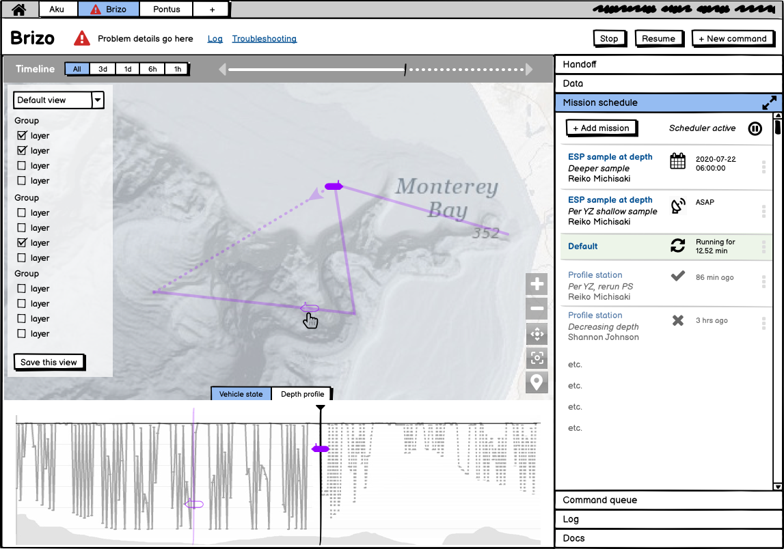

And more intuitive menus for scheduling missions and commands that allows users to see what is coming up and what has already been executed.

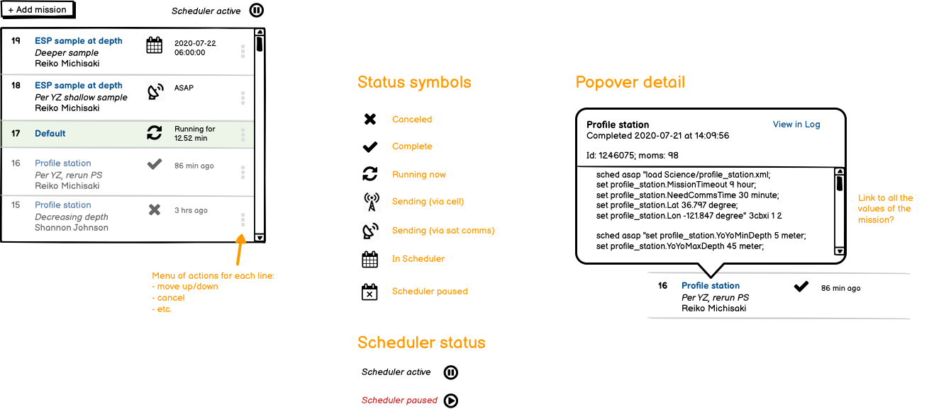

A full presentation of the concept design can be found on the project library server for this project here:
\\atlas.shore.mbari.org\ProjectLibrary\902009-LRAUV-UX\SlicedBread\project_page

What percentage of labor and budget have been used through the 1st half of year?

6% labor and 0% budget have been used

Will you complete the current year’s scheduled work?

Yes. The remaining budget will be used as part of the final design iteration at Sliced Bread.

Significant changes from previous project proposal
Changes have occurred on this project due to the departure of Dr. Leila Takayama from UCSC. While work continued during covid, the project elected to delay spending of the $10k in outside services while awaiting the decision from the MBARI hiring committee on whether or not Leila would be hired in house. She was not and subsequently we no longer have access to the 2 PhD students nor the 7 research assistants. Thus we plan to use the outside services to finish the project with Sliced Bread.

Over the past two years, what peer-reviewed publications, education and/or outreach activities have resulted directly from this project? Please be brief.
Outreach has included 2 PhD students and 7 research assistants from UCSC.

All Projects: Specific Plans for 2022

Research Activities
The research phase of the project has completed.

Engineering/technology development

The final year of this project will focus on detailed user interface design implementation. Implementation. This consists of 4 areas:

Detailed user interface
For this work, we propose continuing with Sliced Bread Design to create a complete interface design based on original rough concept sketches and to user test the designs. In order to implement the design, we need to create detailed designs for the screens that were only sketched at a high level, add designs for screens that were not include in Phase 1, and validate the designs with prospective users.

Front End
For this work, we propose Jim Jeffers on the front end. https://www.linkedin.com/in/jimjeffers
Jim works closely with Sliced Bread and he has previous experience working with MBARI on the eDNA web based interface (Elif Demir-Hilton). Jim will be a sub through Sliced Bread and all scoping and billing will continue to be with Sliced Bread Designs.

Back End
Implementation of the front end requires backend (dash and database) changes. For this work, Carlos will lead the implementation effort working closely with the front-end development team. His work with Leila’s team on various topics from user research to the widget provide the context for successfully implementing the Tethys Dash back end.

LRAUV Application

Particularly for conveying a clear vehicle state, changes to the LRAUV application will be required. Tom O’Reilly, Ben Raanan, and Brian Kieft will lead these changes. In general, implementation will cover a more formal dissemination of vehicle configuration and scheduler state.

Field programs (detail ship requirements/deployments/diver requirements)

In addition to describing anticipated field programs, please be sure to include requirements for specific platforms and equipment (Dorado AUVs, LRAUVs, Wave Glider, mini ROV, etc.) for each proposed field program so that expectations are clear. Requests must also be entered in the budget entry system.

The project will make use of routine LRAUV deployments

Specific deliverables
Deliverables divided between Sliced Bread and MBARI labor.

Sliced Bread
- Design a detailed user interface for the full LRAUV functionality based on early design work for the following:
  - Areas with concept sketches to build on:
    - Overall Dashboard layout
    - Mission schedule
    - Command queue
    - Battery monitor
- Areas without concept sketches:
  - Handoff
  - Data
  - Log
  - Docs
  - Vehicle state
  - Depth profile
  - New command creation
  - Map centered interactions (science data, hover, timeline, etc.)

• Design a detailed user interface for the full LRAUV functionality based on early design work for the following:
• Areas with concept sketches to build on:
• Overall Dashboard layout
• Mission schedule
• Command queue
• Battery monitor
• Areas without concept sketches:
• Handoff
• Data
• Log
• Docs
• Vehicle state
• Depth profile
• New command creation
• Map centered interactions (science data, hover, timeline, etc.)
• 2 rounds of lightweight user feedback on designs in progress
• Implementation of entire front-end user experience
• 6 months follow-up maintenance

MBARI
- New landing page including widget front and center as well as mission projection. See images above. (Carlos 16)
- New front end display for mission and command queue. See images above. (Carlos 16)
- Command queue that tracks the status of all commands/mission requests for all communication methods. (Carlos 80)
- Design of dash events and database entries that can be queried and visualized in the frontend. Match dash events with status symbols identified in the UI front end design. (Carlos 80)
- Shore-side representation of the LRAUV mission scheduler, and design dash events and database entries that can be queried and visualized in the frontend. Match dash events with status symbols identified in the UI front end design.(Carlos 20, Tom 60)
- Design framework to allow forward projection of vehicle status and mission plan, including waypoints, depth profile, next leg for autonomous tracking, and any planned sampling. (Carlos 8, Tom 40, Brian 16, Ben 16)
- Refinement of battery management and projection interface to support front end display (Tom 20)
- Widget refinement tailored to accurately depict vehicle state (Carlos 40, Tom 40)
- Iterative user testing/feedback on parallel dash while development is in progress. (Carlos 40, Tom 16, Brian 16, Ben 16, Brett 8)

Carlos: 300
Tom: 176
Brian: 40 (includes pm overhead)
Ben: 32
Brett: 8
Leila Takayama- Collaborating with Sliced Bread Design on user research that will feed into the design iterations of the LRAUV dashboard: 80
Additionally Steve Haddock will be contributing but his hours are not required to be listed here

Milestones and required personnel (see personnel classification list for staff classifications)

2022 Project Start Date:  MM/DD/2022 | Milestone 1 | Milestone 2 | Milestone 3 | Milestone 4 | Total Resources (in hours) for each resource category for all milestones listed here
Milestone Date | Q1 | Q2 | Q3 | Q4
Milestone Description | Final design completed | Back End and DB | Front end implementation completed | Back end and application interfaces completed
Electrical Engineer
Software Eng-Embedded | 30 | 86 | 50 | 82 | Kieft(40)  O’Reilly(176)  Raanan(32)
Software Eng-Info Eng | 32 | 160 | 28 | 80 | Rueda(300)
Mechanical Engineer | 2 | 2 | 2 | 2 | Hobson(8)
Mechanical Eng-Division
Mechanical Eng-Mfg
Associate Engineer
Electrical Tech
Software Tech
Mechanical Tech
Machinist
Divers

Budget justification

Up to $160k outside services for UI design/implementation. Up to $20k for Dr. Leila Takayama

Project team
- Brian Kieft
- Ben Raanan
- Brett Hobson
- Carlos Rueda
- Tom O’Reilly
- Steve Haddock
- Leila Takayama (consultant via ICA)
- Sliced Bread Designs (Julie Stanford, principal – outside services)

Project lab and office space requirements
In addition to any changes to current space usage, please also include anticipated office and lab needs for students, postdocs, collaborators, etc.

None

Risk matrix (development and infrastructure projects only)

 | Technical Risk | Organizational Risk | Tech Transfer Risk | Labor Estimate Risk
High
Medium | X |  |  | X
Low |  | X | X

Compliance Considerations
Please respond “Yes” or “No” to each line item below, and provide details as necessary.

CATEGORY | Yes/No | DETAILS
Isotope Use (see policy and cruise planning)  Will the project use stable or radioisotopes? | No
Battery waste over 4 liters (1 gallon)  Indicate type and amount. | No
Liquid hazardous waste over 60 liters (15 gallons)  Indicate composition and quantity. | No
Export Regulation  Foreign collaborations or international travel? | No
Export controlled purchases  Items purchased/in possession or to be purchased that are not on list? | No
Export controlled items (hardware, software, tech data)  Items to be transferred outside US (temporarily or permanently)? To what countries (including International Waters)? | No
Work covered by Marine Sanctuary permit?  Yes, if work falls under blanket authorization. | Yes
Work conducted in SESAs?  ID # for Sanctuary Ecologically Significant Areas | No
Equipment deployed with anchors?  Give details for deployment; recovery if < 500lbs | No
CA Fish & Wildlife permit required for samples? | No
Working in State Marine Protected Area? | No
Require Coast Guard PATON for buoys?  Private Aid to Navigation. Permit in hand? | No
Require Local Notice to Mariners  Indicate who will be submitting | No
Permits from other agencies? | No
Use of active acoustics not already on list? | No

This date and number should remain the same for the duration of the project. If your project start date for 2022 is not January 1, please indicate the start date in the first cell of the milestone chart. Format for duration example: “Year 2 of 5”.
Development and infrastructure projects must complete the risk matrix (see end of the proposal form).
Not all projects will require all four titles to be filled in. Please indicate individuals only for those titles that are appropriate for your project.
This category includes transfer of hardware, know-how, publications, presentations, etc.
This number should be the same number you entered on the web budget resource requests for this particular resource.

