ABSTRACT FORM

Project Title: LRAUV UI assimilation

Expected Project Duration (in years): 3

PI | Project Manager | Lead Scientist | Lead Engineer
Brian Kieft | Brian Kieft

Project Overview

This effort builds on the work completed in years 1-3 of 902009 AUV User Experience Design. The scope includes time requests for MBARI engineering staff to integrate the newly designed LRAUV user interface (UI) into the LRAUV operational workflow, respond to issue, and add minor functional improvements to satisfy operational needs.

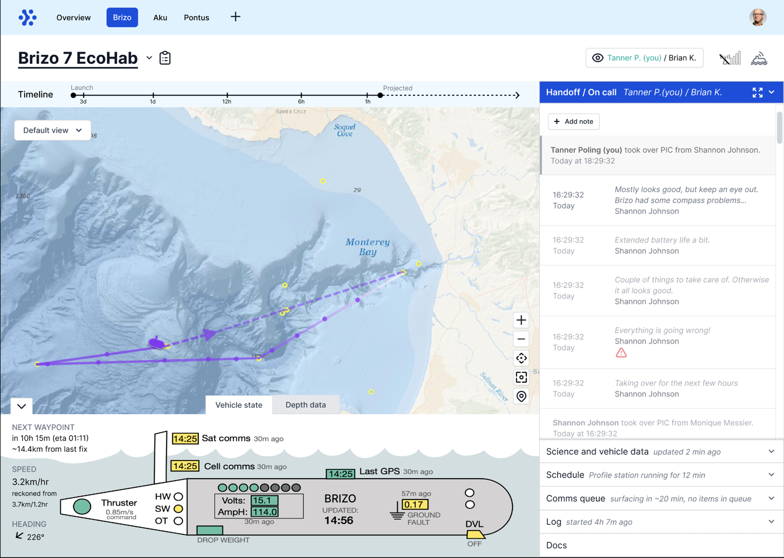
Screen capture from the new LRAUV dash design.

Is this project one of multiple projects your team plans to submit?

N/A

Nature and Scope of the Proposed Project

Engineering time is required in order to put the new UI into production.

Budget Category | Minimal | Medium | Significant
Labor | X  (~300 eng hrs)
Expense | X  (~$5k)
Ship/Assets | N/A

Anticipated Shared Resource Needs

IE Eng. time: Rueda and Salamy.
ES Eng. time: Kieft.

Anticipated Expenses
$5k for external support.

Intellectual Property (IP) Considerations

N/A

Data

N/A

Anticipated Impact

Increase LRAUV operational capacity for MBARI and external LRAUV users.

Anticipated Outreach Needs

N/A

