Project Number: | 902010

Project Start: Jan. 1, | 2021 | Project Duration (in years): | 3 ¹

Please indicate if proposal includes requests for any of the following (mark all that apply).

Ship Time |  |  | ROV |  |  | AUV |  |  | Wave Glider |  |  | Mini ROV

Please indicate what type of project is being proposed (mark only one).

 |  |  |  | x
Feasibility/Scoping  [Less than 100 days effort] |  |  | Development |  |  | Research |  |  | Infrastructure² |  |  | Education |  |  | Time Series |  |  | Institute Initiative

Project Manager: Brett Hobson
Principal Investigator: Brett Hobson
Lead Scientist: Henry Ruhl, Kelly Benoit-Bird, Kakani Katija, Bruce Robison, Francisco Chavez
Lead Engineer: Jon Erickson

Project Title: Mesopelagic LRAUV

Please indicate which category best describes the project theme (mark only one).

 |  |  |  | x
Ocean  biogeochemistry |  |  | Ecosystem dynamics |  |  | Ocean visualization |  |  | Exploration & discovery

Please indicate percentage of effort on this project anticipated for 2021 toward these three highest institutional goals (percentage total should equal 100%).

Goal | Developing/adapting innovative technologies | Utilizing developments to explore and understand ocean systems | Technology/knowledge transfer
Percentage | 100 | [Enter percentage here] | [Enter percentage here]

- ABSTRACT (if submitted during abstract phase)

There are uncertainties in rates of carbon sequestration in the deep ocean that have profound effects on our understanding of the global carbon cycle. Much of this uncertainty stems from an inability to make detailed observations of the biological carbon pump over sufficient time and space scales, beyond the capability of ship-based observation or fixed point and depth autonomous platforms. MBARI’s Long Range Autonomous Underwater Vehicle LRAUV is a unique platform that has the endurance to estimate dynamics that occur over periods of days to weeks or more, and up to mesoscale ocean circulation features such as eddies, filaments and jets that are common to the California Current Large Marine Ecosystem. Depending on the specific application, observing such dynamics can be enhanced through on-board adaptive sampling to find areas of interest and stop to sample and observe specific features that cannot be well determined independently. Unfortunately, many critical processes of the biological carbon pump occur to depths of 1000 m or more. It is in this midwater ‘twilight zone’ that most carbon sequestration / remineralization processes occur, which relate to the biodiversity and ecology of the inhabitants of these depths (see Figure to bottom right; source: www.pnas.org/cgi/doi/10.1073/pnas.1415311112). Here we propose a feasibility study to enhance the LRAUV depth rating to 1500 m that will focus on two science applications that each tie back to understanding biodiversity, community composition, and biological carbon pump function: 1) EyeRIS Plenoptic imaging of particles and plankton, 2) Bioacoustic imaging of plankton and nekton. We will also collate existing information on seafloor photographic mapping, acoustic mapping, genomic sampling, and other potential camera system developments such as the “Planktivore” imaging system requirements. The project will progress plans for a new pressure hull design LRAUV and other work to achieve a to 1500 depth rating. This information will be presented in a 2021 proposal for a new pressure hull that could be retrofitted to an existing vehicle, or be a feature of a new vehicle.

We present two example science applications that have existing development support, detailed requirements established, detailed use and mission plans, and beneficiaries both at MBARI, externally and internationally.

1) EyeRIS Plenoptic imaging of particles and plankton: It is expected that the data from scientific deployments enabled by this new depth rating will aid in the (re)parametrization of biogeochemical models used for resource management, industry impact assessments, and managed marine space assessments and estimating the impacts of climate change. The Moore Foundation currently supports the EyeRIS project, which includes the development of a deep rated plenoptic camera system and its integration into the LRAUV. The key application for this camera use in LRAUV is the imaging of objects in relation to the functioning of the biological carbon pump (BCP). This includes the measuring of the size- and type-distribution of objects in vertical profiles of the upper midwater and surface ocean. This information can be used to infer particulate carbon fluxes and the related plankton dynamics over time and/space not possible by other means. Specifically, the remineralization length scale (RLS) is specific quantification that can be determined in high resolution for each profile and measured over a bloom and sinking pulse cycle, and/or assessed across specific ocean circulation features. By imaging both particle variation and the zooplankton community dynamics that relate to such variations, along with other tools like optical backscatter fluorescence, this approach is expected to be able to address an unprecedented set of hypotheses on factors controlling RLS and the BCP. For example, the temperature control hypothesis entailed in the above figure. Measurements to a depth of 1500 m are expect to account for ~75 of the remineralization depending on the RLS value (i.e. shape of the flux attenuation curve). This is a key determinant of carbon sequestration depth and food supply to various depths. This quantification relates directly to model form and evolution currently used by the Intergovernmental Panel on Climate Change (IPCC), enabling a pathway for the rapid transfer of knowledge the highest levels of global biogeochemical carbon cycle modelling. MBARI science support includes Robison, Barry, Smith and Ruhl (see internal 2019 EyeRIS proposal), as well as Chavez. Ruhl works with model experts at the National Oceanography Centre, UK, and elsewhere that contribute regularly to models used by the IPCC and explicitly relate RLS variation. This system could also benefit the Integrated Ocean Observing System and related partners to include the collection of biology observations that can be assimilated into ocean models, improving model realism.

2) Bioacoustic imaging of zooplankton and nekton: The Bioacoustic LRAUV that is currently under development will allow us to map the distribution of zooplankton and nekton in the water column to a depth of ~450 m when including both the depth capabilities of the platform and the range of the sensor. However, many vertically migrating animals go much deeper than this, in fact the peak of mesopelagic biomass is typically centered between 500 and 650 m in Monterey Bay and in other systems, up to 50% of carbon export is mediated by these vertical migrators. To understand these midwater organisms, the drivers of their migration, their impacts on carbon flux, and the influences of longer term processes like upwelling and climate on mesopelagic animals requires that we be able to sample them persistently. The sensors developed for the LRAUV are capable of deployment to 1500 m thus only modest engineering would support integration of a system on the mesopelagic LRAUV, allowing us to sample crustaceans, fish, and cephalopods to a depth of 1750 m. These samples would be of use to the US Navy in managing deep diving species like beaked whales as part of our ongoing, externally funded efforts. In addition, we anticipate these data will be of particular importance in developing accurate biomass and life history data for the mesopelagic as NOAA prepares to revisit their decision (influenced by efforts by the Packard Foundation) not to allow commercial fishing access to the mesopelagic. We also envision these capabilities allowing us to link the epipelagic, mesopelagic, and export approaches taken independently by the time series efforts at MBARI. A long duration mobile asset with mesopelagic depth capabilities will provide the opportunity to link these programs in space and time to reveal the processes by which production is transferred to the deep.

This is a low-risk, mechanical engineering project that opens up access to the mesopelagic zone MBARI has been exploring with ROV Ventana for over 30 years. This brings a more persistent, targeted and dynamic presence to evolving sensor technologies. The feasibility study will demonstrate how enhancing prospective use cases will develop further MBARI technologies towards understanding change, ocean system function in frameworks that can readily disseminate capability and knowledge. In addition to the specific cases above, additional interest is expected towards enhancing the range of depths, spatial extents and timeframes than currently exist for additional modes of, physical and chemical sensing, midwater imaging and genomic sensing and sampling .

Why use the LRAUV in the Mesopelagic zone?

- Low operational costs
  - Weeklong deployments from small vessels. ~3 hours of Paragon time per deployment/recovery vs. 24 hour deployments requiring 2 days of Carson time for deployment/recovery at high cost. We estimate a cost per hour of data collection differential of ~50x based on current vessel day rates.
  - Primary operations from shore rather than at sea reduces personnel time costs.
  - Deployment capacity from small vessels will be particularly important in the gap between the R/V Western Flyer and R/V David Packard when large ship time will be at a premium.
- Long duration data collection facilitates novel science questions
  - Diel migration, and its relation to longer term variations
  - Influences of upwelling processes on the mesopelagic
  - Variance estimation of carbon flux and sequestration through bloom and pulse events
- Exploits ongoing investments in vehicle control and coordination in shallow LRAUV fleet
  - Multi-vehicle coordination
  - Lagrangian tracking
  - Waveglider positioning and data transfer
  - Adaptive sampling e.g., autonomous decision making and tracking of fronts, animal biomass, and triggering of sensors

- PROPOSAL

  - All Projects

Statement of the challenge, why it is important

Enhancing the LRAUV depth rating will enable new scientific capabilities that address local, regional and global scientific challenges. This includes:
- Constraining and projecting the magnitude and variation of the BGC, which is currently estimated to export ~5-15 Gt C yr^-1 globally;
- Identifying factors that drive variation in BGC processes, including the importance of BGC variation;
- Leveraging various sensor technologies to bring high-resolution vertical measurements of objects from marine snow to whales capable of discerning diel vertical migration, change RLS, and longer term variations that arise from ocean circulation and other variations over time.
- Providing information to help evaluate and manage marine spaces including the Monterey Bay National Marine Sanctuary and the California Current Large Marine Ecosystem concept enabling the missions of the National Oceanographic and Atmospheric Administrations and the US Navy, for example.

Relevance

How does it relate/contribute to MBARI’s mission and strategic plan?

This project is focused on the Ecosystem Dynamics theme of MBARI’s Strategic Plan by developing an ability to possibly follow and document the trophic evolution of entire ecosystem as it evolves from raw nutrients in freshly upwelled water, to the phytoplankton blooms through to zooplankton grazing, fish and whale predation.

Does it relate to the Technology Roadmap? If so, please describe how. (See http://mww.mbari.org/oed/TechnologyRoadmap.pdf.)

If this effort is supported, MBARI scientists will be able to program the LRAUVs to find transient areas of high productivity though bio-acoustics for Targeted Sampling and use the on-board sensors to distinguish different plankton species, which is taking the Lab into the Ocean and then park offshore until a second or third sampling session is initiated, which is Advancing a Persistent Presence.

How does it relate/contribute to the Packard Foundation’s Ocean Grantmaking Program? (See https://www.packard.org/what-we-fund/ocean/ and documents therein.)

This proposed effort aims to illuminate a holistic view of the ecosystem dynamics in the open ocean, the largest biome on the planet. This expanded understanding of the ocean can be used to improve the models of open ocean CO₂ uptake and predict the effects of proposed open ocean aquaculture.

Overall approach to the challenge: Over the complete term of the project, what is needed to address the challenge (e.g., sensors, platforms, marine operations, de novo R & D, etc.)

Research

N/A

Engineering/Technology Development
This development project aims to investigate how best to build a pressure housing upgrade for a standard LRAUV and perform some pressure testing to confirm a few higher risk components will operate reliably during routine operations to 1500m. If this proposed work moves forward, we propose to upgrade LRAUV Tethys, as this vehicle is currently used for development projects and is outside of the operational fleet and would not therefore impact any other planned operations.

Marine Operations/Field Programs

None operations planned

Data
What data products will be generated?

No science data will be generated.

How will the data products be managed?
N/A
Describe data availability outside of the project team.

N/A

Describe data storage requirements.

N/A

Anticipated Impact

Who are the consumers of the instruments, methods, systems, and data that will be generated?

If the Mesopelagic LRAUV is ultimately developed, we expect that the platform will have broad use within MBARI including by PIs Katija, Ruhl, Benoit-Bird, Robison, Haddock, and Chavez. The data that can be generated with this newly adapted platform could answer important questions about the 10 billion tons of biological resources in the mesopelagic, their role in ecosystem processes and carbon flux, and the impacts of proposed fisheries on this understudied zone.

Anticipated Outreach

What outreach assets might you need to better reach the audience/consumers you are targeting? Specify how you might like to reach your audience (published paper, seminar, conference, social media, etc.) and what type of assets (graphic, animation, video, etc.) you might need ITD to help generate.

Our 2022 proposal could us a concept drawing showing how the vehicle could be used at Sur Ridge.

Intellectual Property (IP) Considerations

Do you anticipate a need for a cooperative research and development agreement or licensing arrangement with an external entity?

No, not during this feasibility study.

Will novel IP be created, and how might it be disseminated (e.g., open-source, royalty-free license, commercial license agreement)?

Novel IP will be created that could ultimately be disseminated with a commercial license agreement.

Will the work potentially result in a patentable product or service?

Some aspects could be patentable.

For additional guidance please review MBARI’s intellectual property internal web page: https://mww.mbari.org/itd/ip/.

[Click here to provide any additional details]

  - All Projects: Specific Plans for 2021

Research Activities

N/A

Engineering/technology development
The high risk design elements are the strength and compressibility of the pressure hull and scaling of the propeller. We propose to address this risk before the submitting a full proposal by fabricating three hull sections and performing testing that will require depth de-rating, if it does not fail. The test hull will be instrumented to validate expected strains and a device to measure compressibility will be used. Simplified endcaps will be used to minimize the risk to damage should an unexpected failure of the hull occur. We believe we can detect an impending failure with enough warning to abort the test, but there is still some risk of damage. The propeller design will be tested on one of the existing LRAUVs that have been fitted with an add-on drag panel to replicate the increased drag of the deep rated vehicle.

Picking up where the previous proposal left off we plan work out the details of the components described in the PDR. Machine prints will be generated that will allow us to get realistic cost estimates to perform the proposed upgrade. The cost of all COTS components will be tallied and added to the cost estimate and a complete Bill of Materials (BOM) will be created. The final design details and cost estimate will be evaluated during a Critical Design Review before the 2022 proposal is submitted.

If our 2022 proposal makes it through Phase 2 and the budget is approved by the board we propose to take LRAUV Tethys off line and begin the conversion to a Mesopelagic LRAUV. Due to the large number of vehicle development projects that rely on Tethys, we propose to take over use of LRAUV Galene, which was previously built for Mathieu Kemp’s development.

- Validate high risk designs – 310 hours
  - New propeller- During 2020 Dr. Zhang plans to use the MIT propeller program to scale up the LRAUV propeller to push the added drag of the slightly larger and longer vehicle. We plan to have a prototype cast using a new rapid manufacturing process to print metal parts. Hobson 10 hours, Erickson 10 hours, Zhang 40 hours.
  - The prototype propeller will be tested on LRAUV Tethys, along with a drag ring to approximate the added drag of the larger vehicle. Hobson 10
  - Several of the pressure hull tubes designed in 2020 will be manufactured for testing. Hobson 10, Erickson 10
  - Two dummy aluminum endcaps will be machined at MBARI for the pressure test. Strain gauges will be installed on the tubes to measure stain during the test to validate the simulated strain and act as a trigger to abort the test if the tube is yielding. Erickson 30, Machine shop 60.
  - The pressure test will be conducted at Maripro in Santa Barbara, or possibly the naval station at Point Hueneme. Hobson 20, Erickson 60
- Cost Estimate – 150 hours
  - In preparation for the CDR and submission of the 2022 proposal we will summarize the expected build cost of the Mesopelagic LRAUV. The remaining machine drawings will be completed. Erickson 120
  - A new Bill of Materials will be generated for the new vehicle. Hobson 20
  - We will work with the machine shop to update the cost of all the machined parts. Erickson 10
- Critical Design Review (CDR) 70 hours
  - Prepare the CDR presentation Hobson 40, Erickson 10
  - Conduct the review and address issues that were raised. Hobson 10, Erickson 10
- Contingency tasks 70 hours – Only proceed if 2022 proposal to build the Mesopelagic LRAUV is approved
  - Disassemble Tethys, service components and begin building the new sub-assemblies. Hobson 40,
  - Request discretionary funds to order long-lead parts. Hobson 10, Erickson 20
- Management – 100 hours
  - Meetings, Hobson 20, Erickson 20
  - Contingency to solve unplanned problems, Hobson 20, Erickson 20
  - Project management. Hobson 20

Will novel intellectual property be developed and/or disseminated?
Dissemination includes patenting, licensing, and collaboration agreements.

Yes, novel IP will be developed, but not disseminated in 2021.

Field programs (detail ship requirements/deployments/diver requirements)

In addition to describing anticipated field programs, please be sure to include requirements for specific platforms and equipment (Dorado AUVs, LRAUVs, Wave Glider, mini ROV, etc.) for each proposed field program so that expectations are clear. Requests must also be entered in the budget entry system.

None

Isotope Usage
Project teams must provide details regarding any planned isotope use on shore, on ships, in the Sanctuary, etc. Please review the guidance on isotope usage at http://www.mbari.org/at-sea/cruise-planning/hazardous-materials/ and policy at http://mww.mbari.org/safety/SafetyManual/Isotope_Use_Policy.pdf, and then provide details on plans below.

None

Safety Disposal Needs

So the Safety office can plan and budget accordingly, please respond to the questions below regarding any anticipated safety disposal needs for the coming year. Budget for cost of such removal will be captured by the safety office based on responses received.

Will this project generate more than 1 gallon (4 liters) of battery waste per year?

No

If yes, please indicate the type of batteries (alkaline, NiCad, NiMH, lithium ion or lithium metal) and the approximate amount of each to be generated.

N/A

Will this project generate more than 15 gallons (60 liters) of hazardous liquid waste per year?

No

If yes, please indicate the composition of the waste(s) and the quantity of each to be generated.

N/A

Specific deliverables

A CDR in Q2, which includes machine prints, a Bill of Materials and cost estimate for the deep vehicle and a contingency deliverable will be purchase orders for long lead-time parts.

Milestones and required personnel (see personnel classification list for staff classifications)

[Click here to enter text]

2021 Project Start Date:  MM/DD/2021 | Milestone 1 | Milestone 2 | Milestone 3 | Milestone 4 | Milestone 5 | Total Resources (in hours) for each resource category for all milestones listed here
Milestone Date | March | April | July | Nov
Milestone Description | Validate high risk | Cost Estimate | CDR | Contingency tasks if green light | Project Mgt
Electrical Engineer
Software Eng-Embedded
Software Eng-Info Eng
Mechanical Engineer | 160 | 150 | 70 | 70 | 100 | 550
Mechanical Eng-Division
Mechanical Eng-Mfg
Associate Engineer
Electrical Tech
Software Tech
Mechanical Tech | 50 |  | 40 |  |  | 90
Machinist | 60 |  |  |  |  | 60
Divers
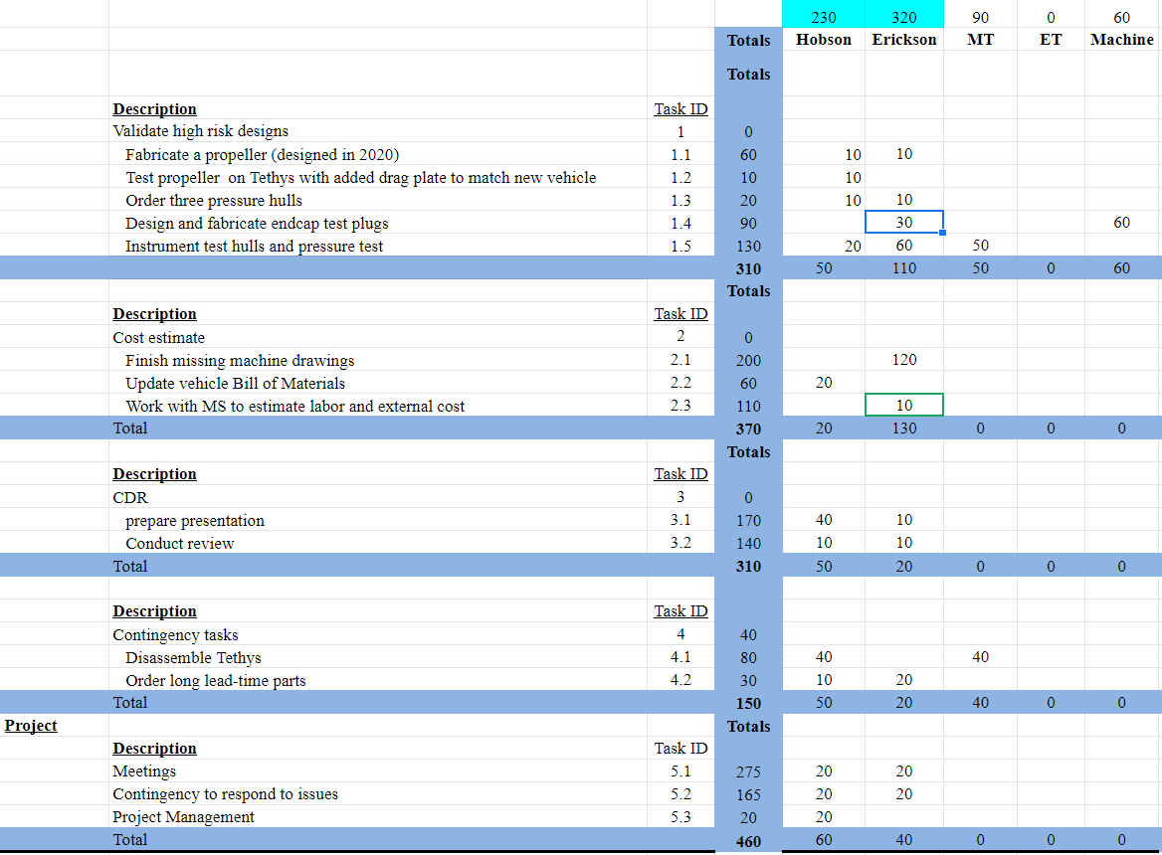

Budget justification

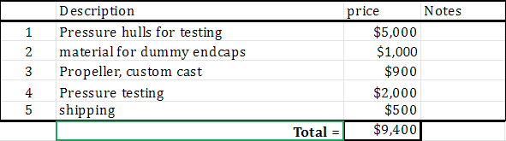

Project team

Brett Hobson, 230 hours
Jon Erickson, 320 hours

Project lab and office space requirements
In addition to any changes to current space usage, please also include anticipated office and lab needs for students, postdocs, collaborators, etc.

No extra lab space required

R/V Paragon Requests
If the project team will be requesting time for the R/V Paragon, please specify the operators in the group and provide estimates of their availability to operate the vessel. DMO staff have extremely limited availability to be operators and only with advanced budgeting and planning.

None

Risk matrix (development and infrastructure projects only)

 | Technical Risk | Organizational Risk | Tech Transfer Risk | Labor Estimate Risk
High | x
Medium |  | x | x | x
Low

  - Compliance Considerations

Export Regulation
Does the project team anticipate any foreign collaborations or international travel? If so, please identify collaborators by name, institution, and country.

No

Does the project team plan or anticipate export-controlled purchases, shipments, or transfers of items (e.g., research instruments, proprietary data, hand-carried tools or samples) outside the U.S. temporarily or permanently? If yes, please identify country or countries and indicate whether these items will remain under MBARI control while abroad or controlled by others. Will the items be exported to more than one country? Please include foreign collaborator information as described above.

No

Monterey Bay National Marine Sanctuary (MBNMS)

General Permit
Projects teams need to indicate if any work will be performed that is either: (1) currently authorized under our general permit; or (2) will require that we obtain authorization. The current permit can be viewed at https://mww.mbari.org/pco/permits/mbnms-2020-006_exp28feb2025.pdf. Please see Mandy Allen for questions.

Is a permit with MBNMS required for your work?

No

SESAs (General map)
Projects will need to indicate whether or not work will be conducted within one of the Monterey Bay National Marine Sanctuary's Ecologically Significant Areas (SESAs). If your work will be conducted in one of these areas, please indicate which area by number or name.

None

Anchors
For activities conducted under MBARI's permit for the Monterey Bay National Marine Sanctuary, Paragraph 16, we are required to recover anchors weighing less than 500 pounds. Project proposals, which involve anchors weighing less than 500 pounds, shall specifically indicate cruise time allocated to anchor recovery. Lack of cruise time is not an acceptable reason for deeming an anchor less than 500 pounds “unrecoverable” under Paragraph 17 of MBNMS permit. Also under Paragraph 17, ALL anchors not recovered during the year must be reported detailing location, description of anchor, and reason not recovered. (Mandy Allen will collect this information from project teams to submit as part of the annual report to the Sanctuary.) Each ship will be tracking anchors deployed, duration of attempted anchor recovery, and anchors abandoned on the seafloor with the intent that they be recovered in the future as per MBNMS permit requirements.

Will you be deploying equipment that will require anchoring? If so, please indicate approximate weight of anchors to be used and recovery plans.

None

California Department of Fish & Wildlife
A Scientific Collecting Permit will be required for biological and geological sample collections offshore California (even in Federal waters and beyond), and for many activities in State Marine Protected Areas (MPAs). Please see Mandy Allen for questions.

Will you be collecting samples that require a permit?

No

Will you be working in a State Marine Protected Area?(See link above for Statewide MPAs or this link for Central California MPAs.)

No

United States Coast Guard

If your project will deploy or maintain moorings, the project team must ensure proper compliance and notification of these activities to the US Coast Guard. DMO does not automatically do these notifications on behalf of projects. Two common types of permits and notifications that may apply to your project are Private Aid to Navigation (PATON) authorizations (required for buoys deployed for six (6) months or longer) and Notice to Mariners, which must be submitted for temporary PATONs (less than 6-month deployments). Other science operations may submit a request for a Local Notice to Mariners and are useful for missions or deployments with risk of 3rd Party Liability such as the Wave Glider.

Will your project require a PATON?

No

If yes, have you obtained a PATON? (Please provide a copy to Mandy Allen.)

N/A

Will your project require submission of a Local Notice to Mariners?

No

If yes, please indicate who will be submitting request and provide a copy of the submission to Mandy Allen.

N/A

Authorizations/Permits from other Agencies or Organizations
Is the project team aware of any other permits or authorizations that will be necessary to perform the proposed work? If so, please list below along with status of authorizations (obtained, pending, need to apply, etc.). Please see Mandy Allen if you have questions.

None

Active Acoustics
We are keeping an inventory of acoustic instrumentation. The current list is posted here: https://mww.mbari.org/resources/2021_Proposal_Process/mbari_acoustic_instruments_updated_may_13_2020_ver_13.xlsx. If you have or plan to use equipment that is not already on this list, please be sure to include that information here.

None

This date and number should remain the same for the duration of the project. If your project start date for 2021 is not January 1, please indicate the start date in the first cell of the milestone chart. Format for duration example: “Year 2 of 5”.
Development and infrastructure projects must complete the risk matrix (see end of the proposal form).
Not all projects will require all four titles to be filled in. Please indicate individuals only for those titles that are appropriate for your project.
This category includes transfer of hardware, know-how, publications, presentations, etc.
This number should be the same number you entered on the resource requests for this particular resource.

