Project Number: | 902010

Project Start: Jan. 1, | 2021 | Project Duration (in years): | 2/3¹

Please indicate if proposal includes requests for any of the following (mark all that apply).

 |  |  |  |  |  |  | x
Ship Time |  |  | ROV |  |  | AUV |  |  | Wave Glider |  |  | Mini ROV

Please indicate what type of project is being proposed (mark only one).

 |  |  |  | x
Feasibility/Scoping  [<100 days effort] |  |  | Development |  |  | Research |  |  | Infrastructure² |  |  | Education |  |  | Time Series |  |  | Institute Initiative

Project Manager: Brett Hobson
Principal Investigator: Brett Hobson
Lead Scientist: Kelley Benoit-Bird, Henry Ruhl
Lead Engineer: Jon Erickson

Project Title: Mesopelagic LRAUV

Please indicate which category best describes the project theme (mark only one).

 |  |  |  | x
Ocean  biogeochemistry |  |  | Ecosystem dynamics |  |  | Ocean visualization |  |  | Exploration & discovery

Please indicate percentage of effort on this project anticipated for 2022 toward these three highest institutional goals (percentage total should equal 100%).

Goal | Developing/adapting innovative technologies | Utilizing developments to explore and understand ocean systems | Technology/knowledge transfer
Percentage | 100 | 0 | 0

- ABSTRACT (all projects)
Briefly provide a high-level summary of the project (ideally no more than 1/2 page).

Here we propose a depth rating upgrade for the existing Tethys LRAUV to 1500 m. This upgrade will allow us to focus on two science applications that each tie back to understanding biodiversity, community composition, and biological carbon pump function: 1) EyeRIS Plenoptic imaging of particles and plankton, 2) Bioacoustic imaging of plankton and nekton.

There are uncertainties in rates of carbon sequestration in the deep ocean that have profound effects on our understanding of the global carbon cycle. Much of this uncertainty stems from an inability to make detailed observations of the biological carbon pump over sufficient time and space scales, beyond the capability of ship-based observation or fixed point and depth autonomous platforms. MBARI’s Long Range Autonomous Underwater Vehicle LRAUV is a unique platform that has the endurance to estimate dynamics that occur over periods of days to weeks or more, and up to mesoscale ocean circulation features such as eddies, filaments and jets that are common to the California Current Large Marine Ecosystem. Depending on the specific application, observing such dynamics can be enhanced through on-board adaptive sampling to find areas of interest and stop to sample and observe specific features that cannot be well determined independently. Unfortunately, many critical processes of the biological carbon pump occur to depths of 1000 m or more. It is in this midwater ‘twilight zone’ that most carbon sequestration / remineralization processes occur, which relate to the biodiversity and ecology of the inhabitants of these depths.

We present two example science applications that have existing development support, detailed requirements established, detailed use and mission plans, and beneficiaries both at MBARI, externally and internationally.

1) EyeRIS Plenoptic imaging of particles and plankton: It is expected that the data from scientific deployments enabled by this new depth rating will aid in the (re)parametrization of biogeochemical models used for resource management, industry impact assessments, and managed marine space assessments and estimating the impacts of climate change. The Moore Foundation currently supports the EyeRIS project, which includes the development of a deep rated plenoptic camera system and its integration into the LRAUV. The key application for this camera use in LRAUV is the imaging of objects in relation to the functioning of the biological carbon pump (BCP). This includes the measuring of the size- and type-distribution of objects in vertical profiles of the upper midwater and surface ocean. This information can be used to infer particulate carbon fluxes and the related plankton dynamics over time and/space not possible by other means. Specifically, the remineralization length scale (RLS) is specific quantification that can be determined in high resolution for each profile and measured over a bloom and sinking pulse cycle, and/or assessed across specific ocean circulation features. By imaging both particle variation and the zooplankton community dynamics that relate to such variations, along with other tools like optical backscatter fluorescence, this approach is expected to be able to address an unprecedented set of hypotheses on factors controlling RLS and the BCP.

2) Bioacoustic imaging of zooplankton and nekton: The new Bioacoustic LRAUV is able to map the distribution of zooplankton and nekton in the water column to a depth of ~450 m when including both the depth capabilities of the platform and the range of the sensor. However, many vertically migrating animals go much deeper than this, in fact the peak of mesopelagic biomass is typically centered between 500 and 650 m in Monterey Bay and in other systems, up to 50% of carbon export is mediated by these vertical migrators. To understand these midwater organisms, the drivers of their migration, their impacts on carbon flux, and the influences of longer term processes like upwelling and climate on mesopelagic animals requires that we be able to sample them persistently. The LRAUV Bioacoustic payload can be used to 1500 meter depth with one new pressure housing, allowing us to sample crustaceans, fish, and cephalopods to a depth of 1750 m. These samples would be of use to the US Navy in managing deep diving species like beaked whales as part of our ongoing, externally funded efforts. In addition, we anticipate these data will be of particular importance in developing accurate biomass and life history data for the mesopelagic as NOAA prepares to revisit their decision (influenced by efforts by the Packard Foundation) not to allow commercial fishing access to the mesopelagic. We also envision these capabilities allowing us to link the epipelagic, mesopelagic, and export approaches taken independently by the time series efforts at MBARI. A long duration mobile asset with mesopelagic depth capabilities will provide the opportunity to link these programs in space and time to reveal the processes by which production is transferred to the deep.

This is a low-risk, mechanical engineering project that opens up access to the mesopelagic zone MBARI has been exploring with ROV Ventana for over 30 years. This brings a more persistent, targeted and dynamic presence to evolving sensor technologies.

Why use the LRAUV in the Mesopelagic zone?

- Low operational costs
  - Weeklong deployments from small vessels. ~3 hours of Paragon time per deployment/recovery vs. 24 hour deployments requiring 2 days of Carson time for deployment/recovery at high cost. We estimate a cost per hour of data collection differential of ~50x based on current vessel day rates.
  - Primary operations from shore rather than at sea reduces personnel time costs.
  - Deployment capacity from small vessels will be particularly important in the gap between the R/V Western Flyer and R/V David Packard when large ship time will be at a premium.
- Long duration data collection facilitates novel science questions
  - Diel migration, and its relation to longer term variations
  - Influences of upwelling processes on the mesopelagic
  - Variance estimation of carbon flux and sequestration through bloom and pulse events
  - Compatible with the new AUV Docking station, and allows the deployment of a 10m high dock at MARS.
- Exploits ongoing investments in vehicle control and coordination in shallow LRAUV fleet
  - Multi-vehicle coordination
  - Lagrangian tracking
  - Waveglider positioning and data transfer
  - Adaptive sampling e.g., autonomous decision making and tracking of fronts, animal biomass, and triggering of sensors

- PROPOSAL (all projects)

Background
Provide context for the project, being sure to address these questions:
- What fundamental problem does this project address, and why is it important?
- What makes this work relevant to MBARI and the Packard Foundation?
- Is this effort linked to other internal or externally funded projects or collaborative efforts?
- Where does this work fit into the ~5–10 year plan for your group, at MBARI, and in the field?

Enhancing the LRAUV depth rating will enable new scientific capabilities that address local, regional and global scientific challenges. This includes:
- Constraining and projecting the magnitude and variation of the BGC, which is currently estimated to export ~5-15 Gt C yr^-1 globally;
- Identifying factors that drive variation in BGC processes, including the importance of BGC variation;
- Leveraging various sensor technologies to bring high-resolution vertical measurements of objects from marine snow to whales capable of discerning diel vertical migration, change RLS, and longer term variations that arise from ocean circulation and other variations over time.
- Providing information to help evaluate and manage marine spaces including the Monterey Bay National Marine Sanctuary and the California Current Large Marine Ecosystem concept enabling the missions of the National Oceanographic and Atmospheric Administrations and the US Navy, for example.

Nature and Scope of the Proposed Project
Please provide a sense of the scale and scope of the proposed work. Is this a large de novo R&D effort, modest platform/sensor integration, targeted science investigation with minimal or no engineering needs, extension of current program, small-scale scoping exercise expected to lead to a larger effort, or other? If the project is intended to be multiple years, how will the anticipated level of effort likely change over time?

This is modest engineering development and manufacturing effort with relatively low technical and planning risk or risk of being extended.

Anticipated Shared Resource Needs
What staffing is required to advance the work in 2022 (e.g., is this a multi-faceted engineering development or a targeted science investigation that does not require significant use of shared personnel)? Is in-house or contract manufacturing needed? What level of ship/ROV/AUV (DMO) support is likely? If this is intended to be a multi-year effort, please provide a rough indication of anticipated shared resource needs over the duration of the project (e.g., will stay flat, will significantly increase in Year X, will significantly decrease by Year Y).

Almost all of the work will be performed within the Engineering division. We will work with an outside company to cast the titanium endbells and another for the composite fabrication of the tube and another for the shells. We expect the costs in the final year to be a fraction of this year as we refine the design.

Anticipated Expenses
What rough order of magnitude direct expense budget is anticipated annually over the course of the project? Is procurement of specialized capital equipment or outside contractors required? Will there be annual travel?

We estimate the cost to convert LRAUV Tethys to a Mesopelagic LRAUV to cost about $70k.

Intellectual Property (IP) Considerations
Do you anticipate a need for a cooperative research and development agreement or licensing arrangement with an external entity? Will the work potentially result in a patentable product or service? Will novel IP and/or custom-made equipment be created, and how might it be disseminated (e.g., license agreement and/or collaborations)?

For additional guidance please review MBARI’s intellectual property internal web page: https://mww.mbari.org/itd/ip/.

We expect the Mesopelagic variant of the LRAUV to increase our chances of licensing the platform.

Data
What data will be generated? How will they be managed/stored? Are any special data visualization needs anticipated?

The LRAUV Data pipeline will be used.

Anticipated Impact
Who are the consumers of the instruments, methods, technology, and data that will be generated within and beyond MBARI? Will the project create tangible connections with other organizations (e.g., academic, NGO, MBA, MBNMS, state or federal agency)?

The Mesopelagic LRAUV will generate immediate interest for operations at Axial Seamount and under ice-shelf of Antarctica. The volcano at Axial is expected to erupt soon so there is great interest in having an AUV that can park on a mooring and be activated via an acoustic message sent through the OOI cable and sample the water within the early stages of an eruption.

Anticipated Outreach Needs
Thinking about the audiences/consumers you highlighted in the question above, do you anticipate needing to create outreach assets to help increase your impact? If so, please specify whether you anticipate needing to work with ITD and also specify what type of asset (story, graphic, animation, video, etc.) you might need.

We are interested in developing an animation showing the EyeRIS and Bioacoustic payloads on the Mesopelagic LRAUV working to make discoveries in the midwater. The animation could be extended to show a volcanic plume sampling at Axial Seamount and flight under the Antarctic ice shelf to sample near the marginal ice boundary.

Continuing Projects Only: Status Report
Briefly provide an update of the current project relative to what was proposed for 2021 by responding to the prompts below. If the project includes multiple subproject projects, please list each of these under a subheading as you deem appropriate.

Current status of project and results to date

We are most of the way through the design phase of the vehicle depth upgrade. The high-risk design of the pressure hull design is complete, and three custom carbon fiber tubes are on order. We were able to find a fiber layup/diameter/length configuration that we believe will maintain near neutral buoyancy throughout the 1500m depth range. The MBARI machine shop is working on the endcaps that will be used for testing and a sacrificial tube will be instrumented for destructive pressure testing. We hope not to implode the tube, but do need to over pressure the design to confirm the safety factor. Unfortunately, the carbon tubes were almost twice the estimated cost ($9.3k vs $5k, for 3) than what we budgeted, so we do not have funding to complete the prototype tests and will be submitting a request for discretionary funding soon. The outside diameter of the hull had to be increased to 14.47” (36.7 cm) to provide enough buoyancy for the stronger pressure hull. The 300m vehicles are 12” (30.5 cm) diameter for the 300 meter vehicles. A new offset chassis has been designed to allow the battery to sit as low in the vehicle as possible. The variable buoyancy reservoir was increased from 1 liter to 2 liters to provide more reserve buoyancy at the surface and to better compensate for fresh water. A larger drop weight is being used. We were able to retain most of the original tail components, antenna and all of the electronics. New titanium underwater connectors are requested to match the material and corrosion resistance of the pressure hull endbells. We worked closely with an outside composite fabricator to figure out how to build the larger carbon fiber outside flow hull and selected a compromised approach that doesn’t use molds and therefore works for a few shells, but doesn’t scale up to build more than a few shells. The existing radio antenna passed repeated pressure cycles to 1700m, so that was one more of the existing components we could re-use.
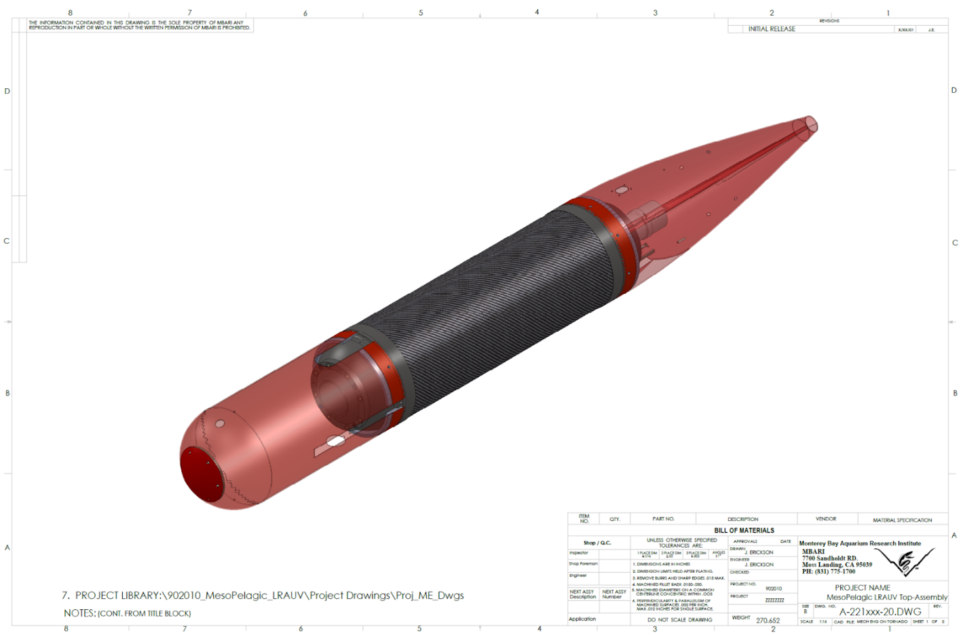
Figure 1: CAD Image of the Mesopelagic LRAUV, showing the carbon fiber tube and cast titanium endcaps. The diameter of the vehicle increased from 12" (30 cm) to 14.47" (34.75 cm).

What percentage of labor and budget have been used through the 1st half of year?

We have burned 44% of our ME hours, but none of our Machine shop or MT yet.
We have spent almost all of our expense budget and will be requesting funds to cover pressure testing in the fall.

Will you complete the current year’s scheduled work?

Yes, we expect to complete this year’s scheduled work.

Significant changes from previous project proposal

No changes

Over the past two years, what peer-reviewed publications, education and/or outreach activities have resulted directly from this project? Please be brief.

No publications

All Projects: Specific Plans for 2022

Research Activities

- Order the manufacturing of all requied parts to upgrade Tethys to 1500m
  - Work with TiSquared to cast the titanium endbells
  - MBARI will perform all machining in the new 5-axis mill
  - Order new sheet metal parts and printed plastic tail brackets
  - Order missing sensors

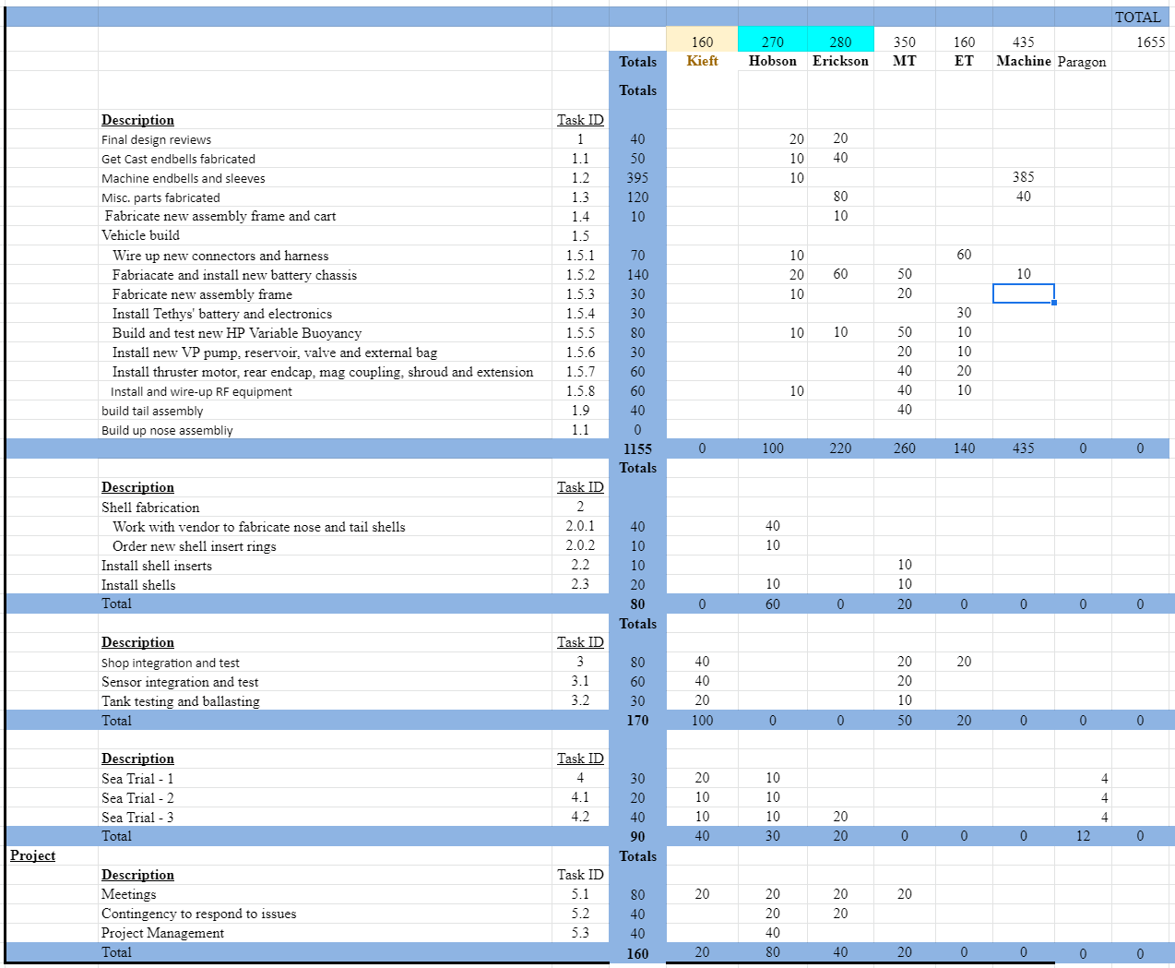

Engineering/technology development

[Click here to enter text]

Field programs (detail ship requirements/deployments/diver requirements)

In addition to describing anticipated field programs, please be sure to include requirements for specific platforms and equipment (Dorado AUVs, LRAUVs, Wave Glider, mini ROV, etc.) for each proposed field program so that expectations are clear. Requests must also be entered in the budget entry system.

[Click here to enter text]

Specific deliverables

Upgrade LRAUV Tethys to 1500 meter depth rating, including a new assembly frame and launch cart.

Milestones and required personnel (see personnel classification list for staff classifications)

[Click here to enter text]

2022 Project Start Date:  01/01/2022 | Milestone 1 | Milestone 2 | Milestone 3 | Milestone 4 | Milestone 5 | Total Resources (in hours) for each resource category for all milestones listed here
Milestone Date | 02/1/2022 | 6/1/21 | 8/30/21 | 10/1/21 | 12/1/21
Milestone Description | Design and Cast Ti Endbells | Machining complete | Assembly Complete | Integration & Test | Sea Trials
Software Eng-Embedded |  |  | 100 | 40 | 20 | 160
Mechanical Engineer | 320 | 60 |  | 50 | 120 | 550
Electrical Tech | 140 |  | 20 |  |  | 160
Mechanical Tech | 260 | 20 | 50 |  | 20 | 350
Machinist |  | 435 |  |  |  | 435
Divers

Budget justification

The expense budget is broken into about $50k in pressure hull and vehicle component changes and $37k in core sensors. Most of the machining will be done in-house.

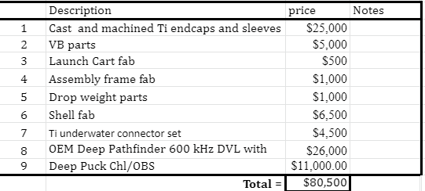

Project team:

Brett Hobson: 270 hours, Project Lead and Mechanical Engineer

Jon Erickson: 280 hours, Lead Engineer

Brian Kieft: 160 hours, Software Engineer

TBD Mechanical Technician, 350 hours

TBD Electrical Technician, 160 hours

Ray Thompson, Machinist – 435 hours

[Click here to enter text]

Project lab and office space requirements
In addition to any changes to current space usage, please also include anticipated office and lab needs for students, postdocs, collaborators, etc.

[Click here to enter text]

Risk matrix (development and infrastructure projects only)

 | Technical Risk | Organizational Risk | Tech Transfer Risk | Labor Estimate Risk
High
Medium | x | x
Low |  |  | x

Compliance Considerations
Please respond “Yes” or “No” to each line item below, and provide details as necessary.

CATEGORY | Yes/No | DETAILS
Isotope Use (see policy and cruise planning)  Will the project use stable or radioisotopes? | No
Battery waste over 4 liters (1 gallon)  Indicate type and amount. | No
Liquid hazardous waste over 60 liters (15 gallons)  Indicate composition and quantity. | NO
Export Regulation  Foreign collaborations or international travel? | Yes | Increased depth rating increases export level and we plan to operate outside of state waters
Export controlled purchases  Items purchased/in possession or to be purchased that are not on list? | No
Export controlled items (hardware, software, tech data)  Items to be transferred outside US (temporarily or permanently)? To what countries (including International Waters)? | Yes | Increased depth rating increases export level and we plan to operate outside of state waters
Work covered by Marine Sanctuary permit?  Yes, if work falls under blanket authorization. | No
Work conducted in SESAs?  ID # for Sanctuary Ecologically Significant Areas | No

Equipment deployed with anchors?

Give details for deployment; recovery if < 500lbs

CA Fish & Wildlife permit required for samples?

Working in State Marine Protected Area?

Require Coast Guard PATON for buoys?

Private Aid to Navigation. Permit in hand?

Require Local Notice to Mariners
Indicate who will be submitting

Permits from other agencies?

Use of active acoustics not already on list?

This date and number should remain the same for the duration of the project. If your project start date for 2022 is not January 1, please indicate the start date in the first cell of the milestone chart. Format for duration example: “Year 2 of 5”.
Development and infrastructure projects must complete the risk matrix (see end of the proposal form).
Not all projects will require all four titles to be filled in. Please indicate individuals only for those titles that are appropriate for your project.
This category includes transfer of hardware, know-how, publications, presentations, etc.
This number should be the same number you entered on the web budget resource requests for this particular resource.

