Project Number: | 9021010

Project Start: Jan. 1, | 2024 | Project Duration (in years): | Year 2 of 3

Please indicate if proposal includes requests for any of the following (mark all that apply).

Ship Time |  |  | ROV |  |  | AUV |  |  | Wave Glider |  |  | Mini ROV

Please indicate what type of project is being proposed (mark only one).

 |  |  |  | x
Feasibility/Scoping  [<100 days effort] |  |  | Development |  |  | Research |  |  | Infrastructure² |  |  | Education |  |  | Time Series |  |  | Institute Initiative

Project Manager: Brett Hobson
Principal Investigator: Brett Hobson
Lead Scientist: Steve Haddock, Kakani Katija, Kelly Benoit-Bird, John Ryan, Yanwu Zhang, Giancarlo Troni, Henry Ruhl
Lead Engineer: Brian Kieft

Project Title: Mesopelagic LRAUV

Please indicate which category best describes the project theme (mark only one).

 |  |  |  |  |  |  |  |  |  | x
Ocean  biogeochemistry |  |  | Ecosystem dynamics |  |  | Ocean visualization |  |  | Exploration & discovery

Please indicate percentage of effort on this project anticipated for 2025 toward these three highest institutional goals from the Strategic Roadmap (percentage total should equal 100%).

Goal | Innovate and Build | Explore and Protect | Inspire and Engage
Percentage | 80 | 10 | 10
- ABSTRACT (all projects)

We are planning to finish the construction of the 1500 meter depth rated LRAUV by the end of 2024, so this proposal seeks support to conduct ocean testing and the integration of six important payloads: Bioacoustics, Passive Acoustics, Chiton imaging, Planktivore, Hovering module and add AUV Docking hardware. By the end of 2025 the Mesopelagic LRAUV should be ready for science deployments and operation from a MARS-based docking station. During 2026 we plan to propose routine seafloor imaging at Sur Ridge with Barry, Caress, Troni and Rock, so we have included the purchase and integration of the INS in this 2025 proposal that will be required for near seafloor operations. We have also included additional engineering resources to conduct a study on cyclic fatigue, and methods to extend the life of carbon fiber pressure vessels.

- PROPOSAL (all projects)

Background
Provide context for the project, being sure to address these questions:
- What fundamental problem does this project address, and why is it important?
- What makes this work relevant to MBARI and the Packard Foundation?
- Is this effort linked to other internal or externally funded projects or collaborative efforts?
- Where does this work fit into the ~5–10 year plan for your group, at MBARI, and in the field?

The existing LRAUV cannot follow particulates of the biological carbon pump below the re-mineralized zone, or even follow many of the vertical migrators to their daytime prey avoidance zone. Carbon cycling and ecology within the Mesopelagic zone are major research themes at MBARI so this project aims to develop the missing link, which is a 1500 meter depth upgrade for the LRAUV. The Mesopelagic LRAUV is being requested by the Deep Sea Bioinspiration lab, Acoustical Ocean Ecology lab, the Carbon Flux Ecology lab, and Ruhl’s Synchro program.

With the development of the new Hovering Module for the LRAUVs, seafloor imaging in complex terrain is possible. The largely unexplored seamount at Sur Ridge is only 35 km from MARS, so routine missions can be conducted to map the entire seamount in 3D with images without any ship time, and the corresponding carbon footprint. We have, almost, all of the technology in place to conduct this amazing technological feat. Starting with a fully charged battery at MARS, the Mesopelagic LRAUV would spiral to the surface and begin a slow, low-power transit to Sur Ridge, which would take about a day. Once on site it would rendezvous with an Autonomous Surface Vehicle (ASV) and begin its mission by spiraling to the seafloor. After a short transit, its position would be determined and continuously updated using Terrain Relative Navigation against the existing AUV multi-beam map. The vehicle would descend to imaging depth and begin a preplanned survey using Caress/Troni mapping and imaging payload while sending periodic updates acoustically to the ASV, which get forwarded to shore. We estimate up to about 48 hours of mapping can be accomplished before the vehicle needs to make the return trip back to MARS for data upload and battery recharge for a day, and then the mission can be repeated.

Nature and Scope of the Proposed Project
Please provide a sense of the scale and scope of the proposed work. Is this a large de novo R&D effort, modest platform/sensor integration, targeted science investigation with minimal or no engineering needs, extension of current program, small-scale scoping exercise expected to lead to a larger effort, or other? If the project is intended to be multiple years, how will the anticipated level of effort likely change over time?

This is a medium sized project that is sharing people and technology with many other projects. We are working directly with the #901809 Deep Sea Bioinspiration lab, #901700 Acoustical Ocean Ecology, 901103 Biodiversity and Biooptics of Zooplankton, #902004 Planktivore projects and the following additional projects will become active once the system is fully operational: #902111 Carbon Flux Ecology, #902204 Scaleable Marine Robotics, #901101 Seafloor Mapping, #901904 Deep-Sea Coral-Sponge Community Observatory

Does this activity relate to one or more 2025 proposals your team is submitting?
If so, provide a list of relevant projects by project/DQ # and provide a brief description of how they are related. Since resources are limited and cuts during Phase 1 are likely, please indicate where this project fits in the hierarchy of your priorities. Does this proposal take precedent over other ongoing or planned activities?

This project shares people and resources with the core LRAUV Development project #902101, and unfortunately, this project has taken a back seat to the core project schedule.

Anticipated Shared Resource Needs
What staffing is required to advance the work in 2025 (e.g., is this a multi-faceted engineering development or a targeted science investigation that does not require significant use of shared personnel)? Is in-house or contract manufacturing needed? What level of ship/ROV/AUV (DMO) support is likely? If this is intended to be a multi-year effort, please provide a rough indication of anticipated shared resource needs over the duration of the project (e.g., will stay flat, will significantly increase in Year X, will significantly decrease by Year Y).

We are requesting 1848 hours of shared engineering resources and are planning on 6 deployments that we’ll double up on other deployments.

Anticipated Expenses
What rough order of magnitude direct expense budget is anticipated annually over the course of the project? Is procurement of specialized capital equipment or outside contractors required? Will there be annual travel?

We have requested $99k, which includes $82k for an INS and $17k for carbon fiber tubes, cabling and some printed parts.

Intellectual Property (IP) Considerations
Do you anticipate a need for a cooperative research and development agreement or licensing arrangement with an external entity? Will the work potentially result in a patentable product or service? Will novel IP and/or custom-made equipment be created, and how might it be disseminated (e.g., license agreement and/or collaborations)?

For additional guidance please review MBARI’s intellectual property internal web page: https://mww.mbari.org/itd/ip/.

We expect to license the Mesopelagic LRAUV to Saab during 2025.

Data
What data will be generated? How will they be managed/stored? Are any special data visualization needs anticipated?

Only engineering data will be collected next year.

Anticipated Impact
Who are the consumers of the instruments, methods, technology, and data that will be generated within and beyond MBARI? Will the project create tangible connections with other organizations (e.g., academic, NGO, MBA, MBNMS, state or federal agency)?

In addition to the list of MBARI science users, we expect to expand this list significantly through the licensing to Saab. There are emerging markets for 1500 meter depth rated un-crewed vehicles in the ocean wind farm lease areas off the west coast.

Anticipated Outreach Needs
Thinking about the audiences/consumers you highlighted in the question above, do you anticipate needing to create outreach assets to help increase your impact? If so, please specify whether you anticipate needing to work with ITD and also specify what type of asset (story, graphic, animation, video, etc.) you might need.

No outreach products are planned.

Continuing Projects Only: Status Report
Briefly provide an update of the current project relative to what was proposed for 2024 by responding to the prompts below. If the project includes multiple subproject projects, please list each of these under a subheading as you deem appropriate.

Current status of project and results to date

We are behind schedule, and under-scoped on shared engineering hours for 2024. After a few setbacks that consumed all of our allocated ME resources, we are finally ready to move forward. The setbacks included:
- Endcap retention failure during pressure testing (Figure 1 and 2).
- LRAUV Thruster motors are no longer available, so we did an extensive search and modeling and selected a replacement motor that took16 weeks to arrive. The motor mounts to the rear endcap, which mates to the tube so the motor had to be selected and endcap designed before the tube could be machined and welded to the rear endbell. This work is complete
- The 1500 meter depth capable Variable Buoyancy system design was difficult. During high pressure pump testing we found the pump we selected required about 10+ more torque to pump when holding the high pressure. We abandoned that design, but most other options were too large and heavy. Eventually we contracted The Lee Company to modify versions of their miniature hydraulic components to support our application. We hope to start testing the new VB system in October. If the new system doesn’t work, we’ll move forward with the existing 100m depth capable system.

The external flow shell fabrication is proceeding well, though at a slow pace. All of the molds are complete (Figure 3).

The pressure testing did confirm that the novel construction technique Jon used for the carbon fiber tube matched the compressive modulus of water very well. The hull had gained only 25 grams of buoyancy at 1400 meters. During preliminary cyclic testing we suffered damage at the tube to endcap interface, which confirmed our design decision to bond end rings to the tube. A second set of pressure tests of the deployable hull and two sacrificial tubes (test to failure) is scheduled for August 2024.

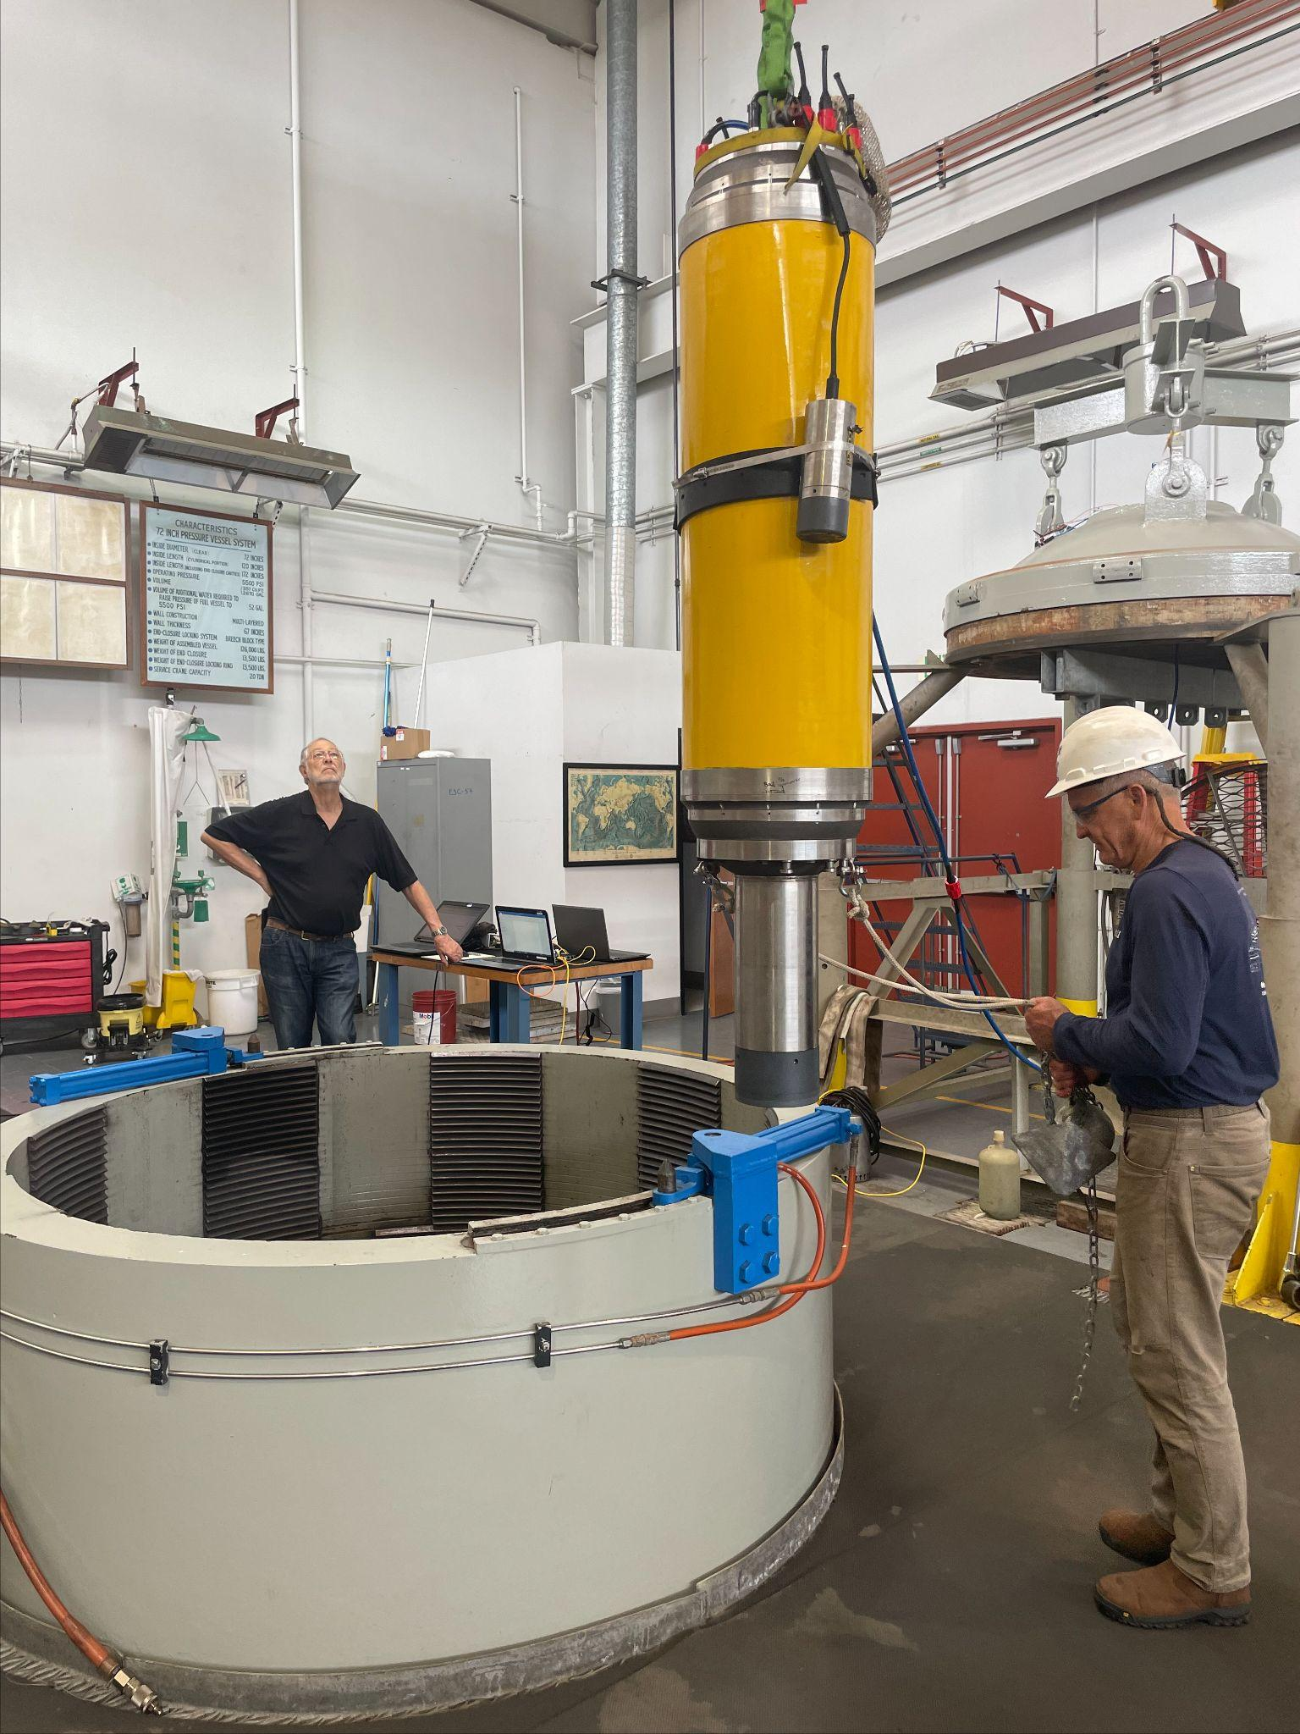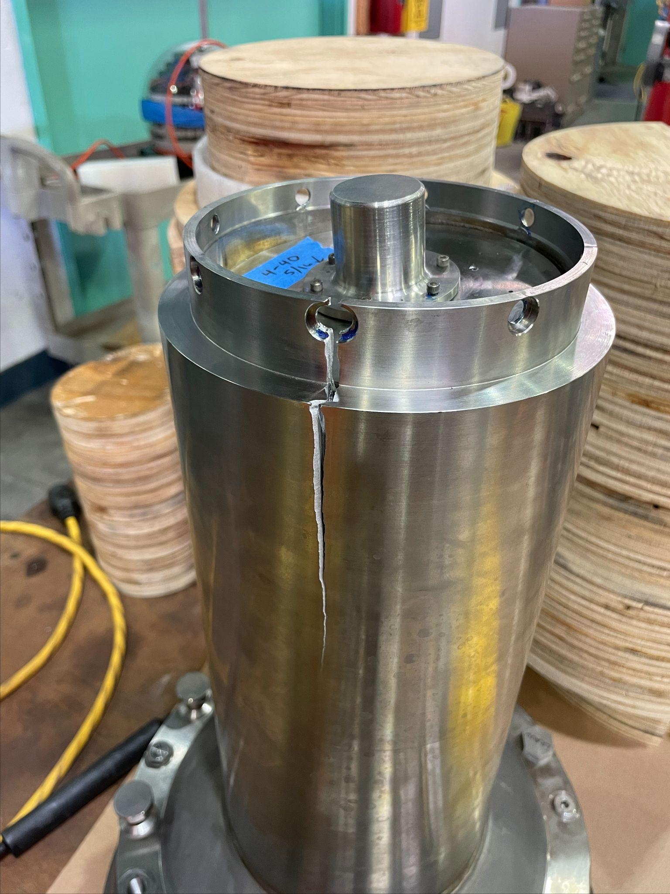
Figure 1: Pressure testing Figure 2: The thruster tube damaged when mounting screws failed
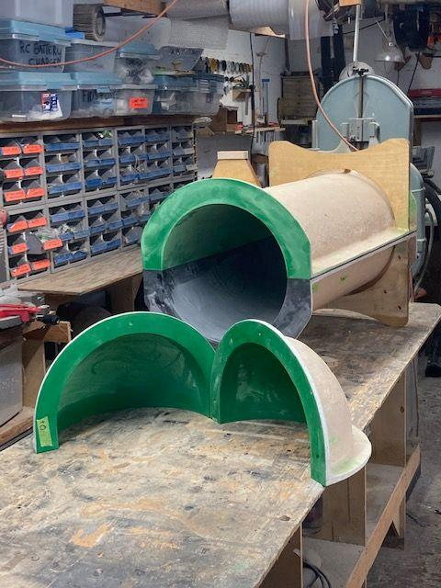
Figure 3: External flow shell molds ready to start laying up carbon fiber shells

What percentage of labor and budget have been used through the 1st half of year?

Unfortunately, the design challenges burned up our allocated ME time. . Overall, we’ve consumed 88% of our allocated shared resources. We will be requesting additional ME time and fortunately, Justin Tucker should have time to help

Will you complete the current year’s scheduled work?

If we’re able to get more ME and Machine Shop time allocated, we should finish the construction of the vehicle by the end of the year.

Significant changes from previous project proposal

No significant changes

Over the past two years, what peer-reviewed publications, education and/or outreach activities have resulted directly from this project? Please be brief.

None

All Projects: Specific Plans for 2025

Engineering/technology development

During 2025 we will start performing test deployments and preparing and integrating the science payloads. Around mid year. We will add AUV docking hardware and then spend time in the fall exercising the docking system in preparations for docking on MARS in 2026. We are also requesting some engineering support to address possible issues with the VB system. Work on the cyclic fatigue and design ideas for carbon fiber pressure vessels will be fit into the schedule throughout the year. We hope to integrate the mid-range INS into the front endcap as soon as possible to enable longer missions between visits to the surface for GPS fixes.

When the Triton submarine disaster happened last summer there was a flood of criticism of using carbon fiber (CF) for high external pressure applications. There were a few design mistakes, but the real problems were in non-technical realms, so the extremely unfortunate accident hasn’t changed our minds about using CF for this application. Our colleagues at UW and Webb Research also remain steadfast in their attraction of filament wound carbon fiber pressure hulls. Now that Justin Tucker, who has extensive CF experience, has joined our team, we’ve re-started a technical study group to look at the general use of carbon fiber for pressure hulls. Of particular interest is the fatigue resistance so we’ve started a semi-automated fatigue cycle test of smaller carbon fiber cylinders that fit inside the MBARI test chamber. And we suffered a failure at only 600 cycles. We are requesting time during 2025 to continue investigating carbon fiber pressure hull failure modes.

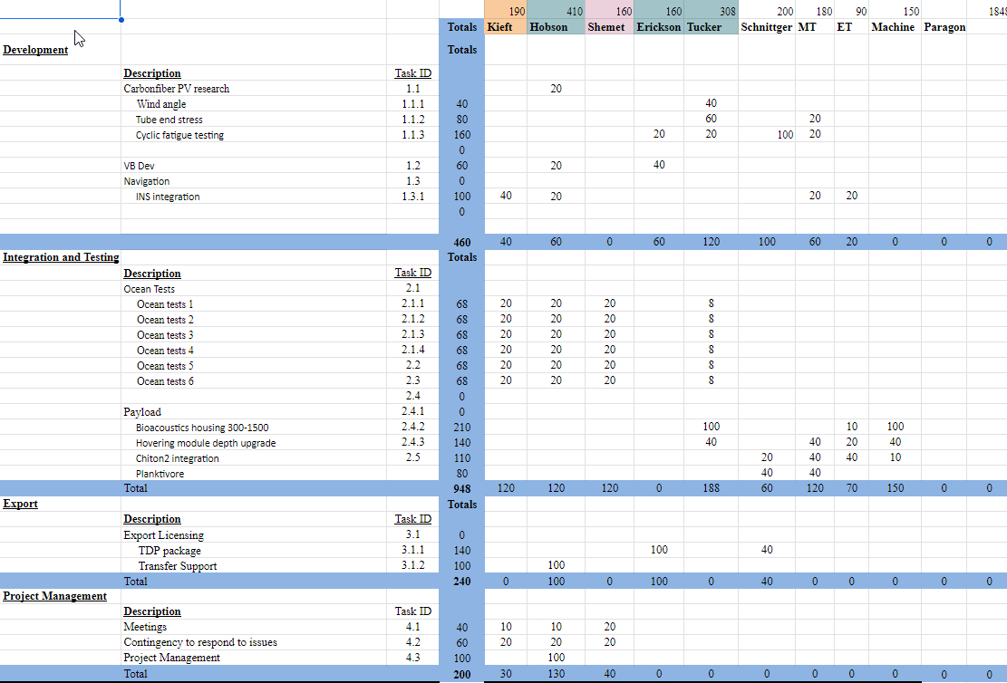
Figure 4: Spreadsheet showing labor hour breakdown for each task

Field programs (detail ship requirements/deployments/diver requirements)
In addition to describing anticipated field programs, please be sure to include requirements for specific platforms and equipment (Dorado AUVs, LRAUVs, Wave Glider, mini ROV, etc.) for each proposed field program so that expectations are clear. Requests must also be entered in the budget entry system. Note that AUV deployment numbers and diver requirement questions are also included in the Compliance and Planning Considerations Form described at the end of this proposal form.

We have requested support for 28 days of ocean testing throughout the year as a standard LRAUV deployment. about ¼ of these days should be on the AUV docking station. All of the dives will be considered development test dives, though we will be doing instrument testing and collecting data for our science champions.

Piloting/Watchkeeping
If you plan to use a platform that requires piloting/watchkeeping, please provide a high level staffing plan, including who will be responsible for these duties.

The LRAUV development team, Brett, Brian, Quinn, will perform all of the watch-standing and deployments/recovery.

Specific deliverables

The fully operational Mesopelagic LRAUV with six payloads ready to start routine science missions.

Milestones and required personnel (see personnel classification list for staff classifications)

2025 Project Start Date:  MM/DD/2025 | Milestone 1 | Milestone 2 | Milestone 3 | Milestone 4 | Milestone 5 | Total Resources (in hours) for each resource category for all milestones listed here
Milestone Date
Milestone Description | Dev | Integration and testing | Export | Project Mgt.
Electrical Engineer
Software Eng-Embedded | 40 | 120 |  | 30 |  | 190
Software Eng-Info Eng
Mechanical Engineer | 240 | 308 | 200 | 130 |  | 878
Mechanical Eng-Division
Mechanical Eng-Mfg
Associate Engineer | 100 | 60 | 40 |  |  | 200
Electrical Tech | 20 | 70 |  |  |  | 90
Software Tech
Mechanical Tech | 60 | 120 |  |  |  | 180
Machinist |  | 150 |  |  |  | 150
Divers
Video Lab
Research Engr |  | 120 |  | 40 |  | 160

Budget justification:
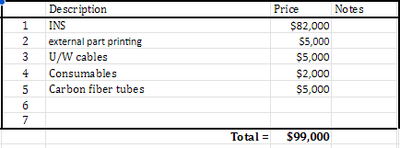
The justification for the INS was described above, but briefly this deeper version of the LRAUV will be running missions farther from surface GPS, so a lower drift navigation system will reduce the risk of hitting the seafloor or canyon wall during longer submerged missions. The external part budget is to cover 3D printed parts printed with PA12 material. There are dedicated instrument interface cables required for the new payloads. The consumable category is for oils, zip ties, lint-free wipes, plus some titanium hardware. Finally, the Carbon fiber tubes are needed for the cyclic fatigue testing.

Project team

Hobson ME/PI 410 hours
Kieft SE-Emb 190 hours
Shemet REng 160 hours
Erickson ME 160 hours
Justin Tucker ME 308 hours
Schnittger A-ME 200 hours
Yamir Hernandez MT 180 hours
Chris Bebee ET 90 hours
Machinist MS 150 hours

External consultants/contractors
If you propose to engage an external consultant/contractor, please attach a sufficiently detailed SOW and budget proposal from the vendor. If approved, a fully executed Independent Contractor Agreement must be in place before work can begin.

None

Project lab and office space requirements
In addition to any changes to current space usage, please also include anticipated office and lab needs for students, postdocs, collaborators, etc.

Existing LRAUV lab

Risk matrix (development and infrastructure projects only)

 | Technical Risk | Organizational Risk | Tech Transfer Risk | Labor Estimate Risk
High
Medium | x | x | x | x
Low

Compliance and Planning Considerations

All responses must be recorded in the Google form linked below. A form must be submitted for every project.

Link to Google Compliance and Planning Considerations form -OR- https://forms.gle/mRYKKEztAPYaiTz7A

Development and infrastructure projects must complete the risk matrix (see end of the proposal form).
Not all projects will require all four titles to be filled in. Please indicate individuals only for those titles that are appropriate for your project.
This category includes transfer of hardware, know-how, publications, presentations, etc.
This number should be the same number you entered on the web budget resource requests for this particular resource.

