Mesopelagic LRAUV Development, project 902010
- Following the successful pressure testing in mid-2024, the team has been busy assembling the new 1500m depth rated LRAUV.
- New titanium and carbon-filer pressure hull, new thruster motor, variable buoyancy system, battery controllers, propeller, control surfaces, external flow shells, and DVL with a custom housing were used to upgrade an existing standard LRAUV.
- The new vehicle is being configured to carry the Planktivore, Chiton 3-D imager, a 4k video camera with red/white lights, a bio-acoustic system, 6DOF hovering, seafloor imaging/mapping and AUV docking at MARS.
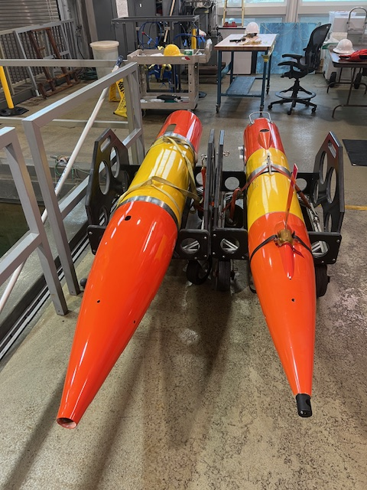
Figure 1: The new Mesopelagic 1500m depth rated LRAUV on the left, is 21% larger than the standard 300m LRAUV on the right.
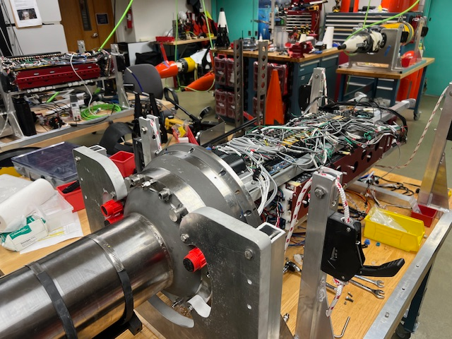
Figure 2: Mesopelagic LRAUV nearing final wiring before testing begins
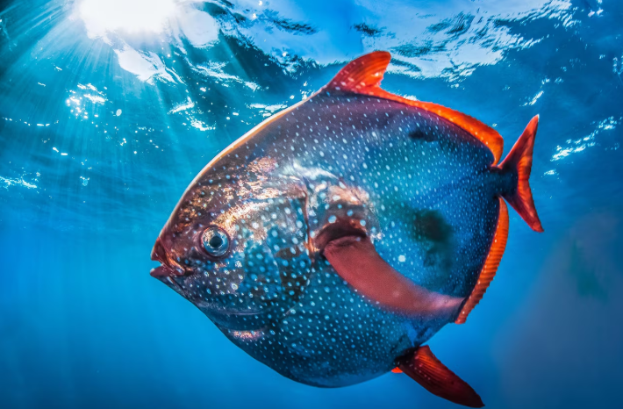
Figure 3: Mesopelagic LRAUV's namesake: Opah. photo by Ralf Pace

