Deep Pathfinder Housing

SWD requirement: 1500m
Depth FOS: 1.1 → 1650m → 2402.24psi
Design Yield FOS: 1.25 → 3003 psi
Design Buckling FOS: 2 → 4805 psi

Ti-6Al-4V Properties
Conservative tensile values used
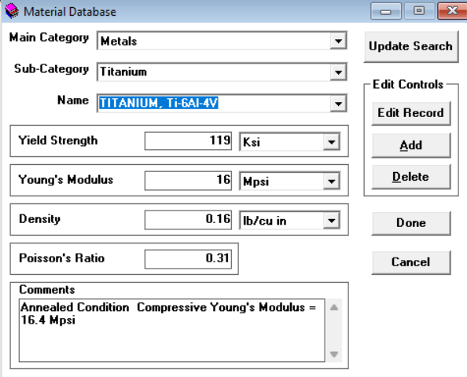

Cylinder buckling

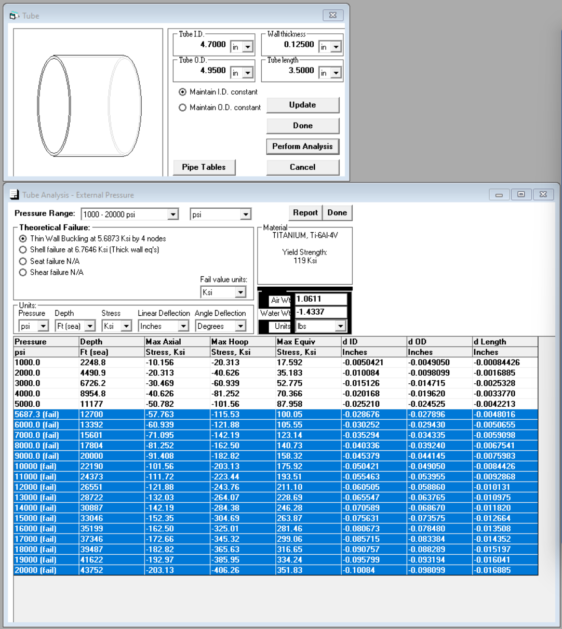
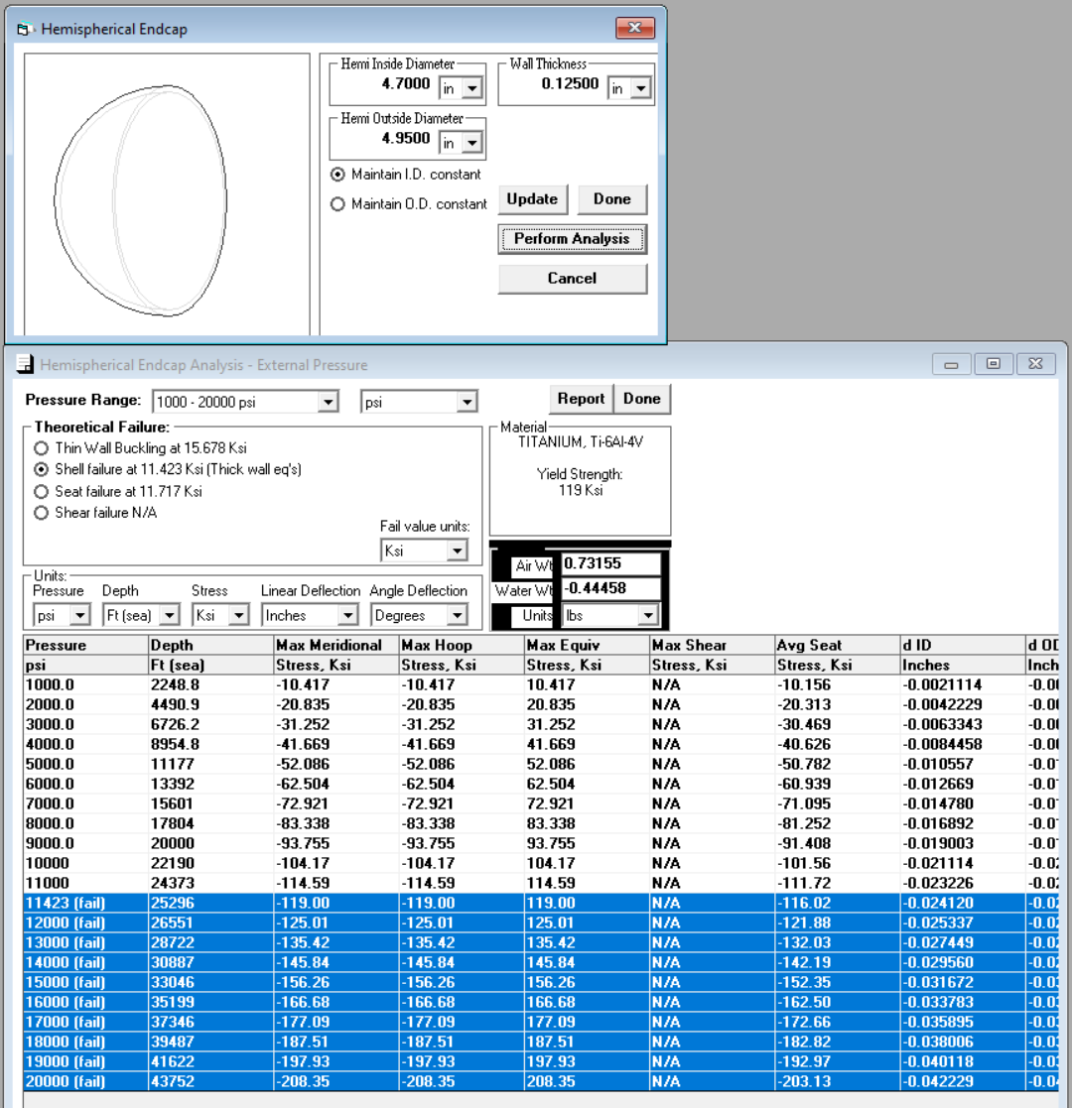
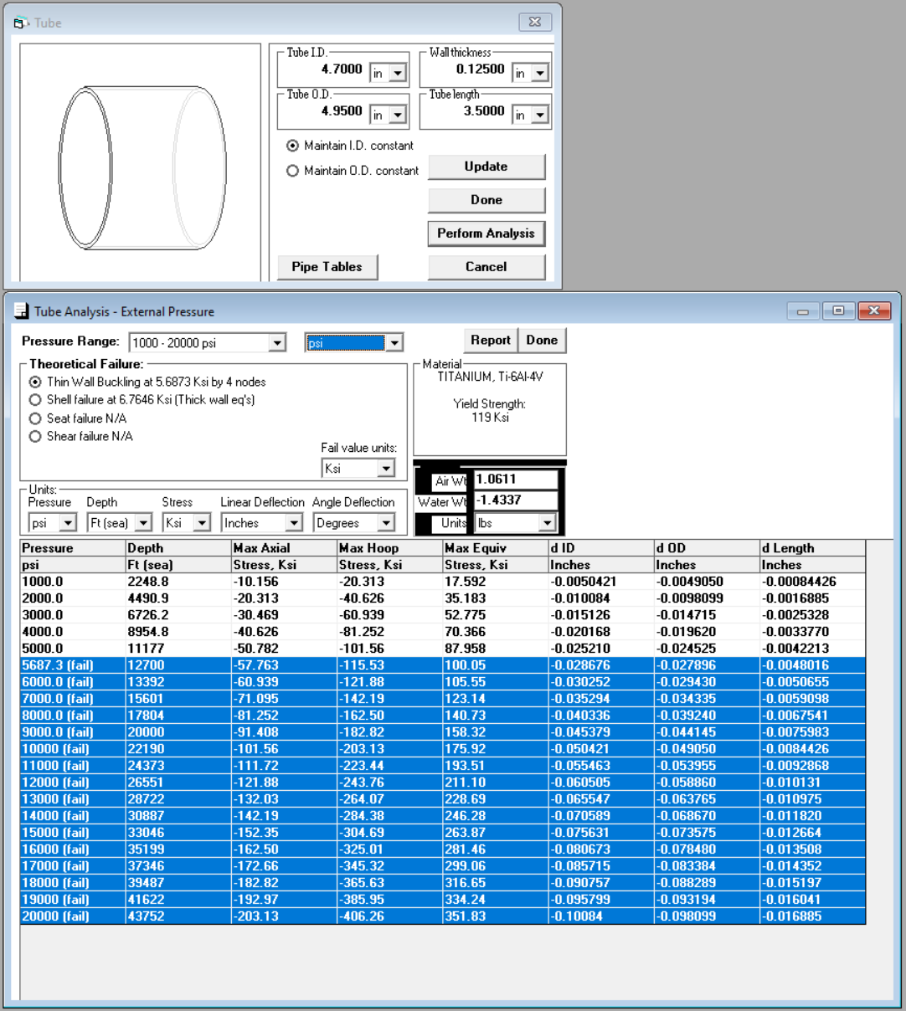
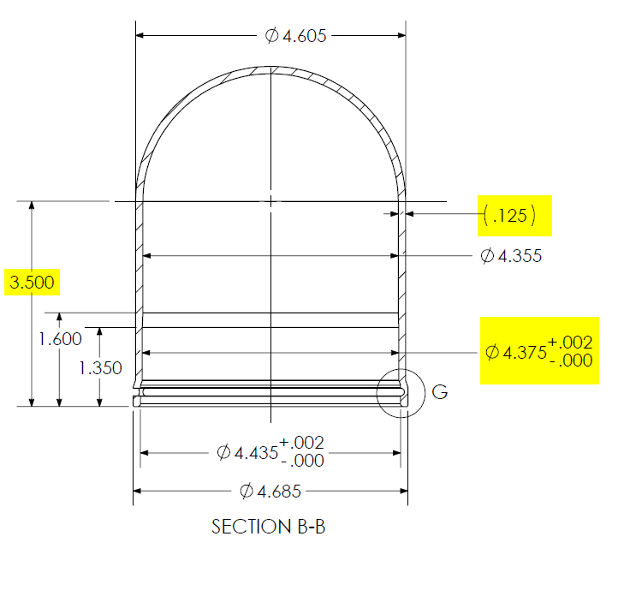

FEA stress calcs
3003psi yield checks
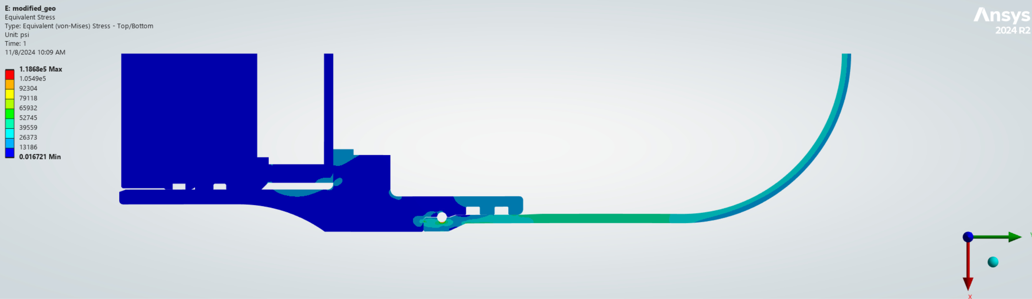
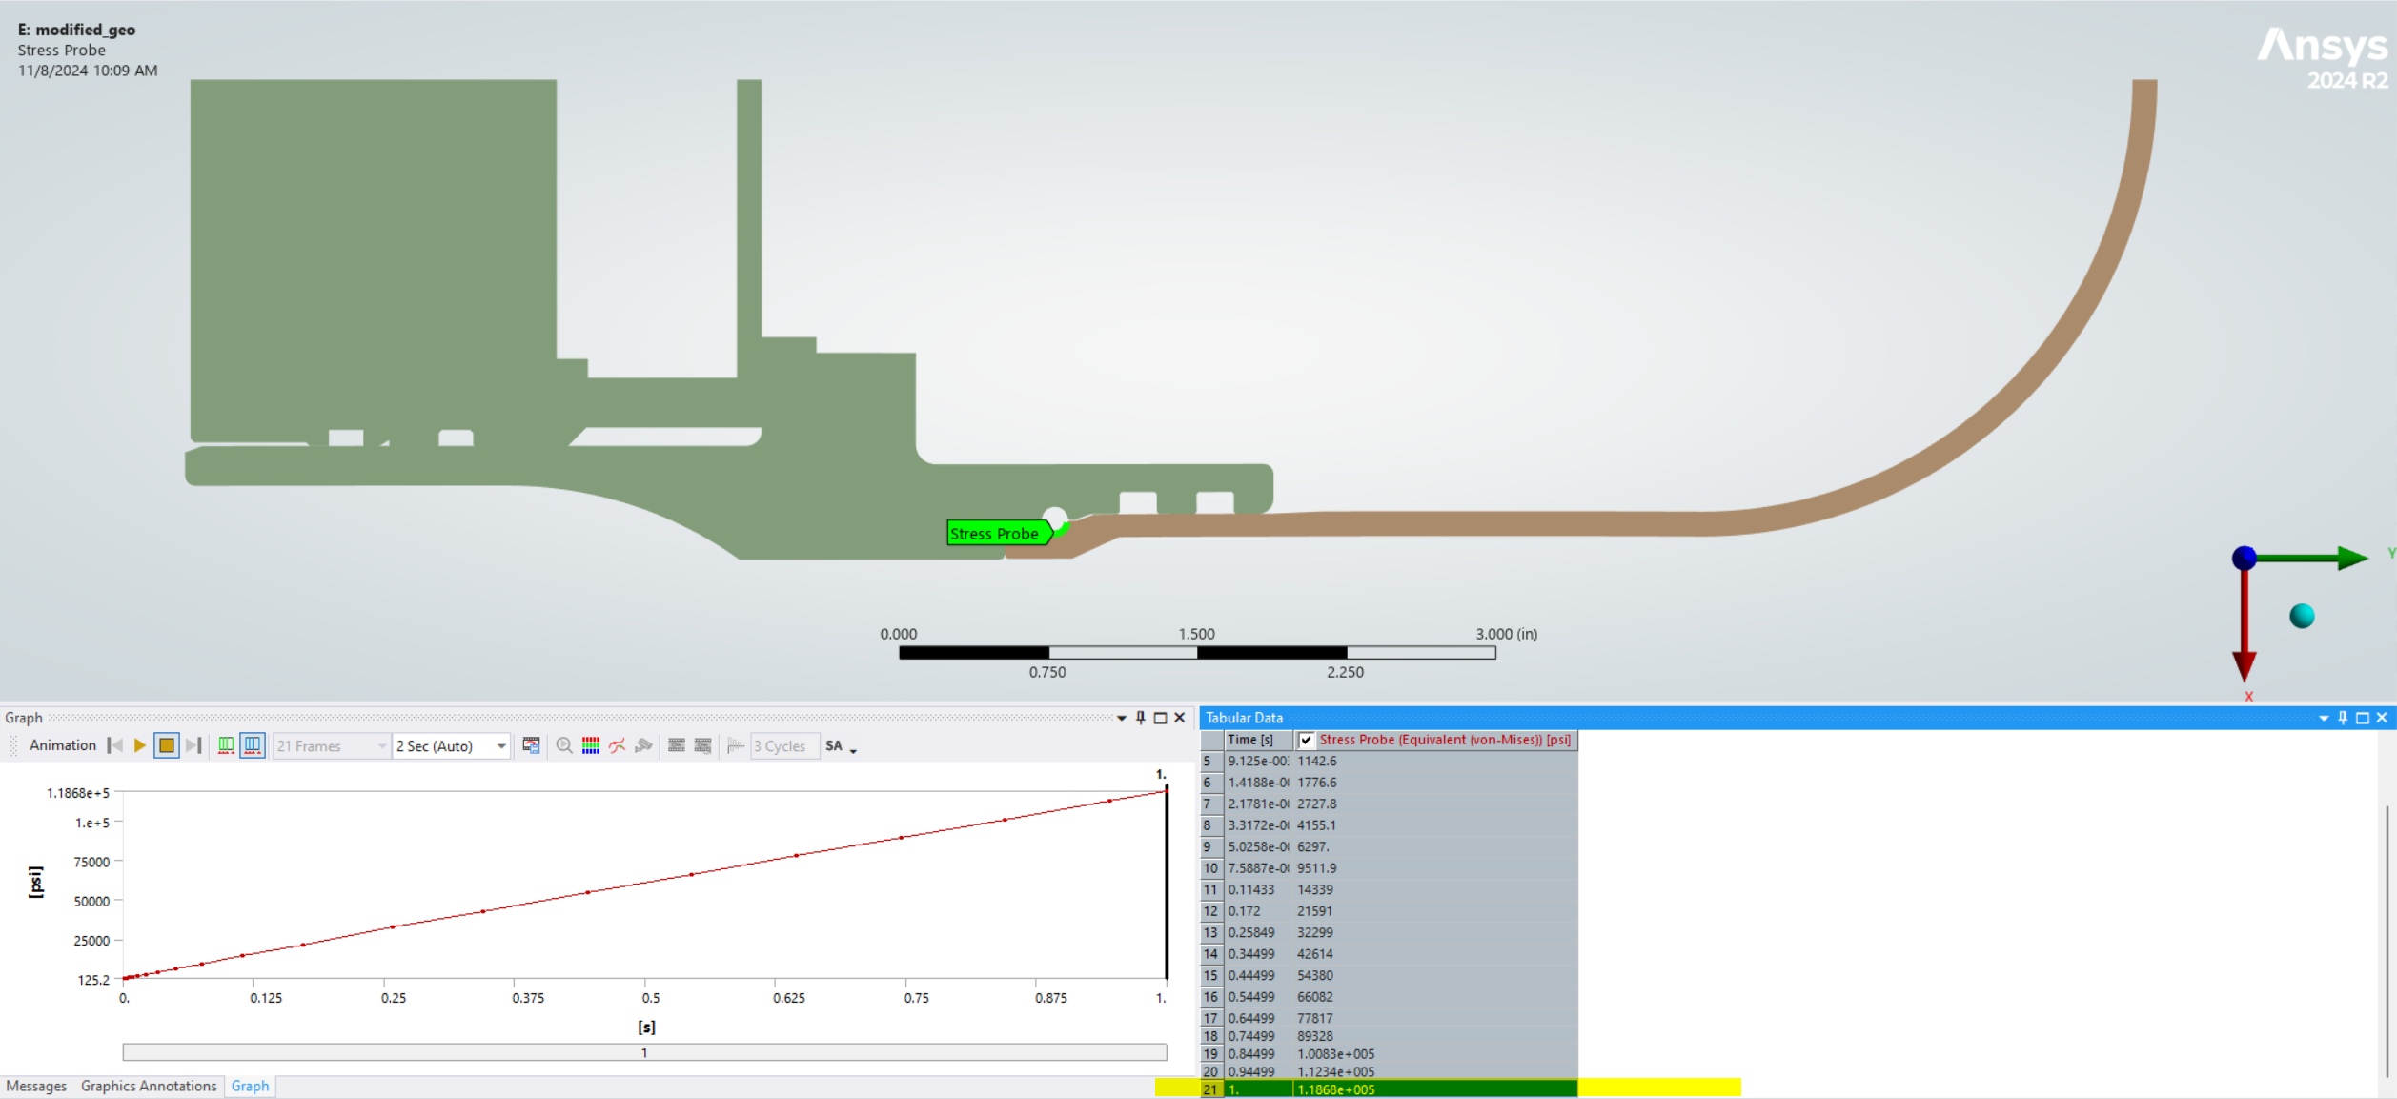

Gap
~0psi
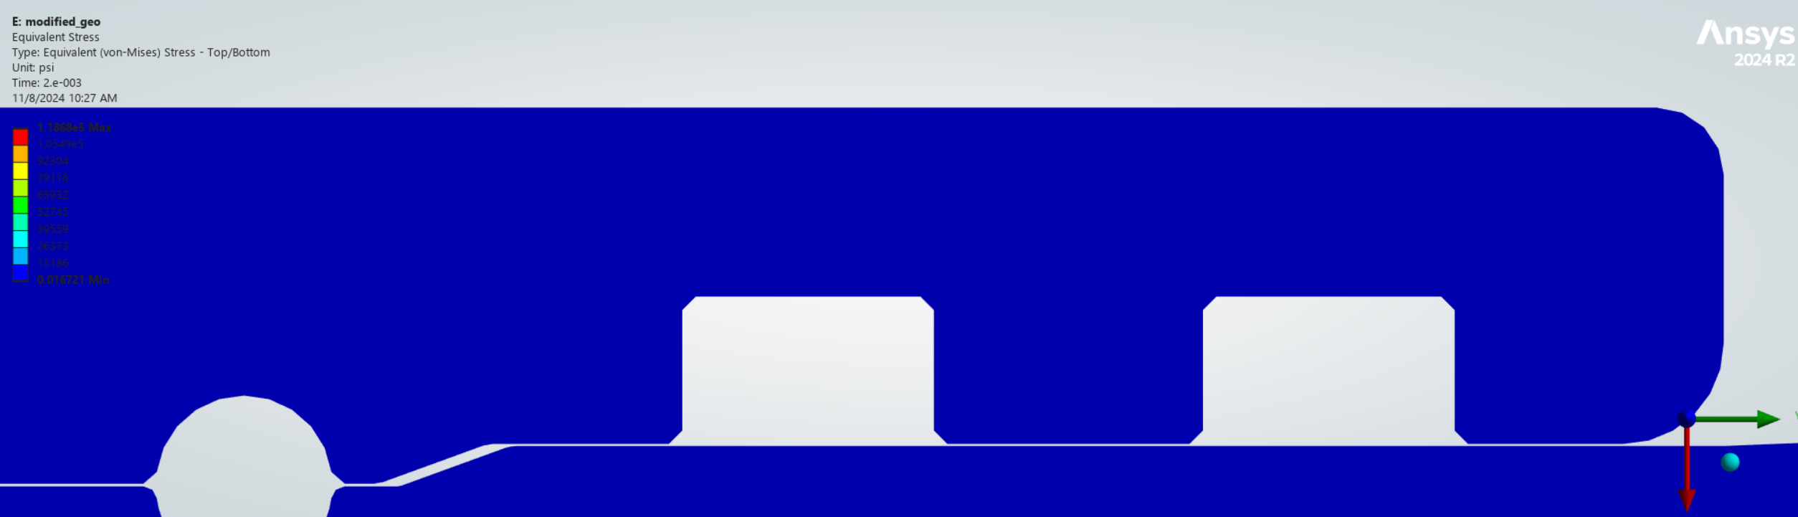
1336psi
