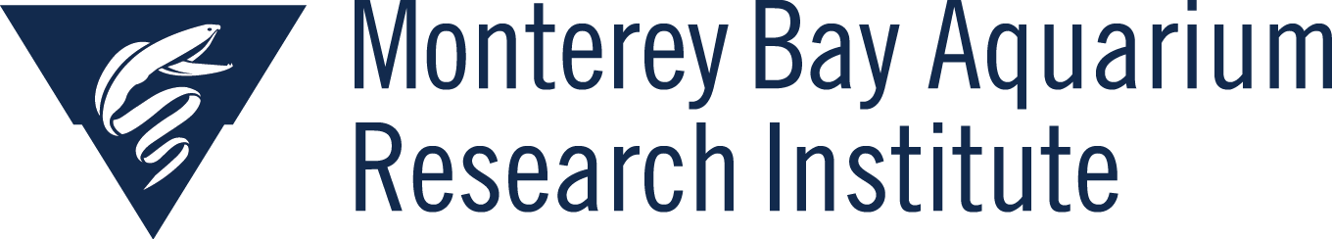
7700 Sandholdt Road
Moss Landing, CA 95039

Telepresence Meeting
January 13th, 2022

Agenda
- Welcome Kevin Barnard!
- 2022 WF Telepresence Schedule:
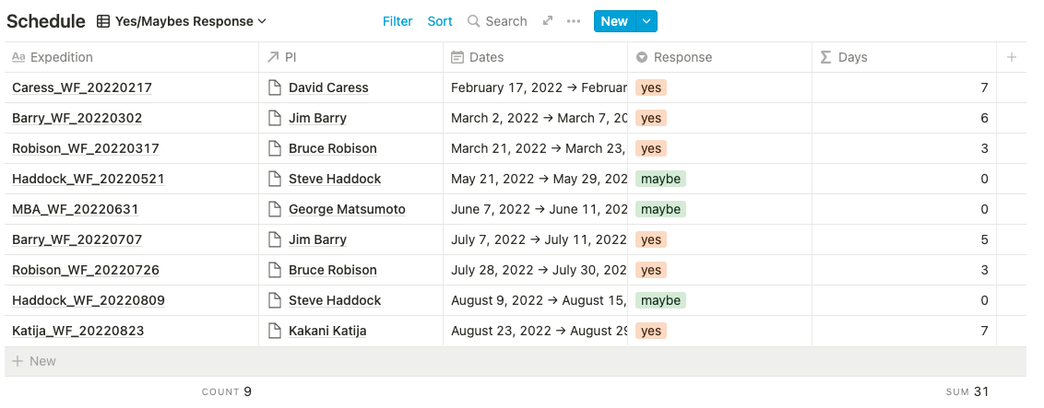
- Live broadcast: Coming back, now likely with the Aquarium in June 7-10
- Update on upgrades in the control rooms:
  - New cards on order for 4K input
  - Flyer has new video matrix, moving 20x20 matrix to RC
- HCI Efforts
  - Finalizing documents/priorities
- UI Upgrades
  - Need to migrate VMs
  - https://telepresence.mbari.org/

