902012.00 -- R/V Telepresence
Eric Martin (Kakani Katija, David Caress, Benjamin Erwin)
The aim of this effort in 2020 has been focused on providing a rapid response to new staffing restrictions on MBARI research vessels. Successful telepresence for ROV operations allows remote users the capabilities to contribute to interpretation and decision making as if they are present in a ship’s ROV control room. This project is currently supported under discretionary funds awarded in July, after a scoping effort determined that a telepresence capability could be developed that leveraged the telecommunications solutions already present on our research vessels. We have proposed to increase the capabilities of the prototyped system developed in 2020 as part of a 2-year project continuing through 2022.
Administrative Activities:
- Hosted David Lees, NASA Ames Research Center, for his seminar, “Using science operations tools and methods from NASA for remote presence ocean exploration on Earth: E/V Nautilus cruise NA108.” (June 12th, 2020)
- Modifications to pre-cruise forms now collect relevant information for telepresence.
- Formation of a telepresence advisory committee.
- To address privacy concerns, we have worked to draft a Telepresence Policy and Procedures document, currently under review.
Engineering Activities:
- Development a server system that collects video, audio, and contextual data from ROVs Doc Ricketts, Ventana, and the MiniROV. There are identical systems integrated into both the R/V Rachel Carson and the R/V Western Flyer.
- This server assembles video and audio sources into a single feed for broadcast back to shore for redistribution using Webex teleconferencing.
- Resultant video latencies are less than 500 milliseconds on the Rachel Carson (using microwave communications) and less than 2 seconds on the Western Flyer (using satellite communications). This is a remarkable improvement over using conventional encoder/decoder pairs.
- The system is intentionally memoryless, optimizing for the best possible real-time experience and maximized privacy.
- Telepresence calls can be initiated by hosts on shore and managed remotely, reducing the need for a dedicated technician to manage the system at sea, which would occupy valuable bunk space.
Science Activities:
Telepresence has been used on both vessels since mid-July enabling contributions for remote science contributions from a myriad of users:
- Kakani Katija used telepresence for remote direction of Machine Learning Tracking MiniROV dives on the R/V Rachel Carson, with the ability to halt ROV operators on target from shore and view the efficacy of the ML algorithms simultaneously. (July 20-21)
- Bruce Robison offered an available bunk to Paul Roberts during his R/V Western Flyer expedition to test the new EyeRIS system, and telepresence enabled contribution from the rest of the Bioinspiration Lab. (August 25-29)
- Charlie Paull used telepresence functionality for his 21-day northwest expedition, soliciting remote help from a team at MBARI and collaborators at the USGS. By the end of the expedition, contributions were made by more members than could have fit on the Western Flyer before COVID-19 restrictions were in place. (September 9-29)
- The Aquarium Midwater Aquarist team used telepresence functions to bring dives back into the auditorium and allow the shore team to aid in sample selection during ROV Ventana operations. (September)
- Ken Smith directed offshore operations at the MARS observatory from shore during ROV Ventana operations using the telepresence system. (September 28-29)
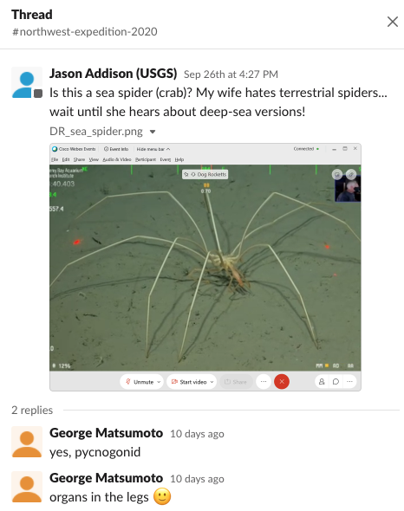
Figure: A conversational thread from the Paull 2020 Northwest Expedition, showing Jason Addison, USGS collaborator, onshore getting animal identification of a screengrab from MBARI Research Specialist George Matsumoto.
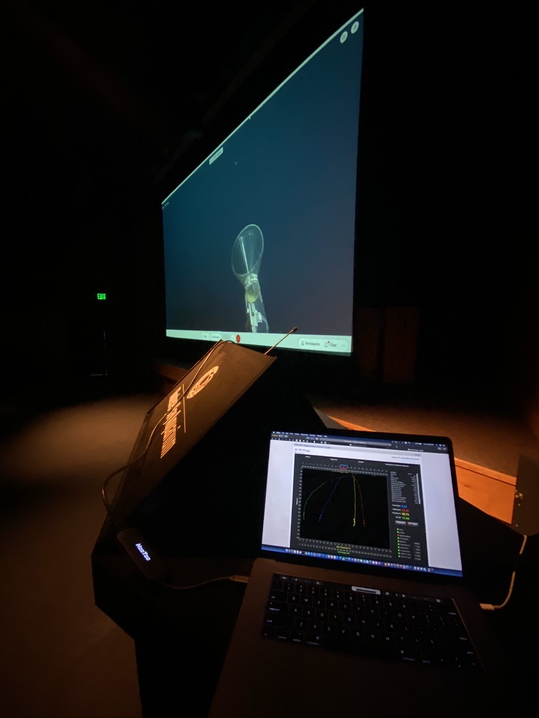
Figure: Live operations back in the Aquarium auditorium during AMP dives, photo by Wyatt Patry, Senior Aquarist at the MBA.

