902012.00 -- R/V Telepresence
Eric Martin (Kakani Katija, David Caress, Heidi Cullen, Benjamin Erwin, Kevin Gomes, George Matsumoto, Karen Salamy, Rich Schramm, Brian Schlining, Susan Von Thun)
Since November the Telepresence project entered a production use phase leveraging the prototype system built in Q3 2020. The system was used to great affect on both the Western Flyer and Rachel Carson in new ways in October and up through the cessation of operations brought on by the latest surge in COVID-19.
Despite the operational shutdown in December, the telepresence project has been busy using the time to document its remarkable achievements and begin engaging new team members as it begins its next phase of development. In 2021, the system will be refined towards further automation, higher contextual data input, and improved annotation.
Administrative Activities:
- Worked with the telepresence committee and the management team to ratify the Telepresence Policy Document. This will help set requirements and bounds for future developments.
- Developed a training program that has helped remove the need for continuous engineering monitoring, and allowed remote participants to manage and connect the telepresence sessions.
- Eric Martin participated in the Scientific Ocean Vehicle Alliance meeting, discussing telepresence use in ROVs and submersibles for organizations including: WHOI, University of Hawaii, Schmidt Ocean, Ocean Exploration Trust.
Engineering Activities:
- Leila Takayama (UCSC) is collaborating with the telepresence project in 2021, having great experience in human robot interaction research. She is nearly complete with a user study interviewing participants in MBARI’s 2020 efforts with the prototype telepresence system. We intend to use the findings of this study to help focus our efforts this year.
Science Activities:
Telepresence has been used successfully in more expeditions of note:
- David Caress leveraged telepresence functionality aboard the Western Flyer (October 12-17) enabling operation of the Low Altitude Survey System attached to ROV Doc Ricketts. Telepresence allowed Dr. Caress to sail aboard with only 3 science team members. Collaborators at the Pontificia Universidad Católica de Chile used the telepresence connection to manage source code and adjust camera settings and software remotely. We also connected engineers at MBARI to help direct the research. Telepresence also allowed Charlie Paull and his team to participate on a cruise they normally would not attend, accelerating the interpretation of data as they are collected.
- James Barry and his team used telepresence to enhance their efforts during their expedition December 1-6. Collaborating with scientists at MLML, BOEM, and the MBNMS, telepresence was used to enable remote annotation, animal collection, and gear recovery. The telepresence system was also used to connect a television director for the BBC to the ROV control room, enabling remote direction of footage collection for a future production from as far as the United Kingdom.

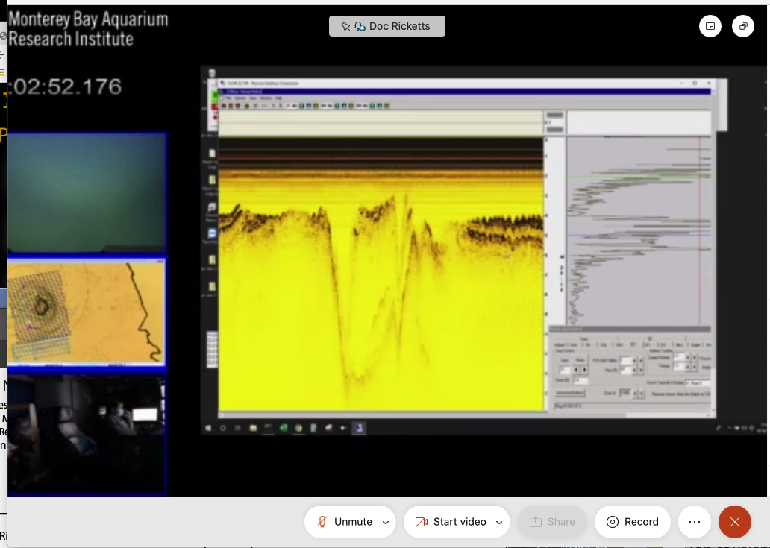
Figure: A screengrab of the telepresence view during low altitude surveys near a large boulder in Monterey canyon. Video from computer data views and live ROV and Control Room video are available in a standard teleconferencing application.

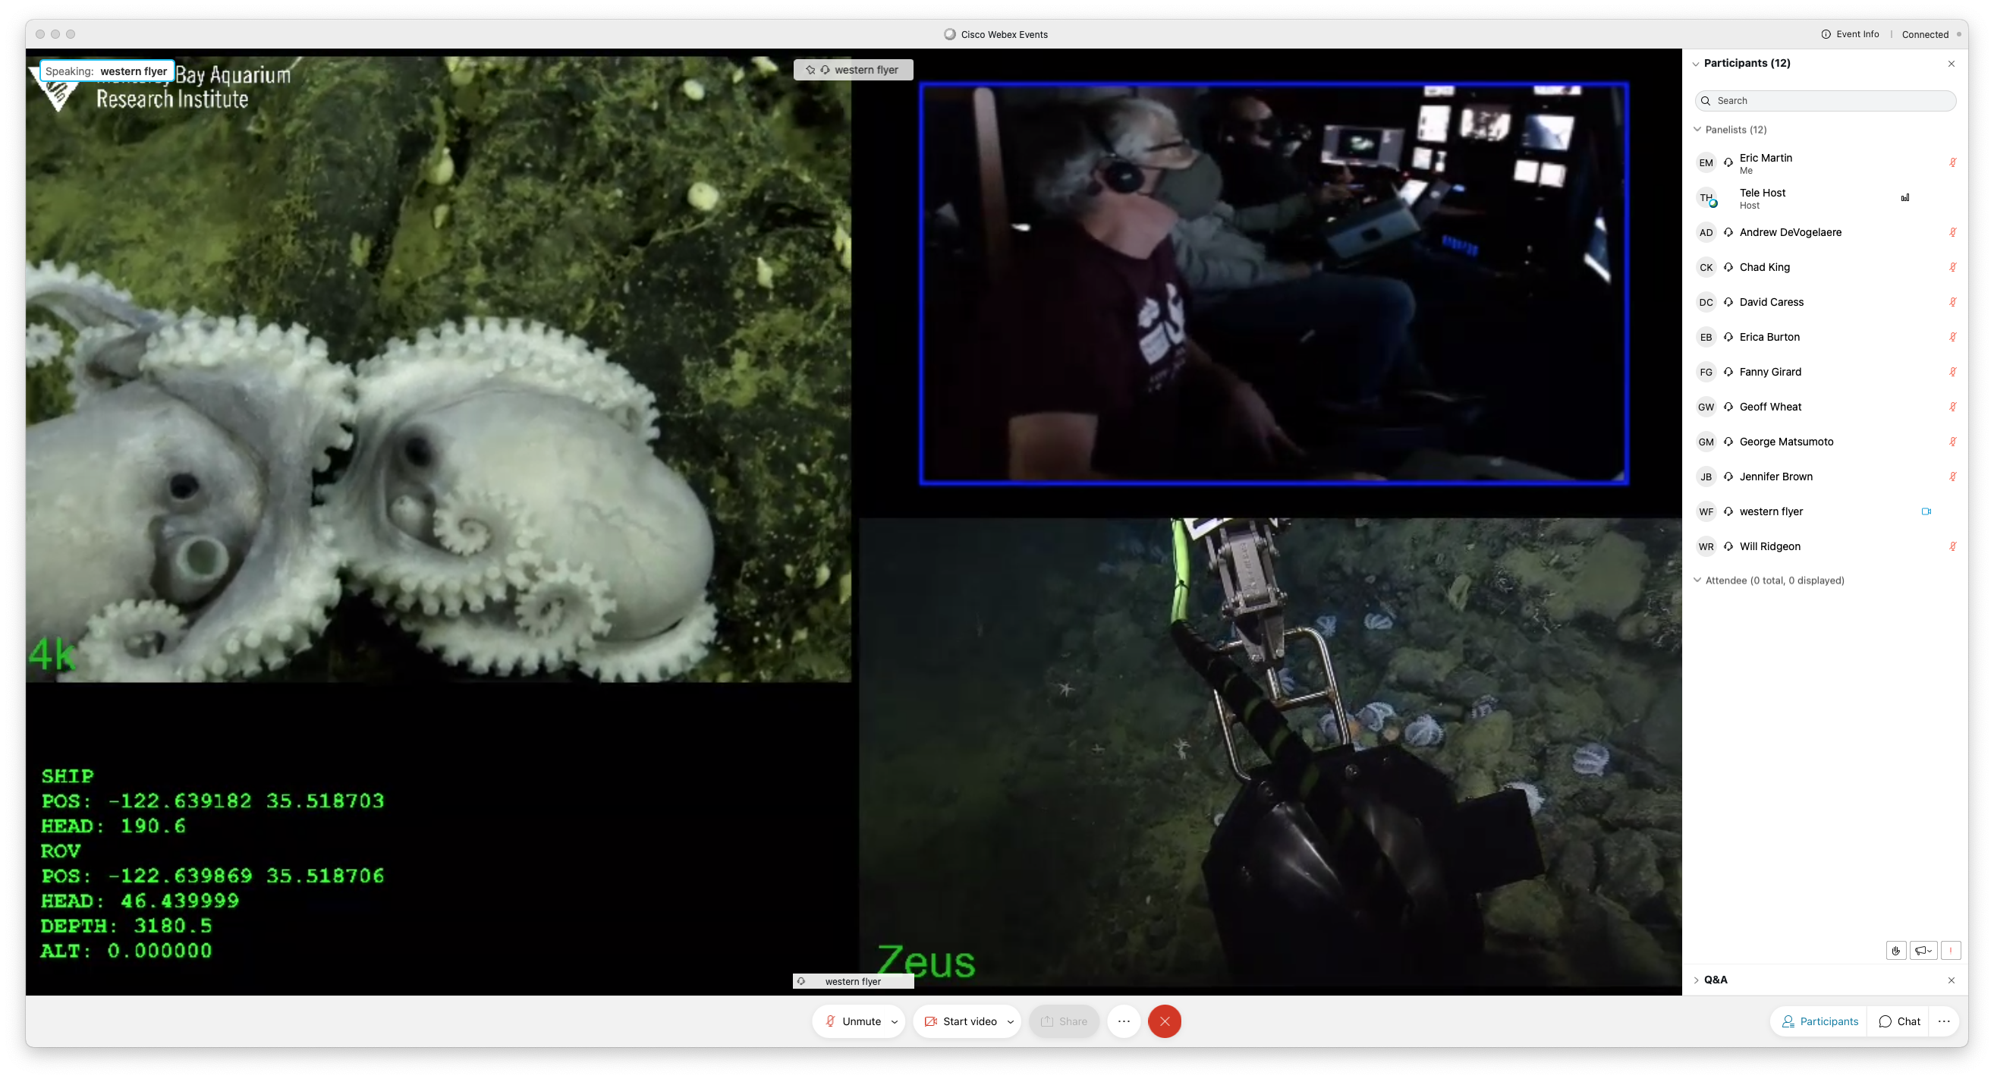
Figure: Telepresence client view during the remote direction of BBC video collection using a 4K camera in the arm of the ROV Doc Ricketts. Will Ridgeon (BBC) was able to talk directly to pilots and coordinate over 4 hours of film shoots.

