MBARI ROV Telepresence Requirements & Concept
May 2020
Authors: Eric Martin, Kakani Katija, David Caress, and Ben Erwin

Executive Summary
This document presents requirements needed to provide a low-cost and basic telepresence capability to MBARI research vessels in response to expected new collaborator guidelines that restrict access to offshore operations. A recommendation for a small scoping and testing effort is presented as well. Finally, the document explores expected costs associated with implementation of these telepresence components, enabling use on all future expeditions.

Contents
Requirements 3
Considerations 3
Functional Requirements 3
Derived Requirements 3
Novel Concept 4
Bandwidth Use Estimates 5
Connectivity Solutions 5
Control Room Equipment 6
Evaluation System 6
Broadcast Grade Systems 7
Shore Equipment/Services 7
Next Steps: Testing 8
Final Summary 8
Appendix: Notes From Field Experts 10
Appendix: Notes from Service Managers and Providers 14

Requirements

Considerations
- The Western Flyer is retiring in Fall 2022, and telepresence interest may not extend past the restrictions of the pandemic.
- The initial solution needs to be employed quickly and be portable enough not to require shipyard modifications.
- There is no existing budget at present that covers this design.
- Long term designs should be considered as well, and perhaps will be best captured in a future proposal under the MNV.

Functional Requirements
- Provide access to live ROV operations at their locations so that they can contribute to operations.
- Provide ROV video at quality good enough to aid in decision-making.
- Provide contextual information required to aid in decision-making and annotation.
- Provide capability for at-home collaborators to provide real-time feedback to the ROV control room.

Derived Requirements
- Video feed, at 480/30 and preferably better quality, to display relevant (selected) ROV or ship video.
- Ability to change video stream input to present ancillary footage relevant to the dive, i.e. sonar display, charting software, or control room video.
- For any data stream, maintain latencies less than 10 seconds.
- Collaborator needs access to basic information required for annotation, i.e. ROV position, ROV attitude, Ship position, and to develop contextual awareness.
- Collaborator needs bidirectional communication with Chief scientist and pilot to be effective, likely audio at a voice rate (>24kbps) with the capability to administrate feeds from the ROV control room.
- A suitable data transport solution to accommodate the composite bi-directional data rates either to the internet or direct to MBARI. This includes dive data needed for decision support and the ability to provide relevant annotations that can be time-aligned in post-dive data products.

Novel Concept
These requirements were derived through conversations with a number of field experts over the last week. Based on these requirements, we can establish a functional concept. Below is a figure drawn to illustrate the components needed to assemble the telepresence at a functional level. This assumes whatever transport is identified is IP based and will provide a broadband connection to shore based networks. It provides a collaborator with the means to view ROV video, listen to control room conversations, understand basic contextual data, communicate via audio and textual chat, and hopefully contribute through annotation.
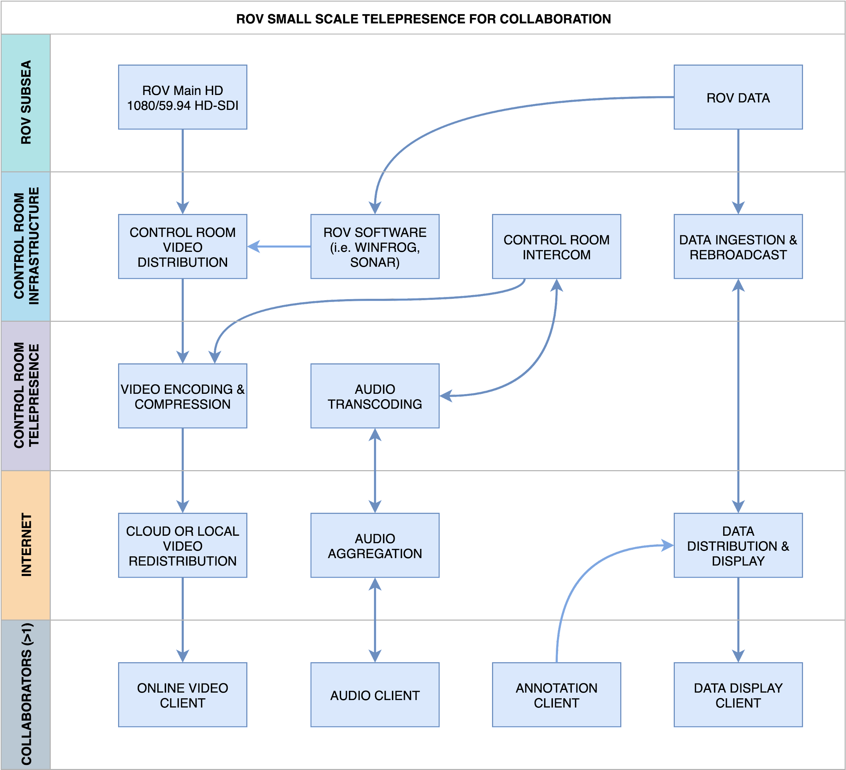

Bandwidth Use Estimates
This is an estimate for what may be considered the smallest possible footprint for telepresence at a data quality scientists are currently using on other platforms. We have calculated for two use scenarios, one with standard definition (SD480) quality, which would be encoded at 480 lines, 30 frames per second. The second is high definition (HD720), which is 720 lines, 30 frames per second. Both ROVs operate cameras at full high definition (HD1080).

 | SD 480 Stream | HD 720 Stream | Notes
Ship-to-Shore Rate (mbps) | 1.6 | 3.1 | 1 stream outbound
Shore-to-Ship Rate (mbps) | 0.4 | 0.4 | Data and audio inbound
Western Flyer Total (GB/day) | 21.0 | 29.1 | Assumes a 12-hour stream and current ship usage, combined up/down traffic.
Rachel Carson Total (GB/day) | 8.3 | 15.8 | Assumes a 10-hour stream and current ship usage, combined up/down traffic.

Connectivity Solutions
All commonly available streaming solutions employ internet protocol (IP) as their communications layer. We have at our disposal three methods for creating a connection from our vessels to the greater internet on shore: cellular data, microwave, and satellite communications. Given the bandwidth estimates, we can project data service costs as well. Calculating costs can vary greatly based on monthly and weekly expected use, and each different provider manages contracts differently. In the interests of simplifying the comparison, these estimates are based on a common month for both vessels. In the case of the Western Flyer, they average 2 week-long cruises per month. On the Rachel Carson, ROV dives average 10-dives per month when operating in the sanctuary. The optimal plan selections have been made for these scenarios.
All of the solutions presented can accommodate the demands set by the requirements, with reliability caveats for the cellular solutions. Cellular networks cannot guarantee quality of service needed for a stable video stream.
It is possible to find new vendors to use the equipment on board each ship and maximize cost savings, but these prices capture what is capable with the currently operating systems, and are thus the quickest paths to operation.

 | WF Satellite | RC Satellite | Cellular | RC Microwave
Equipment | Seatel 1009 8W | TracPhone V7HTS | New LTE Modem | MBARI Managed
Service Provider | Isotropic (Current) | KVH (Current) | Verizon (Current) | MBARI (Current)
Speed Maximums | 20 mbps down / 8mbps up | 10 mbps down / 3 mbps up | 5-15mbps down / 2-10mbps up | 10mbps down / 10mbps up
Range | All MBARI Ops | All MBARI Ops | 7 nm offshore in MBS | Out to M2
Reliability | high | mid (untested) | low | high
HD Cost Per Dive Day | $485 | $805 | $189 | $0
SD Cost Per Dive Day | $843 | $805 | $108 | $0
Current Cost Per Day | $100 | $198 | N/A | N/A
The above comparison is between all available telecommunication ship-to-shore systems available on MBARI vessels. Speed maximums are currently supported by both service and equipment, costs include continued use of these systems as internet gateways for ship’s crew. Further detail on the pricing structures can be found below for Isotropic and KVH.

Control Room Equipment

Evaluation System
Given the reduced scale and relative immediate need of the system, we can scope a small system that provides the required functional elements. The live gaming market has coalesced around a tool set that may provide easy to manage overlay features that will allow us to present contextual data overlaid on ROV video. This is known commonly as OBS (open broadcaster software), and can easily ingest video, overlay elements, and generate a constant bitrate stream all in one step. This stream is optimized for a variety of cloud base video redistribution services such as Youtube, Skype, Zoom, and enterprise content delivery networks (CDNs). The great risk to this approach is uncontrolled latencies, and no clear route for audio bridged into the control room without some testing. Approaches like this are currently being evaluated by SOI’s R/V Falkor and URI’s Innerspace Center. A sample budget follows:
Function | Potential Item | Cost ($)
Video/Audio Ingestion | Blackmagic Web Presenter or Decklink Duo 2 | $1,000
Video Adapters/Cabling |  | $500
Audio Interface Components | Audiocom WM1000 for line tap | $1,000
Audio Adapters/Cabling |  | $500
Broadcast PC | NUC 9 Extreme with RTX2070 | $3,300
Chat Server | Skype/Zoom/XMPP | $0
Professional Overlay Software | Wirecast | $1,000
 | Total: | $7,300

Broadcast Grade Systems
Though the previously outlined evaluation system may be sufficient, we are conscious that latency will be a limiting condition of some of these technologies. If those latencies cannot be overcome, we may be better positioned to build or rent a system built using TV production-quality hardware. These costs could likely rise to $15,000 of hardware per ship for purchase, and we are pursuing rental quotes of a system with the Innerspace Center. This is discussed more in the next section.

Shore Equipment/Services
We are considering a number of avenues for redistributing the video broadcast from the seagoing vessels. Upon recommendations from other telepresence users, we are exploring use of teleconferencing tools like Skype, Webex, and Zoom. Youtube and Facebook rebroadcasting work well for outreach, but often adds 30 seconds of latency to the video stream. Using these types of services are low cost subscriptions, averaging around $30 monthly.
One robust solution, albeit costly, is using an enterprise CDN to redistribute the video. The advantage is that it avoids any traffic flowing through MBARI and these networks are set up specifically to minimize latencies for live video. Once service commences, the stream is rebroadcast to clients, often visiting a web portal for video. We can use Wowza as a good example, and determine cost estimates of this sort of service with our estimates shown earlier. Using this service on the Western Flyer would cost $600 monthly. Alternatively, we can purchase a license for our own instance of the server, a monthly fee of $100 per month, but requires labor efforts at MBARI to host this software and make appropriate changes to MBARI’s firewall.
Additionally, the Innerspace Center runs its own media redistribution and has agreed to partner in support, though no quotes have been requested at this point. An added advantage to the Innerspace Center is its own collaborations with Isotropic networks, the ISP for the Western Flyer. Their expertise in creating at-sea telepresence with this ISP ensures they have the knowledge to implement a solution quickly and at the best fidelity.

Next Steps: Testing
As this is a concept backed by no testing and limited access to equipment, we propose this starting budget, which will enable testing the best way forward. Since there are no new major telecommunication investments at present, we need funds to support testing the streams from each vessel, and opportunity to test at sea, though no dedicated sea days.
An initial evaluation of the satellite capabilities and redistribution challenges can be done by borrowing equipment from the ROVVR project and purchasing the airtime required to evaluate the quality and latency with our current telecommunications equipment. Those costs are captured below.

Item | Cost
Evaluation System Control Room Components | $2,000
WF Expanded Isotropic Service (2 days) | $2,196
RC Microwave Testing | $0
Wowza Cloud CDN 1 week | $200
Total: | $4,396

Final Summary
In summary, this fact-finding effort has determined that both ships have systems that can accomplish the requirements set forth in this document, and in some cases will grow to eventually achieve full HD streaming that might be needed for outreach efforts as well. Some further testing is needed to evaluate how well these systems will work in our intended use. To conclude, we can present the ways in which this telepresence can be achieved on both vessels for the rest of 2020.
Specific to the Western Flyer, we are encouraged in our initial discussions with Isotropic systems that our use of this capability can be discretized in its use to a specific day, given our existing relationship. With advance knowledge, PIs can decide if they want this capability on their particular cruise. The augmented connection should allow for remote management and troubleshooting of new components, thus keeping bunk allocations unchanged.
The presence of the microwave on the Rachel Carson and the monthly blocking of the satellite plans leads us to recommend that telepresence on the Carson can be achieved via the microwave link. PIs who wish to use telepresence tools on Ventana should plans dive sites within high reliability areas covered by the microware system. This will not be as stable as the VSAT solutions, but is most cost-effective.

Appendix: Notes From Field Experts

Webb Pinner (Contracting SE)
Webb is a software engineer who has specialized in data aggregation systems for research vessels with telepresence components like the R/V Okeanos (NOAA), R/V Falkor (SOI), R/V Annie (GFOE), and currently the R/V OceanXplorer (OceanX), amongst others in UNOLS and WHOI. Here are some comments from an informal call.
- Effective telepresence users often only watch 1 stream, and need a latent communication (chat) and audio to be effective. (Same as Katy Croff’s comments)
- Data-presence has been an important tool in dive decision enabling (i.e. sharing maps or other data when selecting dive sites or dive sampling discussions)
- He recommended that we consider no larger than 720/30 streams, and that since most people are watching on browsers, that we could possibly have a sufficient product at standard definition (480), allowing for higher framerates in the same bandwidth as a slower, high resolution stream. He said the visual artifacts from compression at higher resolutions often distracts, and a higher frame rate seems to allow better visual interpretation.
- He has seen others than SOI using OBS tools to help get streams online, paid products can improve reliability and reduce latencies.
- The gold standard for latency of video is 2 seconds. After 10-20, decision opportunities are often missed. Youtube live offers many nice services, but poor control on latencies (6-20 seconds).
- Recommended cloud based media redistribution services may be good tradeoff of short term costs for reducing otherwise necessary infrastructure demands at MBARI.
- Wowza has software tools for media redistribution (http://wowza.com) as well as its own content distribution network (CDN) as service product. (Not recommended, just an example)
- He has open sourced tools for automated event logging (dive annotation) that have been adopted on some vessels, named Sealog
  - Client Repo - https://github.com/oceandatatools/sealog-client-vehicle
  - Server Repo - https://github.com/oceandatatools/sealog-server
  - Live Demo - https://sealog-subastian.oceandatarat.org/ User: admin, Pass: demo

Katherine Croff-Bell (MIT Media Lab, OET)
Kakani spoke with Katy Croff Bell last Friday (formerly OET) and from her experience, minimum requirements for telepresence should include the ability to stream the following:
- Audio: control room, bridge, pilots
- Chat
- Video feeds (switchable): Science camera, Auxiliary cameras (instrument, collection, vehicle data), Control room video

Terry Fong (NASA Ames)
Terry Fong is Director of the Intelligent Robotics Group at NASA Ames.
- Direct collaboration with NOAA OER, OET E/V Nautilus under a project called SubSea. Directly applying NASA knowledge to the ocean exploration scenario.
  - Dave Lees and Matt Deans have been leads on Subsea.
  - Have a slide deck we may get later on.
  - xGDS: XGDS is a tool for end to end science missions
- Augment dives through spatial presentation of data to help build context.
- Real-time displays of data for moon missions, so real time data display are more relevant for his lab than before.
- Astrobees: Borg like cube robots they are using for telepresence across maintenance tasks in space.
- Lunar rover mission, Viper, will be restrict to 280kbps.
- VR Resource, look into work by Steve Ellis at NASA
- David Lees presents SUBSEA

Dwight Coleman (ISC URI/GSO)
Dwight Coleman is the Director of the Innerspace Center at the University of Rhode Island, a facility initiated by Bob Ballard and funded through a state bond to serve as a hub for ship to shore communications for many ships across the UNOLS fleet, the E/V Nautilus and the R/V Okeanos.
- Audio is the real challenge, something still modifying
- Data is video/audio/data
- Has some experience with remote control.
- Have systems for rent potential, would require training/travel
- Knows isotropic, with R/V Endeavour
- ISC has syndication through Youtube is 40 seconds, through ISC is 1 second latency. Can create custom solutions.
- Will send WHOI model over the weekend.
- 5mbps UP/2mbps download. Speeds can be limited by tech and location.
- Isotropic is a good partner, can bill for many different use cases.
- Derek and Rachel may know more OBS
- Avwatch internet hotspots in the ocean
- Working on VSAT solutions as well for OceanX OceanXplorer (KA band)
- Gould work was successful at 512kbps

Adrian Tramallino & Stian Alesandrini (SOI)
Adrian is the IT manager for Falkor, Stian is the science manager for SOI Falkor.
- Two antennas, VSAT. Multiband, can go in linear or horizontal. KU or C-band. Auto switchover removes issues with shadows.
- Employ year long contract. KU near shore, C band offshore (less bandwidth).
- All traffic routed through “intelligent” management system, VLANs with different operating modalities.
- 64x64 Video router to encoding/scaling step prior to single computer running OBS. Audio mixer as well.
- Tried OBS (worked fine), use WireCast with more filters/options, license is $1200 for pro version
- Audio setup: PBX system; can’t do much due to latency, evaluating new LEO sat opportunities this year
- Stream to “custom server” (built in-house, agreement with ISP to Hawaii, fiber to mainland, Adobe Video Solutions) shoreside and then restreamed to FB/YT. YT only allows 720p; one stream off vessel to shore 4 MB up/ 3.5 MB down, when start 6 MB up (in-rush bandwidth)
- Latency: changed to UDP instead of TCP to improve latency but no feedback; YT only accepts TCP should expect 30 s, best case 9 s (also restrict usage on-board)
- No difference in latency using KU versus C-band, only coverage
- ISP needs 30+ days to make adjustments for schedule and operating location.
- VPN to ship, go into web browser and change streaming feeds (controlled ROV from shore???); most of this is done by science crew on ship
- Google meet not great, but skype/zoom works well for video conferencing on ship
- Wirecast can be setup to broadcast to zoom; can conduct conferencing within wirecast (rendezvous)
- Can host zoom meeting shoreside, one login from ship (video out and audio) in hopes to reduce latency; audio coming from different places; can set up zoom that enforces HD (and drops down if bandwidth not available) streaming. This is under active evaluation.
- Bought computer from wirecast but not powerful enough, Adrian will share computer specs

Appendix: Notes from Service Managers and Providers

Todd Ruston and Adriana Sisfontes
- 1 m dish, currently 1.5 mbps up and 4 mbps down (guaranteed 683 kbps down, 256 kbps up)
- $4100/month for data rate, 7.3 GB down, 2.7 GB up per day
- Hotel load ??: nothing mission critical
- Most of traffic is morale- (recreational) based
- Flyer VSAT terminates at ground station in central US (Missouri/Wisconsin?); co-located router there with VPN split-tunnel to MBARI; not VPN running on satellite link (Isotropic)
- Todd is okay with us speaking with Isotropic - “boutiquey”: James Bowden
- Uses “quality of service” to control bandwidth; full separation of video from other bandwidth, nothing available let; Adriana suggests creating separate VLAN; integration would take time as only cost.
- The Carson is currently limited to a 60cm dish because of weight restrictions on its current mounting position.

James Boden (Isotropic Networks)
James is chief satellite scientist at Isotropic, and his company caters to many research vessels and private yachts. Due to the mixed schedules of these vessels, Isotropic is a good partner as they are flexible in providing different rate structures on the same service narrowed to a weekly basis. He is our current contact for VSAT service on the Western Flyer.
- With the 1 meter dish on the Western Flyer, we can accommodate the required ship-to-shore speeds required by the streams.
- Our service is shared at present, but could, on a weekly basis, have the upstream link switched into a dedicated mode for stable video output onto the internet.
- To get up to 4 mbps x 4 mbps links, we may need to upgrade the transmitter on our current dish (UPDATE: no we have 16W already).
- To have this level of service constantly, would cost ~$19,500 per month. Our current plan is $3,000 per month.
- Below is a table of quoted rates, the most likely use structures have been labeled. These costs are broken out based on commitments of days, weeks, or month, all are acceptable given appropriate and scheduled notice months in advance. Isotropic with prorate and refund against our usual plan to this one as well.
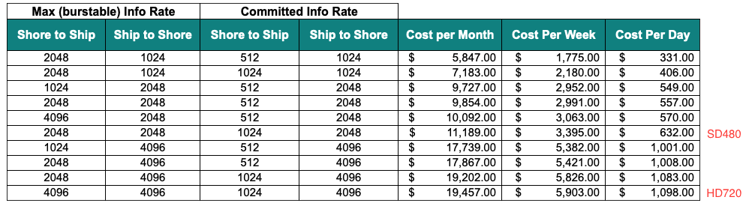

Craig Okuda (MBARI)
Craig, as many of you know, manages many of the shipboard telecommunications systems, notably the microwave system on the R/V Rachel Carson.
- The Carson microwave can support 57 mbps but is service limited to 25 mbps at present, and is operational.
- The Western Flyer does not have a functional system installed or in storage. Replacement of the system would cost likely >$16,000.
- There are some components that still exist that could help, but their operating states are unknown.
- The microwave system can work out to M2, dependent on day and sea state.

Leika (KVH)
KVH is the ISP and manufacturer for the VSAT system on the Rachel Carson. This is a different system because it was brought over from the Zephyr. It is scheduled for an upgrade to a TracPhone V7-HTS this summer.
- KVH offers month to month service changes, as well as suspension.
- We would need the V7L-HS-150GB plan, would cost $8,050 per month, and is enough data to cover 10/days a month of 9 hours of streaming.
- There are other plans with lower prices and data limits and overage charges.
- You can view the new pricing sheet here: Leisure Airtime Rate Sheet – Standard TracPhone®
- The current pricing sheet is here: TracPhone® V7/V7IP Airtime Rate Sheet
- We currently have the OP10K plan on the V7 plans, which covers 3mbps down, 512 kbps up.

Ian (Waveform)
Ian is a sales engineer for a cell booster reseller. I called to ask some questions about cell booster technology and the use landscape in general.
- Cell boosters can sometimes contaminate data streams due to noise amplified in the gain stage.
- They are best for expanding cellular reception inside shielding structures like ships and office buildings.
- Waveform recommends a good omnidirectional MIMO capable antenna to provide best service in our paradigm, and a good industrial cellular modem.

Darlene (Verizon Business Rep)
- For cellular modems, the business plans top out at 10GB per month of data transfer.
- Speeds at 4G are 2-10 mbps up, 5-15mbps down.
- Our current plans are 10GB per month for $90. Overage charges at $10 per GB.
- Verizon will not guarantee upload or download speeds, meaning interruptions would definitely occur. Depending on tower and other users. There is a priority data category, but you must dictate that your connection is for public safety (i.e. first responders)
- For the Carson, I am estimating 15GB per 9-hour dive at 720p. That would extend the monthly cellular costs to near $1,600 per month for the Rachel Carson, averaging a 10-dive month. The Western Flyer for its expected use would be higher, due to longer dive days. A 12-hour dive would consume 20GB of data, costing closer to $2,000 for a 10-dive month.

