Project Number: | 902012

Project Start: Jan. 1, | 2021 | Project Duration (in years): | Year 2 of 2

Please indicate if proposal includes requests for any of the following (mark all that apply).

Ship Time |  |  | ROV |  |  | AUV |  |  | Wave Glider |  |  | Mini ROV

Please indicate what type of project is being proposed (mark only one).

 |  |  |  | x |  |  | x |  |  | x
Feasibility/Scoping  [<100 days effort] |  |  | Development |  |  | Research |  |  | Infrastructure² |  |  | Education |  |  | Time Series |  |  | Institute Initiative

Project Manager: Eric Martin
Principal Investigator: Kakani Katija
Lead Scientist: Heidi Cullen
Lead Engineer: Eric Martin

Project Title: R/V Telepresence

Please indicate which category best describes the project theme (mark only one).

 |  |  |  |  |  |  |  |  |  | x
Ocean  biogeochemistry |  |  | Ecosystem dynamics |  |  | Ocean visualization |  |  | Exploration & discovery

Please indicate percentage of effort on this project anticipated for 2022 toward these three highest institutional goals (percentage total should equal 100%).

Goal | Developing/adapting innovative technologies | Utilizing developments to explore and understand ocean systems | Technology/knowledge transfer
Percentage | 40 | 30 | 30

- ABSTRACT (all projects)
Briefly provide a high-level summary of the project (ideally no more than 1/2 page).

A perennial challenge that the oceanographic research community is trying to address is how to effectively engage participation in and expand access to ocean exploration and discovery. While MBARI is fortunate to have a highly regarded marine operations program and consistent access to the sea, scarce seagoing resources are a significant limiting factor for many members of the research community. Additionally, livestreamed outreach capabilities that enable real-time participation and observation of research cruise operations—part of David Packard’s original vision for MBARI—have been shown to have measurable impact on public engagement and support for ocean science and conservation (e.g., E/V Nautilus, NOAA’s Okeanos Explorer). Therefore, there is a significant value to increasing participation and involvement in research cruises at MBARI through either increased engagement of external collaborators or more broadly through outreach.
Telepresence is a promising modality that can augment both science engagement and public outreach, and has been gaining traction in the oceanographic community in recent years. This project seeks to design, acquire, and implement telepresence on MBARI research vessels for both use cases. This work addresses the grand challenge of increasing access and engagement in ocean sciences, exploration, and discovery, without significantly impacting resources and science and engineering missions while at sea. Telepresence presents a strategic opportunity to engage external science partners while also promoting ocean science and conservation through public audiences and outreach. This effort is relevant in that it can provide the capabilities that facilitate broader science/engineering partnerships, and enable a persistent presence and sustained involvement in ROV operations.
Our efforts will focus on leveraging existing technologies on MBARI’s current research vessels. Surveying the specific science and outreach requirements of MBARI collaborators and users, we will aim to find appropriate tools that we can integrate in each ROV control room. While online streaming has evolved into a ubiquitous consumable for the internet, there remain technical challenges with reducing latencies for operational use. Latencies will inherently compromise collaborator contributions, but initial testing has proven that those can be reduced in exchange of video clarity. Since initial scoping efforts have determined that both ships possess ship-to-shore telecommunication systems capable of meeting requirements, innovation will occur in developing tools to emplace remote users in the control room, providing context, and allowing for remote contributions.

- PROPOSAL (all projects)

Background
Provide context for the project, being sure to address these questions:
- What fundamental problem does this project address, and why is it important?
- What makes this work relevant to MBARI and the Packard Foundation?
- Is this effort linked to other internal or externally funded projects or collaborative efforts?
- Where does this work fit into the ~5–10 year plan for your group, at MBARI, and in the field?

Providing access to the deepest parts of the Monterey Bay Sanctuary is a core reason MBARI was established in Moss Landing. Few research institutions can claim to reach deep water in only a single day’s transit, and this access has driven MBARI as a world leader in deep-ocean research. However, despite access to deep water, MBARI research vessels continue to be limited in at-sea contributions due to personnel restrictions imparted by limitations on accommodations. Also, the remote nature of oceanography serves to restrict participants who have health limitations or physical disabilities. This problem was addressed in recent ship designs for NOAA’s latest AGOR class vessels. Both the R/V Sally Ride and R/V Neil Armstrong were designed with staterooms and limited deck access to accommodate wheelchair access for scientists at sea. However, addressing the accessibility and space limitations of oceanographic vessels is a solution with large capital costs, large facility requirements, and does not scale effectively. We must endeavor to attack this problem from other perspectives, leveraging new technologies from other domains than marine architecture.
Telepresence describes a broad set of technologies that when combined, facilitate interaction with an environment by an individual in a distant location. ROVs are in their own way, a technology of telepresence, and their prevalent use in oceanographic research has almost completely replaced manned submersibles over the last 40 years, extending our reach to the ocean floor and expanding the access to all personnel onboard a research vessel. Telepresence systems for use on ROVs date back to developments against Woods Hole’s Jason ROV, when Dr. Robert Ballard created the JASON Project in 1988 to bring ROV video directly into classrooms to share the excitement and discovery with classrooms around the world. In this initial incarnation and through the 1990s, the technology needed to bring ROV video and data back to shore was both large, expensive, and required a team of broadcast engineers to maintain and operate, both at-sea and on land. More impactfully, those engineers occupy valuable bunks, making this technology unobtainable to regional class research vessels.
Even today, with advances in both satellite technology and the advent of broadband internet, satellite technologies needed to transmit multiple video feeds and accommodate daily ship internet needs are still too physically large to fit on many vessels, and service costs still remain high. Few vessels carry the budget to maintain a constant telepresence functionality for their at sea operations. However, you will be hard pressed to find a research vessel today that does not possess a consumer grade VSAT system, with dishes sized under 1.5 meter diameter. These systems can provide connection speeds up to 5mbps, just enough for a single feed of high- definition (HD) quality video. There are many vessels, including the R/V Rachel Carson, and R/V Western Flyer, which could benefit from a solution designed to meet basic requirements and live within the constraints of the consumer VSAT systems already installed onboard.
Telepresence can help by allowing for remote science direction, annotation, and collaborator contribution. In times of great strife such as these, history has taught us to expect a great expansion in technology development in response. We can already see this in recent advances of telecommunications. During the COVID-19 world-wide shutdown, the general public has become more broadly literate in teleconferencing and remote work. Daily, new rockets are bringing constellations of new communications satellites to expand the reach of broadband internet to all parts of the world, addressing the digital divide, such as the Starlink system. Heightened competition in these spaces ensure that the future cost estimates of having a persistent telepresence solution onboard marine vessels are shrinking.
Relevant to the goals of the institute, telepresence should be considered as an important asset to our recent investment in the R/V David Packard, a ship to replace the Western Flyer and expand the capabilities of MBARI researchers. With it, we will have a revived capability to reach beyond the sanctuary. Telepresence can help expand our reach onto the vessel with collaborators throughout the scientific community, ultimately increasing utility of this new vessel.

Nature and Scope of the Proposed Project
Please provide a sense of the scale and scope of the proposed work. Is this a large de novo R&D effort, modest platform/sensor integration, targeted science investigation with minimal or no engineering needs, extension of current program, small-scale scoping exercise expected to lead to a larger effort, or other? If the project is intended to be multiple years, how will the anticipated level of effort likely change over time?

We propose to design a system that integrates recent advances in teleconferencing, gaming, broadcast, and cloud technologies into a small turnkey system designed to provide telepresence for the general purpose of expanding access and informing ROV dive operations onboard MBARI’s research vessels. The impact of designing such a small and simplistic system will ensure that we can export the knowledge to other at-sea operations that are also meeting these new restrictions. MBARI has also begun pursuing a myriad of new outreach efforts. We would be remiss in not recognizing that this development is also an opportunity to expand outreach from our platforms as an added value proposition.

Anticipated Shared Resource Needs
What staffing is required to advance the work in 2022 (e.g., is this a multi-faceted engineering development or a targeted science investigation that does not require significant use of shared personnel)? Is in-house or contract manufacturing needed? What level of ship/ROV/AUV (DMO) support is likely? If this is intended to be a multi-year effort, please provide a rough indication of anticipated shared resource needs over the duration of the project (e.g., will stay flat, will significantly increase in Year X, will significantly decrease by Year Y).

Given that the minimal components of the current system have proven capable for science and outreach needs, our needs will require a small team of software and electrical engineers with broadcast experience. DMO and IS support are critical for ensuring communication integrity. The project cannot staff individuals aboard each expedition where telepresence is used, so a turnkey solution is needed. These requirements have been somewhat alleviated, through remote troubleshooting and science operator training.

Anticipated Expenses
What rough order of magnitude direct expense budget is anticipated annually over the course of the project? Is procurement of specialized capital equipment or outside contractors required? Will there be annual travel?

The prototype system components have proven capable, and future investments will be covering spares and services, total roughly $15,000. As Leila Takayama is taking a leave of absence to pursue other interests, she is continuing to offer her services to MBARI at a discounted rate, the maximum proposed effort is $50,000. We have marked some items as optional to facilitate any descoping that may need to occur as the proposal process advances.

Intellectual Property (IP) Considerations
Do you anticipate a need for a cooperative research and development agreement or licensing arrangement with an external entity? Will the work potentially result in a patentable product or service? Will novel IP and/or custom-made equipment be created, and how might it be disseminated (e.g., license agreement and/or collaborations)?

For additional guidance please review MBARI’s intellectual property internal web page: https://mww.mbari.org/itd/ip/.

Yes, we intend to engage the services of Leila Takayama, who will require a new agreement by the end of 2021.

Data
What data will be generated? How will they be managed/stored? Are any special data visualization needs anticipated?
The video experience streamed in real-time is the only uniquely new data product proposed that may need intermittent archiving for project documentary purposes. All other data products that will be used in contextual display or annotation are already logged under data management software present on both vessels. Core video is already logged. These archival video experiences will be stored in the project library, and those archived for outreach will be managed directly by ITD personnel.

Anticipated Impact
Who are the consumers of the instruments, methods, technology, and data that will be generated within and beyond MBARI? Will the project create tangible connections with other organizations (e.g., academic, NGO, MBA, MBNMS, state or federal agency)?

This telepresence system is an asset to many investigators and engineers who conduct ROV operations from MBARI vessels. Both in expanding science, as well as bringing support offshore. We have already sparked interest from other institutions interested in expanding their capabilities. We aim to publish these efforts through conference proceedings.

Anticipated Outreach Needs
Thinking about the audiences/consumers you highlighted in the question above, do you anticipate needing to create outreach assets to help increase your impact? If so, please specify whether you anticipate needing to work with ITD and also specify what type of asset (story, graphic, animation, video, etc.) you might need.

We have demonstrated that telepresence has evolved into an asset that ITD can leverage. ITD will drive the creation of any assets that are needed.

Continuing Projects Only: Status Report
Briefly provide an update of the current project relative to what was proposed for 2021 by responding to the prompts below. If the project includes multiple subproject projects, please list each of these under a subheading as you deem appropriate.

Current status of project and results to date

The telepresence project has achieved many milestones as the project has just reached a year of operation, since starting under mid-year approval in 2020. As of July 2021, we have successfully connected science personnel on MBARI research vessels with over 150 participants on 12 expeditions. We have also hosted MBARI’s first livestream event for a general audience. Along the way, we have refined the system progressively and begun the technology transfer process, enabling science operators to manage telepresence with 30 minutes of training from the development team. The demand for telepresence has exceeded projections as restrictions stayed in place far longer than many anticipated. However, overwhelming feedback from users who were originally reluctant to use the system signaled a desire to keep using the system moving forward. Allowing our chief scientists to extend their collaborations beyond the bunkspace available on a given cruise, we have brought 44 unique organizations along with us on MBARI’s research vessels.

Working with Leila Takayama and her Human-Computer-Interaction Lab at UCSC, we have completed one round of interviews with 8 MBARI and 4 non-MBARI telepresence users. Results from that round of interviews were presented to the team in March, highlighting those users’ perceived benefits and concerns (slides). That study has been used to shape plans for the next revision of the system. Another round of interviews is planned this summer as the number of users continues to grow.

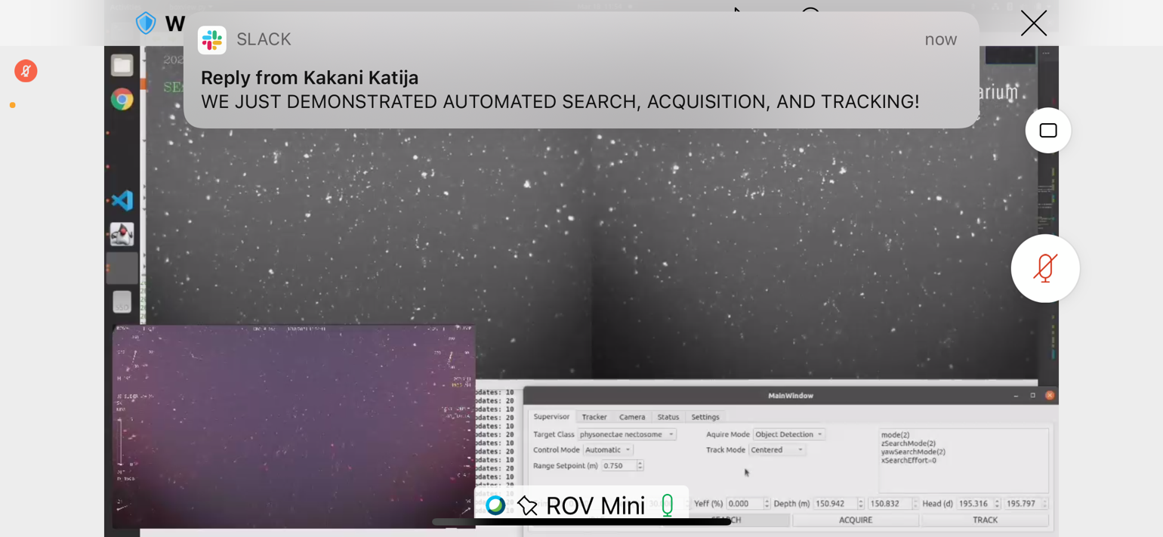
Figure 1: Kakani Katija announces a major milestone to the telepresence community during a MiniROV expedition aboard the R/V Rachel Carson. She was a remote investigator for this expedition.

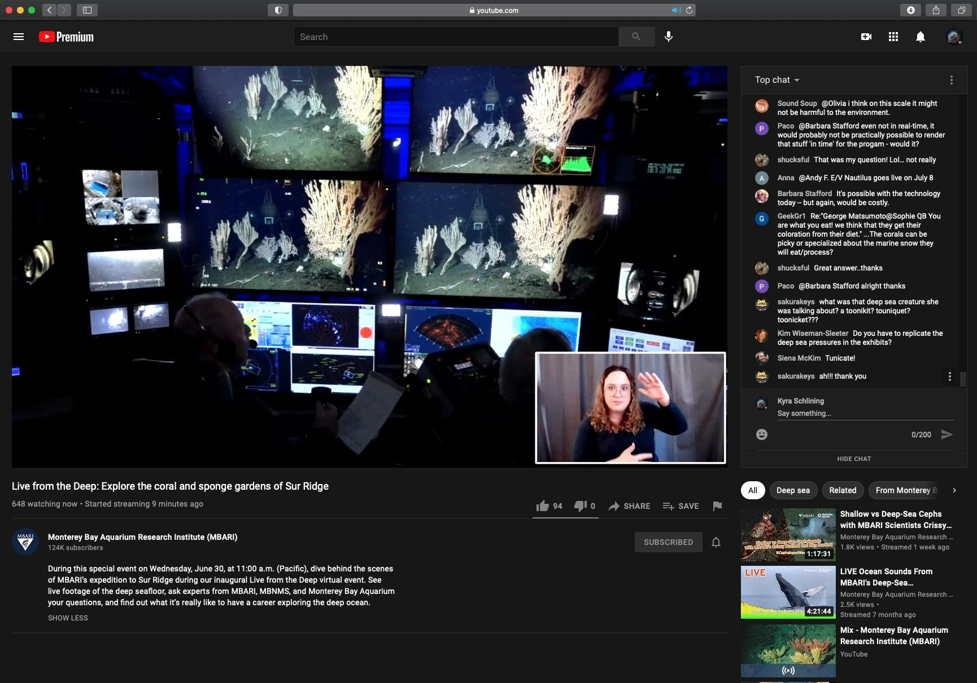
Figure 2: Live from the control room of the Western Flyer where Knute Brekke and Jim Barry fielded questions from audience members. In the lower right, American Sign Language interpreter Ali Phelan.

What percentage of labor and budget have been used through the 1st half of year?

Eric Martin has used approximately 50% of time through the year, as primary support for ongoing operations and coordinations. For other parties with labor allocations, we have deferred much work to the remaining half of 2021 due to lack of availability (with confirmation that those labor needs will be addressed by the end of 2021), and to give the UCSC lab time to provide direction from their studies. When Eric Martin becomes more available after September, we expect to use all of the $17K budgeted for this project in 2021.

Will you complete the current year’s scheduled work?

Due to a clear demand for a less complex telepresence experience, we are re-focusing efforts on providing a flexible and streamlined service. We expect to have a second revision of both the hardware and software components complete by the end of year.

Significant changes from previous project proposal

Most notably, highly detailed VARS annotations are of little demand, but cruise log tools are of great interest. To accommodate this need, we have chosen to develop lightweight tools within Slack to allow for latent cruise logs entries to be added to the VARS database onboard the vessel. We originally scoped a full version of VARS to be created to allow for multi-user contribution, but upon further study, the complexity of custom software solution was not justified. Slack has emerged as a fantastic tool for telepresence updates, and allows for non-distractive discussions to occur during operations.

Also worth noting, in light of the retirement of Craig Okuda and likely retirement of the current microwave system, we have not used labor hours or funds for modifications to the telepresence system. We understand that the new satellite system is currently under specification by DMO and will defer to their proposal. Demand for telepresence on the Rachel Carson has been more infrequent, but we do expect some users to continue to leverage whatever system is settled upon.

Over the past two years, what peer-reviewed publications, education and/or outreach activities have resulted directly from this project? Please be brief.

- Eric Martin chaired a session on remote participation at the Scientific Ocean Vehicles Alliance (SOVA) in April.
- Ongoing collaboration with Dr. Leila Takayama at UCSC is enabling students to conduct research on telepresence for research vessels.
- On June 30th, 2021, MBARI hosted its first Live from the Deep event (Figure 2). The show featured footage of the stunning coral and sponge gardens at Sur Ridge in NOAA’s Monterey Bay National Marine Sanctuary (MBNMS) as well as interviews with MBARI, NOAA, and Aquarium staff. With a goal of making the livestream as accessible as possible, ITD incorporated American Sign Language interpretation and Wordly.ai translation into 16 languages on our website. Across platforms, we had over 22,000 views in the first 14 days. The Sur Ridge broadcast from the Western Flyer was a collaboration between the Telepresence project and ITD. We were able to use the new telepresence equipment to great effect when integrating rented production gear.
- Kakani Katija gave a talk during the National Geographic Explorers Festival in June describing their work that was facilitated by telepresence during the COVID19 pandemic.

All Projects: Specific Plans for 2022

Research Activities

Primary research goals for 2022 will be to continue collaborating with Leila Takayama and students she will continue to advise. These are the activities that Dr. Takayama has identified:

- Articulate the goals of the R/V Telepresence project for each of its high priority user groups (e.g., external science collaborators, outreach and scientific communication) and contexts of use (e.g., quarantine conditions vs. the new normal)
- Provide the R/V Telepresence project team with user-centered design research (e.g., interviews with current and prospective telepresence users, observations of current telepresence usage, and questionnaires of broader telepresence user groups) to guide the iterative improvement of the system for supporting MBARI’s goals for this project
- Co-author peer-reviewed scientific publications on this project
- If needed, recruit and/or hire interns and/or subcontractors from the HCI research community to speed up our user research capabilities

As we continue to debrief the Sur Ridge broadcast, we also will aim to develop a plan for future livestream events.

Engineering/technology development

As we have a delayed start on many of the efforts for revision 2 of the telepresence system to Q3 of 2021, we expect to complete some minor modifications to the system in 2022. As we conduct a revision 2 survey in Q1 2022, we will reserve some time in Q2/Q3 2022 for changes to the system after the vessels return from the Gulf of California expedition.

Major efforts will be made for technology transfer of relevant aspects of the system to both science users and operations support teams. More discussions will take place with stakeholders to determine best how to transition the system out of the hands of its developers and into its users.

Field programs (detail ship requirements/deployments/diver requirements)
In addition to describing anticipated field programs, please be sure to include requirements for specific platforms and equipment (Dorado AUVs, LRAUVs, Wave Glider, mini ROV, etc.) for each proposed field program so that expectations are clear. Requests must also be entered in the budget entry system.

None required.

Specific deliverables

Through a proposed consultation effort with Leila Takayama, our deliverables would include:
- Write and present R/V Telepresence goals in user-centered terms (e.g., user stories)
- Write and present a report after each of the two phases of development (end of 2021 and mid-2022)
  - Each report will include the results of interviews, shadowing sessions (behavioral observations), and questionnaires (as needed)
  - Each report will also include design recommendations for iteratively improving upon the design and operations for R/V telepresence
- Submit research manuscripts for peer-reviewed scientific publication venues (optional)

Along with these research deliverables, we expect to deliver a working video/audio/software system that will last for many years after 2022. The system will be refined and transitioned away from development control. One system will also be decommissioned on the R/V Western Flyer in 2022 along with the rest of the vessel. We expect to spend some resources to make sure the system can eventually be integrated in the control room of the R/V David Packard in 2023.

Milestones and required personnel (see personnel classification list for staff classifications)

The technology development goals can be described in the following milestones:
- Carry over the work not completed in 2021 for the second revision of the system, prior to deployment of the research vessels to the Gulf of California Expedition, which expects to use telepresence assets for the entire expedition.
- Implementing design modifications as generated by user feedback processed by Leila Takayama.
- Complete documentation and tech transfers to parties identified during discussions with the telepresence committee.
- Document and present the efforts at a community conference (TBD) of MBARI’s telepresence efforts.
- Decommission the WF telepresence system and store it for re-installation on the R/V David Packard.

2022 Project Start Date:  1/1/2022 | Milestone 1 | Milestone 2 | Milestone 3 | Milestone 4 | Milestone 5 | Total Resources (in hours) for each resource category for all milestones listed here
Milestone Date | 2/1/22 | 7/1/22 | 12/1/22 | 12/1/22 | 9/1/22
Milestone Description | Rev 2 Completion | Implement Rev 2 Feedback | Tech Transfer | Publication
Electrical Engineer | EM – 60 | EM – 60 | EM – 24 | EM – 40 | EM – 16 | EM-200
Software Eng-Embedded
Software Eng-Info Eng | KG – 120  BS - 120 | KG – 60  BS - 60 | KG – 20 |  |  | KG – 200  BS - 180
Mechanical Eng-Mfg
Associate Engineer |  | KS – 16 |  |  |  | KS – 16
Electrical Tech | TBD - 10 |  |  |  |  | TBD - 10
Software Tech
DMO ROV Pilot | BE – 8 | BE - 8 |  |  | BE - 12 | BE - 28
OED IS Support |  |  |  |  |  | AS - 20

Budget Justification

Task Group | Function | Item | Unit Cost | Qty | Extended
Broadcast Hardware | Video Switcher | Blackmagic Smart Videohub | $1,500 | 2 | $3,000
 | Video Converters | Blackmagic Microconverter Bidi | $75 | 10 | $750
 | Audio Embedder | Blackmagic Audio SDI | $195 | 3 | $585
 | Audio mixer | Yamaha MG06X | $130 | 3 | $390
 | Lavalier microphones | Rode | $80 | 8 | $640
 | Cabling |  | $300 | 1 | $300
 | Hardware |  | $500 | 1 | $500
Software | Production Software License | Vmix Pro | $1,500 | 1 | $1,500
 | Video Conferencing | Webex Monthly | $120 | 12 | $1,440
 | Hard drives for OS snapshots | Samsung SSD | $100 | 4 | $400
Publication | Conference Registration | Oceans 2022 | $1,000 | 1 | $1,000
 | Conference Travel | Travel & Hotel to Virginia | $3,000 | 1 | $3,000
HCI Consults | Leila Takayama // Hoku Labs | Revision 2 2021 Report (Hours) | $250 | 80 | $20,000
 |  | Revision 3 2022 Report (Hours) | $250 | 80 | $20,000
 |  | Co-Authoring TBD Paper (Hours) | $250 | 40 | $10,000
 |  |  |  | Subtotal: | $63,505
 |  |  |  | Estimated Taxes: | $1,249
 |  |  |  | Total: | $64,754

Project team

RDE:
- Kakani Katija, Principal Investigator
- David Caress, Lead Engineer
- Eric Martin, EE, Project Manager
- Kevin Gomes, SE
- Brian Schlining, SE

DMO:
- Ben Erwin, ROV Pilot
ITD:
- Heidi Cullen, Lead Scientist
- George Matsumoto, Senior Education & Research Specialist
- Susan Von Thun, Science Communications and Content Manager

Project lab and office space requirements
In addition to any changes to current space usage, please also include anticipated office and lab needs for students, postdocs, collaborators, etc.

We continue to use bench space in B225 for various testing and spares storage.

Risk matrix (development and infrastructure projects only)

 | Technical Risk | Organizational Risk | Tech Transfer Risk | Labor Estimate Risk
High
Medium |  |  | X
Low | X | X |  | X

Compliance Considerations
Please respond “Yes” or “No” to each line item below, and provide details as necessary.

CATEGORY | Yes/No | DETAILS
Isotope Use (see policy and cruise planning)  Will the project use stable or radioisotopes? | No
Battery waste over 4 liters (1 gallon)  Indicate type and amount. | No
Liquid hazardous waste over 60 liters (15 gallons)  Indicate composition and quantity. | No
Export Regulation  Foreign collaborations or international travel? | No
Export controlled purchases  Items purchased/in possession or to be purchased that are not on list? | No
Export controlled items (hardware, software, tech data)  Items to be transferred outside US (temporarily or permanently)? To what countries (including International Waters)? | No
Work covered by Marine Sanctuary permit?  Yes, if work falls under blanket authorization. | No
Work conducted in SESAs?  ID # for Sanctuary Ecologically Significant Areas | No
Equipment deployed with anchors?  Give details for deployment; recovery if < 500lbs | No
CA Fish & Wildlife permit required for samples? | No
Working in State Marine Protected Area? | No
Require Coast Guard PATON for buoys?  Private Aid to Navigation. Permit in hand? | No
Require Local Notice to Mariners  Indicate who will be submitting | No
Permits from other agencies? | No
Use of active acoustics not already on list? | No

This date and number should remain the same for the duration of the project. If your project start date for 2022 is not January 1, please indicate the start date in the first cell of the milestone chart. Format for duration example: “Year 2 of 5”.
Development and infrastructure projects must complete the risk matrix (see end of the proposal form).
Not all projects will require all four titles to be filled in. Please indicate individuals only for those titles that are appropriate for your project.
This category includes transfer of hardware, know-how, publications, presentations, etc.
This number should be the same number you entered on the web budget resource requests for this particular resource.

