Results of Telepresence Testing on the R/V Western Flyer
Kakani Katija, Eric Martin, Ben Erwin, David Caress
May 31, 2020

We are happy to report that preliminary testing of the satellite system on the Western Flyer for use in telepresence was successful. We were able to build a simple system within the ROV control room, and broadcast to a wide variety of shore targets (Figure 1). The telepresence test system was composed of a video source (Sony HD video camera), a capture device (Black Magic Web Presenter), and a video encoder with overlay (Laptop running Wirecast OBS). We had 6 test users at various locations throughout Monterey County who were able to view all streams at encoded resolutions matching the source video of the ROV’s main camera. Eric Martin acted as a land-based broadcast engineer coordinating tests and managing content distribution. These tests took place over two days, May 28 and 29, 2020.
During the first day we routed the streams over the hard wire connection to shore, and focused on developing all of the content distribution nodes, training testers, and observing time latencies as a control. On the second day we routed the streams over the upgraded VSAT connection, and the shore based testers observed stream quality and robustness and measured time latencies. The connection was upgraded from a 3 mbps down x 1 mbps up connection to a 4 mbps down x 4 mbps up data rate. Isotropic, citing good relations, provided this upgrade for the day at no cost. The system is proven to handle the load of telepresence, with enough overhead to continue to offer normal internet connectivity as it operates onboard the vessels today.
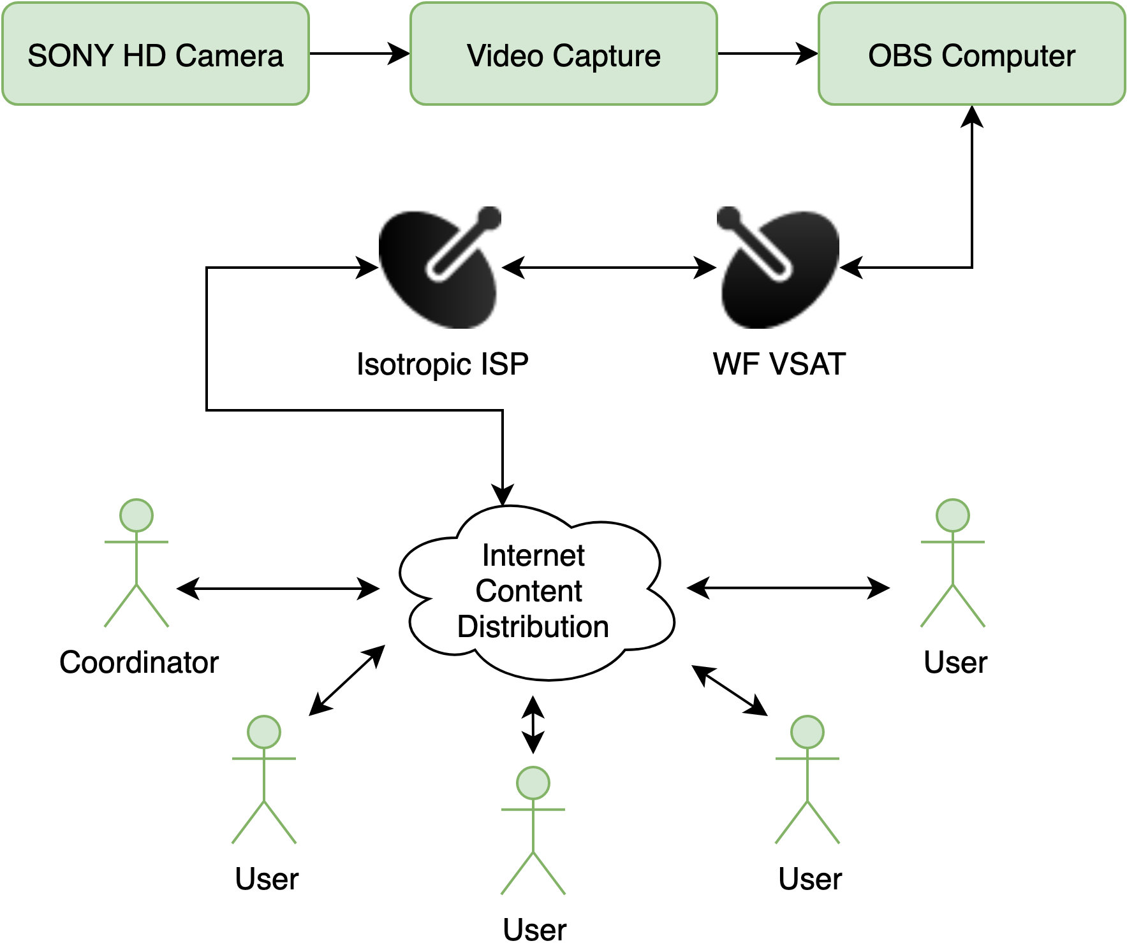
Figure 1: Diagram of the telepresence test system.
Connecting through teleconferencing services like Zoom and Google Meet, we observed latencies less than 3 seconds. Other solutions could stream at high-definition resolutions (e.g., 720p30, 1080p30) with ~30-second latencies. The following table summarizes our test results.

Stream Target | Video Quality | Average Latency (s)
URI Innerspace Center | 720p30 | 35.5
Wowza Cloud | 1080p30 | 23.7
Microsoft Streams | 720p30 | 27.7
Facebook | 1080p30 | 22.5
Youtube | 720p30 | 26.3
Zoom | 480p30 | 1.5
Google Meet | 720p30 | 1.5
To be clear, the qualities here reflect what was tested, and not the highest quality streams possible for any platform. Some services require high level access through license purchases. Screen grabs from our Flyer tests can be found at the end of this document.

Recommendations for achieving telepresence on the R/V Western Flyer
With some modification, we believe we can achieve streaming of high-definition video resolutions with minimal latency. This limited set of changes could enable telepresence operations in time for the Flyer’s return from the shipyard. The modifications along with resource needs include: :
- Funds for an upgraded VSAT service, estimated at $1,100/day (or $800/day if used for a week). Details can be found in the requirements document.
- Cloud restreaming services through Wowza, our current best CDN performer, at $200/month for select months.
- Software licenses for stream construction such as Wirecast is $600.
- A dedicated computer installed in the control room for $3,000-$5,000.
- Support from the IS department (e.g., Adriana Sisfontes) and DMO (e.g., Dan Chamberlain) for network and service configuration needs.
- Support from ROV pilots to specify connection endpoints for video and audio streams.

Request for resources to test and implement telepresence on the R/V Rachel Carson
An initial survey of potential telepresence users on the Rachel Carson has indicated that most operations will take place within microwave range. We would like to work with the Ventana/Carson team to perform a similar series of tests on the Rachel Carson through the microwave system to evaluate system capability. We will potentially need assistance from the following people to complete this test:
- IS Department: network management and configuration.
- Craig Okuda: microwave integration consultations.
- Ventana Pilots: ROV control room integrations.
- Aaron Gregg: ship operations coordination.

Acknowledgements
We want to thank the Management Team for their support. We are also grateful for the support of team members that came together in the past week to make this test a success, including Dan Chamberlain, George Matsumoto, Andrew McKee, Todd Ruston, Adrianna Sisfontes, and Mark Talkovic. Special thanks should also be extended to Dr. Dwight Coleman and his team at the Innerspace Center at URI for helping us by providing a stable streaming target and initial help in our scoping efforts, and James Boden at Isotropic Systems who provided the upgraded satellite service at no cost to the institute for our Flyer tests.

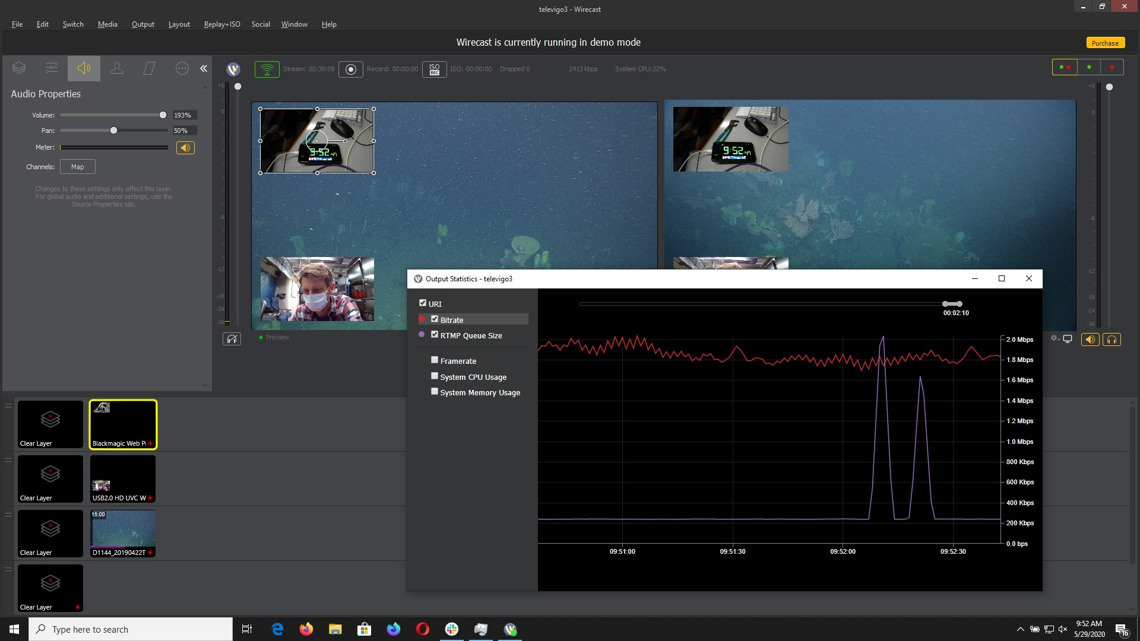
Figure 2: The broadcaster software and metrics for a stream that had no interruptions for 30 minutes with intentional ending over the satellite.
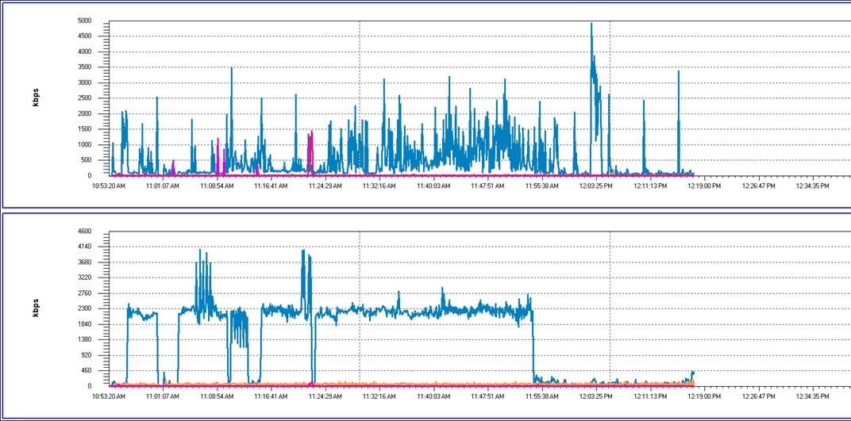
FIgure 3: Satellite traffic confirming nearly constant satellite traffic was stable for the same 30 minute test shown in Figure 1.
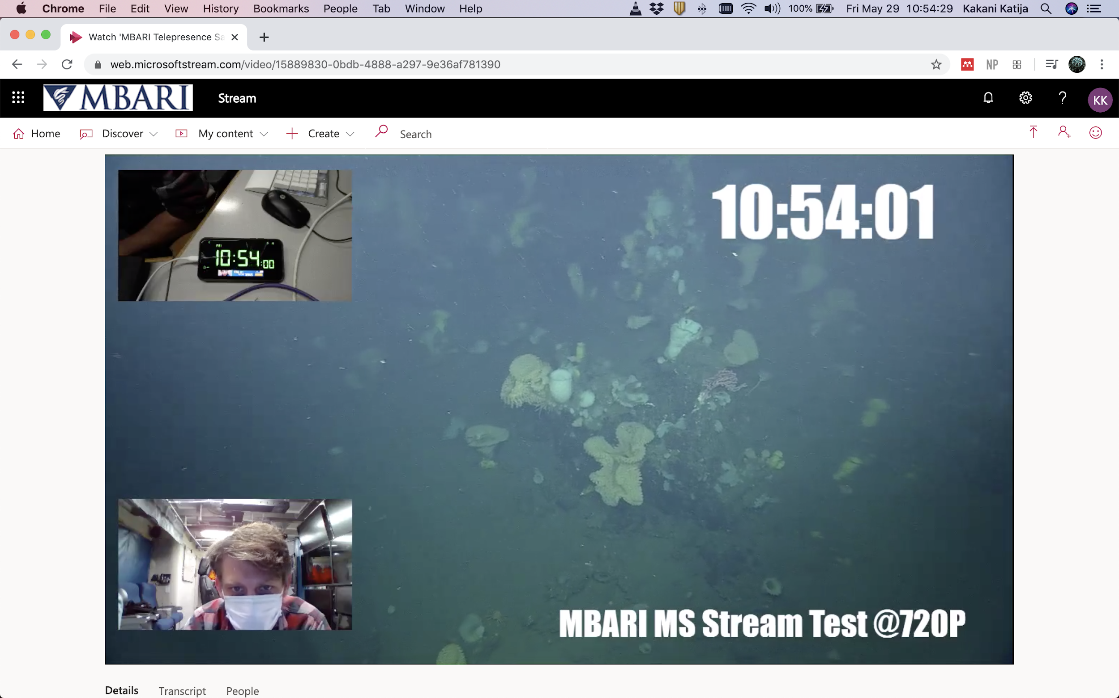
Figure 4: Streaming through Microsoft Stream to Kakani’s computer in Carmel Valley, this is a CDN we have access to through our Microsoft licensing agreement.
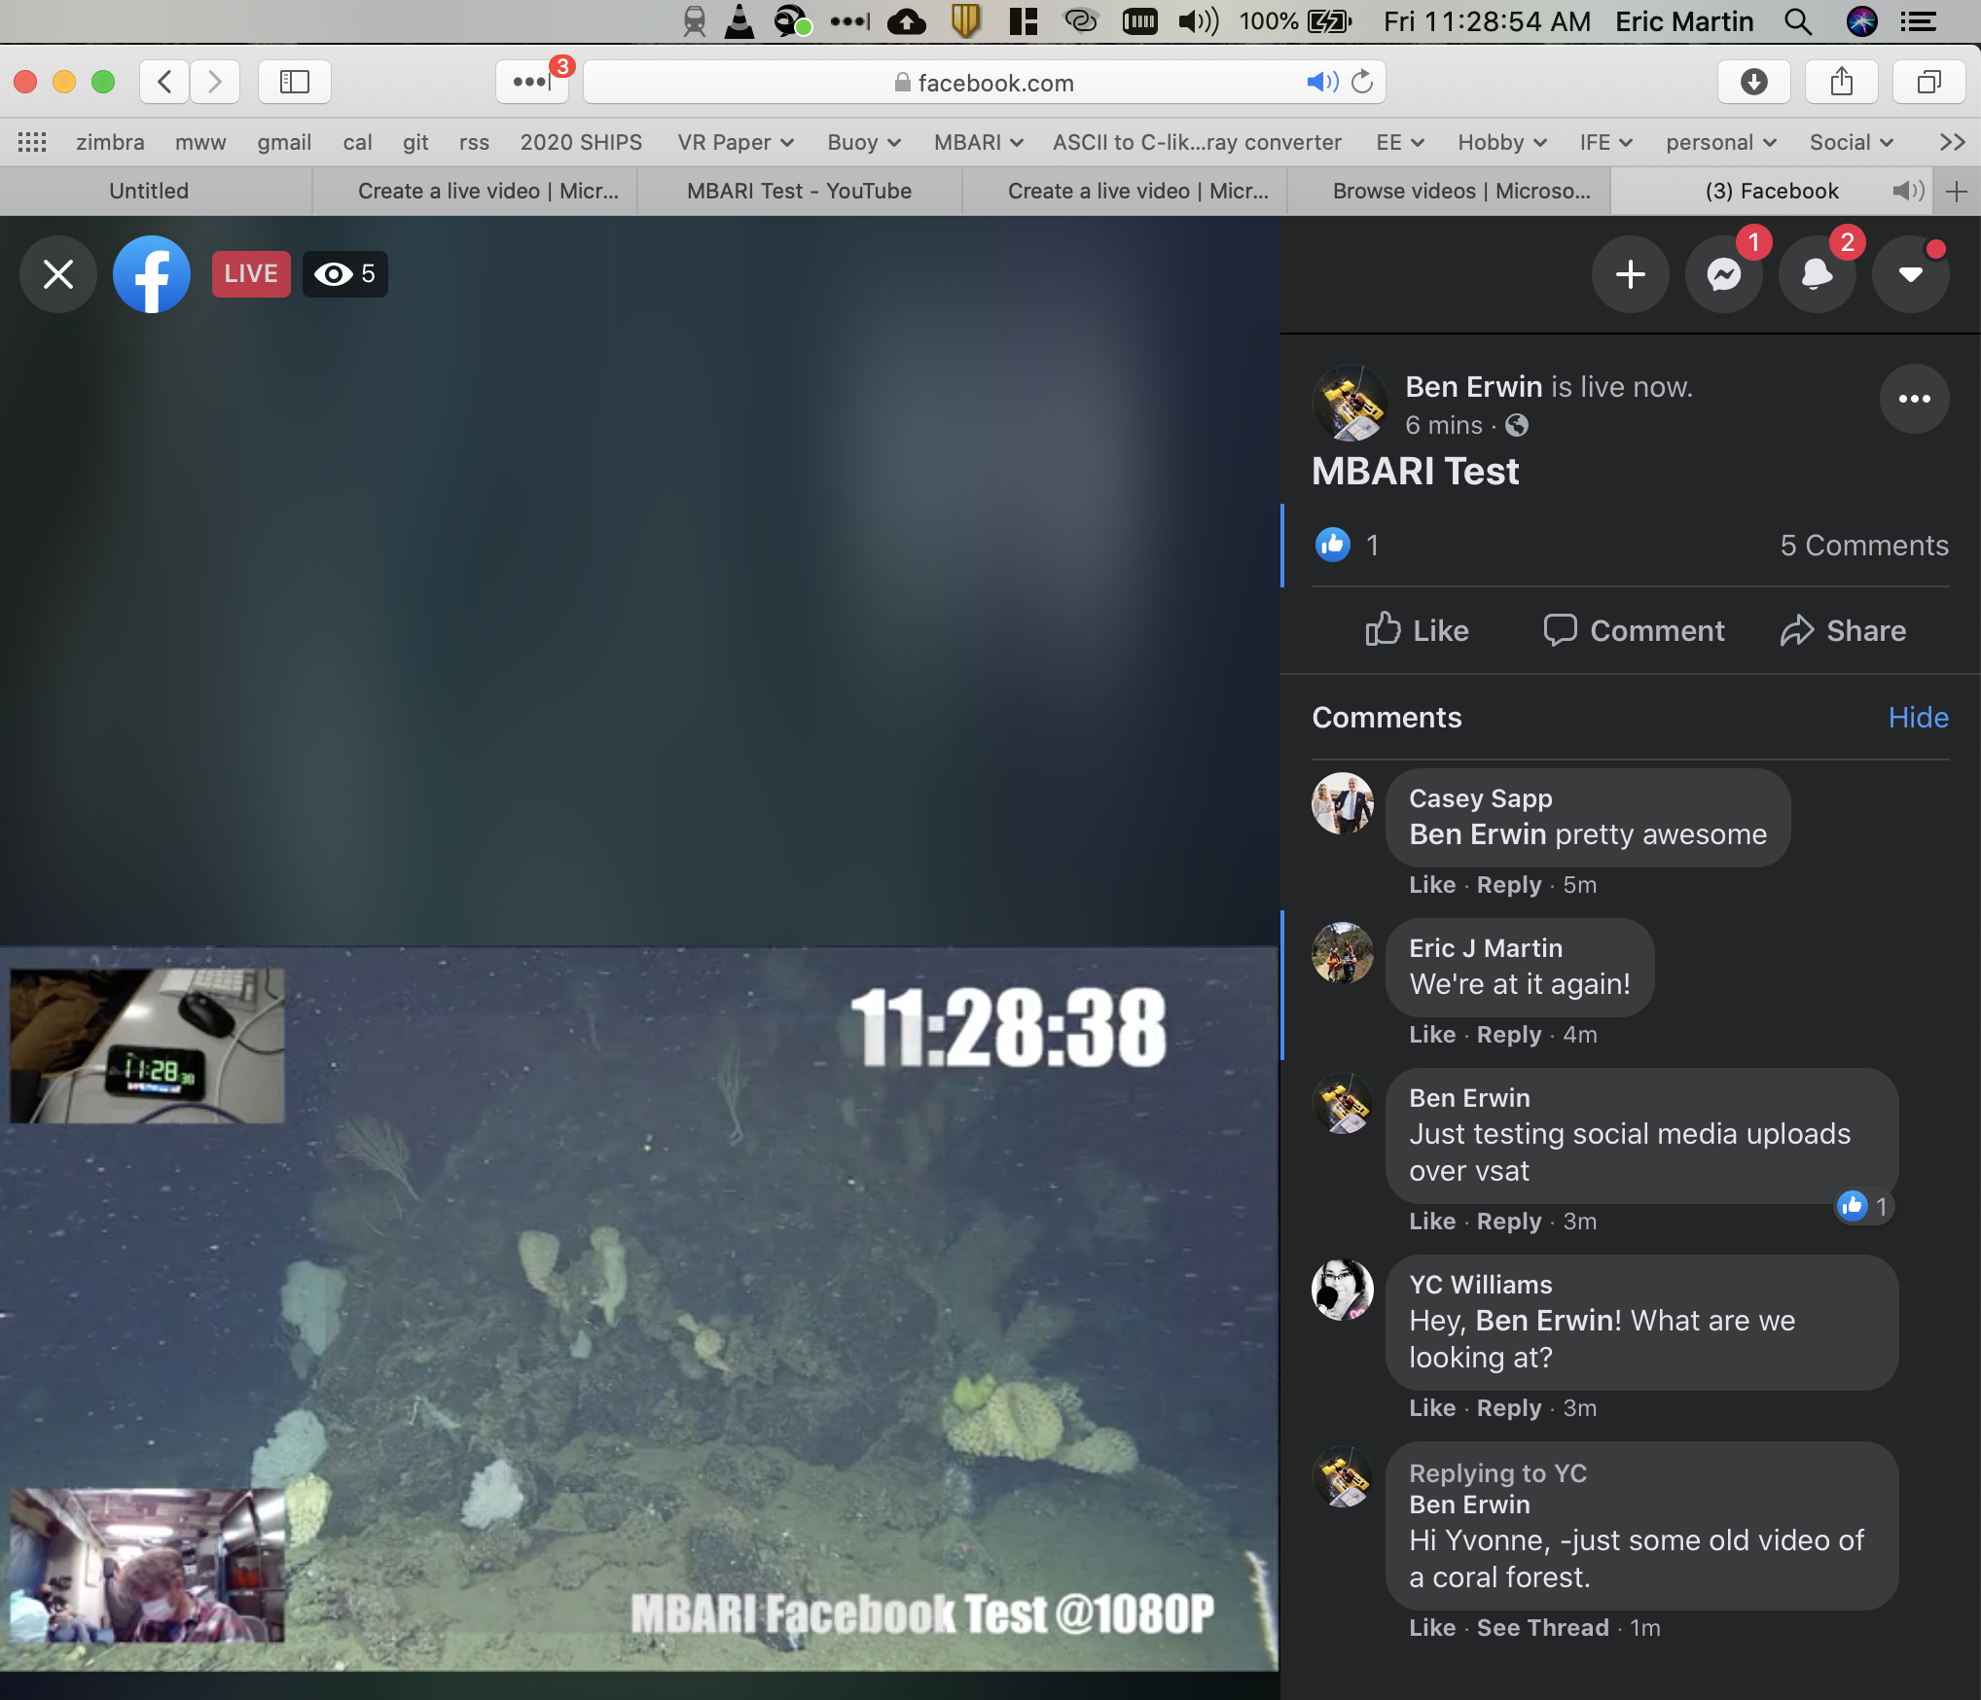
Figure 5: Facebook live direct from the boat at 1080p30. This stream was not as stable as others, as it was near the limits of the satellite service. Isotropic could support high rates that would improve reliability.

