Western Flyer Telepresence Panelist Guide
Updated: November 29, 2020
Western Flyer Telepresence Panelist Guide 1
TLDR; 1
Overview 2
Call Lifetime 2
Software & Hardware Requirements 3
Host Controls 4
Setting up your own client 4
ScreenGrab Access 4
Audio Discussions 5
Adding People During the Call 5
Sharing and Media Best Practices 6

TLDR;
You're already a seasoned pro at telepresence. Here's some handy links you'll want to keep at the ready.
Feature | Link
Screen Grabs | http://teleops.wf.mbari.org:80
Scene Controller | http://teleops.wf.mbari.org:8000/tablet.html
Onboarding Presentation | https://docs.google.com/presentation/d/1cvHOLeI87jfyN5-57SHN2tsBmYMWjHLn6ps0Z3MKm_g/edit?usp=sharing
This document | https://docs.google.com/document/d/14QzECu0TRQDSkHUT6OaiOj4Zx5Lh8ti2MZZJBIrrkOQ/edit?usp=sharing

Overview
At present the telepresence solution is a best effort prototype system under continuous design and refinement as we get more opportunities to test it under use on the Western Flyer. As such, we are excited at the features we've been able to rapidly deploy that can enable a remote user not only access to active ROV dives and research, but also the ability to change what they can view remotely, removing the need for an at sea coordinator of telepresence. The spirit of these efforts are to directly replace displaced personnel on the vessel who cannot be at MBARI due to COVID-19 restrictions.
Thanks to the rapid rise in teleconferencing tools, there are now many options for providing high-quality, and more importantly, low latency audio-visual tools between parties. Also, this project leverages Open Broadcaster Software to help assemble many video and audio streams into a mix that will present a single reliable video source to offshore clients.

Call Lifetime
In consideration of privacy concerns and bandwidth conservation, feeds from the boat are not live at all times. On the morning of a day leveraging telepresence features, a telepresence operator will test feeds into the system to ensure required connections are present prior to call initiation. The webex event will be brought online by the host, and the remote participants will be allowed to call into the event via the Webex client. The vessel will connect at the same time as the panelists. Here is a brief timeline of a day of telepresence ROV dives:
- The ship makes initial contact that a dive will have, and provides an estimate of launch time.
- The host on-shore will create the Webex event and start it near this time, sending a link to all participants via either email or Slack.
- The vessel will connect when approved by the Chief Scientists and Chief pilot. This usually happens on descent.
- The host will make the vessel feed the “presenter”, and announce the call is live.
- Ship operations will conduct as normal, and participants can come and go. Feeds can be changed by the host or the vessel.
- After the dive is complete, the host will end the event, unless there are post-dive discussions that need to take place only after ship recovery operations are complete..
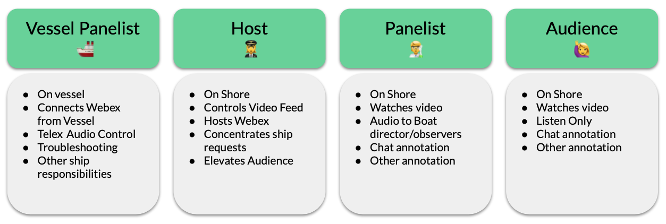
There are four groups of participants online, split as the active participants (panelists in Webex) and the passive participants (attendees in Webex). One active participant will be identified as the Host, who will serve as an administrator to the panelists, with the ability to elevate passive participants into more active roles. Other active participants are the vessel panelist (main source of ROV Video) and the on-shore panelists. These roles are diagrammed below:
The Host and Vessel Panelist will also control what video feeds are assembled and sent out over the broadcast feed. The control room is the primary panelist, and their video feed will be the one to watch. For bandwidth concerns, it is important for no one else to share their video. The roles can be shared, but those with the ability to talk to the control room should be cautious that they are not bothering the control room if the audio into the telex system from the telepresence system is enabled (a button in the control room). There will also be a backup headset on the telepresence station in the control room if the Telex bridge is too crowded.
Once online, the telepresence host will allow control over scene selection to panelists that have MBARI VPN level access. The host will remain available to troubleshoot any issues remotely. After the dive is complete, the call will be terminated. If launch/recovery are to be observed, please do not conduct any audio conversations during these dangerous ship operations.

Software & Hardware Requirements
You will need to install or have the following tools ready
- Reliable internet connection > 15mbps download.
- Audio headset with microphone (for echo removal), do not use your laptop's speaker/mic unless desperate, we recommend USB headsets from Logitech and Corsair.
- Webex Meetings software and account (free). Make sure your headset works with the software.
- VPN connection to MBARI, required for anything beyond connecting to the Webex event. Non-MBARI collaborators may have this level of access.

Host Controls
As a panelist, you must be aware of the controls that the host and ship have over the call. The host will be responsible for three main functions:
- OBS Video Scene Control
- Webex Panel & Audience Management
- Control Room Audio Communications
This role can be transitioned over a day, but it is best to maintain one person at a time in this role. Please connect to the host or ship when requesting a change to these three components.

Setting up your own client
Assuming the host has pinned the right video for everyone, and no one else is sharing their video, we recommend you:
- Open the participants list so you can see who's there and talking
- Open the chat (icon at bottom)
- View>Hide Nonvideo Participants, to help focus your view
- View>Show/hide participant controls, will help clear up the video.

ScreenGrab Access
In order to provide more context to the ROV dive, such as vehicle location, environmental data, or active sonar components, we have created a simple web application that collects screengrabs from individual and presents them, self refreshing every 30 seconds. In order to view this website, you must be VPN'd into MBARI, as these are controlled information components at present.
At present, you can view high quality framegrabs of the following software running in the control room:
- Winfrog (Navigation)
- Sonardyne Ranger (USBL & Navigation)
- CTD (Water Chemistry)
- Gemini and Mesotech Sonar (Multibeam and Scanning Sonars)

Audio Discussions
It is important to understand how audio works on the event once online, as too much discussion can impact success in the control room onboard. All panelists can speak and hear each other, and anyone in the ROV control room or ship's bridge can hear the panelists over the ship's Telex party-line intercom system. There is only one microphone enabled in the control room. Here are the recommended procedures to initiating a safe discussion with the ROV control room.
- Identify yourself, and make a brief statement, i.e. “Control room, this is [your name] on shore. What are we looking at right now?”
- Wait for a response for a short while before repeating your request. Reach out on chat such as Slack if you do not get any response.
- The control room will eventually try and reach the microphone to respond, signalling they are either available to talk further or ask you to wait.
Keep discussions brief and secure, always remember that the entire ship can hear you.

Adding People During the Call
In the event you left someone off the panelist list or want someone new to jump in and help? This isn't too painful. You will have to let that person enter as the attendee, and whoever the host is will have to elevate them as a panelist if they require that level of permission. Please contact the host to inform that you wish new parties to join the call. This must be approved by the Chief Scientist aboard for all parties.

Sharing and Media Best Practices
MBARI is currently in final revisions of its telepresence policies as well as its social media policies. Once adopted, those will be shared here. For now, here is a short list of best practices to avoid violations:
- No video or audio recordings of the broadcasts are allowed without consent of the Chief Scientist in advance.
- Screengrabs and other dive data should not be reposted to any exterior websites or groups without consent of the Chief Scientist on board. Using chat channels such as Slack are allowable.
- Do not redistribute the video or audio feeds live (i.e. phone or screencasts of the event). This includes both online and places like conference rooms. If you invite someone into your office to watch, please check with and notify the Chief Scientist and Chief Pilot.
- All social media content sharing should be verified through the Chief Scientist.
- For all other exports of information, please check with the Chief Scientist.

