Western Flyer Telepresence User Guide
Created: Aug 21, 2020 1:52 PM

Western Flyer Telepresence User Guide 1
TLDR; 1
Overview 2
Call Lifetime 2
Software & Hardware Requirements 3
Host Role 3
OBS Control 4
Webex Panel Management 4
Control Room Audio Control 4
On-Shore Panelist Role 4
Audience Role 5
ScreenGrab Access 5
Getting Started: Hosting a Call 5
Schedule the Event (Before cruise) 5
Start the Event (Day of) 6
Connect the ROV (Vessel Panelist) 6
Setting up the Event 6
Adding People During the Call 7
Setting up your own client 7

TLDR;
You're already a seasoned pro at telepresence. Here's some handy links you'll want to keep at the ready.
Feature | Link
Screen Grabs | http://teleops.wf.mbari.org:80
Scene Controller | http://teleops.wf.mbari.org:8000/tablet.html
Scene Administration | http://teleops.wf.mbari.org:8000
Control Room Teleops PC Access | vnc://teleops.wf.mbari.org:5900
Shore Side MBARI Telehost PC (VNC) | vnc://telehost-wf.shore.mbari.org:5900
Shore Side Telehost PC (RDP) | rdp://telehost-wf.shore.mbari.org
MBARI Webex Events Control | https://mbari-events.webex.com/mw3300/mywebex/default.do?siteurl=mbari-events&service=6

Overview
At present the telepresence solution is a best effort prototype system under continuous design and refinement as we get more opportunities to test it under use on the Western Flyer. As such, we are excited at the features we've been able to rapidly deploy that can enable a remote user not only access to active ROV dives and research on the R/V Rachel Carson, but also the ability to change what they can view remotely, removing the need for an at sea coordinator of telepresence. The spirit of these efforts are to directly replace displaced personnel on the vessel who cannot be at MBARI due to COVID-19 restrictions.
Thanks to the rapid rise in teleconferencing tools, there are now many options for providing high-quality, and more importantly, low latency audio-visual tools between parties. Also, this project leverages Open Broadcaster Software to help assemble many video and audio streams into a mix that will present a single reliable video source to offshore clients.

Call Lifetime
In consideration of privacy concerns and bandwidth conservation, feeds from the boat are not live at all times. On the morning of a day leveraging telepresence features, a telepresence operator will test feeds into the system to ensure required connections are present prior to the boat leaving dock. Once out of the harbor, the webex call will be brought online remotely by the operator, and the remote participants will be allowed to call into the event via the Webex client.
There are four groups of participants online, split as the active participants (panelists in Webex) and the passive participants (attendees in Webex). One active participant will be identified as the Host, who will serve as an administrator to the panelists, with the ability to elevate passive participants into more active roles. Other active participants are the vessel panelist (main source of ROV Video) and the on-shore panelists. These roles are diagrammed below:
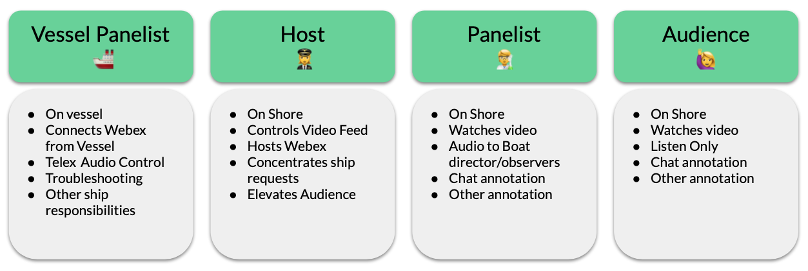
The Host will also be the individual who controls what video feeds are assembled and sent out over the broadcast feed. The control room is the primary panelist, and their video feed will be the one to watch. For bandwidth concerns, it is important for no one else to share their video. The roles can be shared, but those with the ability to talk to the control room should be cautious that they are not bothering control room if the audio into the telex system from the telepresence system is enabled (a button in the control room). There will also be a backup headset on the telepresence station in the control room if the Telex bridge is too crowded.
Once online, the telepresence operator will hand control over to the host at the time. The operator will remain available to troubleshoot any issues remotely. After the dive is complete, the call will be terminated.

Software & Hardware Requirements
You will need to install or have the following tools ready
- Reliable internet connection > 15mbps download.
- Audio headset with microphone (for echo removal), do not use your laptop's speaker/mic unless desperate.
- Webex Meetings software and account (free). Make sure your headset works with the software.
- VPN connection to MBARI, required for anything beyond connecting to the Webex event.
- VNC Client, RealVNC Viewer, you do not need a RealVNC account to use this software.

Host Role
As mentioned, the director will be responsible for three main functions:
- OBS Control (video feed selection)
- Webex Panel Management
- Control Room Communications
This role can be transitioned over a day, but it is best to maintain one person at a time in this role.

OBS Control
We control OBS through a simplified button tool known as the El Gato Streamdeck Controller, a programmable button set that can enable macro functions in OBS software, currently mapped to changing video scenes.
In combination with another software tool, Bitfocus Companion, we can present a web interface that emulates this physical button set that is present in the control room. At present that web interface is reachable only for people VPN'd into MBARI and can be found at http://teleops.wf.mbari.org:8000. When opening the page, you will find the interface below. When the video feed is active, these buttons will change the output video as described in their button labels. These can be tuned prior to dives, and special feeds can be added, such as specialty cameras on the ROV, as well as laptops running specific software.

Webex Panel Management
Panelists can share who's presenting (this should always be the ROV webex client) and can elevate participants from/to the audience. Panelists can have audio discussions, audience members only can communicate through chat. More information can be found in the link below.
Webex - Panelist Options in Cisco Webex Events

Control Room Audio Control
At present, we are still negotiating the best way to communicate with pilots and crew, but the Chief scientist seat in the control room will have a headset that can communicate with the telepresence participants when Telex intercom link is not enabled.
Webex - Panelist Options in Cisco Webex Events

On-Shore Panelist Role
The panelist has the ability to talk to the ship, and should do so only when necessary. They can view video and data available from the ship.

Audience Role
Audience members are participants who wish to watch video and listen to conversations, but not contribute to the active mission of the ROV dive. They cannot talk at all to each other, but can ask the panelists questions and chat textually with them. Audience members can be promoted by the host to a panelist.

ScreenGrab Access
In order to provide more context to the ROV dive, such as vehicle location, environmental data, or active sonar components, we have created a simple web application that collects screengrabs from individual and presents them, self refreshing every 30 seconds. In order to view this website, you must be VPN'd into MBARI, as these are controlled information components at present.
At present, you can view high quality framegrabs of the following software running in the control room:
- Winfrog (Navigation)
- Sonardyne Ranger (USBL & Navigation)
- CTD (Water Chemistry)
- Gemini and Mesotech Sonar (Multibeam and Scanning Sonars)

Getting Started: Hosting a Call
Follow this set of not-so-simple steps (it will get better):

Schedule the Event (Before cruise)
This can be done days in advance, and a new event must be created for each day.
- RDP or VNC to telehost-wf.shore.mbari.org
- Open chrome browser, click on the link for webex events, login using emartin@mbari.org, the password is stored.
- On the left, schedule a new event
- Load the "western flyer template", this should make sure registration isn't necessary (checkbox), new entrants are muted, and
- Scroll down to Panelists, and follow the dialog to add key participants that need the ability to chat and talk to the boat directly using that dialog (there are the abilitie to set up distribution lists in this interface)
- Now add anyone else to the Attendees invitation list.
- Schedule the event, and email participants if so desired.

Start the Event (Day of)
Morning of the event, you will have to start. Events are limited to 12 hours, so start near the start time of the day.
- RDP or VNC to telehost-wf.shore.mbari.org
- Open chrome browser, click on the link for webex events, login using emartin@mbari.org, the password is stored.
- On the "home" page, you should see your event listed under "Upcoming Meetings", click on "Start"
- This should open the event and panelists and attendees can now join.

Connect the ROV (Vessel Panelist)
If the ship is unavailable, you can remotely connect to the PC in the control room that will connect to your event. Through the VSAT this connection is very slow and hard to read. Move carefully and patiently, and you can maintain the system from offshore.
- VNC to teleops.wf.mbari.org
- Make sure the OBS software is running check "Tools>VirtualCam" and see that it is started, if not, click start.
- Use a web browser, and paste in the link for panelists, this will bring you to a page where you will enter name "Doc Ricketts" and the email teleops.wf@mbari.org . Click "Submit", and then you will get a page with a "Join" button, click this and the webex software will begin.
- Before connecting, make sure the Audio/Video Connections are correct:
  - Input (ROCCAT JUKE Microphone)
  - Output (ROCCAT JUKE Speaker)
  - Video (OBS-CAMERA): this one can be hard to set if it doesn't come up by default, use arrow keys to get the right one.
- Click "join" and unmute the microphone

Setting up the Event
Now you're connected, the ship is connected, and you may want to connect again from your local machine with your own account. Keep the host webex client running on teleops-wf.shore.mbari.org, and the host can use that client separately from their own to provide shared control of the call. From that client, we recommend that you:
- Open the participants list.
- Right click on "Doc Ricketts" and "change role to>Presenter"
- In the top middle of the video screen, click on the pin icon and "lock video view for>everyone" to "Doc Ricketts"

Adding People During the Call
In the even you left someone off the panelist list or want someone new to jump in and help? This isn't too painful. You will have to let that person enter as the attendee, and whoever the host is will have to elevate them as a panelist if they require that level of permission.
- Find the attendees link on the webex web interface (see Starting the Event) and click on the event title that is underway. There should be a link for attendees and panelists. Copy the attendees link and send it to your colleague. Wait for them to login and get on.
- In the host client (which would be on [telehost-wf.shore.mbari.org](http://telehost-wf.shore.mbari.org) if you've stuck to these instructions), open the attendees list in the "participants" panel.
- Right click on the attendees, and "change role to> panelist"
- They should be able to unmute themselves and talk to all other panelists

Setting up your own client
Assuming the host has pinned the right video for everyone, and no one else is sharing their video, we recommend you:
- Open the participants list so you can see who's there and talking
- Open the chat (icon at bottom)
- View>Hide Nonvideo Participants, to help focus your view
- View>Show/hide participant controls, will help clear up the video.

