AUVs have become essential data collection tools for ocean science. Traditional ship-based methods for ocean observation are nowadays giving way to fleets of autonomous vessels that work collaboratively to capture meaningful and persistent information about the marine environment in locations and over time periods never before possible. Alongside MBARI’s growing fleet of AUVs, developing tools for design and validation of new robotic applications will be crucial for scaling up autonomous operations and advancing the ocean research they enable.
The goal of this project is to create a simulated environment and vehicle models that will support rapid prototyping and testing of next-generation algorithms and control software for multi-AUV applications under controlled and reproducible settings. The software tools that we are developing will enable researches seeking advanced methods of ocean observation to quickly iterate and validate the performance of their new applications in a fully visualized simulated environment prior to leaving the lab, and then deploy the final product to the AUV for execution at sea.
To this end, we are collaborating with a team of robotics and simulation experts at Open Robotics (https://www.openrobotics.org) to develop simulation tools and software based upon the widely adopted Robot Operating System (ROS) framework. Open Robotics is a research and development non-profit organization and a world-wide hub for activity in open-source robot software development. Open Robotics leads the development of ROS and its robot simulation tools, which have become the industry standard for development in most robotic domains and has been widely adopted in the marine robotics community, including by many of MBARI’s collaborators (NPS, WHOI, UW, OSU, JHU, Liquid Robotics, JPL).
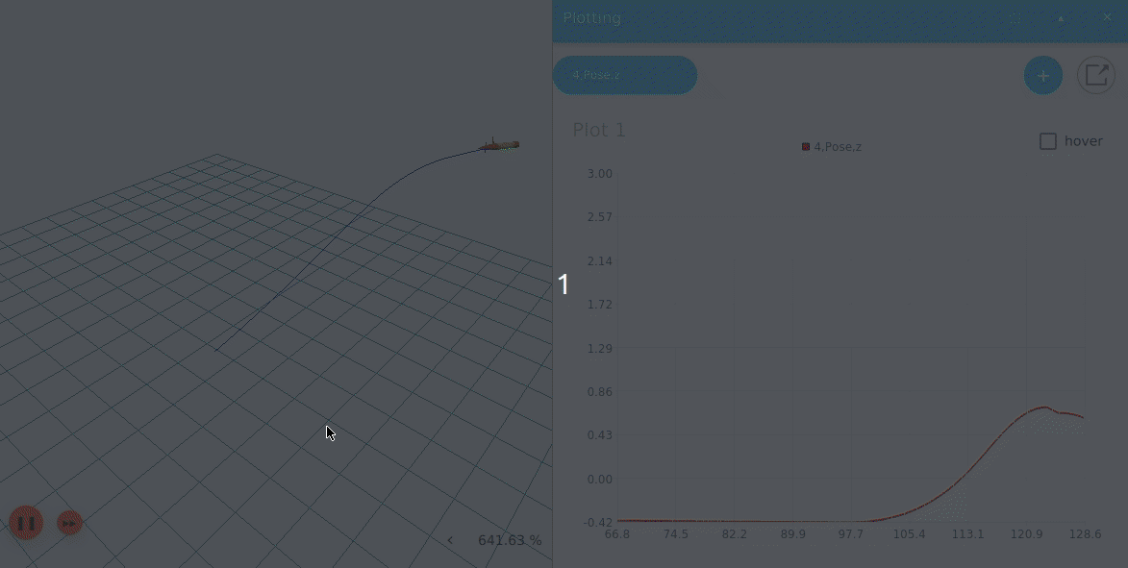
Simulation of LRAUV embedded in the ROS-based simulation environment. The simulator supports live data visualization such as the vehicle’s trajectory (left) and depth (right).
Animation by Louise Poubel (Open Robotics)
- In Q1 the team developed a minimum viable product demonstration of the simulation environment, which focused on eliminating high risk aspects of the implementation. At the end of the quarter, the team presented the results to an MBARI design review panel for validation - the MBARI engineering panel determined that the simulation meets the needs of the MBARI staff and approved continuing to subsequent project phases.
- The team delivered a simulated water-column environment with a 3D vehicle model of LRAUV, including simulation plugins for the vehicle’s fins, thruster, and hydrodynamics. The simulated LRAUV is controlled by the same software that runs onboard during field operations and can run 130-times faster than real-time (a 3-week deployment can be simulated in 4 hours).
- In Q2 the team extended the LRAUV vehicle simulation model to include actuators that are unique to the LRAUV (e.g., mass-shifter, variable buoyancy system, and drop-weight), and added ocean currents to the simulated environment.
- In Q3 the team extended the simulation environment to include oceanographic and biological water properties such as temperature, salinity, and chlorophyll concentrations, which allow users to simulate environmental scenarios such as thermal fronts and productivity hotspots, and develop science missions that require CTD, and fluorometer inputs. The team also added support for inter-vehicle acoustic comms to support development of multi-vehicle/fleet applications that require acoustic localization and tracking.
- We will be presenting our project in ROS World 2021 (virtual) and are also organizing a maritime-robotics community meeting that will include representatives from: MBARI, NPS, WHOI, URI, UW, UNH, OSU, Open Robotics, and many more.
- In Q4 we will add support for inter-vehicle acoustic data packet transfer and acoustic vehicle command and control. The team will also integrate the simulation with LRAUV’s web-based command and control interface (TethysDash: https://okeanids.mbari.org/dash4) and package the software so it can be used by any collaborator or run using cloud services such as AWS.

