AUVs have become essential data collection tools for ocean science. Traditional ship-based methods for ocean observation are nowadays giving way to fleets of autonomous vessels that work collaboratively to capture meaningful and persistent information about the marine environment in locations and over time periods never before possible. Alongside MBARI’s growing fleet of AUVs, developing tools for design and validation of new robotic applications will be crucial for scaling up autonomous operations and advancing the ocean research they enable.
The goal of this project is to create a simulated environment and vehicle models that will support rapid prototyping and testing of next-generation algorithms and control software for multi-AUV applications under controlled and reproducible settings. The software tools that we are developing will enable researches seeking advanced methods of ocean observation to quickly iterate and validate the performance of their new applications in a fully visualized simulated environment prior to leaving the lab, and then deploy the final product to the AUV for execution at sea.
We are collaborating with a team of robotics and simulation experts at Open Robotics (https://www.openrobotics.org) to develop simulation tools and software based upon the widely adopted Robot Operating System (ROS) framework. Open Robotics is a research and development non-profit organization and a world-wide hub for activity in open-source robot software development. Open Robotics leads the development of ROS and its robot simulation tools, which have become the industry standard for development in most robotic domains and has been widely adopted in the marine robotics community, including by many of MBARI’s collaborators (NPS, WHOI, UW, OSU, JHU, Liquid Robotics, JPL).
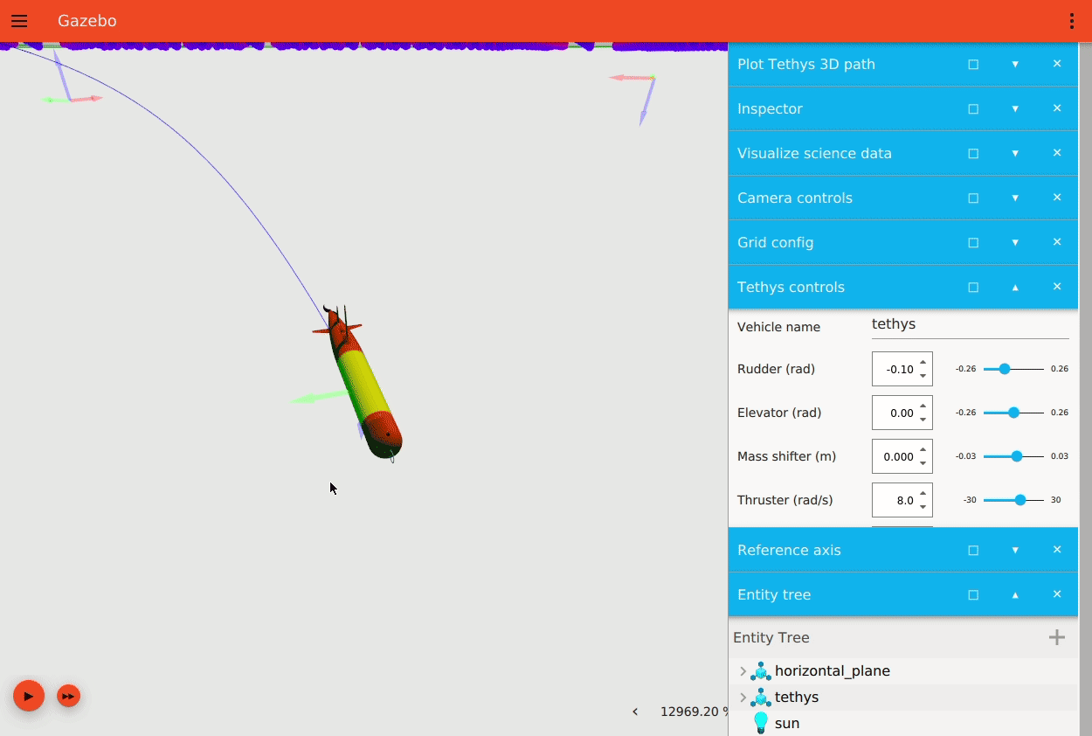
Simulation of LRAUV embedded in the Ignition simulation environment. The simulator supports live data visualization such as the vehicle’s trajectory and science data.
Animation by Louise Poubel (Open Robotics)
- In 2021 the team developed the simulation environment infrastructure, including a simulated water-column environment with oceanographic and biological water properties such as temperature, salinity, chlorophyll concentrations, and currents. The team also delivered a fully functional 3D vehicle model of LRAUV, which is commanded from the actual flight software that runs onboard while the vehicle is deployed to sea. The team added simulated inter-vehicle acoustic comms to support development of multi-vehicle/fleet applications that require acoustic localization and tracking.
- We presented our project in ROS World 2021, an international virtual meeting, and organized a maritime-robotics community meeting that included representatives from: MBARI, NPS, WHOI, URI, UW, UNH, OSU, Open Robotics, and many more.
- The team is currently working on integrating ROMs model data into the simulation to support test and validation of targeted sampling missions in preparation for upcoming EcoHAB this Spring.
- In Q1 of 2022, the team will add required software components, simulation plugins, and data to support the development of advanced navigation and autonomy algorithms using the Multi-LRAUV Ignition simulation framework. Completing this work will enable simulating cooperative navigation missions, such as those developed by Rock’s Precision Control Technologies for ROVs and AUVs (600034).
- In Q2, the team will improve the simulation performance for the ocean’s surface by adding models for waves and wind. The work in this milestone overlaps with tasks identified under Hamilton’s Open Wave-Energy Control System Development Platform DOE project, and we plan to work in close collaboration with his project. Wind and wave models will lay the foundation for adding support for simulating Liquid Robotics wave-gliders in the Ignition environment (which we hope to add in subsequent proposals).
- In Q3, the team will add sensor plugins for a water sampler, such as ESP/CANON sampler. At this point, the simulation environment will be mature enough to support a back-to-back development cycle of a new multi-LRAUV application. We plan to work in conjunction with Hobson’s LRAUV Technology Development and Fleet Operations (902101), Zhang’s Targeted Sampling (901513), Rock’s Precision Control (600034), and/or other to develop a new multi-LRAUV application using the Ignition simulation environment from concept to sea-trail.
- In Q4, the team will prepare the software for open-source and release. The team will generate documentation and tutorials, and the software will be posted on a public source-code repository.
Scan this QR to view an animated screen capture of the simulation 