ABSTRACT FORM

Project Title: Multi-LRAUV simulation environment

Expected Project Duration (in years): 3

PI | Project Manager | Lead Scientist | Lead Engineer
Ben Raanan | Ben Raanan | Yanwu Zhang | Brian Kieft

Project Description: Autonomous multi-vehicle operations are essential to the future of ocean science. Heterogeneous autonomous fleets with complementary sensor payloads can capture comprehensive ocean information and adaptively optimize the mission via inter-vehicle collaboration, in order to achieve complex scientific goals completely and efficiently. MBARI is already a leader in the application of multi-vehicle operations for oceanographic studies, and we are uniquely poised to advance these capabilities and the scientific research they enable. Alongside MBARI’s growing fleet of LRAUVs, developing appropriate tools for design and validation of new applications will be crucial for scaling up multi-vehicle operations and pushing the limits of autonomous ocean research and discovery. Adding to our pre-deployment and field testing practices, the ability to simulate and visualize a multi-vehicle scenario under realistic and reproducible settings will enable rapid prototyping and testing of new algorithms, and improve the overall reliability, extensibility, and exportability of the LRAUV platform.

To this end, we propose a three-year effort in which we will collaborate with the team at Open Robotics (https://www.openrobotics.org) to integrate LRAUV’s software ecosystem with their open-source framework for robotics and multi-robot simulation.

Fundamental Problem
Multi-LRAUV collaborative methods have become a key component in MBARI field programs such as CANON (Chavez), ESP (Birch and Scholin), Targeted Sampling (Zhang), Terrain Relative Navigation (Rock), Acoustical Ocean Ecology (Benoit-Bird), and Biodiversity & Biooptics (Haddock). The success of multi-vehicle operations at MBARI is the result of diligent design work and meticulous field testing by science and engineering staff. Looking ahead, we will need to evolve an effective and scalable development path to support the increasing demand and growing complexity of future multi-vehicle applications, and must do so in a way that is extensible, limits operational overhead, and optimizes for technology transfer.

The LRAUV software currently includes a simulator that covers everything from the mission/guidance level down to vehicle controls and dynamics, but lacks real-time visualization capabilities and is limited to a single-vehicle. More recently, we’ve added a network-based messaging interface using LCM (Lightweight Communications and Marshalling) middleware that enables telemetry and “backseat” control over the vehicle from other processes, including apps that execute on a separate/secondary processing unit mounted in the vehicle hull. These two features are complementary, as they allow researchers to develop implementations independently offline and then upload them to the LRAUV backseat computer for execution.

Through collaboration with the team of simulation experts at Open Robotics, we have an opportunity to catalyze the development of a fully visualized multi-vehicle simulator for LRAUV and extend LRAUV’s existing backseat architecture using common interfaces that are widely adopted in the open-source robotics world, including in the underwater vehicle community. The software tools and vehicle interfaces that we will develop will enable researchers to quickly iterate and validate the performance of their multi-vehicle algorithms and backseat apps, and overall, make development for the LRAUVs more accessible to researchers and collaborators seeking advanced methods of ocean observation.

Technology
We will create a multi-LRAUV underwater simulator and software interfaces for LRAUV based on Robot Operating System (ROS) and its robot simulation and visualization tool Gazebo, and integrate them with the existing LRAUV software stack.
ROS is the industry standard for development in most robotic domains and has been widely adopted in the marine robotics community, including by many of MBARI’s collaborators (NPS, WHOI, Liquid Robotics). Gazebo is a 3D dynamic simulator capable of accurately and efficiently simulating single or swarms of robots in complex (underwater) environments. Gazebo offers a robust physics engine, high-quality graphics, and convenient programmatic and graphical interfaces. ROS and Gazebo are both open-source with hundreds of thousands of active monthly users who regularly contribute to its open repositories.
Open Robotics is the main developer and supporter of ROS and Gazebo, and their extensive experience using this software and creating open-source frameworks will be crucial for the success of this project. Open Robotics will be contracted to develop the following software components in support of this effort, which can be divided to into 3 phases:
- Phase 1 - A Gazebo vehicle model for LRAUV: the Open Robotics team will port the vehicle’s kinematic and dynamic attributes, surface properties, textures, and on-board instrumentation, including actuators and sensors plugins, to a Gazebo compatible format.
Result: the resulting LRAUV vehicle model can be hosted by any Gazebo simulation, and will be drivable via standard ROS message interface (one example of a different AUV is shown in Figure 1).

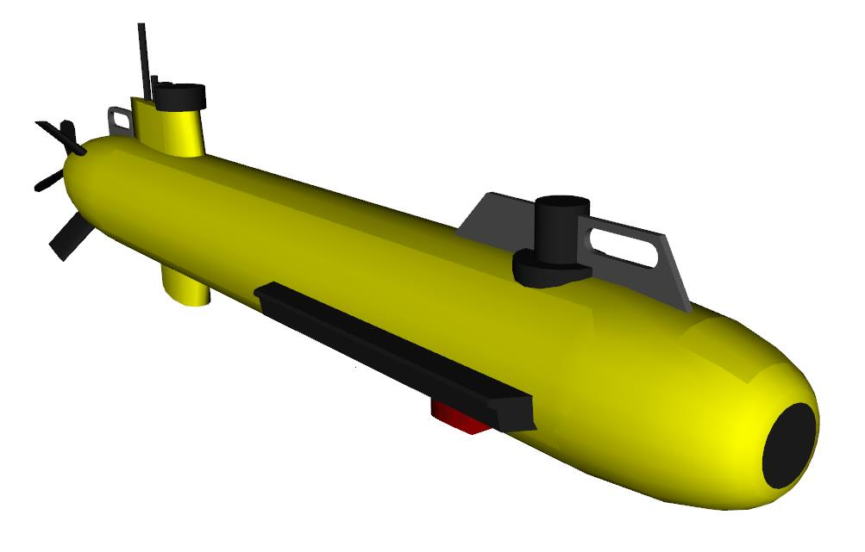
Figure 1: example of Gazebo vehicle model (ECA Group's A9 AUV).

- Phase 2 - A Gazebo world model: Open Robotics will construct a simulated underwater environment with a digital elevation map of a section of Monterey Bay’s shelf and extension points for adding current, wind, and wave models.
Result: the user will be able to load the world model in Gazebo (Linux) and host multiple vehicle models in conjunction in a fully rendered and interactive 3D environment (Figure 2). Simulated vehicles and sensors will be capable of interacting with the rendered environment (e.g., collisions, DVL beam raytracing), and we will use our 2019 summer intern's work to incorporate simulated acoustic messaging for multi-vehicle coordination.

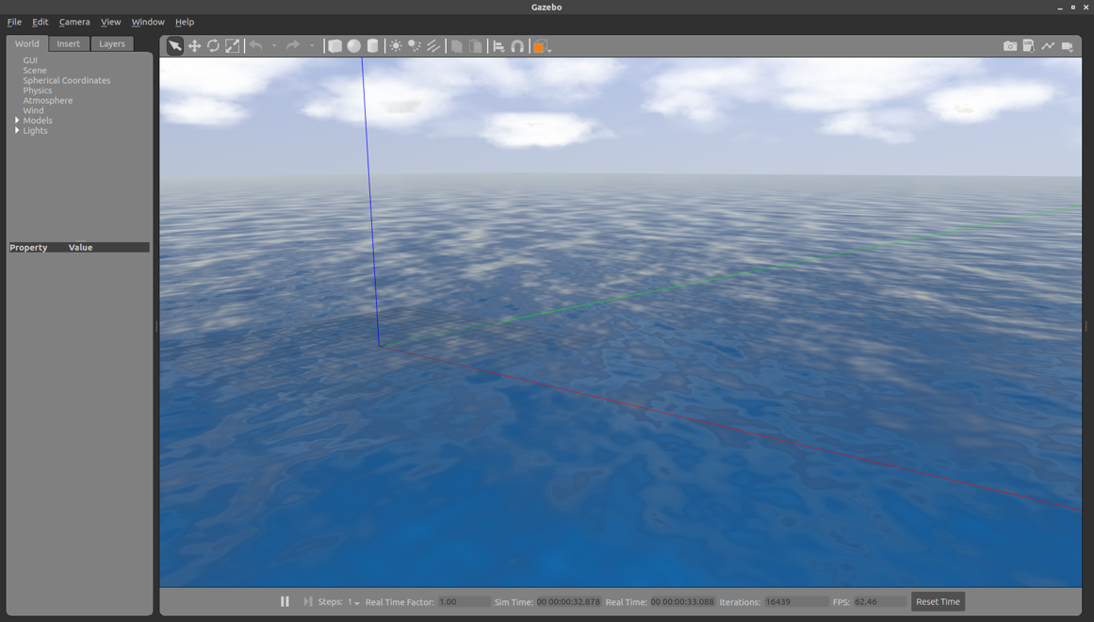
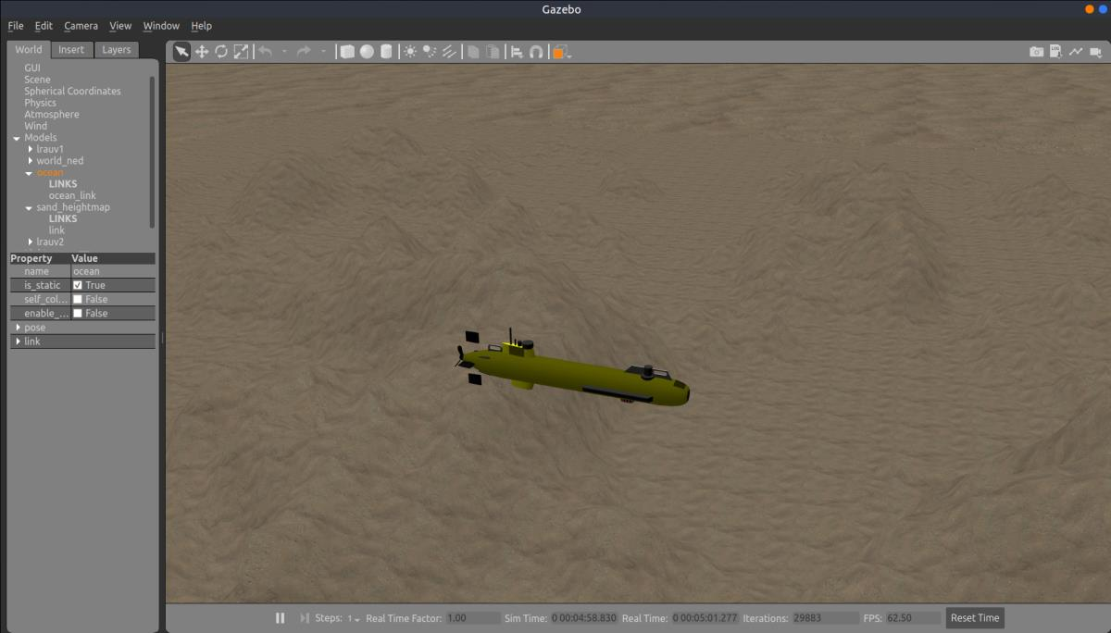
Figure 2: example of a Gazebo world showing modeled ocean surface (top), and an ECA A9 model underwater over a realistic elevation map of the seabed (bottom).
- Phase 3 - Full integration with LRAUV’s software stack: the Open Robotics team will bridge LRAUV data formats for compatibility with the ROS message passing interface, and synchronize the Gazebo sim with LRAUV application processes to allow full simulation with the vehicle’s software stack in the loop, including missions/behaviors, controllers, and device drivers.
Result: the user will be able to command the simulated LRAUV from TethysDash UI and the vehicle’s command line, and exercise all aspects of LRAUV’s software including the multi-vehicle components of the application (missions, behaviors, acoustic messaging ingest) on a Linux host. The integration will result in a standardized extension to LRAUV’s application programming interface (API) that a wide verity of researchers could interact with in a predictable and uniform way.
Data
1-5 GB of data stored on Atlas server.
Intellectual Property (IP) Considerations
At the onset of this project, we will work out a collaborator's agreement and NDA with Open Robotics, under which we will specify what aspects of the project can be open-sourced.

Anticipated Impact
Beyond to the technical capacity ROS offers, ROS has been chosen as the technology infrastructure because of its popularity in the open-source robotics community and the stature Open Robotics has established in this community. MBARI and external researchers developing multi-vehicle/backseat applications for LRAUVs will be able to use generic interfaces that promote technology export, and validate their application and hardware against a fully visualized and accurate simulation of the vehicle with minimal support required from MBARI engineering staff and assets. The capabilities proposed in this project are in synergy with ongoing efforts to improve LRAUV’s UI and user experience, and can serve as a powerful planning and training tool for LRAUV operators.

Anticipated Outreach Needs
None

Budget Category | Minimal | Medium | Significant
Labor | x
Expense |  | x
Ship/Assets

The project can be phased at the discretion of the MT to accommodate institutional spending limitations. However, all three phases must be completed for the end product to be useful.

