The goal of this project is to improve the pre-deployment test and validation capabilities for multi-vehicle applications at MBARI and standardize the LRAUV software such that development for the platform is available to any research group that is interested in advanced methods of ocean observation.
To this end, we are collaborating with a team of robotics and simulation experts at Open Robotics (https://www.openrobotics.org) to develop simulation tools and software based upon the widely adopted Robot Operating System (ROS) framework, and integrate them with LRAUV’s software ecosystem. Open Robotics is a research and development non-profit organization and a world-wide hub for activity in open-source robot software development. Open Robotics leads the development of ROS and its robot simulation tools, which have become the industry standard for development in most robotic domains and has been widely adopted in the marine robotics community, including by many of MBARI’s collaborators (NPS, WHOI, UW, OSU, JHU, Liquid Robotics, JPL).
- The team is currently engaged in developing a minimum viable product demonstration of the simulation to eliminate high risk aspects of the implementation and demonstrate that the simulation will be able to meet the needs of the MBARI team. At the end of the first quarter, the results of this demonstration will be presented to an MBARI design review panel for validation before continuing to subsequent project phases.
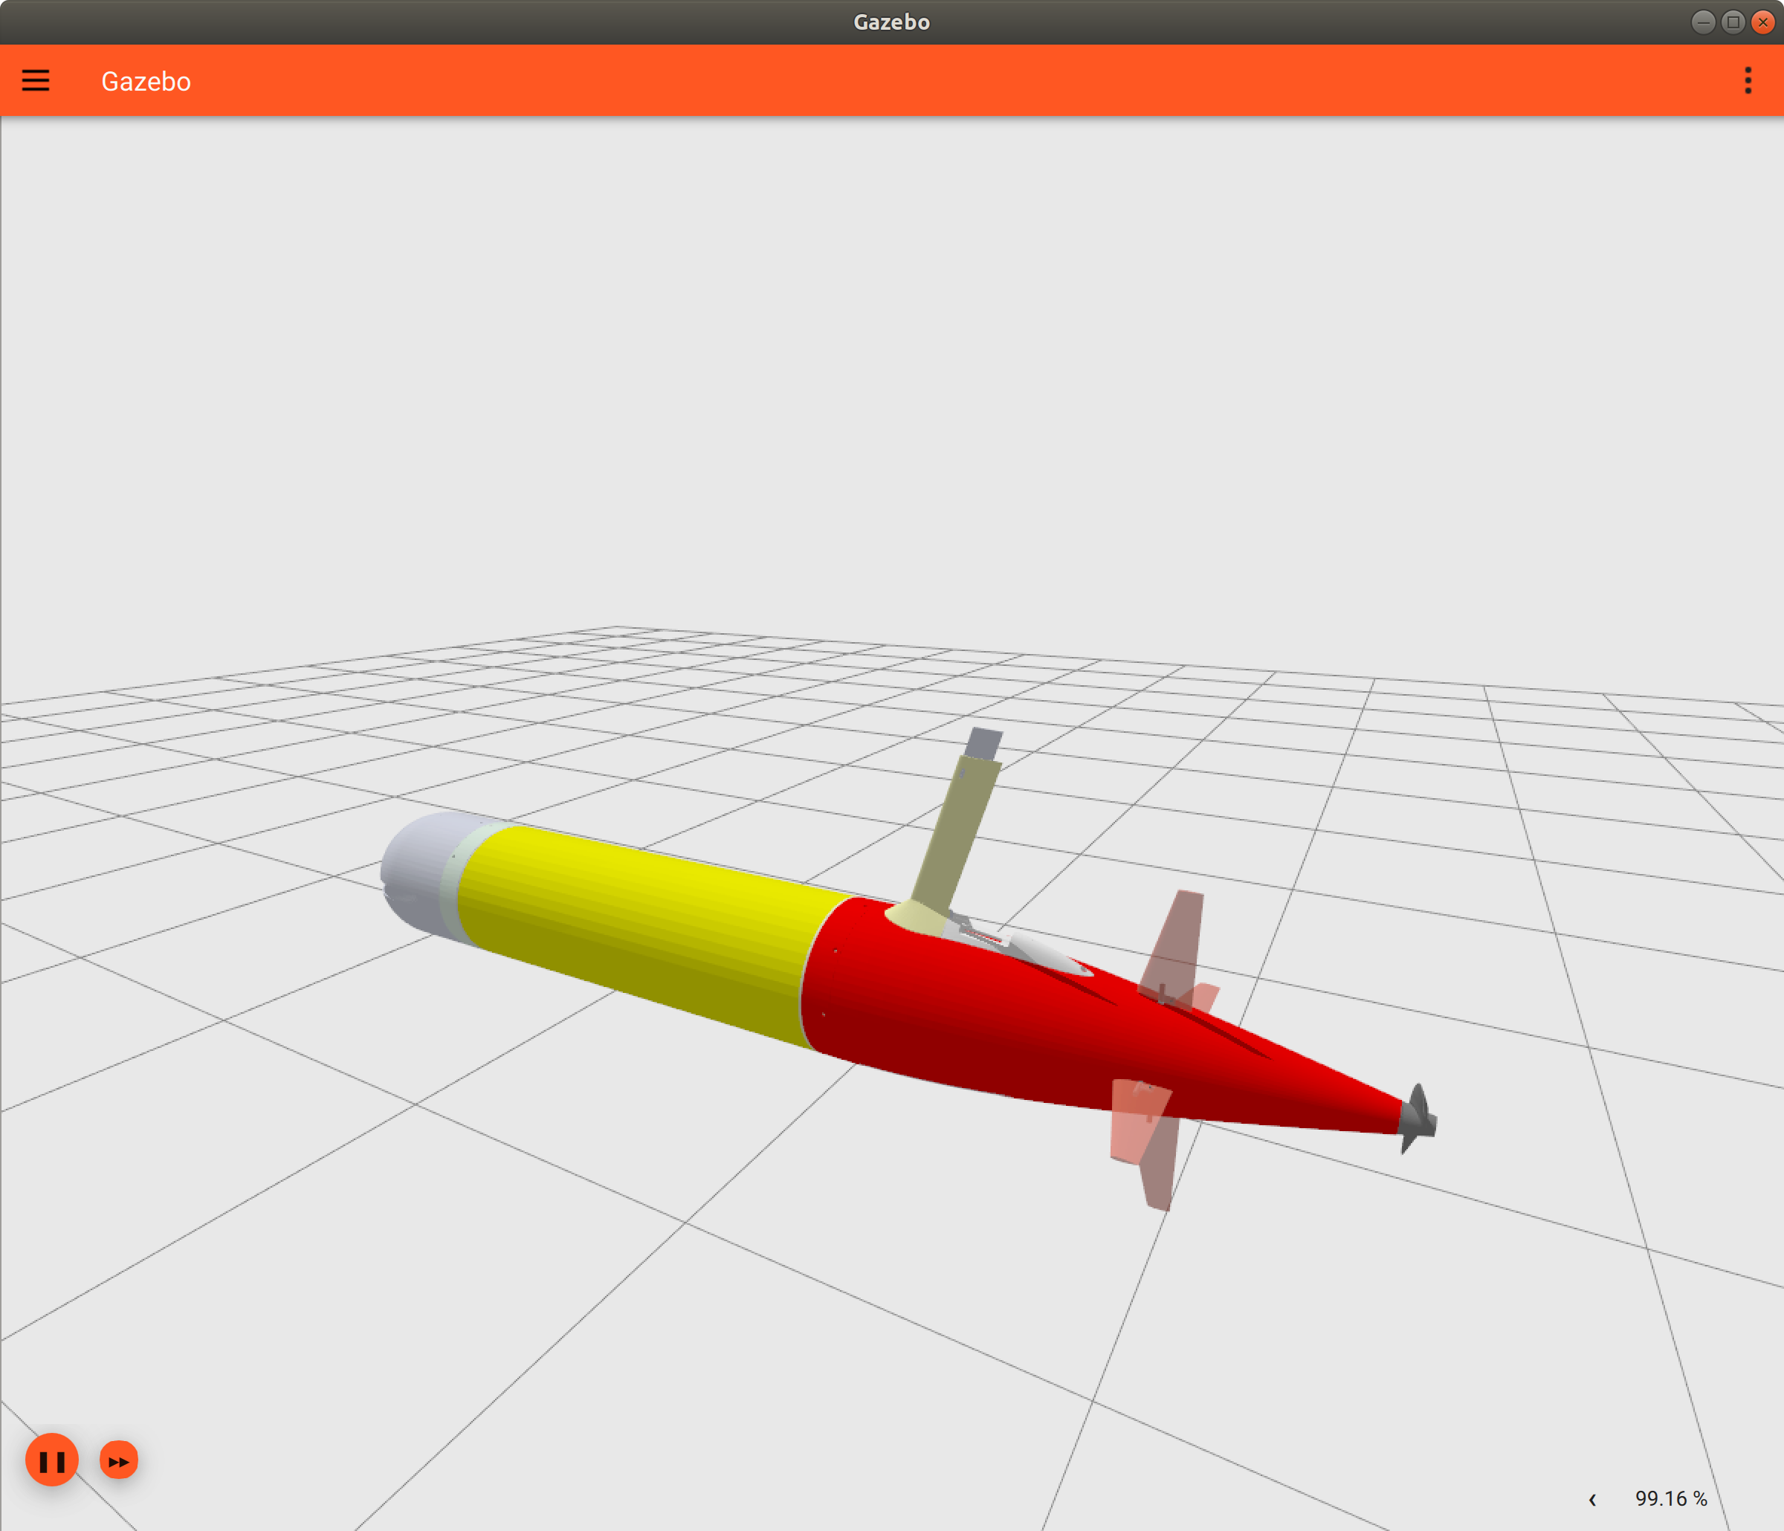
3D rendering of the LRAUV model prototype embedded in the ROS-based simulation environment.
- In Q2 we will extend the LRAUV vehicle simulation model to include actuators that are unique to the LRAUV and improve the fidelity of the simulation.
- In Q3 we will extend the simulation environment to include inter-vehicle acoustic comms and oceanographic and biological water properties such as temperature, salinity, and chlorophyll concentrations. Upon completion of this phase, developers will be able to simulate environmental scenarios such as thermal fronts and productivity hotspots, and simulate science missions that require CTD, and fluorometer inputs. Multi-vehicle tracking using range/bearing will also be supported and it will be possible to recreate simple multi-vehicle campaign such as CANON at this point.
- In Q4 we will add support for inter-vehicle acoustic data packet transfer and acoustic vehicle command and control. The team will also integrate the simulation with LRAUV’s web-based command and control interface (TethysDash: https://okeanids.mbari.org/dash3) and package the software so it can be used by any collaborator or run using cloud services such as AWS.

