Project Number: | 902102

Project Start: Jan. 1, | 2021 | Project Duration (in years): | Year 3 of 3

Please indicate if proposal includes requests for any of the following (mark all that apply).

Ship Time |  |  | ROV |  |  | AUV |  |  | Wave Glider |  |  | Mini ROV

Please indicate what type of project is being proposed (mark only one).

 |  |  |  | x
Feasibility/Scoping  [<100 days effort] |  |  | Development |  |  | Research |  |  | Infrastructure² |  |  | Education |  |  | Time Series |  |  | Institute Initiative

Project Manager: Brian Kieft
Principal Investigator: Brian Kieft
Lead Scientist: Yanwu Zhang
Lead Engineer: Carlos Agüero (Open Robotics)

Project Title: Multi-LRAUV Simulation Environment

Please indicate which category best describes the project theme (mark only one).

 |  |  |  |  |  |  |  |  |  | x
Ocean  biogeochemistry |  |  | Ecosystem dynamics |  |  | Ocean visualization |  |  | Exploration & discovery

Please indicate percentage of effort on this project anticipated for 2023 toward these three highest institutional goals (percentage total should equal 100%).

Goal | Developing/adapting innovative technologies | Utilizing developments to explore and understand ocean systems | Technology/knowledge transfer
Percentage | 75 |  | 25

- ABSTRACT (all projects)

Autonomous multi-vehicle operations are essential to the future of ocean science. Soon, heterogeneous autonomous fleets with complementary sensor payloads will swarm the ocean, adaptively optimizing their common mission using inter-vehicle acoustic communication to capture meaningful information and achieve complex scientific goals. MBARI is already a leader in the development and operation of multi-vehicle technology for oceanographic studies, and we are uniquely poised to advance these capabilities and the scientific research they enable. Alongside MBARI’s growing fleet of LRAUVs, developing appropriate tools for design and validation of new applications will be crucial for scaling up multi-vehicle operations and advancing autonomous ocean research and discovery. Adding to our pre-deployment and field-testing practices, the ability to simulate and visualize multi-vehicle scenarios under realistic and reproducible settings will enable rapid prototyping and testing of advanced algorithms, and improve the overall reliability, extensibility, and exportability of the LRAUV platform.

The goal of this project is to improve the pre-deployment test and validation capabilities for multi-vehicle applications at MBARI and standardize LRAUV’s software interfaces such that development for the platform is available to any research group that is interested in advanced methods of ocean observation. During 2022, we propose to continue and improve the quality of the simulation, add simulation plugins to enable testing of bottom aided navigation algorithms and water sampling missions, and focus on integrating the new simulation framework with the development procedures/workflows of MBARI’s engineering team. To this end, we’d like to continue our ongoing (and very productive) collaboration with the team of robotics and simulation experts at Open Robotics (https://www.openrobotics.org) to develop additional software simulation tools based upon the widely adopted Robot Operating System (ROS) and Gazebo frameworks.

Open Robotics is an independent research and development organization and a world-wide hub for activity in open-source robot software development. Open Robotics leads the development of ROS and its robot simulation tool Gazebo, which have become the industry standard for development in most robotic domains, including marine robotics, and have thousands of monthly users who actively contribute to their open-source software repositories. Open Robotics is comprised of more than 30 full-time technical staff, and their extensive experience using this software and disseminating it in the open-source robotics community is critical for the success of this project.

- PROPOSAL (all projects)

Background
Provide context for the project, being sure to address these questions:

What fundamental problem does this project address, and why is it important?

Targeted sampling within a Lagrangian reference frame is inherently a multi-vehicle problem. A canonical use case is tracking and sampling by two vehicles, where one vehicle tracks a feature of interest (and acquires water samples), while a second vehicle vertically surveys neighboring waters to provide contextual data and search for new features. Collaborative Multi-LRAUV applications have become a key component in MBARI field programs such as CANON (Chavez), ESP (Birch and Scholin), Targeted Sampling (Zhang), Precision Control (Rock), Acoustical Ocean Ecology (Benoit-Bird), Biodiversity & Biooptics (Haddock), and soon EyeRIS (Katija and Roberts) and Scalable Robotics (Troni). We anticipate the demand and complexity of multi-vehicle applications at MBARI will only increase in the future.

The success of multi-vehicle operations at MBARI results from diligent design work and meticulous field testing by dedicated science and engineering staff. To date, researchers designing new capabilities for LRAUV (or iterating on existing ones to improve performance and reliability), rely heavily on testing in the field, which involves much overhead in terms of costs and risk, and results in slow development cycle times. The problem is compounded in collaborative, multi-vehicle applications, and as a result, designs are often driven toward simplistic solutions. Moreover, the LRAUV codebase is highly optimized to allow for efficient execution on the platform’s low-power embedded processor. While necessary, this also sets a development barrier as developers require a significant time investment and advanced programming skills to contribute. Looking ahead, we will need to evolve an effective and scalable development path to support the increasing demand and growing complexity of future multi-vehicle applications, and must do so in a way that is extensible, limits operational overhead, and optimizes for technology transfer.

Practice in simulation alleviates many of the aforementioned issues as it allows the development team to validate new vehicle missions and behaviors in a controlled and reproducible setting prior to leaving the lab and concentrate field testing on critical aspects of the application. LRAUV’s software currently includes a vehicle simulator that was designed as part of the initial LRAUV project back in 2008. The simulator covers everything from the mission/guidance level down to vehicle controllers and dynamics, but lacks real-time visualization capabilities and provides only rudimentary support for simulating environmental forcings (e.g., currents) and sensor data (e.g., chlorophyll concentrations) that are critical for mission validation and edge case testing. More importantly, the existing simulator is limited to simulating a single LRAUV and cannot scale to support simulation of multi-vehicle scenarios or inter-vehicle communications.

More recently, we’ve added a “backseat” messaging interface that enables network-based telemetry and control over LRAUV from other applications, including ones that execute on a separate computer that is mounted in the vehicle hull. The backseat interface allows researchers to develop their applications offline independently from the LRAUV hardware (e.g., against a vehicle simulation), and then deploy it to the LRAUV backseat computer for execution. Decoupling these new backseat applications from LRAUV’s low-power processor marks an important stepping stone toward deploying to sea advanced algorithms for online data processing, control, and autonomy, and opens the possibility for using modern machine learning and edge computing technologies that were previously inaccessible.

Through collaboration with the team of robotics and simulation experts at Open Robotics, we have an opportunity to catalyze the development of a fully visualized multi-vehicle simulator for LRAUV and extend LRAUV’s backseat architecture for compatibility with ROS interfaces that are widely adopted in the open-source robotics world, including in the underwater vehicle community. The software tools and vehicle interfaces that we will develop will enable researchers to quickly iterate and validate the performance of their multi-vehicle algorithms and backseat apps in a development environment that is familiar to them, and overall, make development for the LRAUVs more accessible to researchers and collaborators.

What makes this work relevant to MBARI and the Packard Foundation?

Developing a framework to improve autonomous multi-platform capabilities supports the Packard Foundation's vision of solving basic technology problems to better understand marine ecosystems.

The overall objective of the multi-LRAUV simulation environment project is to develop or adapt innovative technology that will enhance autonomous multi-platform capabilities at MBARI, and enable a development workflow that allows a wide variety of researchers to run new applications on LRAUV during scheduled deployments. These capabilities are relevant to the “Exploration and discovery” research theme of MBARI’s strategic plan. In addition, we are exploring the use of an open-source software framework that is widely adopted by the underwater robotics community. While our collaboration with Open Robotics and the reuse of existing open-source tools stands to offer much value to MBARI, it also presents an opportunity to network and collaborate with external researchers and establishes a viable path for technology export and dissemination.

Is this effort linked to other internal or externally funded projects or collaborative efforts?

MBARI projects currently developing backseat applications for LRAUV:
- Haddock and Messié – Biodiversity & Biooptics
- Rock – Precision Control Technologies for ROVs and AUVs
- Messié – Plankton taxonomic groups from AUVs
- Benoit-Bird – Acoustical Ocean Ecology
- Katija – EyeRIS

External projects currently developing backseat applications for LRAUV:
- Amy Kukulya, WHOI/DHS – Oil & Environmental Anomaly Detection/Mapping
- Andrew Branch, NASA JPL – Autonomous Operations for an Ocean Worlds Submersible

During 2023, we will also work with Troni to explore simulation methods that meet his research needs and support his effort in any way we can.

Where does this work fit into the ~5–10 year plan for your group, at MBARI, and in the field?

The goals of this project to improve autonomous multi-vehicle capabilities align with multiple components of MBARIs Technology Roadmap, specifically, enabling targeted sampling, taking the laboratory into the ocean, and advancing a persistent presence, and feeds directly into MBARI’s vision of a mobile ocean observatory comprised of a heterogeneous autonomous fleet.

Further, the ability to simulate multi-vehicle scenarios under realistic and reproducible settings is a prerequisite for iterative machine learning approaches such as reinforcement learning, policy learning, automated planning, and command and control algorithms, all of which have been identified in the 2020 External Review document as means for reaching future institutional goals.

Nature and Scope of the Proposed Project

Engineering development effort (year 3 of 3). The development work for this project has been completed during years one and two. The focus of the proposed 2023 effort is:
- Minimal engineering requests from MBARI staff for enhancing MBARI user engagement and issue response.
- Enhancement of existing features, user experience improvements, and issue response provided by Open Robotics (external contractor) using funds remaining from 2022.

Does this activity relate to one or more 2023 proposals your team is submitting?

This project will support and operate in close collaboration with:
- Hobson – LRAUV Technology Development and Fleet Operations (902101)
- Kieft – AUV User Experience Design (902009)
- Zhang – Targeted Sampling by Autonomous Vehicles (901513)

Anticipated Shared Resource Needs

No shared resources needed.

Anticipated Expenses

Open Robotics design fees: $239,400 – $444,600 (not to exceed cost)

Intellectual Property (IP) Considerations

Yes, all Gazebo simulation software and ROS interfaces created under this project by Open Robotics will be open-sourced. Existing LRAUV software is under Export Administration Regulations (EAR) and will remain under MBARI IP. During 2021, we have worked with the IP team and determined that releasing a Docker image containing a simulation of the LRAUV software (with no source code) does not violate EAR control (thanks, Mandy!). Therefore, we will create a public release Docker image with the LRAUV software (no source code) that can be deployed on any platform, including cloud services, and used in conjunction with the Gazebo simulation.

Data

1-10 GB of data stored on Atlas server.

Anticipated Impact

Beyond the technical capacity the Gazebo simulator and ROS(2) offer, these frameworks have been chosen as the technology infrastructure for this project because of their popularity in the open-source robotics community and the stature Open Robotics has established in this community. MBARI and external researchers developing multi-vehicle/backseat applications for LRAUV will be able to use generic interfaces that promote technology export, and validate their application and hardware against a fully visualized and accurate simulation of the vehicle with minimal support required from MBARI engineering staff and assets.

The capabilities proposed in this project are also in synergy with Kieft’s ongoing efforts to improve LRAUV’s UI and user experience (902009), and will be added as a powerful planning and training tool for LRAUV operators.

Table 1. list of potential collaborators using ROS/Gazebo/Ignition for ocean science and engineering
 | Researcher | Affiliation | Related research activities
1 | Dr. Mike Jakuba | WHOI | Developing gazebo-based simulation for AUV surveys of the New England Shelf
2 | Kotachi Liu | University of Rohde Island | Develops decentralized controls for multi-node underwater platforms using ROS/Gazebo.
3 | Dr. Louis Whitcomb | Johns Hopkins University | Teaches and uses ROS regularly as part Laboratory for Computational Sensing and Robotics (LCSR) activities
4 | Luke Beatman | Liquid Robotics | Interested in developing a ROS/Gazebo simulation for Wave Glider
5 | Laura Lindzey | University of Washington | Develops ROS packages and plugins for AUVs.

Anticipated Outreach Needs

None.

Continuing Projects Only: Status Report

Current status of project and results to date
- In 2021 the team developed the simulation environment infrastructure, including a simulated water-column environment with oceanographic and biological water properties such as temperature, salinity, chlorophyll concentrations, and currents. The team also delivered a fully functional 3D vehicle model of LRAUV, which is commanded from the LRAUV’s vehicle software. The team added simulated inter-vehicle acoustic comms to support development of multi-vehicle/fleet applications that require acoustic localization, tracking, and communications.

Milestone 1 (Q1, 2022)

- During Q1, the team developed new software components to support loading full, 4D, Regional Ocean Modeling System (ROMS) gridded data into the simulation to support test and validation of adaptive search and targeted sampling missions. The simulators data interface supports a simple CSV format that can easily generated for any location and augmented to satisfy specific test cases. The embedded gridded data can be visualized in the simulation environment and the team developed performant interpolation routines to allow simulated vehicles to “sense” environmental ocean parameters such as temperature, salinity, and chlorophyll using simulated CTD and fluorometer sensors at their given coordinates in space and time.
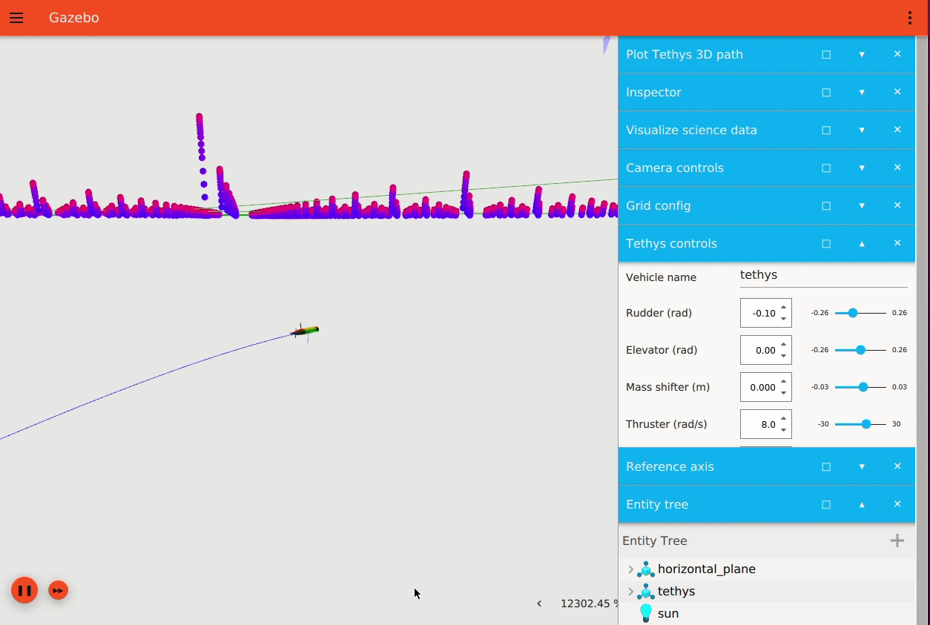
Fig 1. Regional Ocean Modeling System (ROMS) sea water temperature data embedded and visualized in the Gazebo simulation environment. Animation by Louise Poubel (Open Robotics)
- The team added software components and data to support test and validation of bottom-aided navigation algorithms. The team delivered simulation plugins to embed a 1-meter resolution Digital Elevation Maps (DEMs) of the Monterey Bay sea-floor at Portuguese Ledge (mapped by Dorado scans; many thanks to Dave C!). The DEM simulation plugin was designed to dynamically load 1x1km bathymetry tiles under the location of simulated vehicles to reduce the simulators memory usage footprint, enhance faster-than-real-time performance, and increase the scalability of the bathymetry simulation (conceptually, we can tile the entire bay). In addition, the team added an attituded heading reference system (AHRS) simulation plugin that provides attitude, accelerometer, rate-gyro, and magnetometer data (including a noise model) that factor into the LRAUV’s navigation algorithm.
- The team enhanced the performance of graded buoyancy along the ocean’s water/air surface boundary and added a surface-wind simulation plugin to simulate vehicle drift while the vehicle is on the surface.
- The team created Docker container and run scripts to streamline the sim-in-the-loop development workflow for multi-vehicle development and testing.

Milestone 2 (Q2, 2022)
- In Q2 the team delivered a GPU-accelerated 4-beam Doppler Velocity Logger (DVL) simulation plugin and integrated it with the LRAUV main vehicle application. The DVL plugin senses the simulated bottom (DEMs developed in Q1) and streams 4-beam altitude and bottom-referenced vehicle velocity at 1 Hz (identical to the real LRAUV DVL). The DVL simulation plugin includes a noise model. The data are ingested by the LRAUV application and factored in its onboard navigation algorithm. Adding the DVL sensor to the simulator enables the development of advanced data fusion algorithms and simulating cooperative navigation missions, such as those proposed by Rock’s Precision Control Technologies for ROVs and AUVs (600034). During the acceptance test for this milestone, the team demonstrated a much faster-than-real-time test of the TRN system, which included a simulated vehicle surveying Portuguese Ledge and the TRN system running on a Jetson Nano embedded system. The data flowing from the simulated vehicle to TRN (over the network connection) was indistinguishable from field data collected while the vehicle is deployed to sea.
Fig 2. A simulated LRAUV surveying Portuguese Ledge using the 4-beam Doppler Velocity Logger plugin. The DVL beams are rendered in the environment and the 1x1km bathymetry tiles are dynamically loaded under the location of simulated vehicle.
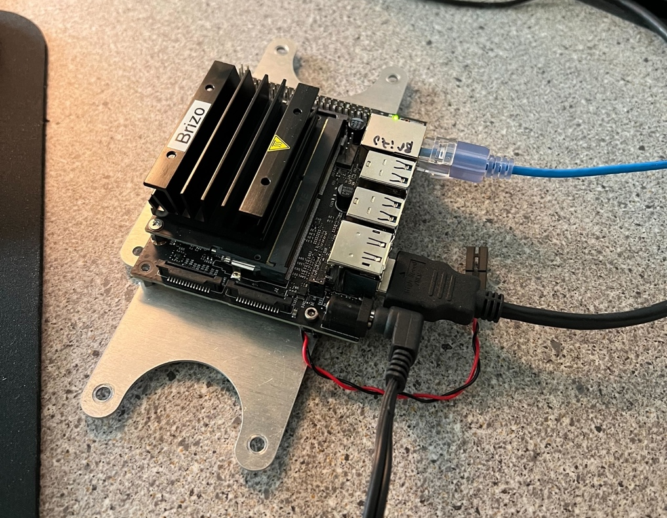
Fig 3. A backseat computer (Jetson Nano) taken out of LRAUV Brizo for testing TRN against the multi-LRAUV Gazebo simulator. Data flowing from the simulated vehicle to TRN over the network connection was indistinguishable from field data collected while the vehicle is deployed to sea.
- The team added a linear-discharge battery simulation plugin and integrated it with the LRAUV application.
- As part of his 2022 MBARI summer internship, Tim Player of OSU developed a new multi-LRAUV mission using the Gazebo simulation environment and demonstrated it at sea (sea trails take place Jul 12-14). The new multi-LRAUV mission, called autonomous hot-bunking, allows an LRAUV to autonomously track and relive another hovering LRAUV using acoustic tracking and communications. The new mission will allow MBARI researchers to extend Lagrangian water-mass tracking by swapping out vehicles as battery charge diminishes or sampling cartridges run out.

Milestone 3 (Q3, 2022)
- With Raanan’s departure at the start of the quarter, the team will suspend further development tasks for the time being. The team will focus on wrapping up ongoing development threads, fixing outstanding issues, and generating documentation and examples that will allow MBARI staff to easily utilize the simulator (this task was originally planned for Q4).

Milestone 4 (Q4, 2022)
- The team will continue to support streamlining the sim-in-the-loop development workflow for MBARI staff, mitigate issues, and push enhancements in response MBARI user feedback.
- The team will optionally resume development tasks originally designated for Q3, including:
  - Adding a simulation sensor plugin for ESP/CANON water samplers.
  - Adding a simulation world plugin for surface waves.

What percentage of labor and budget have been used through the 1st half of year?

Funds rolled over from 2021 budget: $112,032 — the rolled over funds were spent during Q1 of 2022, increasing the project’s total budget in 2022 to $556,632.

Milestone | Estimated min cost | Spending max limit | Actual $ spent | % of max spending limit | Note
1 | $126,540 | $162,450 | $121,533.75 | 75%
2 | $88,920 | $119,700 | $85,187.25 | 71% | Until June
3 | $71,820 | $94,050 | $0 | 0%
4 | $54,720 | $68,400 | $0 | 0%
Total | $342,000 | $444,600 | $206,721 | 46%

Will you complete the current year’s scheduled work?

With Raanan’s departure at the start of the quarter 3, the team will suspend further development tasks until new time allocation arrangements for project management are made on the MBARI side.

Significant changes from previous project proposal

On track.

Over the past two years, what peer-reviewed publications, education and/or outreach activities have resulted directly from this project? Please be brief.

- Presented at the Underwater Simulation Community Meeting. Participants attended from NPS, UW-APL, OSU, WHOI-MIT, URI, UNH.
- Presentation at ROSCon Nov, 2021.
- Sense, Think, Act podcast interview.
- MBARI project update.

All Projects: Specific Plans for 2023

Research Activities

None.

Engineering/technology development

During year 3 of the project we will focus on enhancing usability of the simulator and increase engagement within MBARI. We are requesting minimal engineering time for Brian Kieft for improving sim-in-the-loop development and test workflows, user support, and issue response. Open Robotics will remain under contract until the funds that were committed during 2022 are depleted.

Field programs (detail ship requirements/deployments/diver requirements)

None.

Specific deliverables

- Functioning development environment for MBARI engineering staff.
- Software improvements, issue response, and user support.

Milestones and required personnel (see personnel classification list for staff classifications)

[Click here to enter text]

2023 Project Start Date:  MM/DD/2023 | Q1 | Q2 | Q3 | Q4 | Total Resources (in hours) for each resource category for all milestones listed here
Milestone Date
Milestone Description
Electrical Engineer
Software Eng-Embedded | BK 50 | BK 50 | BK 50 | BK 50 | BK 200
Software Eng-Info Eng
Mechanical Engineer
Mechanical Eng-Division
Mechanical Eng-Mfg
Associate Engineer
Electrical Tech
Software Tech
Mechanical Tech
Machinist
Divers
Video Lab
(Add other categories/rows as needed)

Budget justification

No additional budget requested.

Project team

Brian Kieft

External consultants/contractors

We anticipate that roughly $120k will remain in the budget at the end of 2022 (access rolled over from 2021). We plan to keep Open Robotics under contract in 2023 until these funds are depleted. During this time, Open Robotics will:
- Continue work on any remaining tasks outlined in the 2022 SOW.
- Provide support and add enhancements to ensure smooth usability by MBARI staff.
- Respond to issues.

Project lab and office space requirements
In addition to any changes to current space usage, please also include anticipated office and lab needs for students, postdocs, collaborators, etc.

N/A

Risk matrix (development and infrastructure projects only)

 | Technical Risk | Organizational Risk | Tech Transfer Risk | Labor Estimate Risk
High
Medium
Low

Compliance Considerations
Please respond “Yes” or “No” to each line item below, and provide details as necessary.

CATEGORY | Yes/No | DETAILS

Isotope Use (see policy and cruise planning)
Will the project use stable or radioisotopes?

Battery waste over 4 liters (1 gallon)
Indicate type and amount.

Liquid hazardous waste over 60 liters (15 gallons)

Indicate composition and quantity.

Export Regulation
Foreign collaborations or international travel?

Technology access

Any potential exposure to proprietary information about export controlled equipment?

Export controlled purchases

Items purchased/in possession or to be purchased that are not on list?

Export controlled items (hardware, software, tech data)

Items to be transferred outside US (temporarily or permanently)? To what countries (including International Waters)?

Encryption Items

Use of non-commercial (specially licensed, non-mass-market) encryption or information security software?

Work covered by Marine Sanctuary permit?
Yes, if work falls under blanket authorization.

Work conducted in SESAs?

ID # for Sanctuary Ecologically Significant Areas

Equipment deployed with anchors?

Give details for deployment; recovery if < 500lbs

CA Fish & Wildlife permit required for samples?

Working in State Marine Protected Area?

Require Coast Guard PATON for buoys?

Private Aid to Navigation. Permit in hand?

Require Local Notice to Mariners
Indicate who will be submitting

Permits from other agencies?

Use of active acoustics not already on list?

Development and infrastructure projects must complete the risk matrix (see end of the proposal form).
Not all projects will require all four titles to be filled in. Please indicate individuals only for those titles that are appropriate for your project.
This category includes transfer of hardware, know-how, publications, presentations, etc.
This number should be the same number you entered on the web budget resource requests for this particular resource.

