902106 and 902101 AUV Docking

Principal Investigators: Andy Hamilton and Brett Hobson

Purpose
MBARI seeks to develop technology to enable oceanographic observation anywhere in Monterey Bay, anytime of the year. AUVs can carry instruments throughout the bay, but are limited in their endurance, so MBARI is developing an AUV docking station that can recharge the AUV’s batteries without recovering the vehicles. This enabling new technology will allow near continuous observation throughout the bay.

Methods/Procedures
From 2020 to 2022, the engineering team has developed a prototype of a novel power-transfer system for the LRAUV. In 2022, the team deployed the system in South Monterey Bay, in 75 m water depth, and tested it for several months. We are planning to deploy it again in 2023 in the same location.

The system consists of a buoy, a mooring system, and a subsea docking station.
The buoy is 60” in diameter and carries solar panels, a battery, and control and communication electronics.
The mooring consists of a taught electromechanical cable, in line with a stretch hose and a 1100 lb train wheel anchor (this is a standard oceanographic mooring design, made by WHOI).
From the anchor, a 20 m long cable runs on the seafloor to the docking station. The docking station hangs on a subsea float, 8 meters above the seafloor and is held with a small (120lb) anchor.
The AUV docking station consists of a 1.8 m long, 2 cm diameter charging rod, an electronics housing, a camera, a light, and an acoustic modem. The AUV uses this acoustic modem to locate the docking station, and just before it arrives, the AUV extends a docking arm to capture the charging rod and to hold it in place while the batteries are getting charged. The camera and light are used to document the docking event. A cellular modem on the surface buoy allows real-time monitoring and control of the docking system from shore.

The location of the mooring is 36.777°, -121.861°, which is about 5 nm WSW of Moss Landing in 75 meters of water. To minimize the potential for marine mammal entanglements, the mooring has been designed to maintain a vertical, taut line (see Figure 1 below). Between deployments, the entire mooring and associated equipment and anchor will be recovered, including the anchors.

Sanctuary Prohibition
These moorings utilize anchors, and therefore cause very minor disturbances to the seafloor. Upon recovery of the equipment, the seafloor will rapidly return to its pre-deployment condition.

Activities in 2022
We deployed a tilt current meter from 01/27/22 to 03/08/22 at the experiment site. The purpose was to determine the speed and direction of the current to make sure that the site was suitable for the docking mooring.
We deployed the AUV docking system on 03/24/22 but it quickly had an electrical failure so we recovered it on 05/13/2022. We fixed the problem and redeployed the system on 05/25/22. We performed testing on the system and recovered it on 12/08/22

Plans for 2023
We expect to deploy the AUV docking 2 times in 2023. The deployments will be in the same location as in 2022. Guidelines to reduce the risk of marine life entanglement will be carefully followed, including taut mooring lines and careful tracking of the position of the buoy so that the team is immediately notified if the moorings were to start drifting.
The first deployment will be from late March to Early June, and the purpose will be to test the system.
The second deployment will be from Mid September to Mid December and will be in support of scientific experiments.

During these deployments, we expect to conduct tests on approximately a weekly routine. As the AUV begins its docking approach, it will emit a short acoustic interrogation, and the transponder on the dock will reply. The AUV is able to detect the direction of this incoming acoustic reply ping and steer towards it, pinging every 5–30 seconds. Each docking approach should take about 10 minutes and require about 100 of these short acoustic pings. Once securely docked, power will be applied to the power transfer system, and the batteries aboard the AUV will be charged. A light and camera will be turned on for a short time to record the docking procedure. When the system is fully functional (phase 4 above), the AUV may stay for 10 hours on the dock to recharge its batteries.

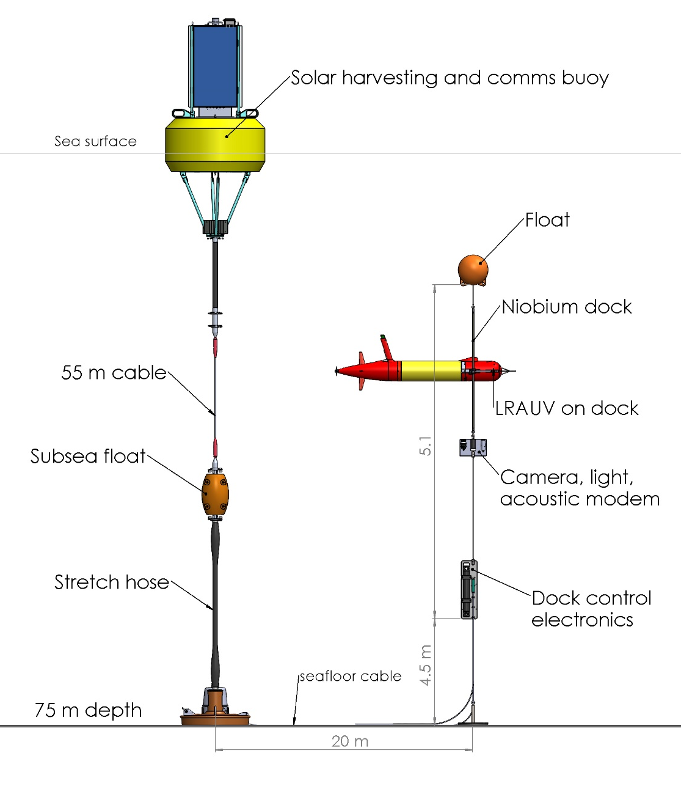

Figure 1. Schematic of mooring design to be used for this project.

