902106 and 902101 AUV Docking

Principal Investigators: Andy Hamilton and Brett Hobson

Purpose
MBARI seeks to develop technology to enable oceanographic observation anywhere in Monterey Bay, anytime of the year. AUVs (Autonomous Underwater vehicles) can carry instruments throughout the bay, but are limited in their endurance, so MBARI is developing an AUV docking station that can recharge the AUV’s batteries without recovering the vehicles. This enabling new technology will allow near continuous observation throughout the bay.

Methods/Procedures
Since 2022, the engineering team has been developing a novel power-transfer system for the AUV. The system has been deployed in two locations in Monterey Bay, in 75 m water depth, for several months each time. In 2025, it was deployed at the two locations, for a total of 6 months. For 2026, we are planning to deploy two units, from August to December, at the same two locations as before.

The system consists of a buoy, a mooring system, and a subsea docking station. The buoy is 60” in diameter and carries solar panels, a battery, and control and communication electronics. The mooring consists of a taut electromechanical cable, in line with a stretch hose and an 1100-lbs train wheel anchor (this is a standard oceanographic mooring design, made by WHOI). From the anchor, a 20-m long cable runs on the seafloor to the docking station. The docking station hangs on a subsea float, eight meters above the seafloor and is held with a small (120 lbs.) anchor.

The AUV docking station consists of a 1.2 m long, 2 cm diameter charging rod, an electronics housing, a camera, a light, and an acoustic modem. The AUV uses this acoustic modem to locate the docking station, and just before it arrives, the AUV extends a docking arm to capture the charging rod and to hold it in place while the batteries are getting charged. The camera and light are used to document the docking event. A cellular modem on the surface buoy allows real-time monitoring and control of the docking system from shore.

A new and important development for 2026 is the combination of the docking station with MBARI’s wave-energy buoy. We are planning to deploy a new mooring that includes the two systems, in order to power the AUV docking station with the wave-energy buoy. This will be a 2-point mooring, with two main anchors. We successfully tested a preliminary version of this mooring in 2025, albeit without electrical connection to the seafloor and without the docking station.

The Southern Monterey Bay location is 36.903, -122.119, which is about 3.5 nm south of 4-mile beach, in about 75 m water depth. The northern Monterey Bay location is 36.905, -122.116, 3.5 nm South of 4-mile beach.

To minimize the potential for marine mammal entanglements, the two moorings have been designed to maintain taut lines (see Figure 1 and 2 below). Between deployments, the entire mooring and associated equipment is recovered, including the anchors.

Sanctuary Prohibition
These moorings utilize anchors, and therefore cause minor disturbances to the seafloor.

Activities in 2025

On 1/23/25, we recovered the AUV docking station, which had been deployed in South Monterey Bay since May 2024.

On 5/31/25, we deployed the docking station at the northern Monterey Bay site. On 8/13/25, we moved the station to the southern Monterey Bay site. We recovered it on 12/15/25. We performed docking operations throughout the duration of the deployment.

Plans for 2025

We are planning to deploy two moorings in August 2026.
At the northern Monterey Bay site we will deploy the solar-powered mooring (same mooring as in 2025).
At the southern Monterey Bay site we will deploy the wave-powered mooring (a new development that includes the wave-energy buoy).

We expect to continue using the docking stations in the coming years.

Guidelines to reduce the risk of marine life entanglement will be carefully followed, including taut mooring lines and careful tracking of the position of the buoy so that the team is immediately notified if the mooring were to start drifting.

During these deployments, we expect to conduct operations on approximately a weekly routine. As the AUV begins its docking approach, it will emit a short acoustic interrogation, and the transponder on the dock will reply. The AUV is able to detect the direction of this incoming acoustic reply ping and steer towards it, pinging every 5–30 seconds. Each docking approach should take about 10 minutes and require about 100 of these short acoustic pings. Once securely docked, power will be applied to the power transfer system, and the batteries aboard the AUV will be charged. A light and camera will be turned on for a short time to record the docking procedure. The AUV may stay for 10 hours on the dock to recharge its batteries.

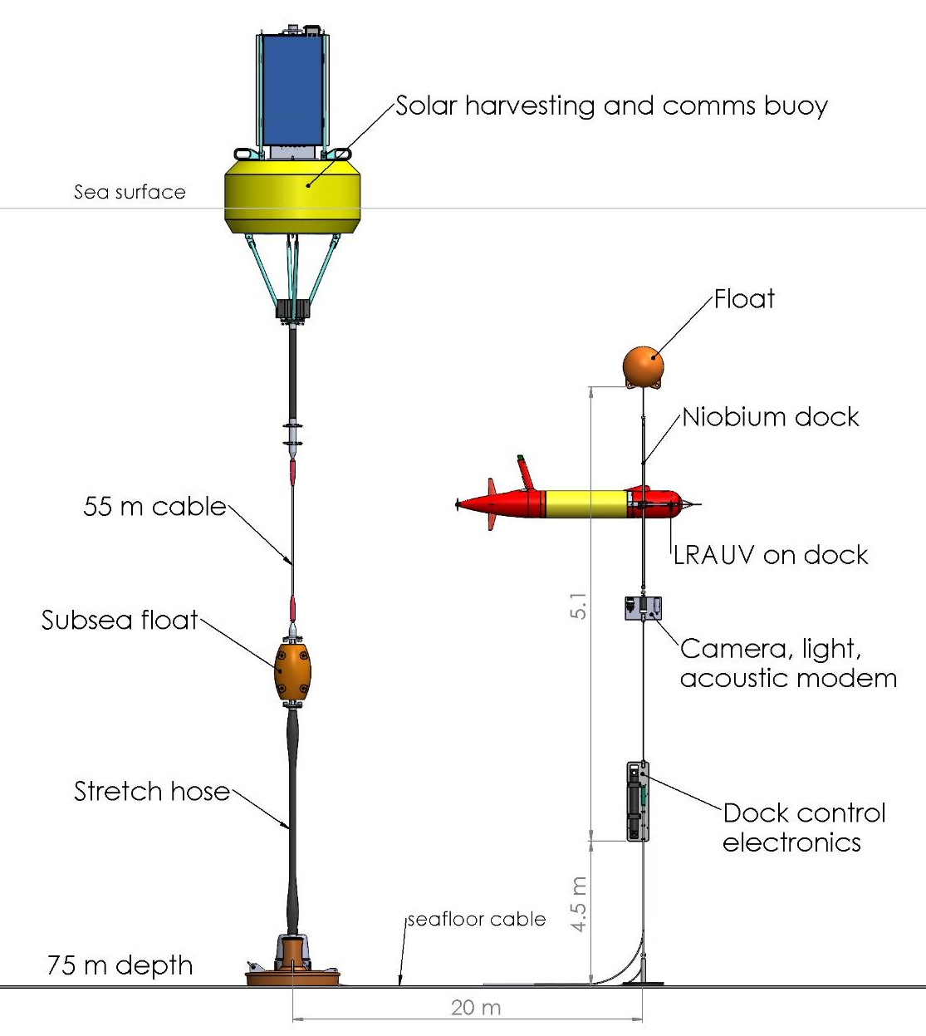
Figure 1. Schematic of the mooring for the solar-powered AUV docking. Drawing is not to scale. Note dimensions on drawing.
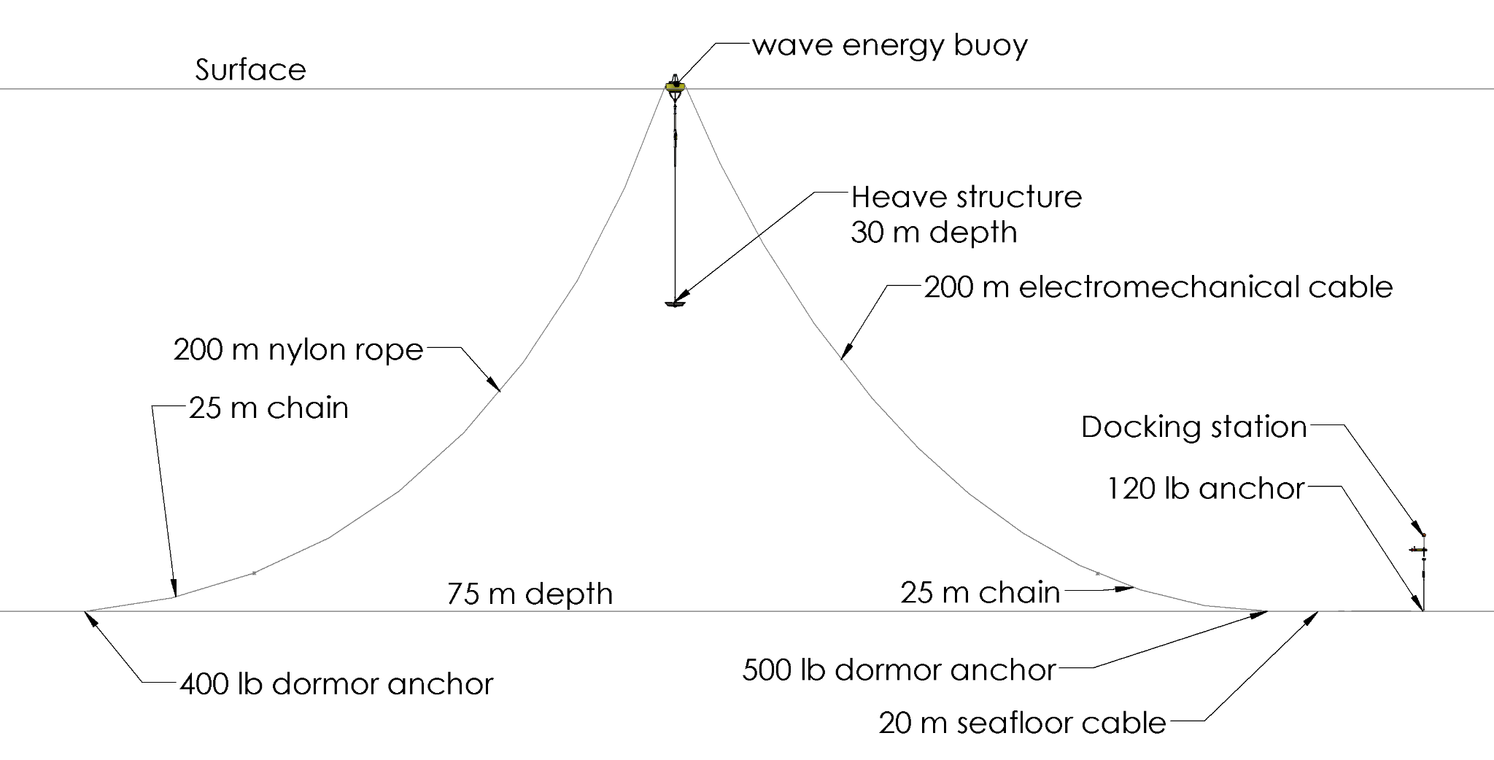
Figure 2. Schematic of the mooring for the wave-powered AUV docking station. This mooring includes the wave-energy buoy and the AUV docking station. Drawing is not to scale. Note dimensions on the drawing.

