Niobicon-Based AUV Docking Development 902106
Andrew Hamilton/Brett Hobson/Francois Cazenave
The team has been busy and numerous achievements have been made over the last few months.
- The line capture and power transfer device has been successfully tested in the test tank (as demonstrated during the DOEST).
- Plans to collaborate with WHOI on a buoy-supported AUV dock in 2022 have been made.
- The team is designing and building a preliminary, short-term, AUV dock and a solar-powered surface buoy to support it. This dock will be deployed and tested in Monterey in late 2021 for a few weeks. Tasks include: modeling of mooring, design and fabrication of the buoy, design and assembly of solar energy system, fabrication of dock, design and assembly of docking electronics.
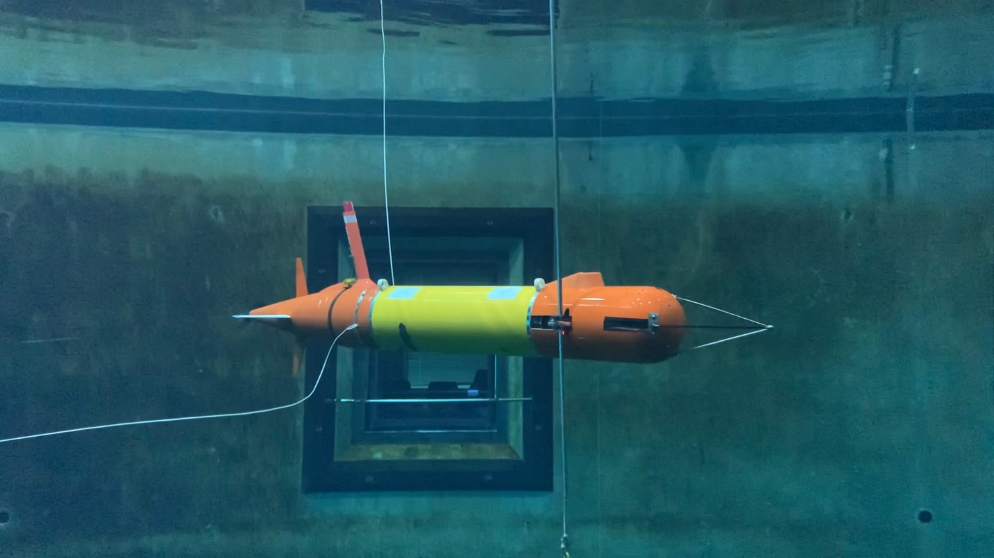
Figure 1: LRAUV on the dock in MBARI’s test tank.

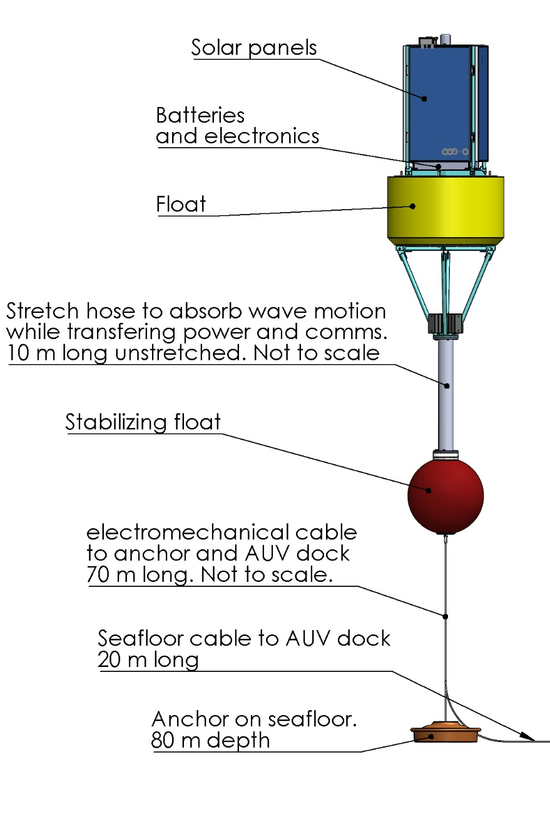
Figure 2: The buoy captures solar energy and transfers it to the dock via an EM cable.

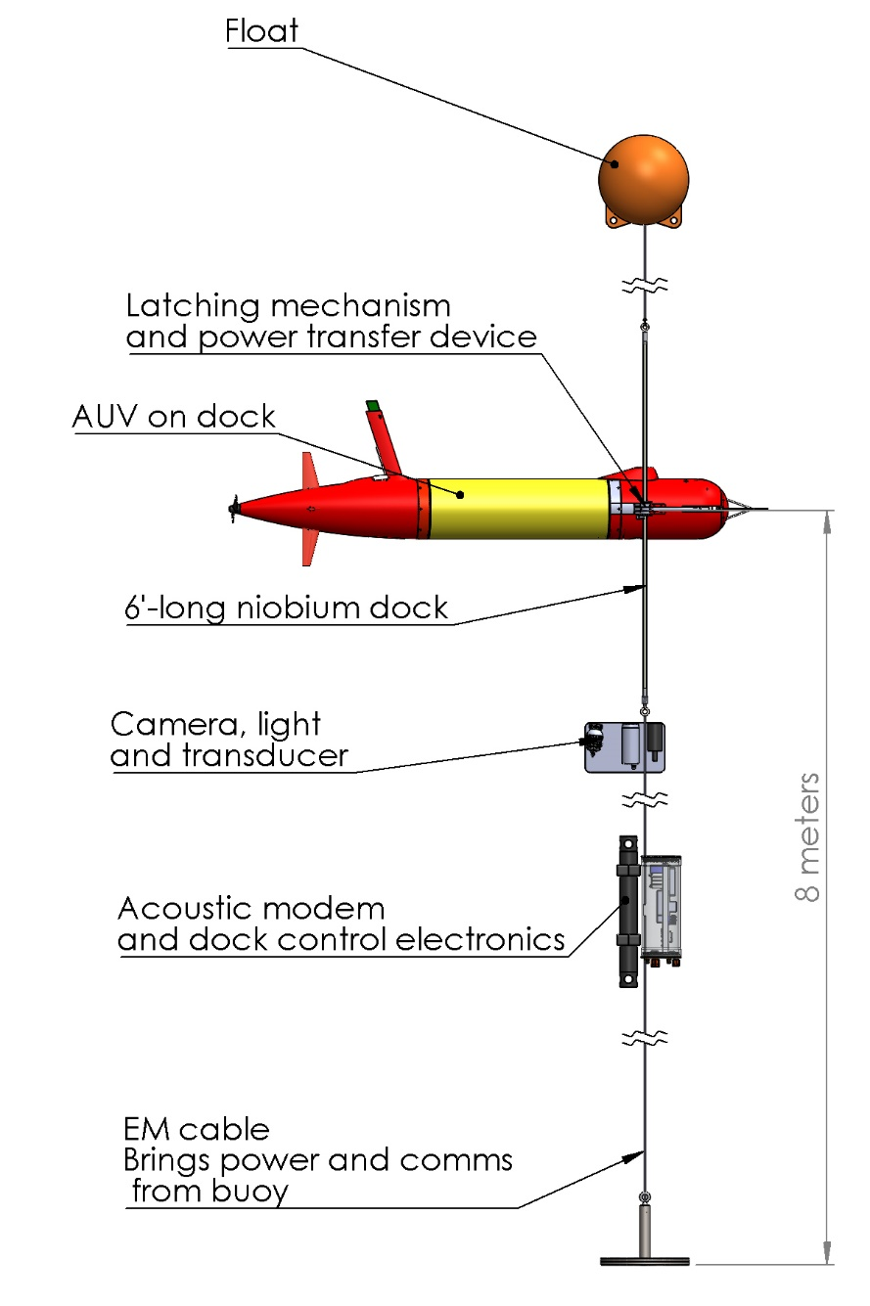
Figure 3:: The dock hangs on a float, 8 m above the seafloor.

